1. When to use (Rapid Application Development) RAD model.When not to use (Rapid Application Development) RAD model

WHEN TO USE
- RAD should be adopted to only those cases where the entire project can be modularized. This helps in incremental delivery of the project and each element can be worked upon concurrently.
- RAD model can be used only if highly skilled designers, developers are availabe. This is because this model prefers fast delivery of the system. Inexperienced employees will take an extra time for training which can be avoided if the employees are domain specific.
- RAD requires high buget and so can be adopted to high budget projects only. The high cost is required for the highly skilled employees and automated tools which helps in fast coding.
- RAD can be adopted if domain experts are available.
- Should be used where the requirements change during the course of the project and working prototypes are to be presented to customer in small iterations of 2-3 months.
- RAD should be employed when the project should be developed in a short span.
- RAD can be adopted to those projects which support code reusability.
- RAD can be used for those projects which supports customer feedback.
- Suitable for project requiring shorter development times
- Suitable for systems that are component based and scalable.

WHEN NOT TO USE

- RAD should not be used if the budget is low as this model employs a team with high qualification who are domain expert and also uses automated tools.
- RAD should not be used when the project delivered demands high quality.
- RAD should not be used for those projects which cannot be modularised
- RAD should not be used for large scale projects which takes a long time to complete.
- RAD cannot be used if highly skilled domain specific team not avalable.
- RAD need not be used for projects which involves less customer feedback.

2. Define an ER diagram of a software Organization with all the relationship model that was discussed in the classroom

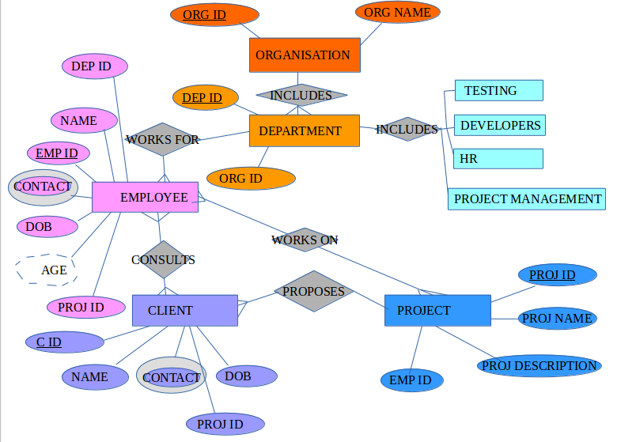

In the above ER diagram there are Entities ORGANISATION, DEPARTMENT, EMPLOYEE, CLIENT and PROJECT with their attributes. Every Organisation has multiple Departments to which the Employees work for. Each Organisation consists of Entities TESTING, DEVELOPERS,HR,PROJECT MANAGEMENT. Multiple Clients are related to multiple Projects and multiple Employees.

One to One Entity

One to Many

Many to Many Attribute

3. Describe the Entity Relationships for the following diagram

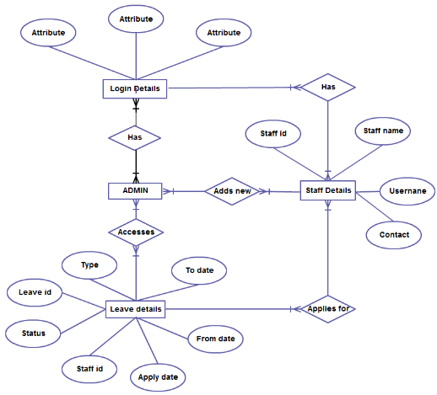

The ER diagram shows the following
Entities and its Attributes

- Login Details
  - having three attributes
- Admin
- Staff Details
  - Staff name
  - User name
  - Contact
- Leave Details
  - Type
  - Leave id
  - Status
  - Staff id
  - Apply date
  - From date
  - To date

Relationship between the Entities

- Login Details and Staff Details
  - Many to Many relation
    - Each staff can have multiple Login like Login to mail, Login to Acadglid,Login to gmail
    - Each login can have multiple Staff like all the employees have a login to outlook mail.
- Login Details and Admin
  - Many to Many relation
    - Each Admin can have multiple Login like Login to mail, Login to Acadglid,Login to gmail
    - Each login can have multiple Admin
- Admin and Staff Details
  - Many to Many relation
    - Admin of different branches can hire any no of Staff to the Organisation
    - All Staff are answerable to all the Admin
- Staff Details to Leave Details
  - Many to Many relation
    - A Staff can apply to more than one leave(multiple days)
    - On a particular day more than one Staff can take leave
- Staff Details and Admin
  - Many to Many relation
    - Admin can view all the Leave Details
    - A Leave Detail can be viewed by all the Admins

