1.Draw a Use Case Diagram for an online Library Management System

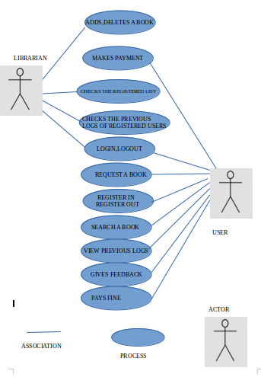

2.List down the best practices from Agile/Scrum methodology

AGILE DESIGN PRACTICES
- Architecture Envisioning
  - Its a light weight modeling
  - Done at the beginning of the project
  - High level study about the project
  - Identifies and solves issues related to architecture level
- Iteration Modeling
  - Its a light weight modeling
  - Done at the beginning of each iteration or sprint
  - Identifies the team’s iteration strategy
  - Its a part of Sprint planning.
- Model Storming
  - Its a light weight modeling
  - Discusses about how the User Interface is going to look like
- Test First Design
  - Test the design first before completing the code and testing it
- Refactoring
  - Small changes done to the project without changing its semantics
- Continuous Integration
  - Automatically compile and test the component of your project whenever a change occurs to that component
- Pair programming
  - Even if the team members are expert, agile always prefer pair programming. This helps a lot in discussion and can remove possible errors.
  - Contributes to perfection in developing.
- Test-Driven Development
- Burndown charts
  - Gives an idea if the project development is going according to the plan and schedule
- Sprint Demo Meeting
  - Customer can assure that he received all the features he expected
- Customer Collaboration
  - Customer involved at multiple stages of development. This gives a better idea about the customers expation and helps to work towards this
- Product Backlog
  - States all the requirements the customer stated in a high level
  - Best part is it can be modified as and when required.
  - Can add new features
- Iterative Development
  - The team can decide how much work they can complete within the specific time goal by analising the previous iteration.
- Scrum Daily meetings
  - Helps in analysing the project progress
  - Gives a clear idea about what to complete and what was completed
  - Discusses about all the impediments

3.Collaboration
a.How does collaboration help agile development?

Collaboration Is the most imporatant part in agile methodology. It promotes frequent face to face discussions amoung the team members.Collaboration can happen within the team members and between the customer and team.
Collaboration with the customer can give a better idea about the requirements. It removes all the impediments and ambiguities related to the requirements. This also helps in adding extra features the client needs according to the changing technology and environment. The client gets a better idea about the project development progress and thus ensures customer satisfaction.
Collaboration amoung the team members helps in solving all the ambiguities arised during project development. It also helps in coordination.Collaboration comes very useful when there is different perception for requirement. It removes all the confusion.
b.What if the team is distributed and can you achieve the same productivity?

- No, the productivity is not the same when the teammis distributed. The productivity gets reduced. Even if the team members can communicate through internet it doesn’t get that efficient as in a face to face communication.
- More clarifications cannot be made in a distributed communication as here the discussion is made precise.
- Team members dont feel that open as in a face to face one.
- This is more difficult when the team members are in different countries as the timings are different.
- Daily Scrum Meetings are really difficult to conduct in distributed team.
- If the team is in the same location a meeting can be organised as and when an ambiguity occurs which doesn’t happen when the team is distributed.

c.What would you do to achieve the productivity for a distributed team?

- Try to get a meeting face to face before the team gets distributed. Discuss all the possible ambiguities and plan how to handle. Plan and fix all the times the remote meetings will take place.
- Try to have face to face meeting for all crucial elements of the project.

4.What is Sprint Zero in Agile? Describe the activities that are done in Sprint Zero.

Sprint Zero is is the initialization step in an agile project which is also called as Iteration Zero. It consists of certain activities that will make the team ready for the sprint 1. It is also known as a project before a project phase because at the beginnig of a project there should be a detailed analysis about how the project has to be done. Following activities are included in the sprint zero :-
- Active stakeholder participation
- Obtain funding and support
- Start building the team
- Initial requirements envisioning
- Initial architecture envisioning
- Set up environment
Sprint zero is a necessary step in a project because there are certain matters that needs to be taken care before the beginning of as project such as the recruitement of the employees,assembling of the resources creating a produce backlog etc.

