MILESTONE 3
End-to-End Verification & Completion Evidence
Streamlining IT Procurement: Automating Standard Laptop Orders with Flow Designer
ServiceNow • Flow Designer • Standard Laptop Procurement

1. Milestone Objective
The objective of Milestone 3 is to verify the completed Standard Laptop procurement workflow in the live ServiceNow instance. The verification confirms that an approved Standard Laptop request produces the expected Requested Item and Catalog Task, with the task routed to the Hardware group.

2. Verification Summary
Verification Item | Observed Result
Catalog Item | Standard Laptop
Requested Item | RITM00100002
Request | REQ00100002
Request Stage | Request Approved
Catalog Task | SCTASK00100003
Assignment Group | Hardware
Approval | Approved
Task State | Open
Short Description | Laptop need to Configured

3. Evidence of Completion
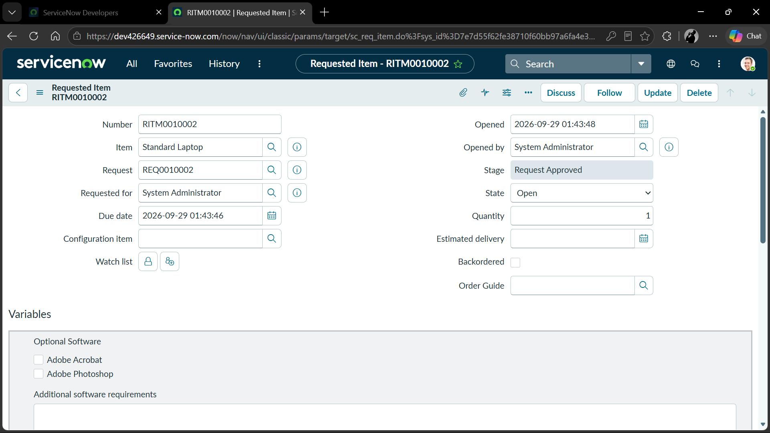
Figure 1 – Requested Item verification
The Requested Item RITM00100002 shows the Standard Laptop item and the stage as Request Approved.
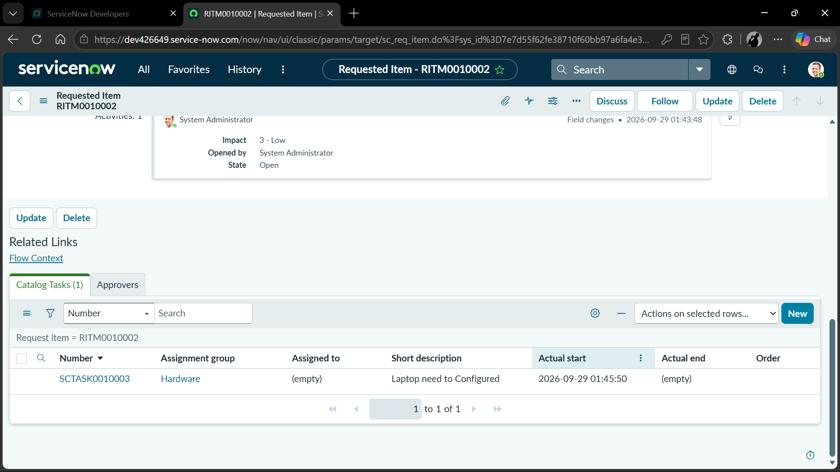
Figure 2 – Catalog Task generated
The Catalog Tasks section shows SCTASK00100003 assigned to the Hardware group with the short description “Laptop need to Configured”.
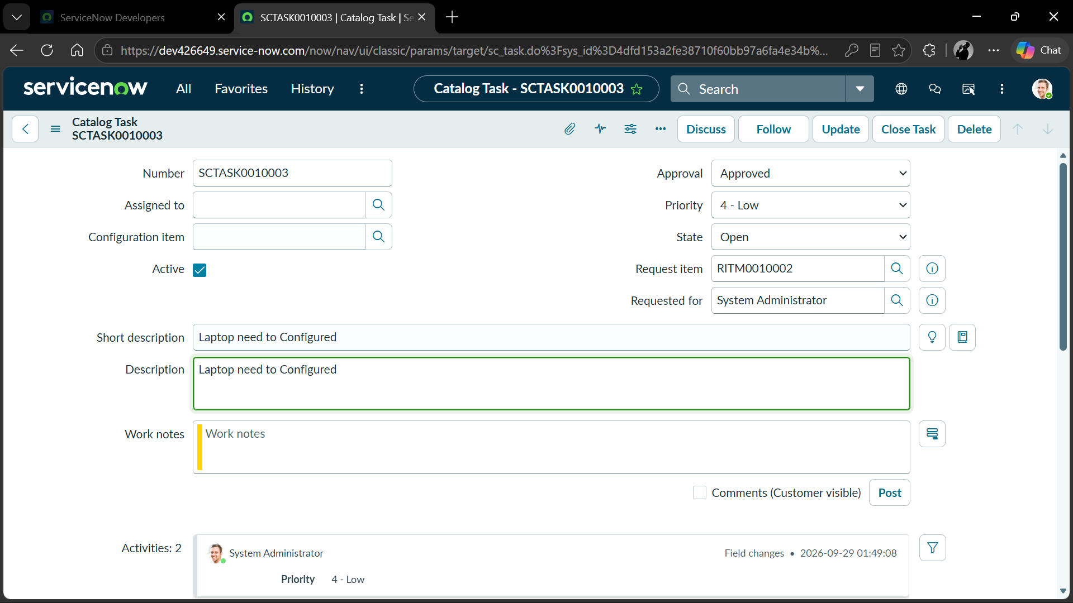
Figure 3 – Catalog Task record verification
The opened Catalog Task SCTASK00100003 shows Approval = Approved, State = Open, Request Item = RITM00100002, and the short description.

4. End-to-End Result
The live verification demonstrates the completed procurement path: Standard Laptop request → Request Approved → Requested Item created → Catalog Task generated → Hardware assignment confirmed. The Catalog Task record also confirms the approved status and task state.

5. Conclusion
Milestone 3 verification is completed successfully. The submitted evidence confirms that the ServiceNow Flow Designer implementation is producing the expected fulfillment task for an approved Standard Laptop request and routing it to the Hardware assignment group.

6. Repository Reference
This milestone documentation is intended to be added to the existing GitHub repository for the project “Streamlining IT Procurement: Automating Standard Laptop Orders with Flow Designer.”
Recommended location: milestones/milestone-3-verification/docs/MILESTONE_3_COMPLETION_REPORT.docx

