Milestone 1 — Required ServiceNow Screenshot Evidence
Streamlining IT Procurement: Automating Standard Laptop Orders with Flow Designer
Only the relevant Milestone 1 evidence screenshots are included in this document.

Evidence | Artifact | What it proves
1 | Flow Designer Overview | Shows the actual ServiceNow Flow Designer / Workflow Studio flow named “Standard Laptop Task”, with the Service Catalog trigger, Create Catalog Task action, and Active badge.
2 | Create Catalog Task Field Mappings | Shows Catalog Task [sc_task], dynamic Trigger → Requested Item mapping, Short Description, Description, Assignment group = Hardware, and Approval = Approved.
3 | Standard Laptop Catalog Item Association | Shows Standard Laptop → Process Engine with Flow = Standard Laptop task, with Workflow and Execution Plan left blank.
4 | Approved Test Request | Shows the real test Request REQ0010001 with Approval = Approved and Request state = Approved.
5 | RITM and Automatically Created Catalog Task | Shows RITM0010001 with Item = Standard Laptop and Catalog Tasks (1), including SCTASK0010002, Assignment group = Hardware, and Short description = Laptop need to Configured.
6 | Generated Catalog Task Record | Shows real Catalog Task SCTASK0010002 linked to RITM0010001, Approval = Approved, State = Open, and the configured short description and description.
Live test result represented in evidence: REQ0010001 → RITM0010001 → SCTASK0010002; the Catalog Task appears under the RITM and is assigned to Hardware.

Evidence 1 — Flow Designer Overview
Shows the actual ServiceNow Flow Designer / Workflow Studio flow named “Standard Laptop Task”, with the Service Catalog trigger, Create Catalog Task action, and Active badge.
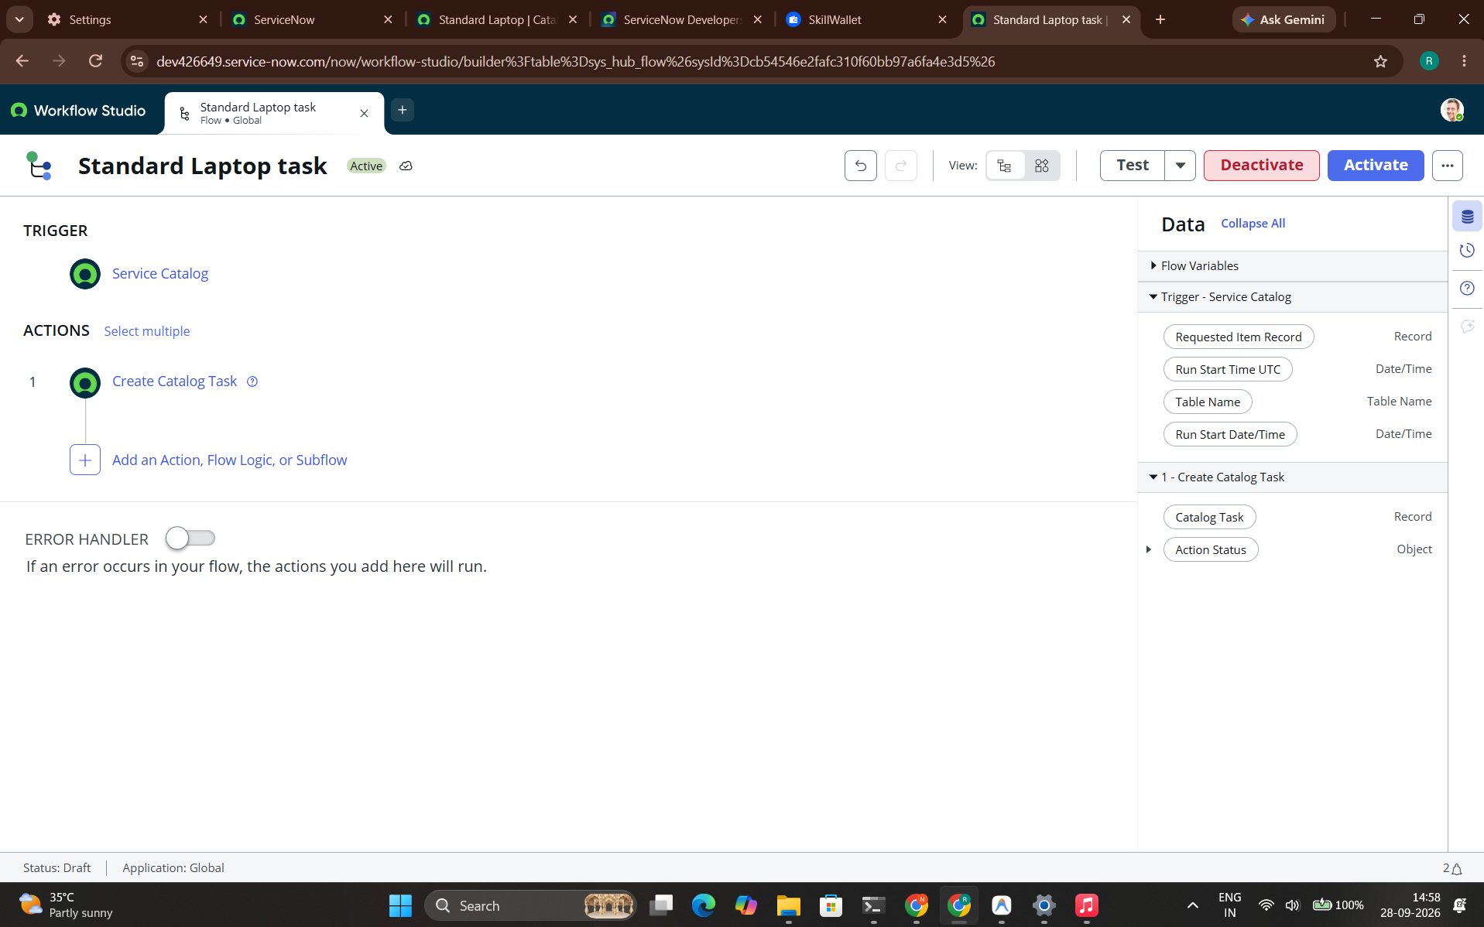

Evidence 2 — Create Catalog Task Field Mappings
Shows Catalog Task [sc_task], dynamic Trigger → Requested Item mapping, Short Description, Description, Assignment group = Hardware, and Approval = Approved.
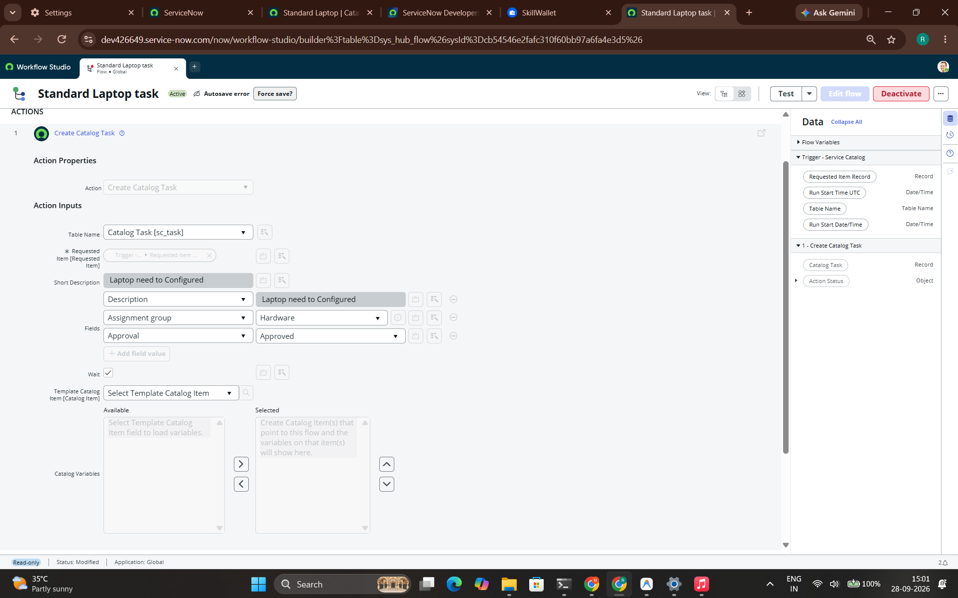

Evidence 3 — Standard Laptop Catalog Item Association
Shows Standard Laptop → Process Engine with Flow = Standard Laptop task, with Workflow and Execution Plan left blank.
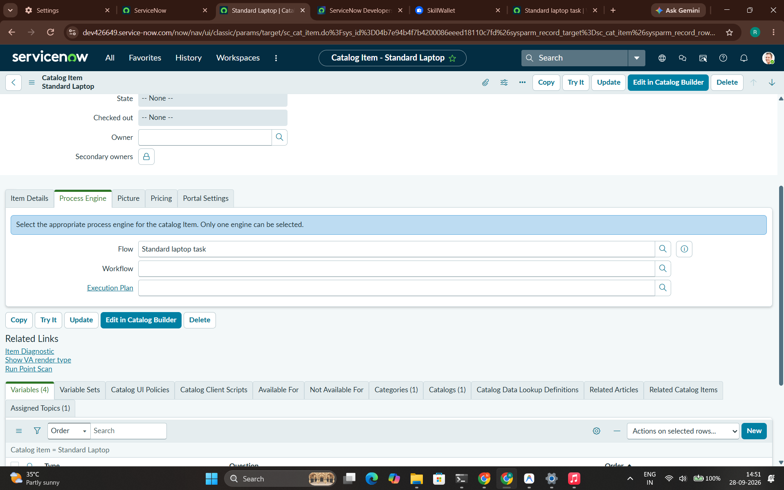

Evidence 4 — Approved Test Request
Shows the real test Request REQ0010001 with Approval = Approved and Request state = Approved.
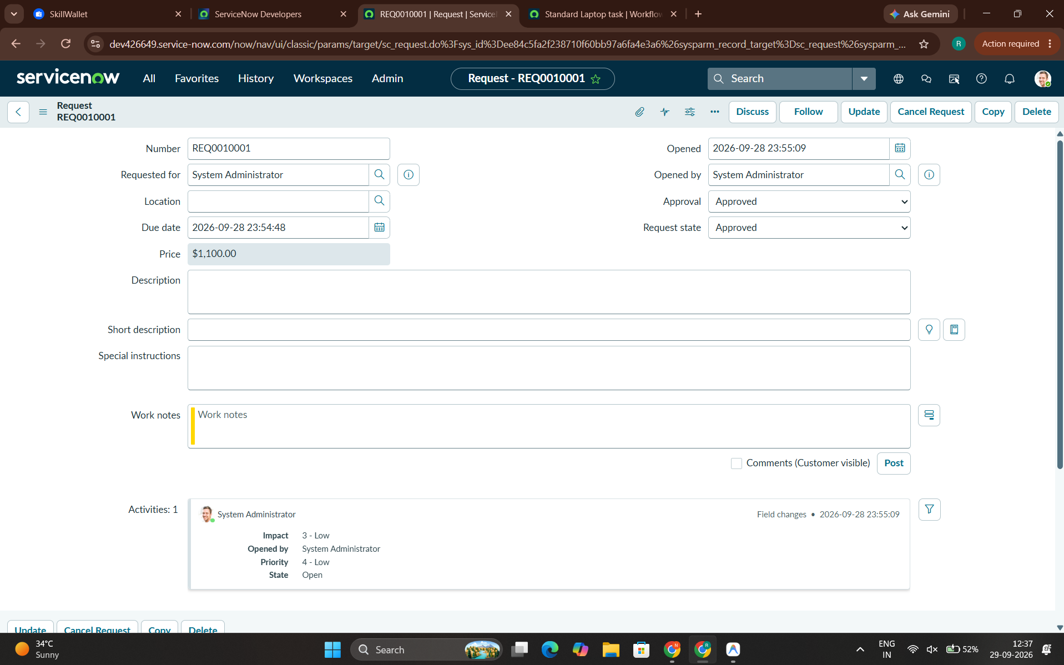

Evidence 5 — RITM and Automatically Created Catalog Task
Shows RITM0010001 with Item = Standard Laptop and Catalog Tasks (1), including SCTASK0010002, Assignment group = Hardware, and Short description = Laptop need to Configured.
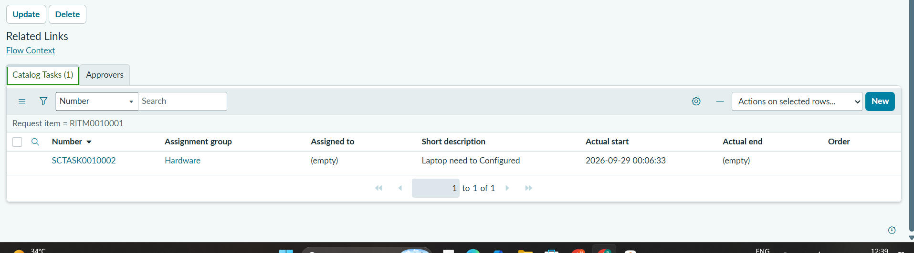

Evidence 6 — Generated Catalog Task Record
Shows real Catalog Task SCTASK0010002 linked to RITM0010001, Approval = Approved, State = Open, and the configured short description and description.
