Milestone 2 — Flow Assignment Evidence
Streamlining IT Procurement: Automating Standard Laptop Orders with Flow Designer
Activity 1: Flow Assignment to Standard Laptop service Catalog

Objective
Assign the existing Standard Laptop Task Flow to the Standard Laptop Catalog Item through the Process Engine configuration.

Milestone 2 Procedure
- Open ServiceNow.
- Click All and search for Maintain Items.
- Select Maintain Items.
- Under the Name field, search for Standard Laptop and open that record.
- Open the Process Engine section.
- Remove remaining process automations as required and use Flow.
- Add the existing flow named Standard Laptop Task.
- Save/update the Catalog Item record.

Verified Configuration
Field | Verified Value
Catalog Item | Standard Laptop
Process Engine | Flow
Flow | Standard Laptop task
Workflow | Blank
Execution Plan | Blank

Evidence Screenshot
The screenshot below shows the Standard Laptop Catalog Item with Process Engine selected and the Flow field populated with Standard Laptop task.
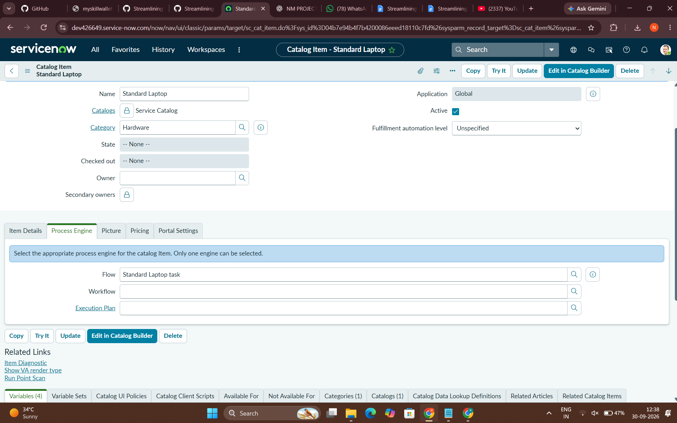

Screen Recording Guide
- Start Windows screen recording with Win + Shift + R.
- Show the Standard Laptop Catalog Item.
- Show the Process Engine tab.
- Keep the Flow field visible with Standard Laptop task.
- Keep Workflow and Execution Plan visible as blank.
- Pause for a few seconds so the configuration is clearly readable.
- Stop the recording with Win + Shift + R.
- Save the recording with a clear name such as Milestone_2_Flow_Assignment_Completion.mp4.

Evidence Checklist
- Standard Laptop Catalog Item is visible.
- Process Engine tab is visible.
- Flow is set to Standard Laptop task.
- Workflow is blank.
- Execution Plan is blank.
- Screenshot captured from the actual ServiceNow instance.
- Screen recording captured from the actual ServiceNow instance.

Submission note: This document records the configuration evidence for Milestone 2 Activity 1. It does not claim any additional Milestone 2 activities beyond the supplied project instructions.

