
COIMBATORE INSTITUTE OF TECHNOLOGY
(AN AUTONOMOUS INSTITUTION AFFILIATED TO ANNA UNIVERSITY)
DEPARTMENT OF COMPUTING
M.Sc. ( DECISION AND COMPUTING SCIENCES)
2023-2028 Batch (Semester 5)

CASE STUDY

NAME : RAKSHAN S.P
REG NO : 2303717673721041
SUBJECT CODE : 22MDC54
SUBJECT NAME : MACHINE LEARNING
STAFF INCHARGES : Dr. A. KANNAMMAL

MARKS:

Business Transformation through Machine Learning and AI

Introduction:
Artificial Intelligence (AI) and Machine Learning (ML) have emerged as transformative technologies across industries. From automation and personalization to predictive analytics and logistics optimization, businesses are harnessing these technologies to achieve competitive advantages.
One of the most prominent examples of successful AI/ML adoption is Amazon, a global leader in e-commerce, logistics, and cloud computing. Amazon has integrated AI and ML into nearly every aspect of its business—from customer experience to supply chain management—redefining modern retail and digital ecosystems.
This report explores Amazon’s business scenario, the specific AI/ML techniques applied, the resulting transformation in business processes, and the measurable outcomes achieved.

Business/Problem Scenario:
Amazon initially started as an online bookstore in 1994 but rapidly expanded into one of the world’s largest e-commerce platforms. With millions of products, billions of customers, and vast global logistics, Amazon faced several challenges:
- Personalization: How to recommend the right products to millions of users in real-time.
- Supply Chain Complexity: Managing warehouses, deliveries, and last-mile logistics at scale.
- Customer Service: Providing 24/7 assistance efficiently.
- Fraud Detection: Preventing payment fraud and fake reviews.
- Operational Efficiency: Reducing costs while speeding up delivery.
AI and ML became central to solving these challenges and maintaining Amazon’s market dominance.

Techniques and Algorithms Applied:
Amazon employs a wide variety of AI/ML techniques across its ecosystem:
- Recommendation Systems
  - Uses Collaborative Filtering, Deep Learning, and Natural Language Processing (NLP) to suggest products based on browsing and purchase history.
  - Example: “Customers who bought this also bought…”
- Forecasting and Demand Prediction
  - Time Series Forecasting & Reinforcement Learning to predict product demand, optimize inventory levels, and reduce stockouts.
- Alexa & Voice Recognition
  - Powered by Natural Language Processing (NLP), Automatic Speech Recognition (ASR), and Neural Networks, enabling conversational AI.
- Amazon Go (Cashier-less Stores)
  - Uses Computer Vision, Sensor Fusion, and Deep Learning to allow customers to pick items and leave without checkout lines.
- Fraud Detection and Security
  - Anomaly Detection, Supervised Learning Algorithms to flag fraudulent transactions and fake reviews.
- Robotics and Automation in Warehouses
  - AI-powered robots guided by Computer Vision and Reinforcement Learning optimize picking, packing, and delivery.

Business Process Transformation:
The integration of AI/ML transformed Amazon’s traditional processes into highly automated, data-driven operations:
- Customer Experience: Personalized shopping journeys increased user engagement and conversion rates.
- Inventory and Logistics: Real-time demand forecasting reduced inventory costs and optimized warehouse utilization.
- Customer Support: AI-powered chatbots and Alexa improved responsiveness and reduced human effort.
- Retail Operations: Amazon Go introduced a frictionless shopping model with no cashiers or queues.
- Cloud Services (AWS AI/ML): Amazon extended its expertise to other businesses, creating a new revenue stream.
- Marketing and Pricing: Dynamic pricing models adjust product prices in real-time based on demand, competition, and customer behavior.

Results and Impact:
The measurable outcomes of AI and ML adoption at Amazon include:
- Revenue Growth: A significant portion (estimated 35%) of Amazon’s revenue is driven by its recommendation engine.
- Customer Satisfaction: Personalized shopping and faster deliveries improved retention and loyalty.
- Operational Efficiency: Warehouse robotics reduced fulfillment time by up to 25%.
- Cost Reduction: Optimized supply chain and automation lowered overall operational costs.
- Market Leadership: Amazon Go revolutionized offline retail with AI-driven cashier-less stores.
- Global Expansion: AI-driven logistics enabled Amazon to scale across countries while maintaining delivery speed.
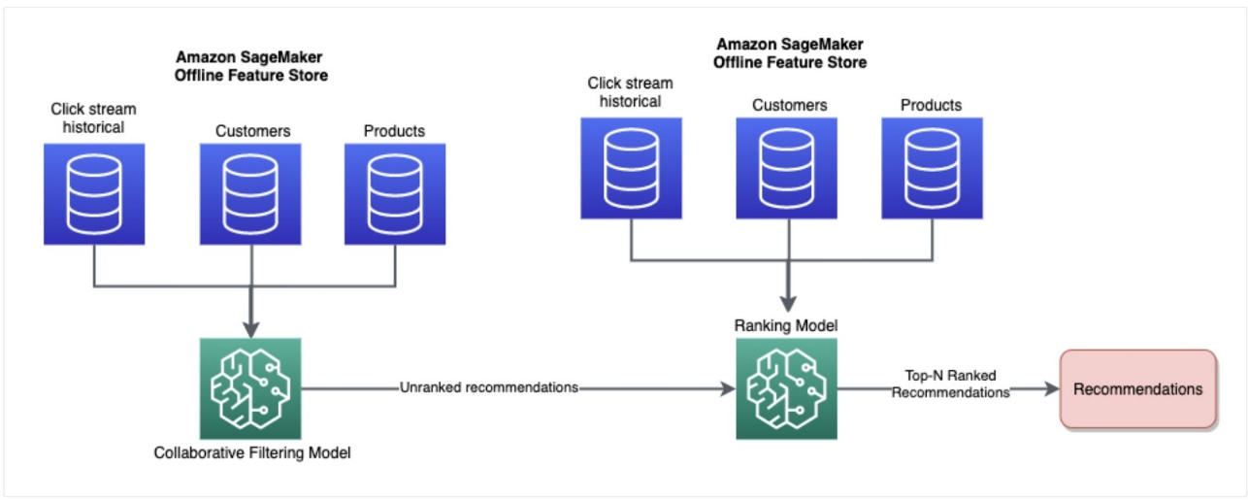

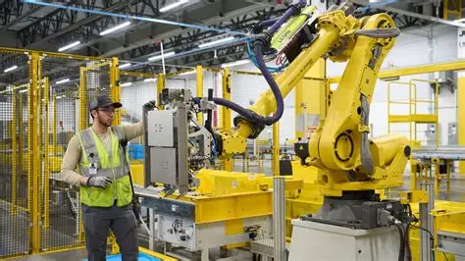

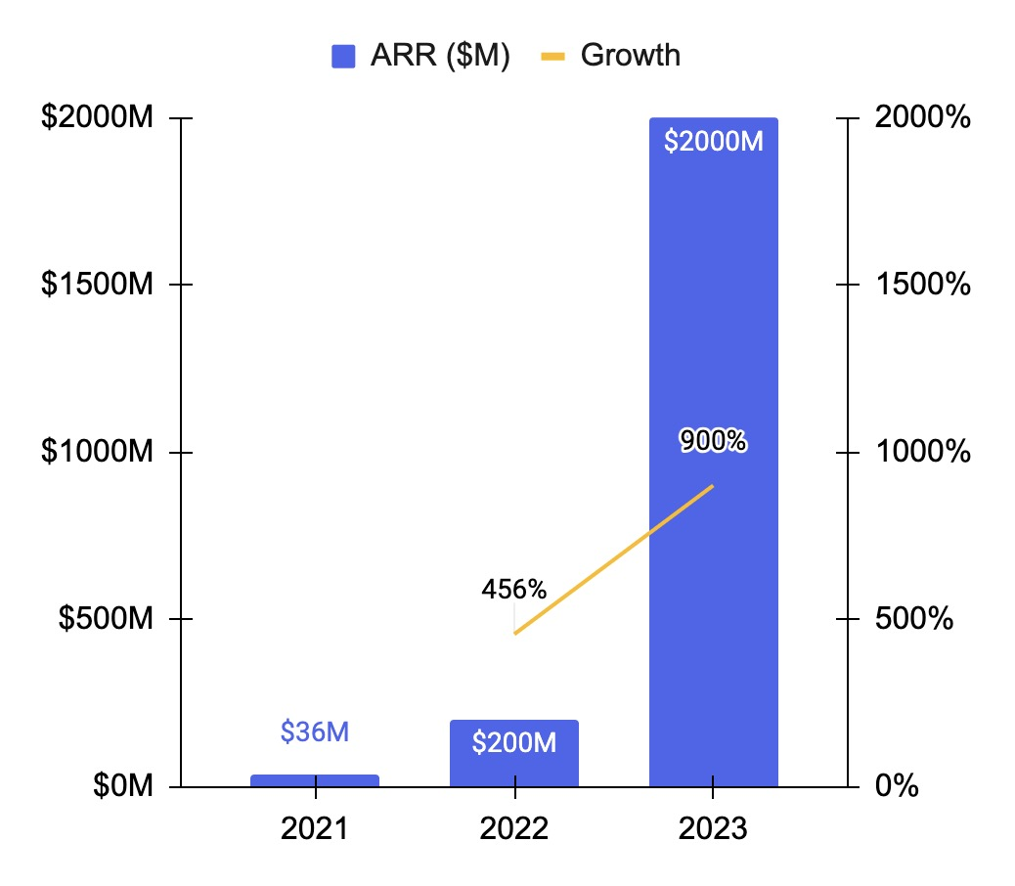

Conclusion:
Amazon’s transformation demonstrates the power of AI and ML in reshaping businesses at scale. Through intelligent algorithms, automation, and personalization, Amazon has redefined customer expectations, logistics management, and retail innovation. The measurable benefits—higher revenue, efficiency, and customer loyalty—make Amazon a leading case study in the strategic application of AI and ML in business.

References:
- Smith, C. (2023). How Amazon Uses Artificial Intelligence in Business Operations. Harvard Business Review.
- McKinsey & Company. (2022). Artificial Intelligence in Retail: The Amazon Case Study.
- Amazon Official Website – AI & Machine Learning (https://aws.amazon.com/machine-learning/)
- Marr, B. (2021). How Amazon Innovates with Artificial Intelligence. Forbes.
- Chui, M. et al. (2022). The State of AI in Business. McKinsey Global Institute.

