EX NO:3 PRIME NUMBER OF GENERATION
08.07.24

AIM:
To write a java program to generate all the prime numbers between 1 to n, where n values given by user.

CODE:
package project;
import java.util.Scanner;
public class Prime {
public static void main(String[] args) {
Scanner scanner = new Scanner(System.in);
System.out.println("Enter the value of n: ");
int n = scanner.nextInt();
System.out.println("Prime numbers from 1 to " +n+ " are:");
for (int i = 2; i <= n; i++) {
boolean isPrime= true;
if (i==0) {
isPrime = false;
} else {
for (int j = 2; j <= i/2; j++) {
if (i % j == 0) {
isPrime = false;
break;
}
}
}

CLASS DIAGRAM:

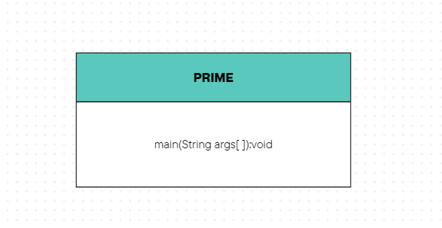

if (isPrime) {
System.out.println(i + " ");
}
}
}
}

OUTPUT:

