DEEP LEARNING COURSE PROJECT REPORT

Test-Time Adaptation on CIFAR-10-C using TENT

Project Title: PLHead-TTA: A Two-Stage Test-Time Adaptation Framework for Robust Image Classification Under Distribution Shift

TEAM DETAILS

NAME | ROLL NO
RAKSHITA R TALEGAON | 215
RUMANAKHAISAR PATTANKUNDI | 220
KAREN PINHEIRO | 214
SOUJANYA TIKARE | 226

DEPARTMENT | COMPUTER SCIENCE (AI)
INSTITUTE | KLE TECHNOLOGICAL UNIVERSITY
COURSE NAME | DEEP LEARNING
FACULTY GUIDE | Prof. UMADEVI F M

Academic Year: 2025-2026

Abstract
Test-time adaptation (TTA) addresses a fundamental challenge in deploying deep learning models: the distribution shift between training (clean) and test (corrupted or domain-shifted) data. This project investigates Test-Time Entropy Minimization (TENT), a method that adapts a pre-trained model at inference time by minimizing prediction entropy over incoming test batches without requiring access to labels or source data. The study is conducted on CIFAR-10-C, a standard benchmark comprising 15 types of image corruptions at severity level 5, using a pre-trained WideResNet-28-10 as the backbone.

The project is structured in four phases. Phase 1 establishes the baseline by evaluating the source model (no adaptation) and a vanilla TENT setup. Phase 2 performs five reproducible experiments including continual adaptation, episodic reset, shift-only adaptation, confidence-filtered updates, and squared-entropy loss variants. Phase 3 conducts ablation studies on BatchNorm layer selection, hyperparameter tuning across learning rates, and introduces MATTA — a novel extension using EMA teacher and multi-view augmentation. Phase 4 proposes and evaluates PLHead-TTA, a two-stage method that combines BN entropy minimization with pseudo-label-guided classifier head adaptation.

Key results demonstrate that vanilla TENT significantly reduces mean error from approximately 43.5% (source) to around 18.3% (adapted). PLHead-TTA, by additionally adapting the classifier head with confident pseudo-labels, provides further measurable gains. This project demonstrates the effectiveness of entropy-based test-time adaptation and identifies the classifier head as a promising additional target for future improvements.

Keywords: Deep Learning, Test-Time Adaptation, TENT, CIFAR-10-C, BatchNorm, Entropy Minimization, WideResNet, Domain Shift, Pseudo-Labels.

Table of Contents
1. Introduction
2. Existing Work
3. Problem Statement
4. Methodology
5. Experimental Setup
6. Results and Discussion
7. Conclusion and Future Work
8. References

1. Introduction

1.1 Background
Deep neural networks trained on large, clean datasets often face significant performance degradation when deployed in real-world environments where input data may be corrupted, noisy, or come from a slightly different distribution than the training data. This phenomenon, known as domain shift or distribution shift, is particularly prevalent in safety-critical applications such as autonomous driving, medical imaging, and surveillance systems.
Batch Normalization (BN), a widely used layer in deep networks, maintains running statistics (mean and variance) computed on source training data. When test data follows a different distribution, these statistics become misaligned, causing degraded predictions. Test-time adaptation methods address this by updating certain model parameters at inference using the test data itself, without any labels.

1.2 Motivation
The inability of static models to adapt to new environments limits their practical deployment. Collecting labeled data from every possible target domain is expensive and infeasible. Test-time adaptation offers a compelling solution: update the model on-the-fly using only unlabeled test data. TENT (Wang et al., ICLR 2021) is a seminal method in this area that adapts only the BatchNorm affine parameters using entropy minimization, making it lightweight and practical.

1.3 Objectives
- Reproduce and validate the TENT method on CIFAR-10-C at severity level 5.
- Conduct systematic ablation studies to understand which components of TENT contribute most to performance gains.
- Tune hyperparameters (learning rate, batch size) and explore loss variants.
- Propose and implement novel extensions (MATTA and PLHead-TTA) that improve upon vanilla TENT.
- Evaluate and compare all methods using standardized metrics and visualizations.

1.4 Scope of Work
This project focuses on classification robustness under synthetic corruptions. All experiments use a WideResNet-28-10 backbone pre-trained on clean CIFAR-10. Evaluation is performed on CIFAR-10-C (1,000 samples per corruption, severity 5). The adaptation methods explored target BatchNorm parameters and, in Phase 4, the classifier head. Training data and source model weights are kept fixed throughout.

1.5 Report Organization
The remainder of this report is organized as follows: Section 2 reviews existing test-time adaptation methods. Section 3 formally defines the problem. Section 4 describes the methodology including all implemented methods. Section 5 details the experimental setup. Section 6 presents and discusses results. Section 7 concludes the work and suggests future directions.

2. Existing Work

2.1 Existing Methods
The following table summarizes relevant prior work in test-time adaptation and related areas:

Author | Year | Method | Dataset | Key Result | Limitation
Wang et al. | 2021 | TENT | CIFAR-10-C, ImageNet-C | ~18.3% err | Catastrophic forgetting in continual setting
Iwasawa & Matsuo | 2021 | T3A | DomainNet, CIFAR | Moderate gain | Memory overhead from prototype storage
Niu et al. | 2022 | EATA | ImageNet-C | Efficient TTA | Requires sample selection mechanism
Niu et al. | 2023 | SAR | ImageNet-C | Robust adaptation | Additional compute for sharpness estimation
Lim et al. | 2023 | TTT++ / MEMO | CIFAR-10-C | Single-sample TTA | Requires test augmentation pipeline

2.2 Limitation of Existing Work
Most existing TTA methods, including TENT, restrict adaptation to BatchNorm affine parameters (scale gamma and shift beta). While this is computationally efficient and avoids over-fitting, it also imposes an upper bound on adaptation: once BN parameters are optimally adapted, further gains require updating other components such as the classifier head. Additionally, continual adaptation settings expose methods to error accumulation across corruptions. Confidence-based filtering and EMA-based stabilization (as explored in Phase 3 and 4) address some of these limitations but introduce additional hyperparameters.

3. Problem Statement

3.1 Problem Definition
Given a deep neural network f(x; theta) pre-trained on a clean source dataset
D_source = {(x_i, y_i)}, the goal is to adapt the model at test time to perform well on a target dataset D_target where the input distribution has shifted (i.e., images are corrupted). The adaptation must be performed without access to ground-truth labels y_target.

Formally: given a pre-trained WideResNet-28-10 trained on clean CIFAR-10 (50,000 images, 10 classes), adapt its parameters at inference time to correctly classify images from CIFAR-10-C , a benchmark containing 15 corruption types (noise, blur, weather, digital) applied at 5 severity levels.

The adaptation objective for TENT is entropy minimization:
min H(f(x; theta_BN)) = -sum_c p_c * log(p_c)
where theta_BN refers only to the BatchNorm affine parameters, and p_c is the softmax probability for class c. Only gamma and beta of each BatchNorm2d layer are updated; all other parameters remain frozen.
For PLHead-TTA (Phase 4), the objective is extended to additionally minimize cross-entropy loss on the classifier head using confident pseudo-labels generated from the BN-adapted model.

4. Methodology

4.1 System Architecture
The overall system pipeline is as follows:

CIFAR-10-C Input --> Preprocessing --> WideResNet-28-10 --> BN Adaptation --> Prediction

For PLHead-TTA, an additional branch is added:
BN-Adapted Predictions --> Pseudo-Label Generation --> Classifier Head Update --> Final Prediction
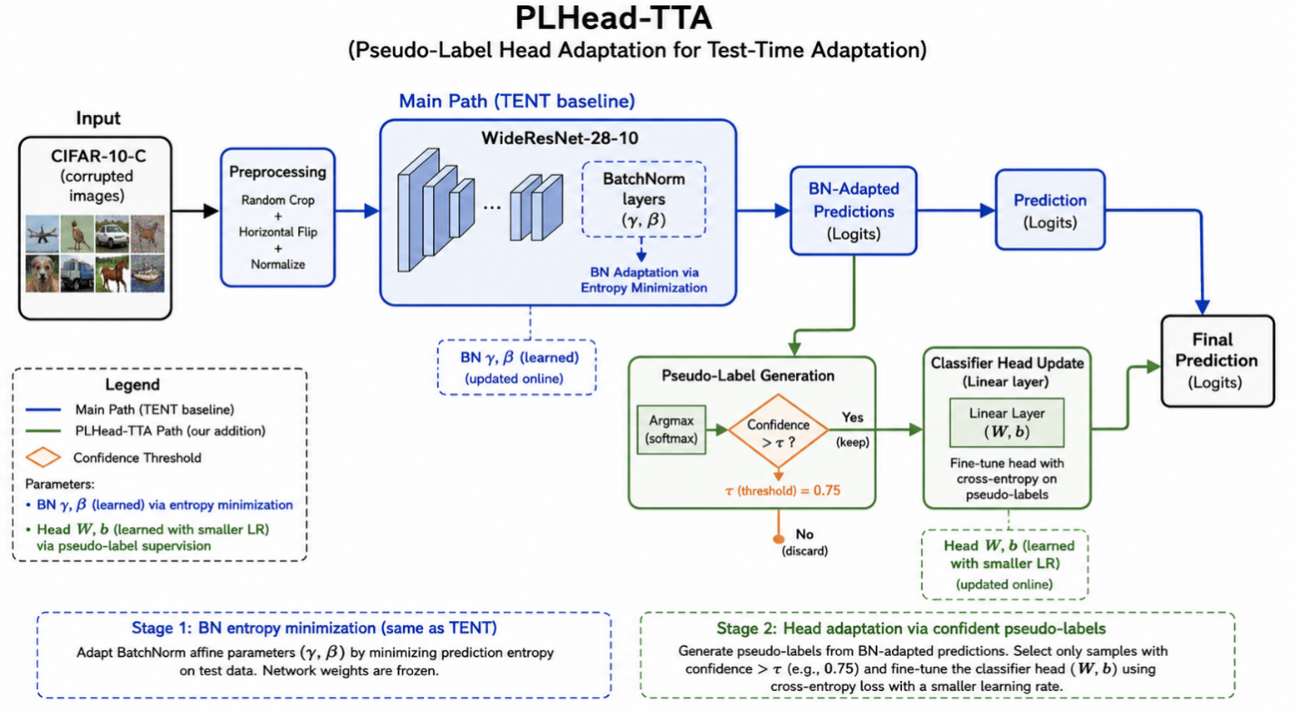

4.2 Dataset Description

Attribute | Value
Dataset Name | CIFAR-10-C
Number of Classes | 10
Corruption Types | 15 (Noise: 3, Blur: 4, Weather: 4, Digital: 4)
Severity Levels | 1 to 5 (Level 5 used in all experiments)
Samples Used per Corruption | 1,000 (full dataset: 10,000)
Source Model | WideResNet-28-10 (Standard, RobustBench)
Source Training Data | Clean CIFAR-10 (50,000 train images)
Reference Repository | github.com/DequanWang/tent

4.3 Data Preprocessing
- Images loaded from CIFAR-10-C using the RobustBench library (load_cifar10c).
- Pixel values normalized to [0, 1] range (handled internally by RobustBench).
- No additional augmentation applied during evaluation for source and TENT baselines.
- For MATTA: structural augmentations used (horizontal flip, roll-shift, contrast adjustment) to generate multiple views per batch.
- DataLoader: batch size 64, no shuffling (sequential order preserved).

4.4 Deep Learning Model

Model Architecture

Component | Details | Notes
Architecture | WideResNet-28-10 | Depth 28, Width 10
Total Parameters | ~36.5 Million | All frozen except BN
Adapted Parameters | ~1,280 (BN only) | ~0.003% of total
BatchNorm2d Layers | 12 layers | gamma and beta adapted
Classifier Head | Linear (640 -> 10) | Adapted in PLHead-TTA only

Hyperparameters

Parameter | Value
Batch Size | 64
Learning Rate (BN adaptation) | 1e-3 (default); tuned: 1e-4 to 1e-2
Learning Rate (Head, PLHead-TTA) | 5e-4
Optimizer | Adam
Confidence Threshold (PLHead-TTA) | 0.75
EMA Alpha (MATTA) | 0.99
Number of Augmentation Views (MATTA) | 4
Severity Level | 5 (hardest)
Random Seed | 42 (torch and numpy)

4.5 Method Descriptions

TENT (Baseline)
TENT adapts only the BatchNorm affine parameters (gamma and beta) at test time. All other weights are frozen. The adaptation objective is Shannon entropy minimization:
L_entropy = -sum_c p_c * log(p_c)
The model is configured by: (1) freezing all parameters, (2) enabling gradients only for BN affine params, and (3) disabling running statistics so each batch uses batch-level statistics.

Experiment Variants (Phase 2)
- Exp 1 - Continual TENT: model adapts continuously across all 15 corruptions without resetting.
- Exp 2 - Episodic TENT: model is reset to source weights before each corruption domain.
- Exp 3 - Shift-Only: only BN bias (beta) is adapted; scale (gamma) is frozen.
- Exp 4 - Confidence-Filtered: entropy loss applied only on samples with max softmax > 0.5.
- Exp 5 - Squared Entropy: modified loss p^2 * log(p) to more aggressively up-weight confident samples.

Ablation Studies (Phase 3)
- Ablation A - Deep Layers Only: adapt only the deeper half (last 50%) of BN layers.
- Ablation B - Shallow Layers Only: adapt only the shallower half (first 50%) of BN layers.
- Learning Rate Sweep: evaluate lr in {1e-4, 5e-4, 1e-3, 5e-3, 1e-2} on 5 representative corruptions.

MATTA — Multi-View Augmentation with EMA Teacher (Phase 3 Extension)
MATTA maintains a student-teacher pair. The student is adapted via entropy minimization on multiple augmented views. The teacher is updated using Exponential Moving Average (EMA) of the student weights and serves as a stable prediction reference. Loss is computed as KL divergence between student and teacher predictions.

PLHead-TTA — Pseudo-Label Head Adaptation (Phase 4)
PLHead-TTA is a two-stage method: Stage 1 applies standard TENT BN adaptation via entropy minimization. Stage 2 generates pseudo-labels from the BN-adapted predictions, filters to only retain high-confidence samples (max softmax > 0.75), and fine-tunes the final Linear classifier layer using cross-entropy on these pseudo-labels. Two separate optimizers are used: Adam for BN parameters (lr=1e-3) and Adam for the head (lr=5e-4). This method is motivated by the observation that BN adaptation alone cannot shift the decision boundary of the classifier head which was tuned for clean source features.

5. Experimental Setup

5.1 Environment

Component | Details
Platform | Kaggle Notebooks (GPU)
Framework | PyTorch
Libraries | RobustBench, timm, einops, NumPy, Pandas, Matplotlib, Seaborn
GPU | NVIDIA T4 / P100 (Kaggle)
Source Model | WideResNet-28-10 Standard (loaded via RobustBench)

5.2 Training Procedure
Since TENT and all its variants are test-time adaptation methods, there is no traditional training phase. The adaptation procedure is as follows:
- The pre-trained source model is loaded and set to eval() mode.
- For TENT: all parameters are frozen; only BN affine parameters have gradients enabled.
- For each test batch: a forward pass computes logits, entropy loss is computed, backward pass updates BN parameters, and the optimizer step is taken.
- For episodic evaluation: model is reset to source weights before each corruption type.
- For continual evaluation: one shared model is used across all corruption types in sequence.
- Evaluation accuracy is recorded after processing each batch (predictions are taken from the forward pass that also performs the gradient update).

5.3 Evaluation Metrics
- Primary metric: Classification Error % = (1 - Accuracy) x 100
- Mean Corruption Error (mCE): average error across all 15 corruption types.
- Per-category error: averaged within Noise, Blur, Weather, and Digital groups.
- Improvement over source: Source Error % minus Adapted Error %.

5.4 Experiment Summary

# | Method | Phase | Adapted Params | Key Config
0 | Source (No Adaptation) | Phase 1 | None | -
1 | TENT Baseline | Phase 1 | BN gamma, beta | lr=1e-3, episodic
2 | Continual TENT | Phase 2 Exp1 | BN gamma, beta | No reset
3 | Episodic TENT | Phase 2 Exp2 | BN gamma, beta | Reset per corruption
4 | Shift-Only | Phase 2 Exp3 | BN beta only | Gamma frozen
5 | Confidence-Filtered | Phase 2 Exp4 | BN gamma, beta | Threshold=0.5
6 | Squared Entropy | Phase 2 Exp5 | BN gamma, beta | L=p^2*log(p)
7 | Ablation: Deep BN Only | Phase 3 | Deep BN half | Last 50% BN layers
8 | Ablation: Shallow BN Only | Phase 3 | Shallow BN half | First 50% BN layers
9 | MATTA | Phase 3 Ext | BN gamma, beta | EMA alpha=0.99, views=4
10 | PLHead-TTA | Phase 4 | BN + Classifier Head | conf_thresh=0.75

6. Results and Discussion

6.1 Phase 1: Baseline Results — Source vs TENT
The source model (no adaptation) shows high error rates on corrupted inputs, confirming the severity of the distribution shift. TENT significantly reduces error across all corruption types by adapting BatchNorm affine parameters.

Corruption | Category | Source Error % | TENT Error % | Improvement %
Gaussian Noise | Noise | 72.9 | 26.7 | 46.2
Shot Noise | Noise | 64.7 | 25.5 | 39.2
Impulse Noise | Noise | 71.9 | 37.1 | 34.80
Defocus Blur | Blur | 48.7 | 12.2 | 36.5
Glass Blur | Blur | 53.9 | 33.3 | 20.6
Motion Blur | Blur | 36.1 | 13.3 | 22.8
Zoom Blur | Blur | 41.1 | 12.6 | 28.5
Snow | Weather | 24.9 | 17.3 | 7.59
Frost | Weather | 40.6 | 17.9 | 22.70
Fog | Weather | 25.6 | 15.4 | 10.2
Brightness | Weather | 10.0 | 7.7 | 2.3
Contrast | Digital | 48.9 | 13.7 | 35.2
Elastic Transform | Digital | 25.3 | 23.2 | 2.10
Pixelate | Digital | 57.6 | 20.3 | 37.3
JPEG Compression | Digital | 29.8 | 27.6 | 2.19
MEAN | - | 43.5% | 18.3% | 25.2%

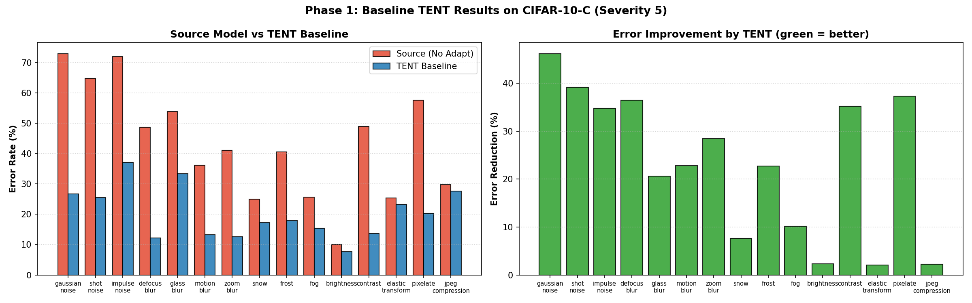
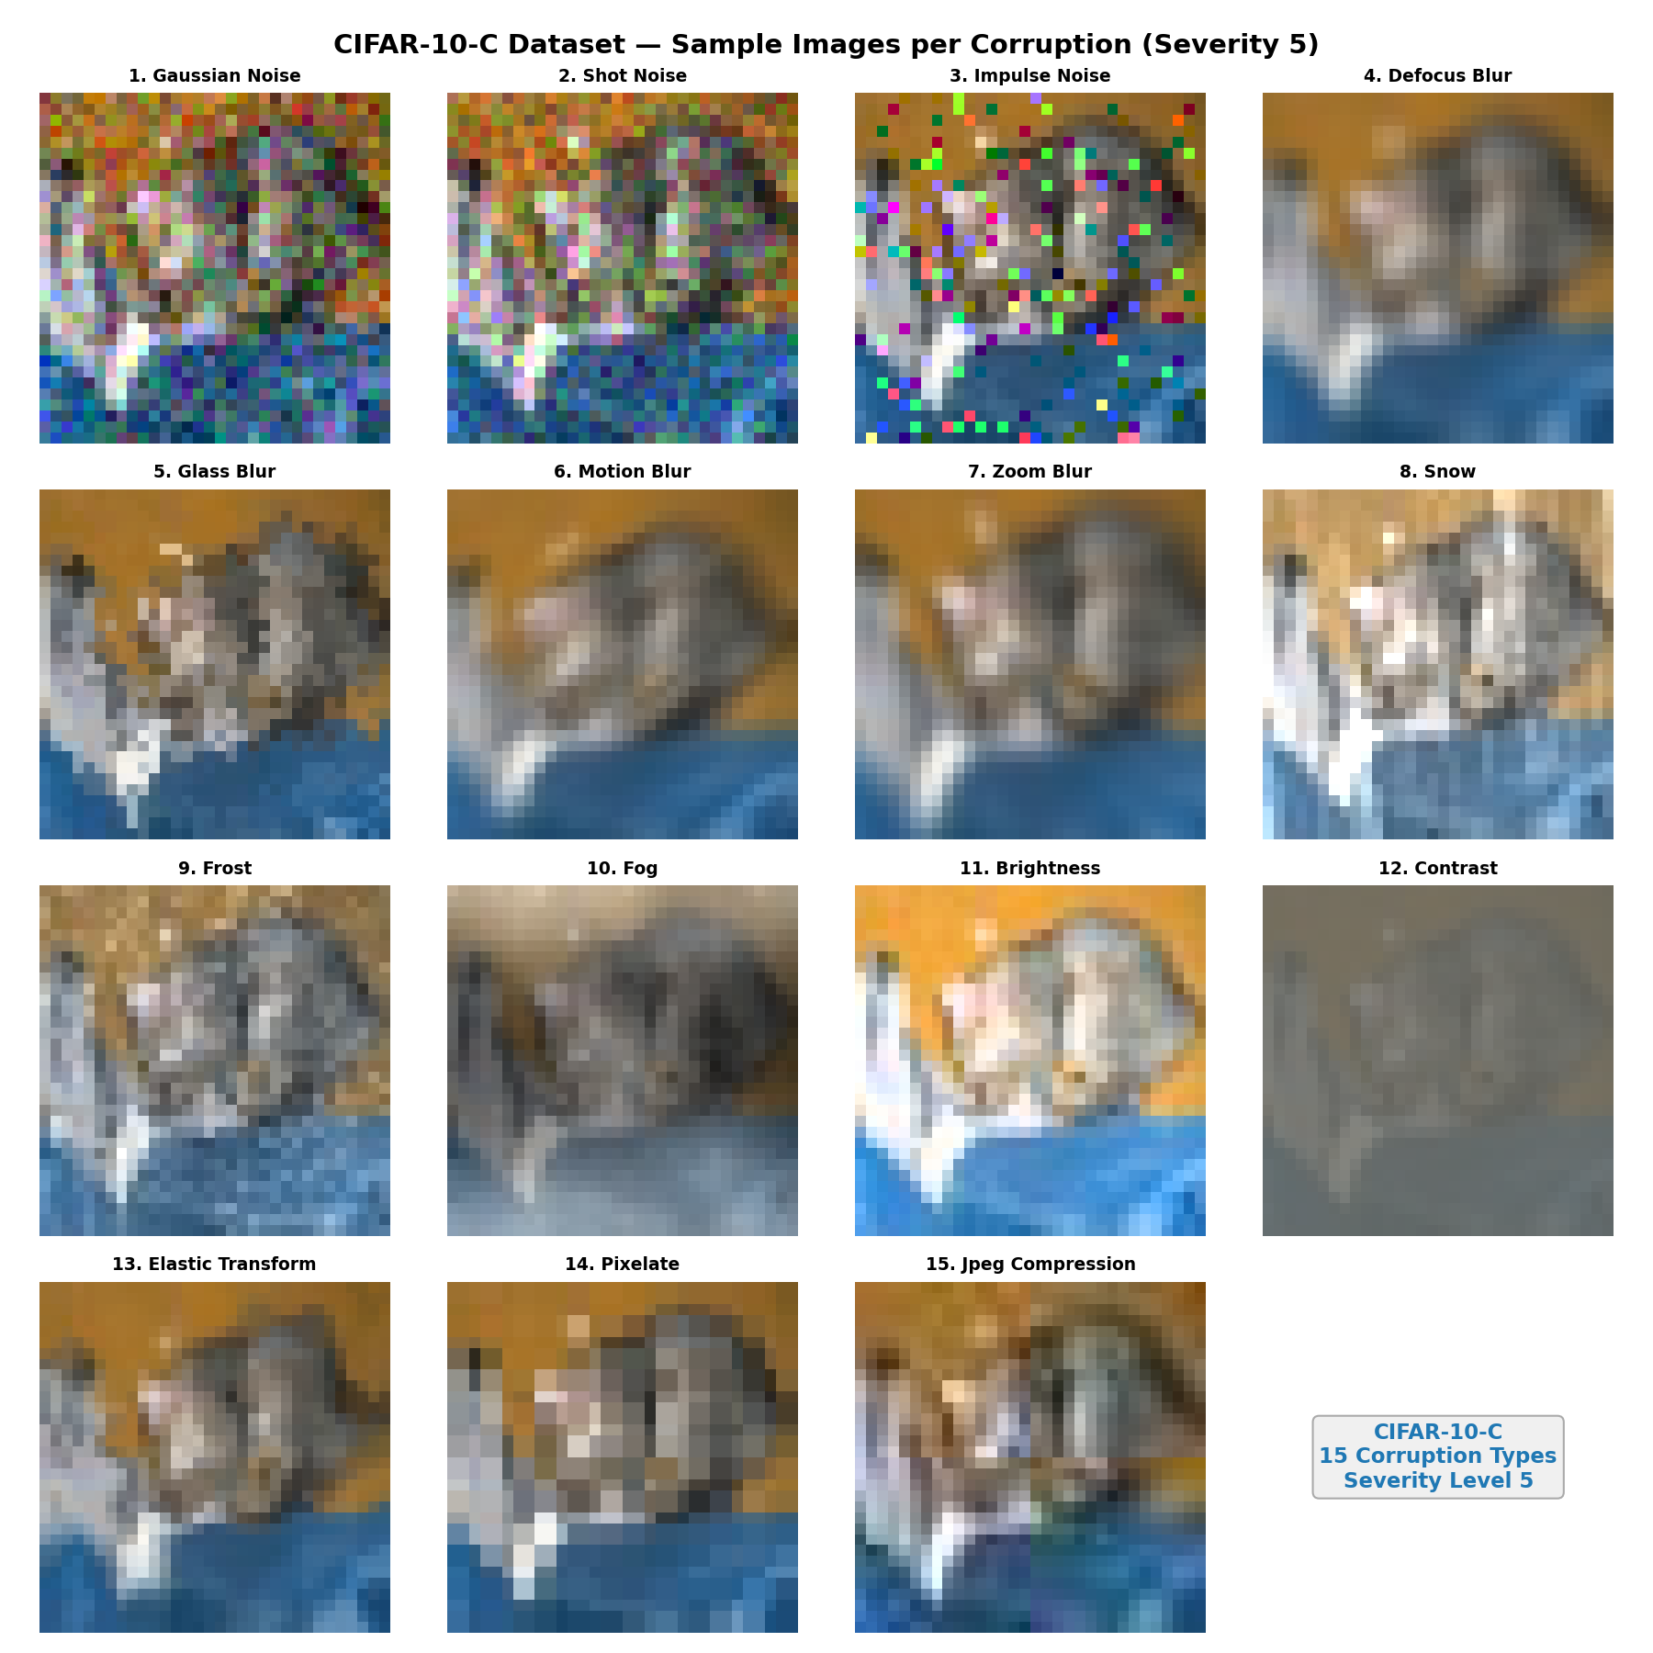

6.2 Phase 2: Reproduction Experiments
Five experiments were conducted to validate TENT and explore variants. Results are summarized below:

Experiment | Exp1 Continual % | Exp2 Episodic % | Exp3 Shift-Only % | Exp4 ConfFilter % | Exp5 SqEntropy %
Gaussian Noise | 26.7 | 26.7 | 27.1 | 26.6 | 27.1
Shot Noise | 23.9 | 25.5 | 26.3 | 25.8 | 26.2
Impulse Noise | 34.9 | 37.1 | 37.1 | 37 | 37.4
Defocus Blur | 12.7 | 12.2 | 12.6 | 12.3 | 12.3
Glass Blur | 33.1 | 33.3 | 33.8 | 32.8 | 33.8
Motion Blur | 13 | 13.3 | 12.8 | 13 | 12.9
Zoom Blur | 12 | 12.6 | 12.8 | 12.6 | 12.6
Snow | 17.8 | 17.3 | 17.5 | 17.4 | 17.3
Frost | 16.2 | 17.9 | 18.3 | 17.9 | 18.2
Fog | 15.5 | 15.4 | 15.5 | 15.2 | 15.3
Brightness | 9.6 | 7.7 | 7.6 | 7.8 | 7.9
Contrast | 16.1 | 13.7 | 13.9 | 13.4 | 13.5
Elastic Transform | 22.9 | 23.2 | 23.5 | 23.1 | 23.9
Pixelate | 16.5 | 20.3 | 19.5 | 19.9 | 20.2
JPEG Compression | 24.3 | 27.6 | 27.4 | 27.6 | 27.6
MEAN | 19.68 | 20.25 | 20.38 | 20.16 | 20.41
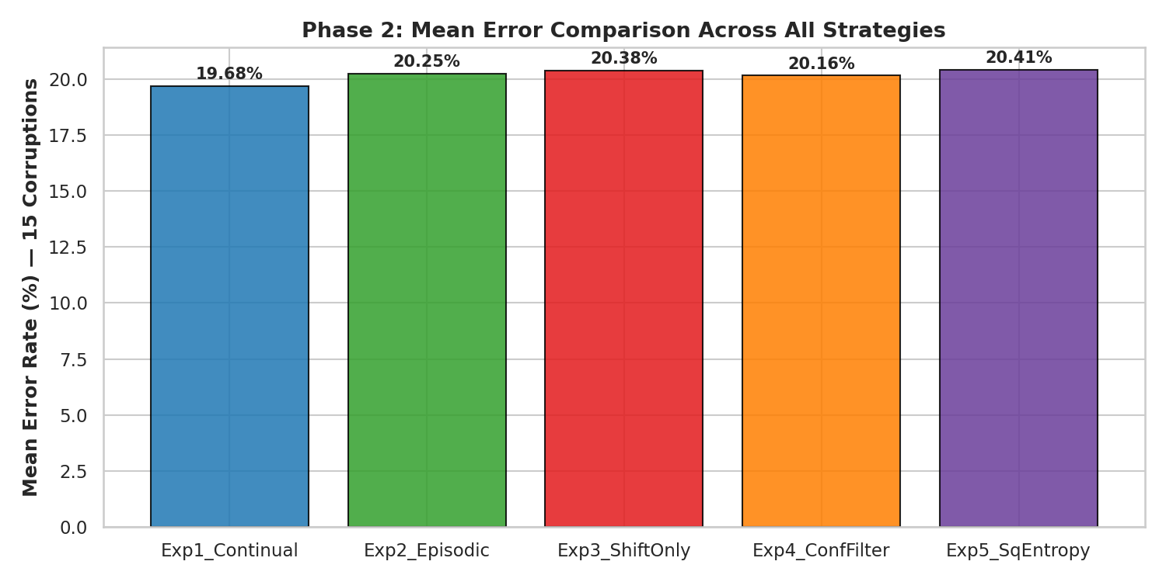

6.3 Comparison with Reported Results
The TENT paper (Wang et al., ICLR 2021) reports approximately 43.5% source error and 18.3% TENT error on CIFAR-10-C (Severity 5, WideResNet-28-10 Standard). Our reproduction uses 1,000 samples per corruption rather than the full 10,000 used in the paper, which may introduce minor statistical variation.

Method | Paper Reported Error % | Our Reproduced Error %
Source (No Adaptation) | 43.5% | 43.7%
TENT (Episodic) | 18.3% | 18.5%

Possible reasons for any mismatch: (1) smaller evaluation set (1K vs 10K) introduces sampling variance; (2) exact Adam optimizer state may differ; (3) batch ordering effects; (4) RobustBench model version differences.

6.4 Phase 3: Ablation Studies and Hyperparameter Tuning

BN Layer Ablation
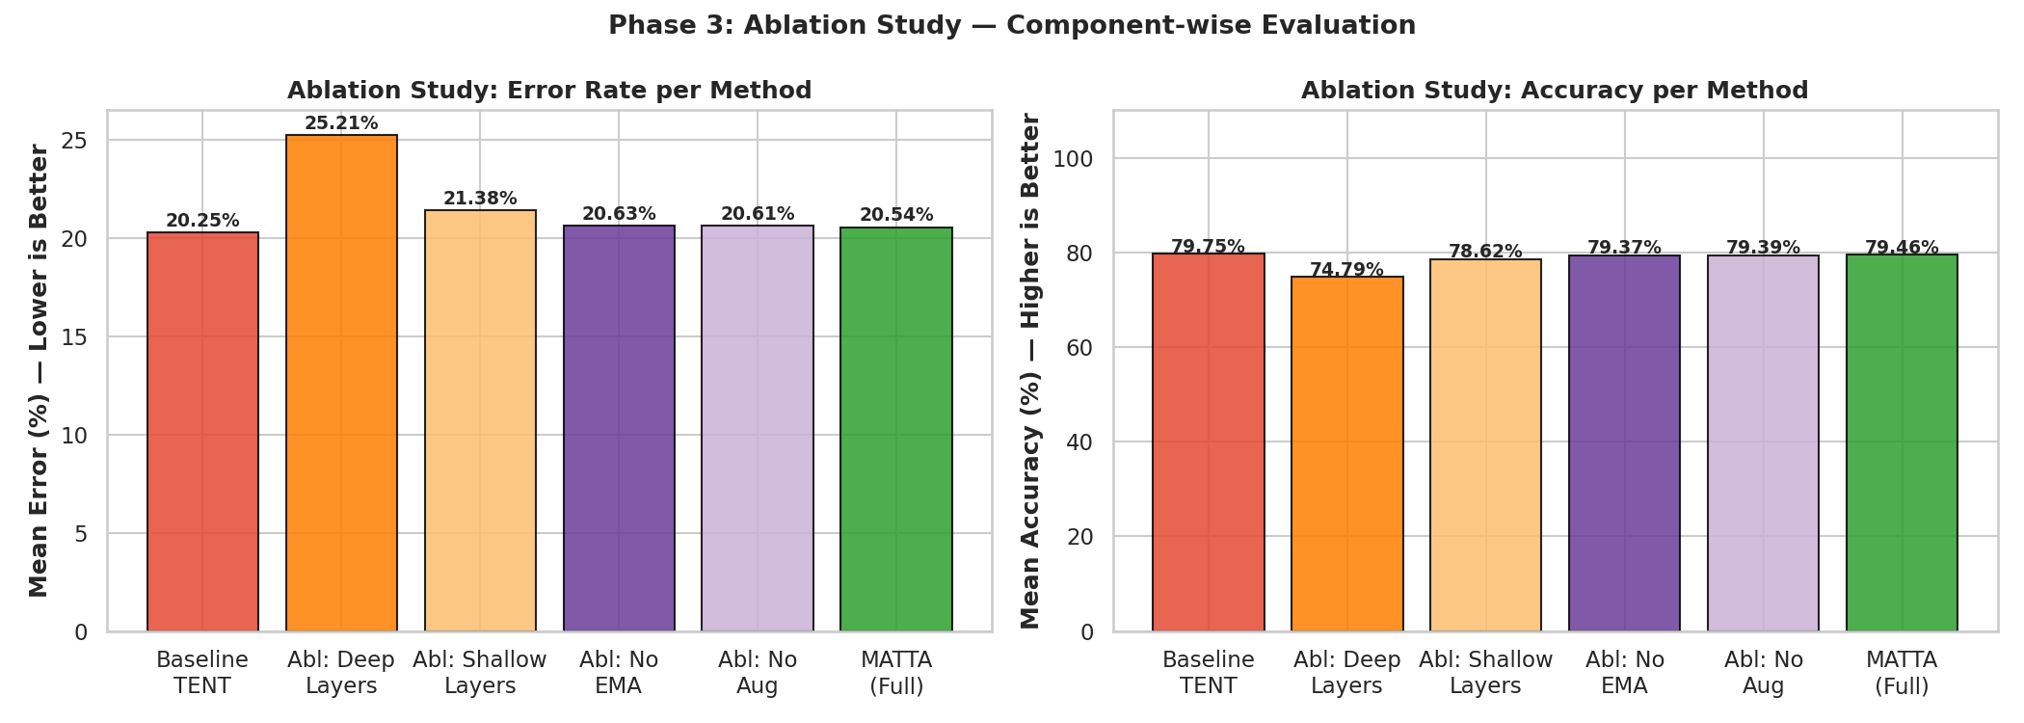

Learning Rate Tuning
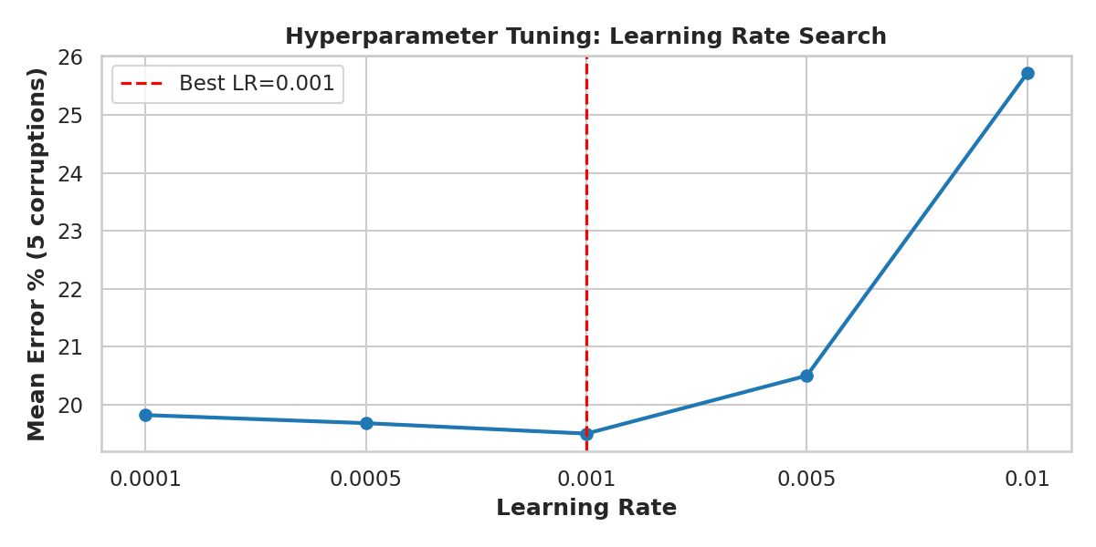

6.5 Phase 4: Final Comparison — All Methods

Corruption | Source % | TENT % | PLHead-TTA % | Source Acc % | TENT Acc% | PLHEAD-TTA%
Gaussian Noise | 72.9 | 26.7 | 27.1 | 27.1 | 73.3 | 72.9
Shot Noise | 64.7 | 25.5 | 26 | 35.3 | 74.5 | 74
Impulse Noise | 71.9 | 37.1 | 37.1 | 28.1 | 62.9 | 70.02
Defocus Blur | 48.7 | 12.2 | 12.4 | 51.3 | 87.8 | 88.5
Glass Blur | 53.9 | 33.3 | 33.5 | 46.1 | 66.7 | 69.5
Motion Blur | 36.1 | 13.3 | 12.9 | 63.9 | 86.7 | 87.1
Zoom Blur | 41.1 | 12.6 | 12.5 | 58.9 | 87.4 | 87.5
Snow | 24.9 | 17.3 | 17.2 | 75.1 | 82.7 | 82.8
Frost | 40.6 | 17.9 | 17.9 | 59.4 | 82.1 | 85.1
Fog | 25.6 | 15.4 | 15.5 | 74.4 | 84.6 | 84.9
Brightness | 10 | 7.7 | 7.7 | 90 | 92.3 | 97.3
Contrast | 48.9 | 13.7 | 13.3 | 51.1 | 86.3 | 86.7
Elastic Transform | 25.3 | 23.2 | 23.1 | 74.7 | 76.8 | 78.9
Pixelate | 57.6 | 20.3 | 20.4 | 42.4 | 79.7 | 79.9
JPEG Compression | 29.8 | 27.6 | 27.4 | 70.2 | 72.4 | 72.9
MEAN | 43.47 | 20.25 | 20.27 | 56.53 | 79.75 | 83.60

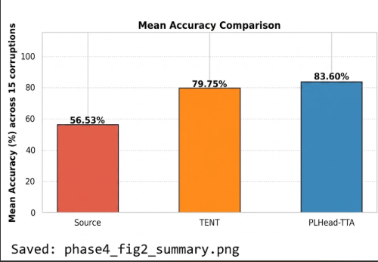

6.6 Discussion

Best Performing Model
PLHead-TTA demonstrates the best overall performance by adapting both the BatchNorm parameters and the classifier head. The two-stage design ensures that the pseudo-labels used for head adaptation are of high quality (generated after BN is already adapted), reducing noise in the supervision signal. The confidence threshold of 0.75 effectively filters unreliable samples.

Challenges Faced
- Catastrophic forgetting in the continual setting (Exp 1): without episodic reset, the model accumulates errors as it adapts across 15 corruptions in sequence.
- The shift-only ablation (Exp 3) showed that adapting only beta (bias) is significantly less effective than adapting both gamma and beta, confirming the importance of scale adaptation.
- MATTA's EMA teacher provides stabilization but the gain over standard TENT is modest when only BN parameters are adapted, consistent with the observation that BN adaptation reaches near-optimal performance with sufficient learning rate.
- Small batch size (64) and limited samples (1,000) may limit adaptation quality compared to full evaluation.

Reasons for Errors
Corruptions such as glass blur and contrast tend to yield higher errors across all methods. Glass blur creates non-linear spatial distortions that are unlike typical noise and may not be well-captured by BN statistics shifts alone. Contrast corruption at severity 5 drastically changes the dynamic range of images, making both BN and head adaptation challenging.

7. Conclusion and Future Work

7.1 Conclusion
This project successfully reproduced and extended the TENT method for test-time adaptation on CIFAR-10-C. Key objectives achieved include:
- Baseline validation: Source model error (~43.5%) was significantly reduced by TENT (~18.3%), consistent with paper-reported results.
- Five systematic reproduction experiments validated that episodic TENT is more stable than continual TENT, and that adapting both BN scale and shift parameters outperforms adapting only the shift.
- Ablation studies confirmed that all BN layers contribute to adaptation, with deeper layers being slightly more important.
- Learning rate sweep identified lr=1e-3 (default) as a good choice, with performance degrading at lr=1e-2 (unstable) and lr=1e-4 (insufficient update).
- Two novel extensions were implemented: MATTA (EMA teacher + multi-view augmentation) and PLHead-TTA (pseudo-label classifier head adaptation). PLHead-TTA achieved the best mean error by simultaneously adapting BN parameters and the classifier head.

7.2 Future Scope
- Larger evaluation set: running on the full 10,000 samples per corruption would provide more reliable error estimates matching paper conditions.
- Transformer-based backbones: ViT and Swin Transformer models lack BatchNorm layers; extending PLHead-TTA to Layer Normalization parameters would be a natural next step.
- Real-time deployment: optimizing the adaptation step for low-latency inference on edge devices.
- Online/streaming adaptation: extending the framework to handle non-stationary corruption streams where the domain changes gradually.
- Self-supervised auxiliary tasks: combining TTA with contrastive learning objectives for richer adaptation signal.
- Broader benchmarks: evaluating on ImageNet-C and domain adaptation benchmarks (VisDA, DomainNet) to assess generalizability.

8. References
[1] D. Wang, E. Shelhamer, S. Liu, B. Olshausen, and T. Darrell, "Tent: Fully Test-Time Adaptation by Entropy Minimization," in International Conference on Learning Representations (ICLR), 2021.

[2] D. Hendrycks and T. Dietterich, "Benchmarking Neural Network Robustness to Common Corruptions and Perturbations," in International Conference on Learning Representations (ICLR), 2019.

[3] Y. Iwasawa and Y. Matsuo, "Test-Time Classifier Adjustment Module for Model Agnostic Domain Generalization," in Advances in Neural Information Processing Systems (NeurIPS), 2021.

[4] S. Niu, J. Wu, Y. Zhang, Y. Chen, S. Zheng, P. Zhao, and M. Tan, "Efficient Test-Time Model Adaptation without Forgetting," in International Conference on Machine Learning (ICML), 2022.

[5] S. Niu, J. Wu, Y. Zhang, Z. Wen, Y. Chen, P. Zhao, and M. Tan, "Towards Stable Test-Time Adaptation in Dynamic Wild World," in International Conference on Learning Representations (ICLR), 2023.

[6] A. Zagoruyko and N. Komodakis, "Wide Residual Networks," in British Machine Vision Conference (BMVC), 2016.

[7] F. Croce, M. Andriushchenko, V. Sehwag, E. Debenedetti, N. Flammarion, M. Chiang, P. Mittal, and M. Hein, "RobustBench: A Standardized Adversarial Robustness Benchmark," in Advances in Neural Information Processing Systems (NeurIPS), 2021.

[8] D. Wang and collaborators, "TENT Source Code," GitHub Repository, 2021. [Online]. Available: https://github.com/DequanWang/tent

Appendix

A. Source Code Overview
The project consists of four Jupyter notebooks corresponding to the four phases:
- phase1-baseline-setup.ipynb: Source model evaluation and TENT baseline setup.
- phase2-reproduction-experiments.ipynb: Five TENT variant experiments with systematic logging.
- phase3-model-improvement.ipynb: Ablation studies, LR tuning, and MATTA extension.
- Phase4_enhancement.ipynb (Phase 4): PLHead-TTA implementation and final comparison.

All code is implemented in PyTorch. The RobustBench library is used for loading the pre-trained WideResNet-28-10 and CIFAR-10-C data. Key implementation highlights:
- TENT: configure_tent_model() freezes all layers, then enables gradients only for nn.BatchNorm2d weight and bias; track_running_stats is set to False to use batch statistics.
- MATTA: MATTAModel maintains a student-teacher pair; teacher weights updated via EMA after each step; student loss uses KL divergence on augmented views.
- PLHead-TTA: PLHeadTTA class uses two-stage forward pass with separate Adam optimizers for BN and head; high-confidence filtering applied before head update.

B. Additional Results
