DOST Form No. 1B
CAPSULE RESEARCH & DEVELOPMENT PROPOSAL
(For the Component Project)
(To be accomplished by the researcher)

(1) Title/Leader/Gender/Agency/Address/Telephone/Fax/Email

Program Title: N/A
Project Title: Merging Science and Cyberinfrastructure Pathways: The Whole Tale
Leader/Gender: Salimar B. Tahil / Male
Agency/Address: Western Mindanao State University / Normal Road, Baliwasan, Zamboanga City Telephone/Fax/Email: 0994385382 / tahil.salimar@wmsu.edu.ph
(2) Cooperating Agencies  DILG RO9, DSWD RO9, DICT RO9, PNP RO9 | (3) Research & Development Station  College of Computing Studies
(4) Classification  Research: Development:  ___ Basic __ Pilot Testing  ___ Applied ___ Tech. Promotion/  Commercialization | (5) Mode of Implementation  ___ Single Agency  __ Multi Agency
(6) Priority Areas/STAND Classification    ___STAND ___ Coconut Industry  ___ Export Winners ___ Other Priority Areas  __ Support Industries (Public Safety, SDG5) | (7) Sector/Commodity  Public Safety and Security
(8) Discipline
Information and Communication Technology (ICT) for Public Safety and Welfare

(9) Significance
Violence against women and children (VAWC) is a significant issue in the community, causing harm and violating basic rights. In 2021, the Philippine National Police Region 9 (PNP RO9) reported a total of 376 VAWC cases, but many incidents likely remained hidden. The lack of an efficient online platform for reporting and monitoring cases of violence against women and children (VAWC) remains a major challenge. Traditional reporting methods may discourage victims from coming forward, resulting in underreported cases, thus making it difficult to stop the violence and help those who need it. This project seeks to address this need by developing a web application that can provide a more accessible and efficient way to report incidents of violence and seek help immediately. This effort aims to improve reporting rates and the response time of authorities, with the ultimate goal of decreasing VAWC cases in the region and the country as a whole.

(10) Objectives General Objective:
- Develop and implement a mobile-responsive web app for reporting and monitoring VAWC cases in Zamboanga City to provide a more accessible and efficient means for reporting incidents of violence and seeking immediate assistance.

Specific Objectives:
- Identify the ways of reporting and factors that limit the reporting of VAWC cases;
- Conduct awareness campaigns to promote the developed web app as an enhanced reporting option and the
availability of support services;
- Evaluate the effectiveness of the web application in reporting and monitoring of VAWC cases.

(11) Methodology

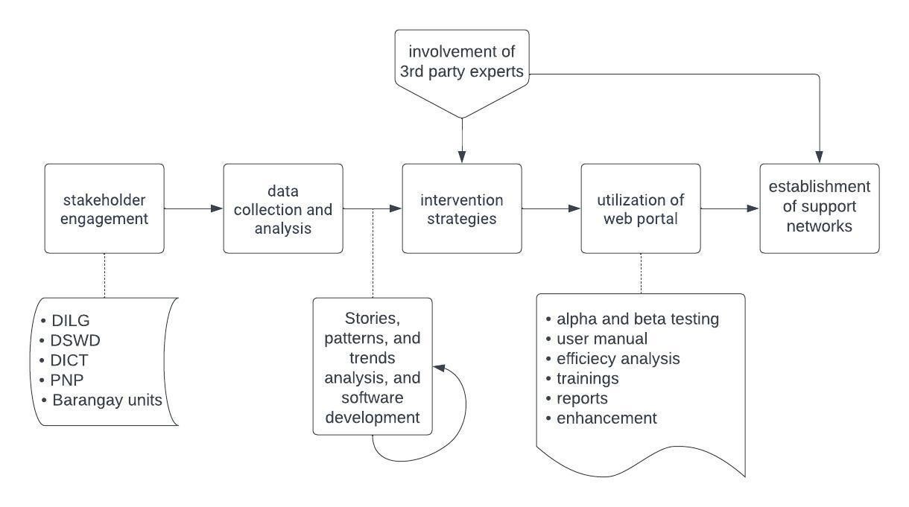

- Conduct a thorough review of existing reporting mechanisms, including traditional channels, online platforms, and community networks.
- Engage with key stakeholders such as DILG RO9, DSWD RO9, DICT RO9, PNP RO9, community leaders, barangay units through interviews, surveys, or focus group discussions.
- Evaluate existing reporting systems to identify gaps and barriers hindering victims from reporting.
- Develop a system module for confidential reporting channels within the web app, ensuring victim privacy and addressing confidentiality concerns.
- Design and implement targeted awareness campaigns to promote the web app, utilizing various media channels and community engagement activities.
- Use metrics to measure reporting rates, response times, and awareness levels through data collected by the web app.
- Conduct training sessions for law enforcement, community leaders, and support personnel on handling VAWC cases, emphasizing empathy and a victim-centric approach.
- Continuously collect feedback from stakeholders and victims through surveys, interviews, or a feedback mechanism within the web app.
- Collaborate with local NGOs and community organizations to establish or strengthen support networks, providing assistance and guidance to victims.

(12) Major Activities

See attached Work Plan

(13) Expected Output
6Ps
- Publication o 1 published article in scientific journal
- Patent o 1 Certificate of Copyright Registration
- Product o Deployed web application for 3 years
- People Service o Trained barangay officials and Purok Leaders
- Place and Partnership o MOU with DICT for internet connectivity
o MOU with DILG for implementation and deployment
- Policy o As input in crafting relevant executive order/s, city ordinance/s, or Sangguniang Panglungsod resolution/s such as the utilization of the web application
2Is
- Social Impact o Enhanced awareness and improved reporting of VAWC cases in Zamboanga City
- Economic Impact o Economic productivity through various government support such us livelihood programs, skills
training, etc.

(14) Target Beneficiaries Beneficiaries:
- Individuals and Communities affected by violence against women and children (VAWC)
- Government agencies, community leaders, law enforcement, and NGOs

Outcome:
• Include increased reporting rates, enhanced privacy through confidential reporting channels, improved community awareness, effective data utilization through metrics, stakeholder engagement leading to better collaboration, capacity building through training sessions, continuous improvement through feedback mechanisms, and the establishment or strengthening of support networks.

(15) Implementing Schedules Month Year
Duration: Planned start Date _January__ ___2024___
(In months) 12________ Planned Completion Date _January__ __2025____

(16) Estimated Budget by Source
Year 1 to 3 Total
Source
Of funds PS MOOE CO TOTAL PS MOOE CO TOTAL
DOST |  |  |  |  | 489,600.00 | 489,120.00 | 60,000.00 | 1,038,720.00
WMSU |  |  |  |  | 444,000.00 | 60,000.00 | ----- | 504,000.00
TOTAL ➔ |  |  |  |  | 933,600.00 | 549,120.00 | 60,000.00 | 1,542,720.00
Note: If the project is part of a program, this form should be submitted together with the capsule R&D proposal summary sheet. See guidelines / definitions.

