EVENT MANAGEMENT

Aim:
To analyze event performance, customer satisfaction, bookings, financial performance, payments, and vendor activities using an interactive Power BI dashboard for better event management.

Table of Contents
Project report structure
1 | Introduction
2 | Data Loading and Transformation in Power BI
3 | Define Objectives
4 | Objective Implementation in Power BI
5 | Dashboard Design
6 | Insights and Findings
7 | Conclusion
Appendix A | Key DAX Measures
Appendix B | Dashboard Page Mapping

1. Introduction
Overview of the Event Management dataset and analytical purpose
Project overview : The Event Management Analytics project uses an interactive Power BI dashboard to understand how events are planned, booked, funded, delivered, and evaluated. The supplied dashboard presents a consolidated view of event volume, bookings, guests, budgets, actual expenses, gifts, ratings, venues, payment status, booking status, and vendor activity. The analysis is designed to support management-level monitoring as well as detailed operational and financial review.
Dataset purpose : The dataset is intended to represent historical event-management records across event types, cities, venues, dates, bookings, customers/guests, payments, budgets, expenses, gifts, ratings, and vendor categories. These fields enable analysis of event demand, customer experience, financial performance, booking outcomes, and resource utilization.
Source : The project report is based on the dataset used to build the supplied Power BI report and the accompanying dashboard screenshots. The screenshots show the final analytical model and report outputs; the original raw-data source name is not specified in the supplied project instructions.
Analytical scope : The dashboard is structured into four analytical areas: Executive Dashboard; Event & Customer Analysis; Financial & Vendor Performance; and Operational Insights. Interactive slicers allow users to filter the analysis by dimensions such as event type, city, payment status, booking status, venue, vendor type, and event date.

Dashboard measures represented in the supplied report
Measure / KPI | Purpose
Total Events | Measures the overall number of events in the selected filter context.
Total Bookings | Measures booking volume and supports booking-status analysis.
Total Guests | Measures the total guest volume associated with events.
Total Budget | Represents planned event spending.
Actual Expense | Represents actual spending incurred.
Gift Amount | Tracks the monetary value associated with gifts.
Average Rating | Indicates customer/event satisfaction.
Avg Event Cost | Provides an average cost indicator for events.

2. Data Loading and Transformation in Power BI
Data transformation process and purpose
Data loading. The event-management dataset is loaded into Power BI and prepared in Power Query before visualization. The transformation stage is essential because accurate dashboards depend on consistent data types, clean category values, reliable dates, and usable numeric fields.
Step | Transformation applied | Purpose
1. Connect / import the dataset | Load the source event-management data into Power BI so the fields are available for Power Query transformation and reporting. | Creates the working data source for the analytical model.
2. Review columns and structure | Inspect column names, field meanings, data types, and the overall table structure. | Confirms that event, booking, financial, customer, venue, payment, and vendor fields are available and interpretable.
3. Promote headers / rename fields where required | Ensure the first row is treated as column headers and use clear, consistent names such as Event_Type, City, Payment_Status, Booking_Status, Venue_Name, Vendor_Type and Event_Date. | Improves readability and makes measures/visuals easier to build.
4. Set correct data types | Assign Date/Date-Time to Event_Date; numeric types to budget, expense, gift, guest, booking and rating fields; and text types to category fields. | Prevents calculation errors and ensures correct sorting, aggregation and filtering.
5. Clean text values | Standardize category text by trimming spaces and correcting inconsistent capitalization or spelling where necessary. | Prevents duplicate categories caused by formatting differences.
6. Handle blank / null values | Review missing values and determine whether they should be replaced, retained as blank, or excluded from calculations. | Improves data quality without introducing misleading values.
7. Check duplicates and record consistency | Review duplicate records and verify that event, booking and transaction-level records are not unintentionally repeated. | Reduces the risk of inflated totals.
8. Validate numeric fields | Check that budgets, expenses, gifts, guest counts, bookings and ratings contain valid numeric values and sensible ranges. | Supports reliable KPI calculations and financial analysis.
9. Prepare date fields | Ensure Event_Date is a valid date and is suitable for month/year trend analysis and slicers. | Enables time-based analysis such as monthly event trends.
10. Apply and load | Finalize Power Query transformations and load the cleaned data into the Power BI model. | Makes the transformed dataset ready for DAX measures and report visuals.

3. Define Objectives
Aim and objective statements exactly aligned to the supplied project brief
Aim :
To analyze event performance, customer satisfaction, bookings, financial performance, payments, and vendor activities using an interactive Power BI dashboard for better event management.

Objectives

1) Executive Dashboard
- To provide an overall view of event performance through key metrics such as total events, bookings, guests, budget, expenses, gift amount, and average rating.
- To compare event performance across different event types and cities.
- To analyze booking status and identify the distribution of confirmed and cancelled bookings.
- To help management quickly understand the current event performance using interactive filters.

2) Event & Customer Analysis
- To compare guest counts across different event types.
- To analyze customer satisfaction through average ratings.
- To analyze venue usage based on the number of events.
- To identify which cities have the highest number of events.

3) Financial & Vendor Performance Dashboard
- To compare the total budget with actual expenses across different event types.
- To analyze actual expenses across different cities.
- To identify areas of high spending and monitor financial performance for better budget control.
- To compare average expenses for different vendor types.

4) Operational Insights Dashboard
- To monitor booking performance by comparing across event types.
- To identify booking patterns and vendor usage for better operational planning.
- To analyze the distribution of bookings among different vendor types.

4. Objective Implementation in Power BI
Mapping objectives to report pages, visuals, slicers and DAX
Implementation approach : Each objective is translated into one or more Power BI visuals. The report uses KPI cards for headline metrics, bar/column charts for category comparisons, line charts for time trends, donut charts for status distributions, and slicers for interactive filtering.
No. | Objective | Power BI page | Primary visual(s) | Interactive filters
1 | Overall event performance | Executive Dashboard | KPI cards: Events, Bookings, Guests, Budget, Expense, Gift Amount, Rating, Avg Event Cost | Event Type, City, Payment Status, Booking Status, Event Date
2 | Compare event performance by type and city | Executive Dashboard | Events by Event Type; Events by City | Event Type, City
3 | Analyze booking status | Executive Dashboard | Booking Status distribution / trend | Booking Status, Payment Status
4 | Interactive management overview | Executive Dashboard | KPI cards + cross-filtering | All executive slicers
5 | Compare guest counts by event type | Event & Customer Analysis | Average Guest Count by Event Type | Event Type, City, Venue, Event Date
6 | Analyze customer satisfaction | Event & Customer Analysis | Average Rating by Event Type; rating trend | Event Type, City, Venue, Event Date
7 | Analyze venue usage | Event & Customer Analysis | Venues by Number of Events | Venue Name, City, Event Type
8 | Identify cities with highest events | Event & Customer Analysis | Events by City | City, Event Type
9 | Compare budget and actual expense | Financial & Vendor Performance | Budget vs Actual Expense by Event Type | Event Type, City, Payment Status, Event Date
10 | Analyze actual expenses by city | Financial & Vendor Performance | Actual Expense by City | City, Event Type
11 | Identify high spending / budget control | Financial & Vendor Performance | Budget vs Actual; expense KPIs | Event Type, City, Vendor Type
12 | Compare vendor expenses | Financial & Vendor Performance | Average Expense by Vendor Type | Vendor Type, City, Event Type
13 | Monitor booking performance | Operational Insights | Booking Status by Event Type | Event Type, City, Booking Status
14 | Identify booking patterns and vendor usage | Operational Insights | Booking Status analysis + Vendor Type Distribution | Booking Status, Vendor Type, Event Date
15 | Analyze vendor booking distribution | Operational Insights | Vendor Type Distribution donut chart | Vendor Type, Event Type, City

Slicers and DAX implementation

Slicers : The supplied screenshots demonstrate slicers for Event_Type, City, Payment_Status, Booking_Status, Event_Date, Venue_Name and Vendor_Type. These controls allow the same visual to answer different business questions without rebuilding the report.
DAX : The following core measures can be used to implement the KPI cards and analytical visuals shown in the report. Column names should be adjusted to match the exact imported table name if the source model uses a different table name.

Measure | DAX formula | Used for
Total Events | Total Events = DISTINCTCOUNT('EventData'[Event_ID]) | Executive Dashboard KPI / event comparisons
Total Bookings | Total Bookings = COUNTROWS('EventData') | Booking KPIs and booking-status visuals
Total Guests | Total Guests = SUM('EventData'[Guest_Count]) | Guest KPI and guest analysis
Total Budget | Total Budget = SUM('EventData'[Budget]) | Financial KPI and budget comparison
Actual Expense | Actual Expense = SUM('EventData'[Actual_Expense]) | Expense KPI and city/event-type analysis
Gift Amount | Gift Amount = SUM('EventData'[Gift_Amount]) | Gift KPI
Average Rating | Average Rating = AVERAGE('EventData'[Rating]) | Customer satisfaction visuals
Avg Event Cost | Avg Event Cost = DIVIDE([Actual Expense], [Total Events], 0) | Average event cost KPI
Confirmed Bookings | Confirmed Bookings = CALCULATE([Total Bookings], 'EventData'[Booking_Status] = "Confirmed") | Operational booking comparison
Cancelled Bookings | Cancelled Bookings = CALCULATE([Total Bookings], 'EventData'[Booking_Status] = "Cancelled") | Operational booking comparison
Budget Variance | Budget Variance = [Total Budget] - [Actual Expense] | Budget-control analysis

5. Dashboard Design
Executive summary and report-page structure
Executive Dashboard : The Executive Dashboard is designed as the management summary page. It brings together high-level KPIs, event-type comparisons, city-level performance and booking status. The supplied screenshots also demonstrate interactive filtering, including a Payment_Status selection of Paid.
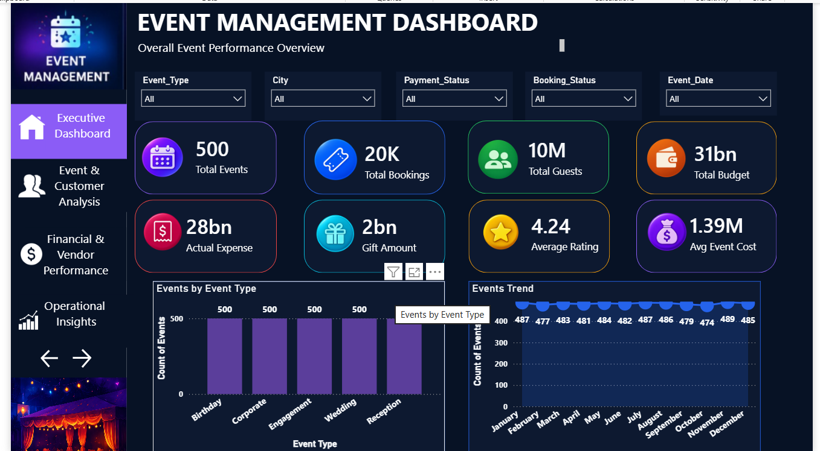

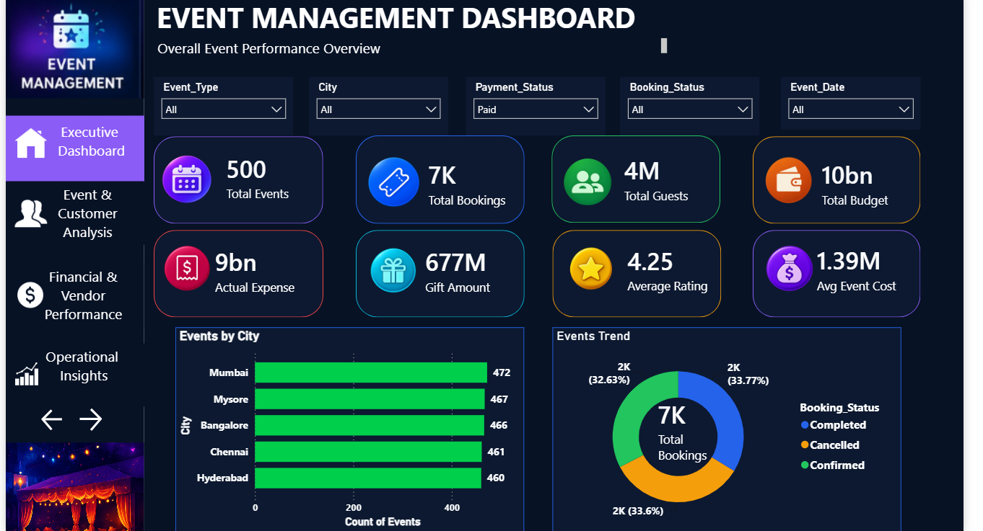

4.1 Objective Implementation — Event & Customer Analysis
Understanding Events, Guests, Venues & Customer Satisfaction
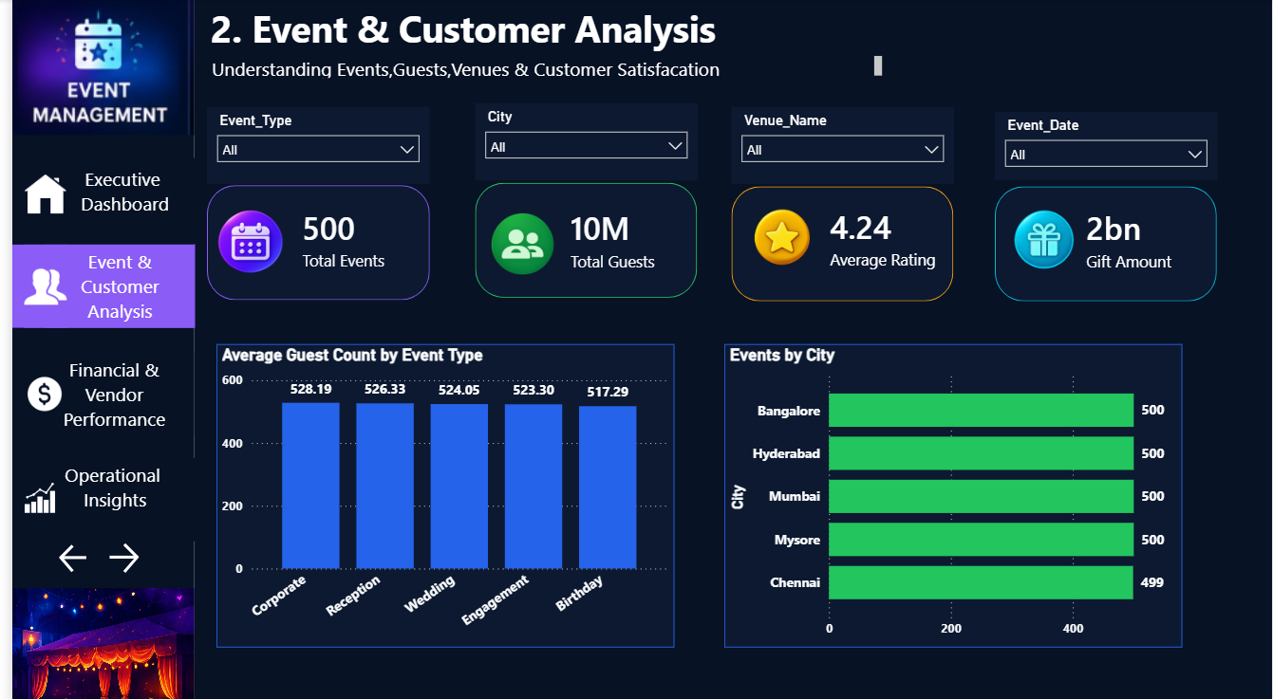

Key implementation : The page uses KPI cards for Total Events, Total Guests, Average Rating and Gift Amount, supported by event-type and city comparison visuals.
Evidence visible in the supplied dashboard : The dashboard shows 500 total events, approximately 10M total guests, an average rating of 4.24 and a gift amount of approximately 2bn in the unfiltered view. The event-type guest comparison shows Corporate with the highest displayed average guest count among the listed event types, while the city chart shows nearly 500 events in each displayed city.

4.2 Objective Implementation — Financial & Vendor Performance
Track Budget, Expenses & Vendor Performance
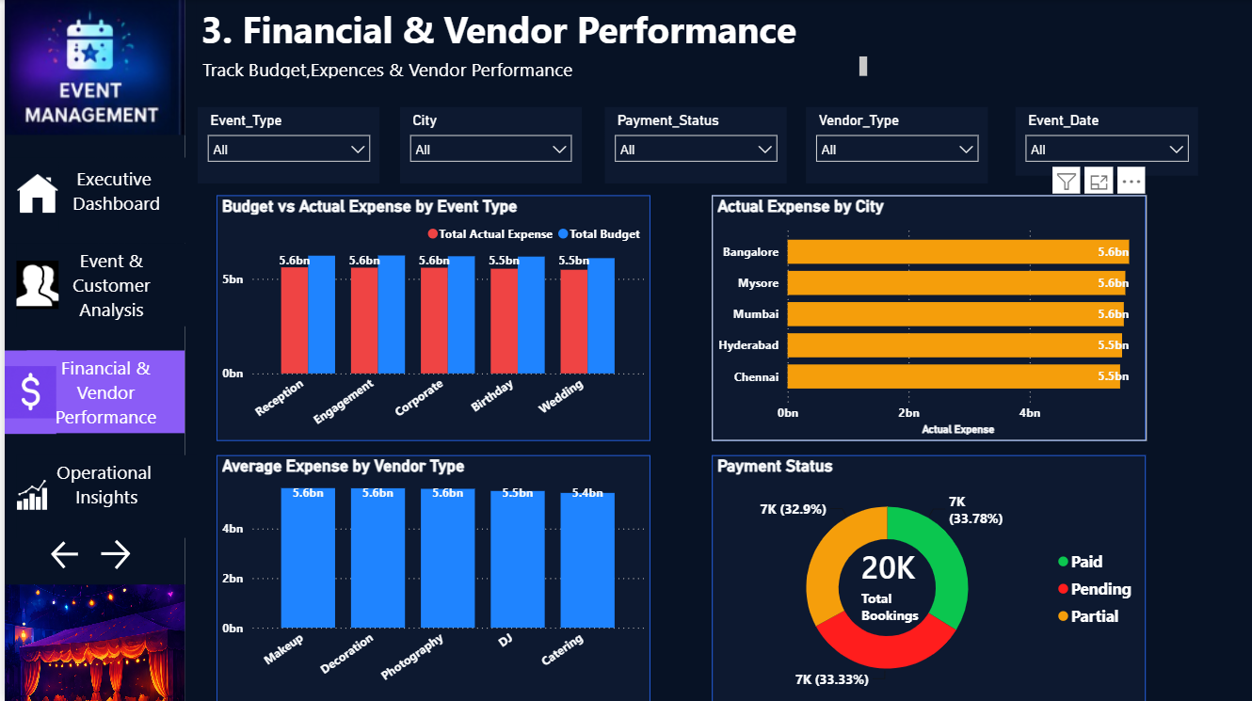
Key implementation. The page combines budget-versus-expense analysis, city expense comparison, vendor expense comparison and payment-status distribution.
Evidence visible in the supplied dashboard. The dashboard shows approximately 5.5–5.6bn expense/budget values across the displayed event types and cities. The Payment Status donut shows the total bookings split among Paid, Pending and Partial categories, providing a direct view of payment distribution.

4.3 Objective Implementation — Operational Insights
Monitor Bookings, Payments, Operations & Customer Feedback
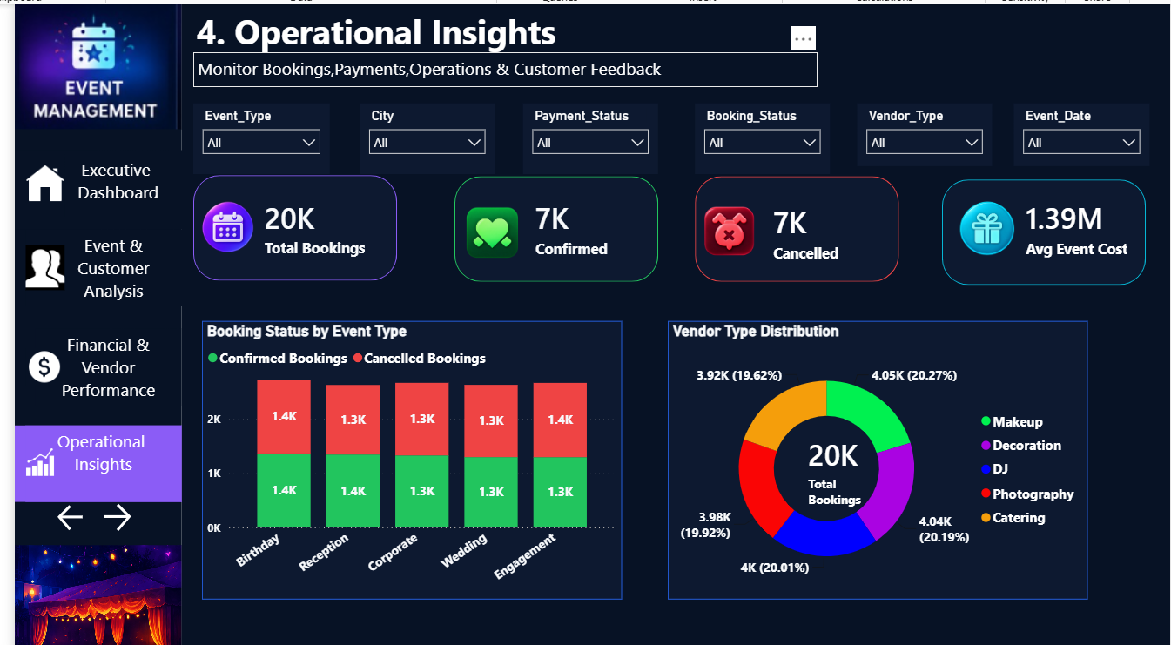

Key implementation : The operational page emphasizes Total Bookings, Confirmed Bookings, Cancelled Bookings and Average Event Cost, then compares confirmed/cancelled bookings by event type and shows vendor-type distribution.

6. Insights and Findings
Main findings from the supplied Power BI dashboard
1. Strong overall event volume. The executive and event/customer pages consistently show 500 total events in the displayed overall context, indicating a substantial event portfolio for analysis.
2. High guest volume. The overall dashboard shows approximately 10M total guests. This highlights the scale of customer/guest activity handled by the event portfolio.
3. Booking volume is significant. The unfiltered executive view shows approximately 20K total bookings. The booking-status visuals indicate that bookings are distributed across confirmed, cancelled and other status categories, making status monitoring important for operations.
4. Customer satisfaction is positive. The average rating is approximately 4.24–4.25 in the displayed dashboard contexts. Ratings across event types are close to one another, suggesting broadly consistent customer satisfaction.
5. Event demand is geographically distributed. The city visuals show very similar event counts across Bangalore, Hyderabad, Mumbai, Mysore and Chennai, with the displayed values around 499–500 on the event/customer page.
6. Budget and actual expenses are close. The financial page shows budget and actual expense values that are relatively close across the displayed event types. This supports using budget variance as an important control metric.
7. Vendor usage is broadly balanced. The operational vendor distribution is close to 20% for each displayed vendor type, indicating that bookings are distributed relatively evenly among Makeup, Decoration, DJ, Photography and Catering.
8. Booking outcomes require active monitoring. Confirmed and cancelled booking values appear close in the operational comparison. Monitoring cancellations alongside confirmed bookings can help identify operational risks and improve planning.

7. Conclusion
Overall project conclusion
The Event Management Power BI project successfully organizes event, customer, financial, payment and vendor information into an interactive analytical reporting solution. The dashboard structure follows the four major business areas specified in the project brief: Executive Dashboard; Event & Customer Analysis; Financial & Vendor Performance; and Operational Insights.
The report demonstrates how data transformation, DAX measures, slicers and visual analytics can convert event-management records into actionable information. The executive page provides a quick management overview, the event/customer page focuses on guest and satisfaction behavior, the financial/vendor page supports cost and payment control, and the operational page supports booking and vendor planning.
Overall, the analysis indicates high event and guest volumes, broadly consistent satisfaction ratings, geographically balanced event activity, substantial booking activity, and relatively close budget-versus-actual expense levels. The interactive design enables users to move from a high-level summary to specific event types, cities, venues, payment statuses, booking statuses and vendor categories for deeper investigation.
Therefore, the dashboard can support better event management by improving visibility, enabling faster comparisons, highlighting financial and operational exceptions, and providing a single analytical environment for management decision-making.

Appendix A. Key DAX Measures
Measures supporting the dashboard implementation
Total Events — Executive Dashboard KPI / event comparisons
Total Events = DISTINCTCOUNT('EventData'[Event_ID])
Total Bookings — Booking KPIs and booking-status visuals
Total Bookings = COUNTROWS('EventData')
Total Guests — Guest KPI and guest analysis
Total Guests = SUM('EventData'[Guest_Count])
Total Budget — Financial KPI and budget comparison
Total Budget = SUM('EventData'[Budget])
Actual Expense — Expense KPI and city/event-type analysis
Actual Expense = SUM('EventData'[Actual_Expense])
Gift Amount — Gift KPI
Gift Amount = SUM('EventData'[Gift_Amount])
Average Rating — Customer satisfaction visuals
Average Rating = AVERAGE('EventData'[Rating])
Avg Event Cost — Average event cost KPI
Avg Event Cost = DIVIDE([Actual Expense], [Total Events], 0)
Confirmed Bookings — Operational booking comparison
Confirmed Bookings = CALCULATE([Total Bookings], 'EventData'[Booking_Status] = "Confirmed")
Cancelled Bookings — Operational booking comparison
Cancelled Bookings = CALCULATE([Total Bookings], 'EventData'[Booking_Status] = "Cancelled")
Budget Variance — Budget-control analysis
Budget Variance = [Total Budget] - [Actual Expense]

Appendix B. Dashboard Page Mapping
Final Power BI report-page structure
Power BI Page | Page Name | Focus | Primary purpose
Page 1 | Executive Dashboard | Overall event performance overview | Executive management summary
Page 2 | Event & Customer Analysis | Understanding Events, Guests, Venues & Customer Satisfaction | Customer/event analysis
Page 3 | Financial & Vendor Performance | Track Budget, Expenses & Vendor Performance | Financial and vendor control
Page 4 | Operational Insights | Monitor Bookings, Payments, Operations & Customer Feedback | Operational planning and monitoring

Submission checklist.
- Word report created with Table of Contents.
- Introduction included with dataset purpose, source note and description.
- Data loading and transformation process documented with purposes.
- All supplied objective statements included and mapped to Power BI implementation.
- DAX measures documented for KPI and analytical visuals.
- Slicers documented across the report pages.
- Dashboard design and key screenshots included.
- Insights and findings summarized from the supplied dashboard views.
- Conclusion included.

