Course:

[Advanced QTP_ILT/VILT](javascript:submitAction_win0(document.win0,'LM_ACT_HYPERLINK$0');)

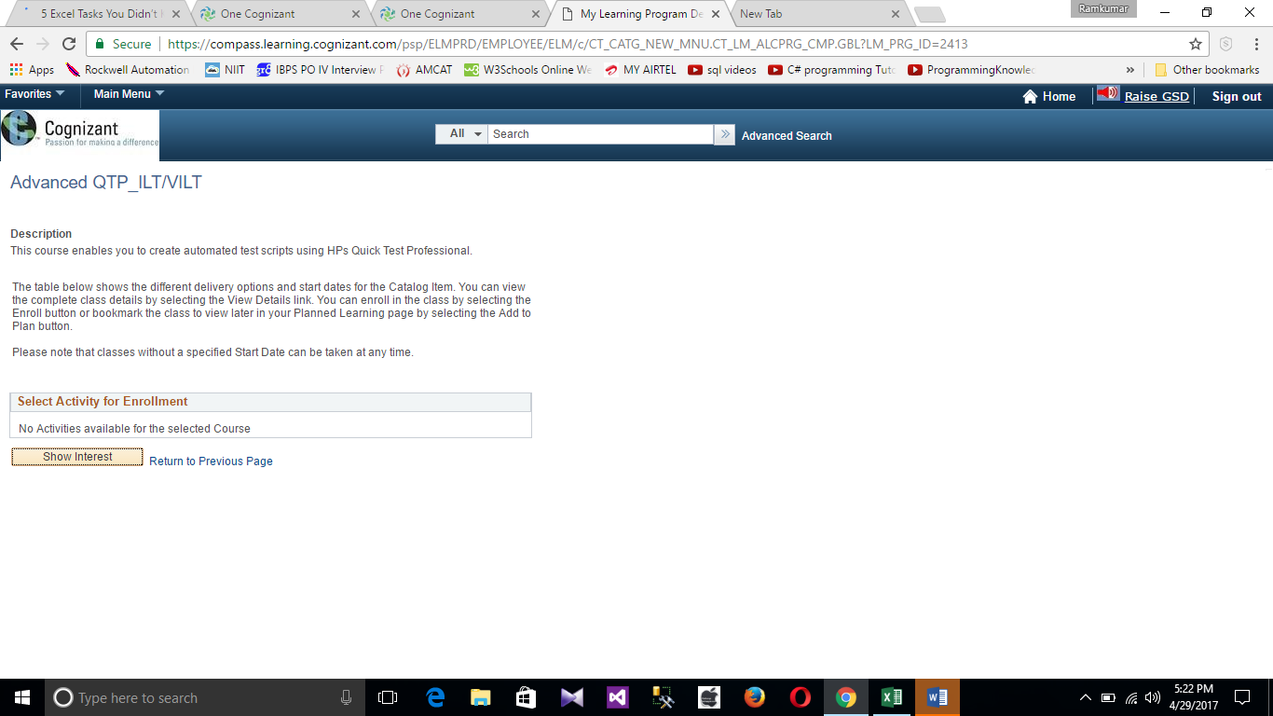

[Working with UFT_ILT/VILT](javascript:submitAction_win0(document.win0,'LM_ACT_HYPERLINK$0');)

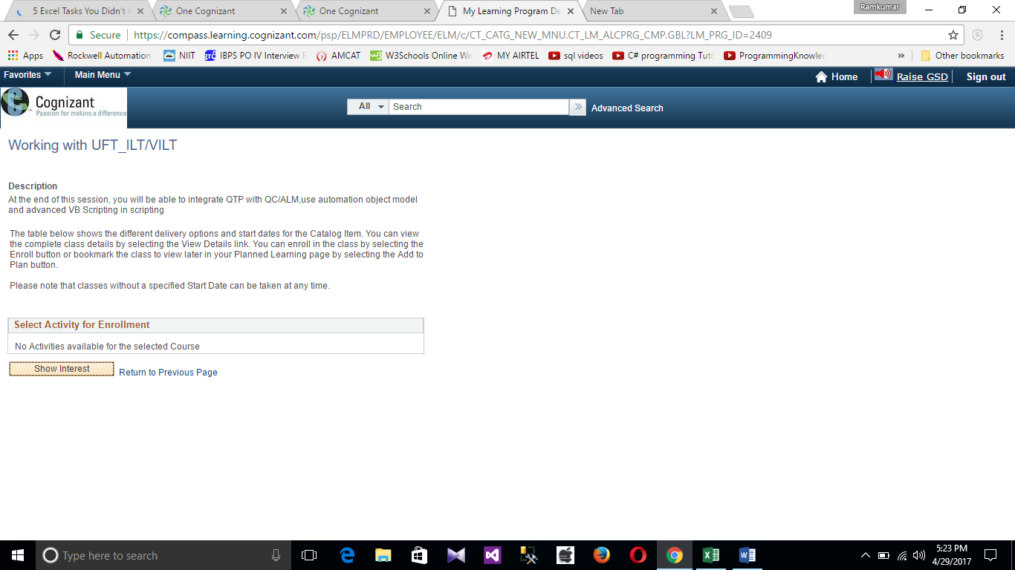

|  |  |  |  |  |  |  |  |  |  |  |  |
| --- | --- | --- | --- | --- | --- | --- | --- | --- | --- | --- | --- |
|  |  |  |  |  |  |  |  |  |  |  |  |
|  | | | | Basics of HP ALM Training_ILT/VILT | | | | | | | |

