### 

### **Support Vector Machine (SVM) - Iris Classification**

### **Data Analytics & Algorithms Log**

* **Algorithm Used:** Support Vector Machine (SVM)
* **Dataset Used:** Iris Dataset
* **Framework:** CRISP-DM

**Original Workbook Link:** [**Notebook**](https://github.com/ipython-books/cookbook-2nd-code/blob/master/chapter08_ml/05_svm.ipynb)

|  |  |  |  |  |
| --- | --- | --- | --- | --- |
| **Phases** | **Changes Made** | **Reason for the change** | **Duration** | **Difficulty level**  **(1-10)** |
| **Datasets selection** | Changed the synthetic dataset to real time iris dataset | I thought of implementing it on some real-world datasets to deepen my understanding of the model. | 10 min | 3 |
| **Algorithm Version** | Changed from LinearSVC to multiple kernels (linear, poly, sigmoid and rbf) | Since versicolor and virginica aren’t perfectly linearly separable, I thought to try all kernels to select the best kernel to move forward | 30 min | 6 |
| **Data Preprocessing** | StandardScalar | Standardized the data for better prediction | 30 min | 6 |
| **Kernels used and their results** | Linear, Poly, RBF and Sigmoid | Cross validated different kernels to select the best kernel to move forward. | 2 hours | 7 |
| **Further Enhancements** | GridSearchCV | After kernel results, the linear kernel outperformed all other kernels. With the linear kernel I tried fine tuning the hyperparameters to enhance the model performance. | 1 hour | 7 |
| **Conclusions** |  | A Drastic decrease in overall accuracy in the enhanced model made it possible to declare that the linear kernel model with default parameters performed the best.  Even though Iris dataset is a well-known linearly separable dataset, exploring different kernels, techniques for improving the performance of the model helped me to deepen my problem-solving skills, decision making skills (selecting the best kernel to improve the model). | 30 min | 6 |

## **1️. Business Understanding**

### **Objective:**

This study aims to classify **Iris flower species** using **Support Vector Machine (SVM)** and analyze how the choice of a kernel impacts the performance of the model. The dataset consists of **three classes** (“**Setosa”, “Versicolor”, “Virginica”**), that require a **multiclass classification approach**.

### **Challenges Faced:**

* **Selecting the appropriate kernel:** SVM supports different kernels (**Linear, RBF, Polynomial, Sigmoid**). Choosing the optimum one was important to achieve high accuracy.
* **Hyperparameter tuning:** The **C** parameter for the SVM model must be **fine-tuned** to achieve optimal performance.
* **Understanding decision boundaries:** A key part of understanding the mode was Visualizing how different kernels separate the classes.

## **2️. Data Understanding**

### **Dataset Overview:**

* **Total Samples:** 150
* **Features Used:** “Sepal Length”, “Sepal Width” (Used the first two features for Visualisation)
* **Target Classes:**
  + Setosa (0)
  + Versicolor (1)
  + Virginica (2)
* **Class Distribution:** balanced (50 samples in each class)
* **No missing values**

### **Key Insights:**

* **No oversampling or resampling techniques** were required as the dataset is **balanced**.
* Few need to scale the features for SVM to perform correctly.

## **3️. Data Preparation**

### **Preprocessing Steps:**

* **Feature Scaling:** Leveraging **StandardScaler** to normalize feature values.
* **Train-Test Split:**
  + **80% Training Set (120 samples)**
  + **20% Testing Set (30 samples)**

## **4️. Training SVM with Different Kernels**

### **Kernels Used & Performance Details:**

|  |  |  |
| --- | --- | --- |
| **Kernel** | **Accuracy** | **Best For** |
| **Linear** | **90%** | Best for linearly separable data |
| **RBF** | 83% | Works well for non-linear relationships |
| **Polynomial** | 63% | Overfits on this dataset |
| **Sigmoid** | 83% | Like RBF but less stable |

### **Key Observations:**

* **The Linear Kernel performed the best (90% accuracy), made it the best choice for this dataset.**
* **Polynomial Kernel, overfitted**, which led to poor performance.
* **RBF and Sigmoid performed similarly but underperformed Linear.**

## **5️. Plotting Decision Boundaries**

* Plotted decision boundaries for all kernels to visualize how well they separate the classes.
* Clean class separations done by Linear Kernel proves its effectiveness.
* However Polynomial Kernel had a complex boundary that probably resulted in poor performance.

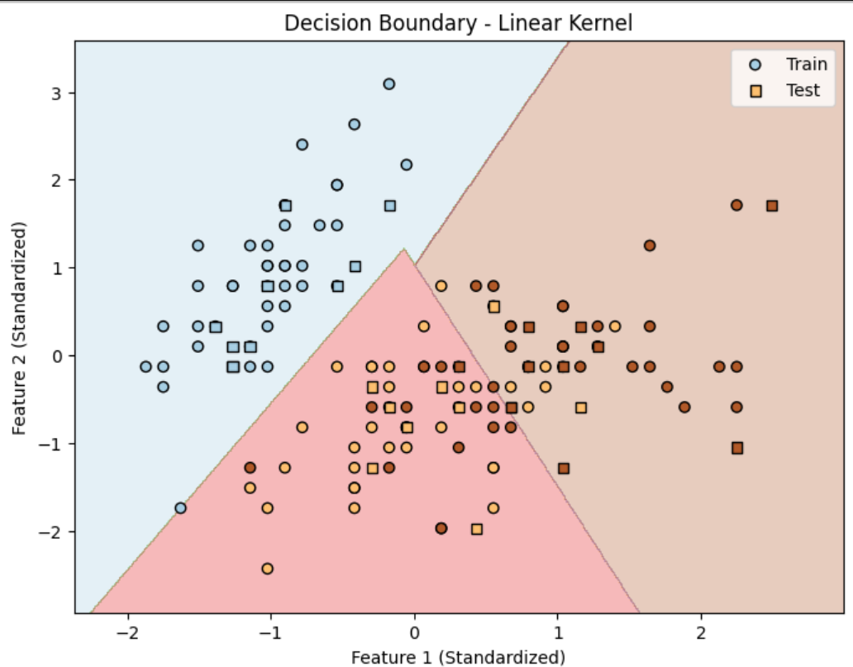

### **Why is this important?**

Knowing how decision boundaries work in detail helps in selecting the right kernel and using hyperparameters properly to generalize better.

## **6️. Hyperparameter Tuning (Linear SVM)**

Since **Linear Kernel performed best**, we tuned it using **GridSearchCV** to fit its C **parameter**.

### **Results:**

* **Best C Parameter:** 0.0316
* **Post Tuning Accuracy:** **80%** (Lower than before 90%)
* **Performance Dropped:** Because of Lower **C** value it led to a **softer margin**, thus permitting more misclassifications.

### **Key Insight:**

* **The SVM tuned model performed less than default SVM settings.**
* **Set C at the default value 1.0 was the good option for this dataset.**

## **7️. Final Model Selection**

### **Final Model: Linear SVM with Default Parameters**

* Attained **90% accuracy** and surpassed all other models.
* Easy and impactful for this dataset.
* Our choice was reinforced since further hyperparameter tuning **did not improve performance**.

## **8️. Final Conclusion**

* Linear SVM was the appropriate algorithm for this dataset.
* The default model without hyperparameter tuning performed the best.
* Linear SVM’s effectiveness confirmed by Decision boundary Visualisation.
* The dataset was balanced and hence there was no need of any resampling techniques.

### **What I Learned:**

* SVM does well as long as **an appropriate kernel is selected** for the dataset.
* Linear SVM is **best for linearly separable data**.
* The (**Polynomial Kernel**) model is over-complicated which leads to **overfitting**.
* **In some cases, default hyperparameters be more effective than fine-tuning.**