A Project Report on

“Online fast and secure digital shopping management system”

Submitted in the partial fulfillment of the requirements for the award of the Degree of

Bachelor of Computer Application
Semester - VI (2025-26)

Submitted by
230801115 – Dabhi Ramji Rajeshbhai

Guided by
Mr. Rahul Bagda

Submitted to

Faculty of Science
Department of Computer Science
Atmiya University
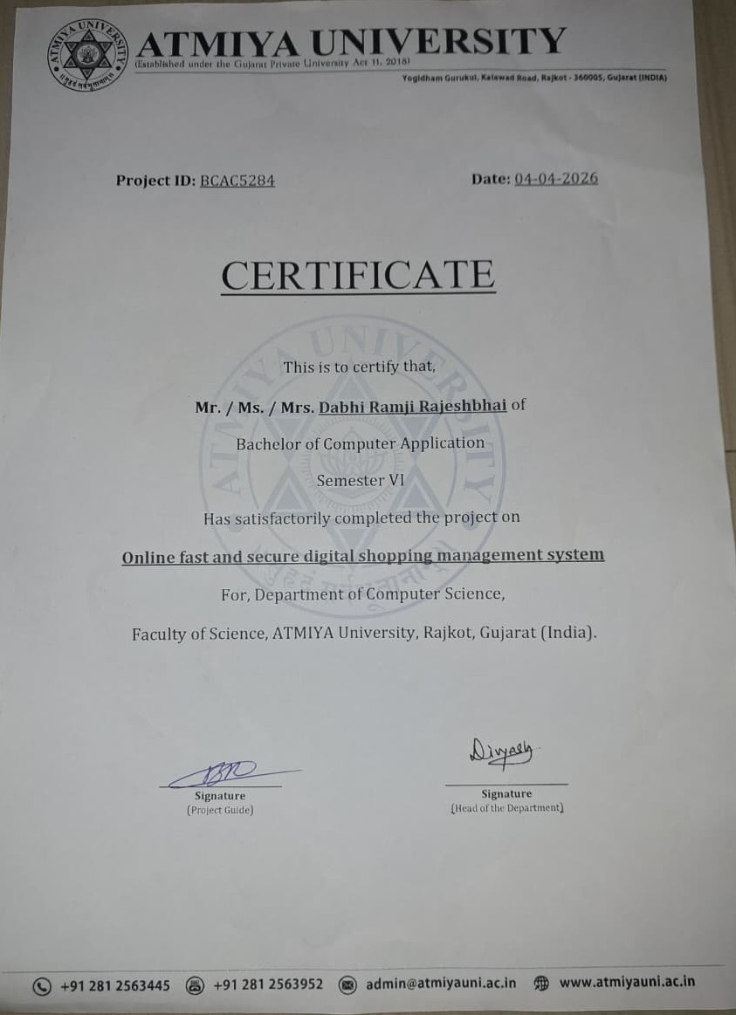

DECLARATION

I hereby declare that the project report titled “Online fast and secure digital shopping management system” is my original work and has been completed under the guidance of Mr. Rahul Bagda. This project is submitted in the partial fulfillment of the requirements for the award of the Degree of Bachelor of Computer Application, Semester – VI (2025–26) under the Faculty of Science, Department of Computer Science, Atmiya University, Rajkot, Gujarat-India.
I also declare that this work has not been submitted to any other university or institution for any degree, diploma, or certificate.

Name of Student: Dabhi Ramji R.
Enrollment No.: 230801115
Signature:
Date:

ACKNOWLEDGEMENT

I express my deep sense of gratitude to the following respected authorities of Atmiya University for their constant support, guidance, and encouragement throughout the completion of this project.
I am sincerely thankful to P. P. Tyagvallabh Swami (President, Atmiya University) for providing an excellent educational environment and continuous encouragement toward academic excellence.
I extend my gratitude to Dr. D. D. Vyas (Registrar, Atmiya University) for ensuring smooth academic processes and administrative support that contributed to the successful completion of this project.
I am grateful to Er. R. S. Tank (Dean, Faculty of Science) for his valuable support, motivation, and guidance throughout the duration of the program.
My heartfelt thanks to Dr. D. P. Gohel (Head, Department of Computer Science) for providing necessary facilities, timely support, and continuous encouragement during the project work.
I would like to express my special appreciation and sincere thanks to my project guide Mr. Rahul Bagda, whose expert guidance, patience, and valuable suggestions helped me complete this project successfully.
I am also thankful to all the faculty members of the Department of Computer Science for their support, feedback, and academic insights throughout the course.
Finally, I gratefully acknowledge the constant support, motivation, and encouragement of my family and friends, without which this project would not have been completed.

ABSTRACT

In the rapidly evolving landscape of digital commerce, the demand for specialized, high-performance e-commerce platforms is at an all-time high. “Moonchild” is a futuristic, niche e-commerce application designed to cater to the market of high-end consumer electronics and next-generation gadgets. While generic e-commerce platforms offer broad solutions, they often lack the specialized user experience and inventory management features required for high-value tech products
This project addresses the need for a seamless, secure, and visually immersive online shopping experience. Developed using PHP for server-side logic and MySQL for robust data management, the system ensures data integrity, fast transaction processing, and a responsive user interface built with HTML5, CSS3, and JavaScript.
The core functionality of the system encompasses a comprehensive product management module, a dynamic shopping cart, a secure user authentication system, and an administrative dashboard for real-time inventory and order tracking. The project successfully demonstrates the implementation of a full-stack web application, adhering to modern software engineering principles. The outcome is a fully functional, scalable e-commerce solution that bridges the gap between futuristic product offerings and present-day consumer accessibility.

Table of Content

SN | Chapter | Page No.
 | Certificate | I
 | Declaration | II
 | Acknowledgment | III
 | Abstract | IV
 | Table of Contents | V
1 | Introduction | 1
2 | Problem Definition | 2
3 | Objectives of the Study | 3
4 | System Analysis | 4
5 | System Design | 5
 | 5.1 Data Flow Diagrams (DFD)
 | 5.2 UML Diagrams
 | 5.3 ER Diagram
6 | Implementation | 6
7 | Testing | 7
8 | Output Screenshots | 8
9 | Conclusion | 9
10 | Future Scope | 10
11 | Bibliography / References | 11
12 | Appendix | 12

Chapter 1
INTODUCTION

  - Overview
The digital revolution has fundamentally transformed how businesses operate and how consumers purchase goods. E-commerce has emerged not just as an alternative to physical retail, but as a primary driver of the global economy. “Moonchild” is a web-based e-commerce application developed to provide a sophisticated platform for buying and selling futuristic electronic products. Unlike traditional online stores, this project focuses on a streamlined, high-performance user experience tailored for tech enthusiasts.
The application serves two primary user roles: the Administrator and the Customer. The Administrator has complete control over the system, including product management, category classification, and order processing. The Customer, on the other hand, enjoys an intuitive interface to browse products, manage their wishlist and cart, and securely place orders. The system is built on a robust architecture that ensures scalability, security, and performance.
  - Purpose and Scope
The primary purpose of this project is to automate the manual processes involved in managing a niche electronics store. By digitizing inventory management, order processing, and customer relationship management, “Moonchild” aims to reduce operational errors and enhance efficiency.
Scope of the Project: * User Module: Registration, Login, Profile Management, Product Browsing, Search, Cart Management, Wishlist, and Checkout. * Admin Module: Dashboard analytics, Product CRUD (Create, Read, Update, Delete) operations, Category management, Order status updates, and System settings. * Data Management: Secure storage of user data, order history, and product details using a relational database. * Security: Implementation of secure session management, password hashing, and input validation to prevent common web vulnerabilities.
  - Background Information
Historically, retail management relied heavily on manual record-keeping and physical storefronts. This approach is fraught with limitations, including geographical restrictions, limited operating hours, and human error in stock tracking. With the advent of the World Wide Web in the 1990s and the subsequent rise of platforms like Amazon and eBay, the retail paradigm shifted.
Technologically, this project builds upon the established LAMP (Linux, Apache, MySQL, PHP) stack architecture, which powers a significant portion of the web. By leveraging modern PHP (Hypertext Preprocessor) for backend logic and MySQL for relational database management, the system provides a costeffective yet powerful solution for small to medium-scale e-commerce enterprises.

Chapter 2
PROBLEM DEFINITION

2.1 Real-World Problem
In the current retail sector, specifically within the niche market of high-end electronics, verify capability and inventory accuracy are paramount. Many existing small-scale tech retailers still rely on disjointed systems—using spreadsheets for inventory, separate tools for billing, and manual methods for customer tracking. This fragmentation leads to data inconsistency, stock discrepancies, and a poor customer experience.
Furthermore, generic e-commerce platforms (SaaS solutions) often come with bloated features and recurring costs that are unsustainable for specialized startups. They may not offer the specific customization required to showcase detailed technical specifications of futuristic gadgets, such as holographic displays or neural-link devices, effectively.
2.2 Existing Challenges
• Manual Inventory Errors: accurate tracking of high-value stock is difficult with manual systems, leading to overstocking or stockouts.
• Data Redundancy: maintaining separate records for sales, customers, and inventory results in duplicated and often conflicting data.
• Lack of Scalability: excel-based or paper-based systems cannot handle a growing customer base or increased transaction volume.
• Customer Inconvenience: without an online presence, customers are restricted to physical store hours and locations.
2.3 Need for a Technical Solution
To overcome these challenges, a centralized, web-based system is essential. A custom-built e-commerce application addresses these issues by:
1. Centralizing Data: combining inventory, sales, and user data into a single relational database.
2. Automating Processes: automatically updating stock levels upon purchase and calculating totals/taxes.
3. Enhancing Accessibility: providing 24/7 access to the store from any location with internet connectivity.
4. Improving User Experience: offering advanced search and filtering capabilities to help users find specific technical products quickly.

Chapter 3
OBJECTIVES OF THE STUDY

The primary objective of this project is to design and develop a fully functional e-commerce website that simplifies the buying and selling process. The specific objectives are as follows:
• To develop a user-friendly interface that provides a seamless navigation experience for customers browsing high-tech products.
• To implement a secure authentication system ensuring the safety of user accounts and personal information through password encryption and session management.
• To create a dynamic product catalog that allows the administrator to easily add, update, and categorize products with rich media and technical specifications.
• To design a robust shopping cart and checkout system that handles calculations for sub-totals, shipping costs, and discounts accurately in realtime.
• To provide an administrative dashboard for comprehensive monitoring of sales performance, order statuses, and inventory levels.
• To ensure data integrity and consistency using a normalized MySQL database structure with proper foreign key constraints.

Chapter 4
SYSTEM ANALYSIS

4.1 Existing System
The existing system largely refers to the traditional method of shopping or using basic, non-integrated digital tools. In a manual or semi-automated setup, the shopkeeper physically checks the stock, manually writes receipts, and maintains a ledger for daily sales.
Working Method
Customers visit the physical store, browse items on shelves, and pay via cash or card at a physical counter. Record keeping is done at the end of the day.
Limitations & Risks
• Time-Consuming: manual processing of orders takes time.
• Human Error: calculation mistakes in billing.
• No Remote Access: business stops when the shop closes.
• Limited Reach: customer base is limited to the local vicinity
4.2 Proposed System
The “Moonchild” proposed system is a web-based application that automates the entire retail lifecycle. It integrates the frontend store with a backend administration panel.
System Workflow
Users register and log in to the portal. They browse categories (e.g., Laptops, VR Headsets), view detailed product pages, add items to a cart, and proceed to checkout. The system records the order in the database and instantly deducts the stock. Administrators view these orders in real-time and update their status (e.g., “Shipped”, “Delivered”).
Advantages
• Global Reach: accessible from anywhere.
• Automation: instant stock updates and bill calculation.
• Data Analysis: easier to track popular products and revenue.
• Cost-Effective: reduces the need for physical retail space and staff.

4.3 Feasibility Study
Technical Feasibility
The project uses PHP and MySQL, which are standard, open-source technologies supported by almost all web servers. The hardware requirements are minimal (client-side browser, server-side hosting), making it technically viable. The development team possesses the necessary skills in HTML, CSS, JS, and SQL.
Economic Feasibility
Since the project utilizes open-source software (XAMPP stack, VS Code), there are no licensing costs involved. The primary cost is development time and potential hosting fees. Compared to purchasing a proprietary enterprise ERP setup, this custom solution is highly consistent with the budget constraints of a startup.
Operational Feasibility
The system is designed with a focus on User Experience (UX). The interface is intuitive, requiring no special training for customers. The admin panel is structured logically, ensuring that the store manager can operate it with basic computer literacy. Therefore, operational adoption is expected to be smooth.
4.4 Requirement Specification
Hardware Requirements
Component | Minimum Specification | Recommended  Specification
Processor | Intel Core i3 or equivalent | Intel Core i5 or higher
RAM | 4 GB | 8 GB or higher
Storage | 256 GB HDD/SSD | 512 GB SSD
Monitor | 1366x768 resolution | 1920x1080 resolution
Internet | 5 Mbps connection | Broadband / Fiber connection

Software Requirements
Component | Requirement
Operating System | Windows 10/11, Linux, or macOS
Server Stack | XAMPP / WAMP / LAMP (Apache, MariaDB/MySQL, PHP)
Frontend Technologies | HTML5, CSS3, JavaScript (ES6)
Backend Language | PHP 8.0+
Database | MySQL 5.7+
Web Browser | Google Chrome, Firefox, or Edge
Code Editor | Visual Studio Code

Chapter 5
SYSTEM DESIGN

5.1 Data Flow Diagram (DFD)
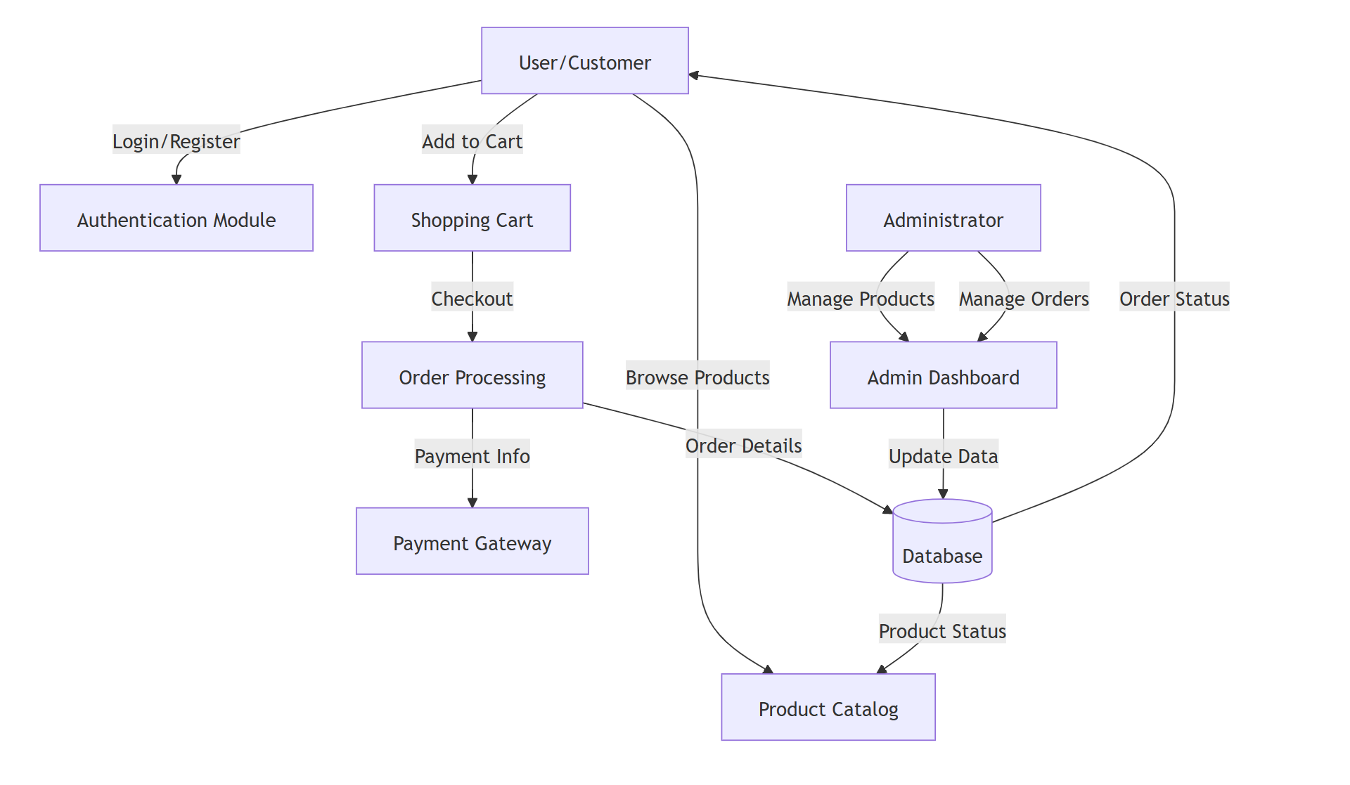

5.2 Use Case Diagram
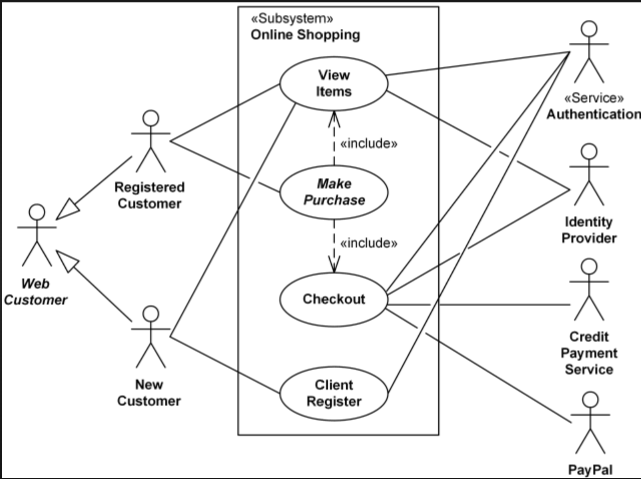

5.3 Class Diagram
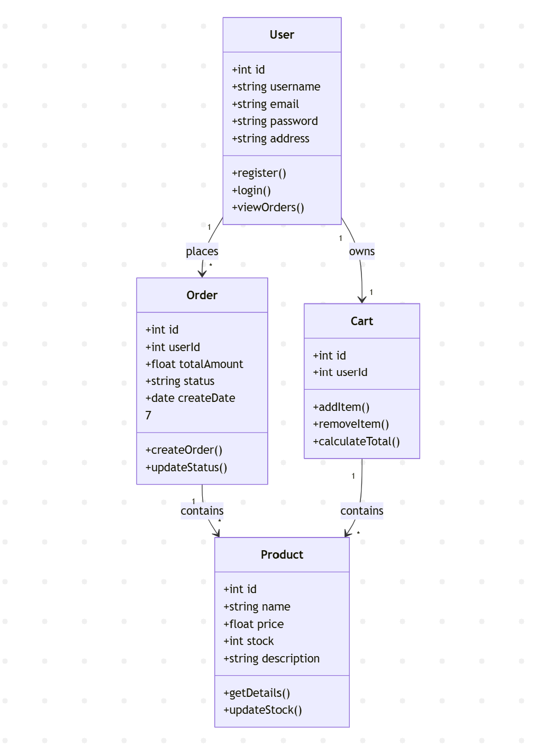

5.4 Activity Diagram (Order Process)
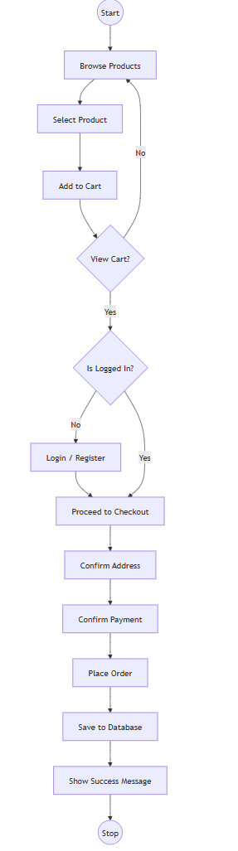

5.5 Entity Relationship (ER) Diagram
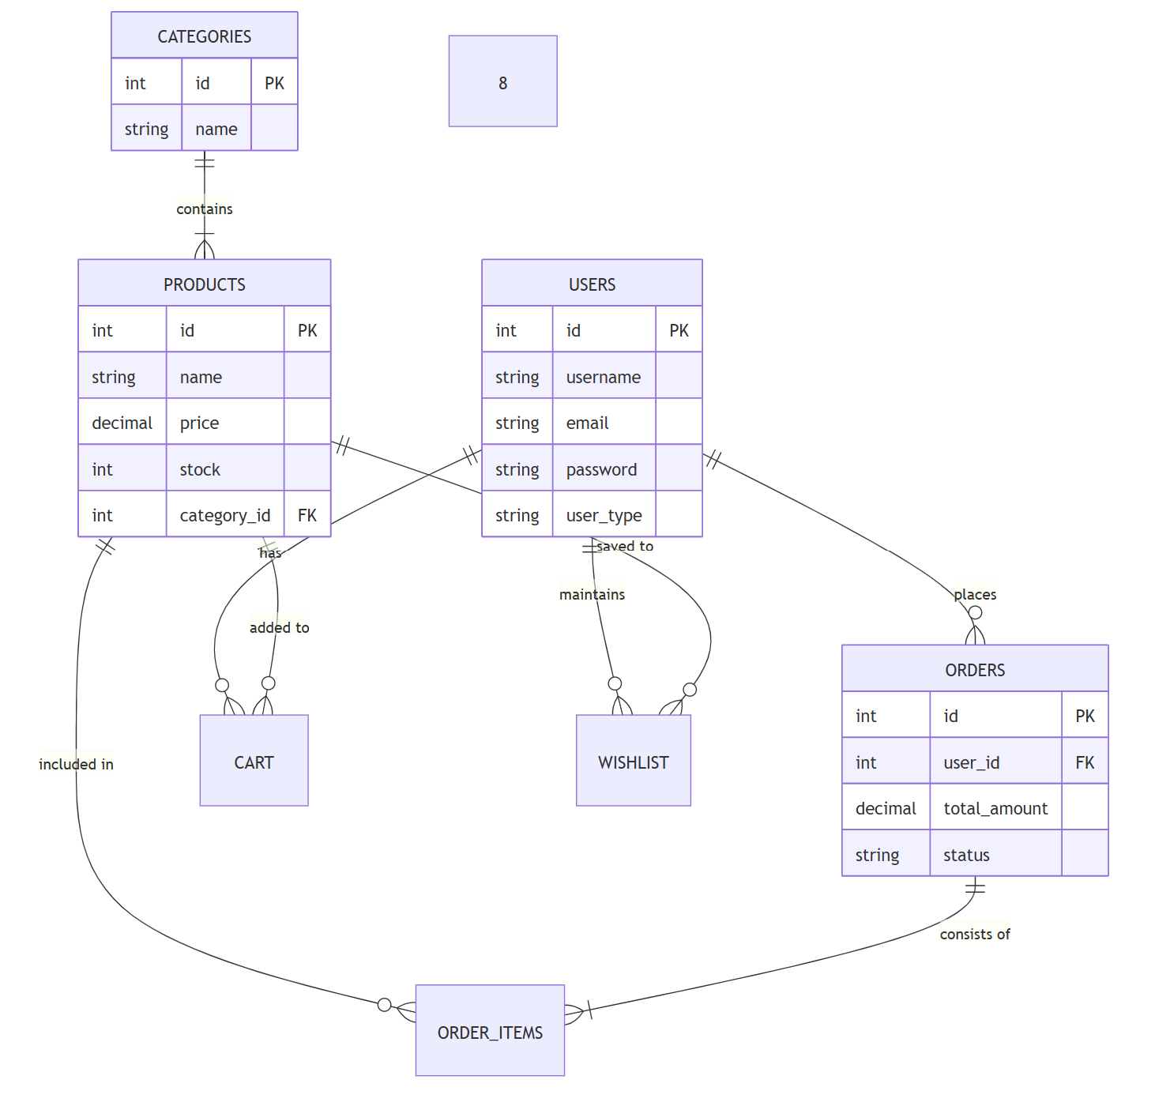

5.6 System Architecture
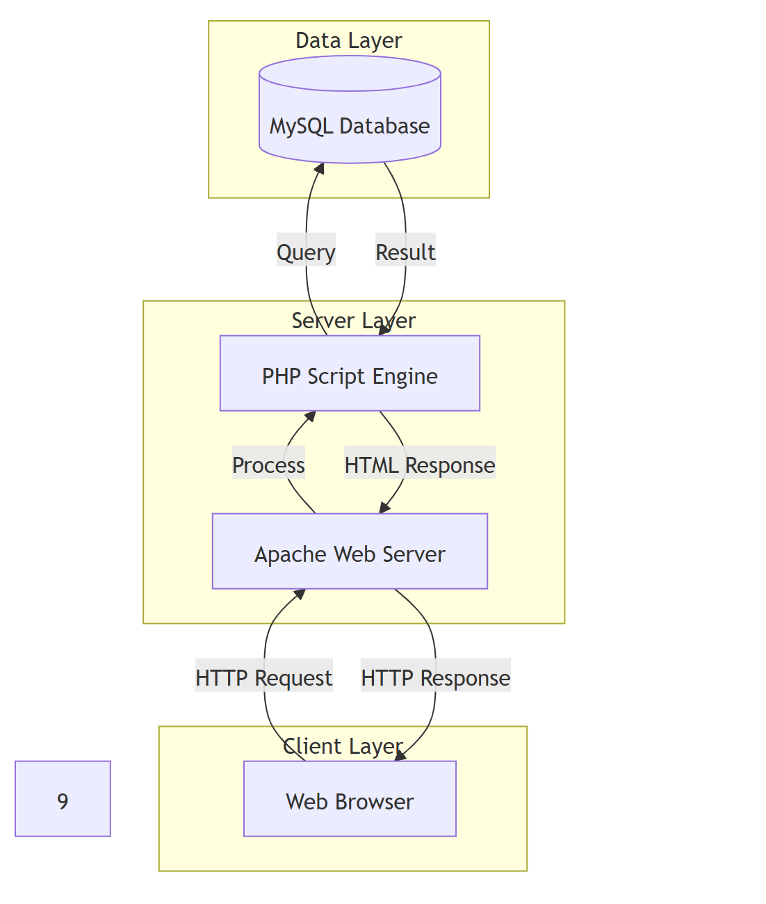

Chapter 6
IMPLEMENTATION

6.1 Module Description
User Authentication Module
This module handles user security. It uses PHP Sessions (session_start())
to track user state. Passwords are hashed before storage using standard algo
rithms to ensure security. * Input: Username, Email, Password. * Process:
Validation, Hashing, Database Insertion/Lookup. * Output: Session creation
and redirection to Dashboard.
Product Management Module
Allows the admin to manage the inventory. Products are categorized (e.g., Elec
tronics, Laptops) for easy filtering. The products table in the database stores
all implementation details including image paths and stock levels. * Technolo
gies: PHP Forms, File Upload for images.
Shopping Cart Module
A crucial component that allows users to accumulate items before purchase.
The cart is persistent for logged-in users, stored in the cart database table. *
Process: Checks current stock, adds item to cart table, updates quantity if
item already exists.
Order Processing Module
Handles the final transaction. It calculates the total price, including shipping
and taxes. When an order is placed, data moves from the cart table to the
orders and order_items tables, and the product stock is decremented to pre
vent overselling
6.2 Technologies Used
• HTML5 (HyperText Markup Language): Used for the structural
skeleton of the web pages.
• CSS3 (Cascading Style Sheets): Used for styling the application, in
cluding layout, colors, and fonts (using shop.css and style.css).
• JavaScript: Used for client-side interactivity, form validation, and dy
namic content updates (script.js).
10• PHP (Hypertext Preprocessor): The core server-side scripting lan
guage used to handle business logic and database connectivity.
• MySQL: The Relational Database Management System (RDBMS) used
to store all application data.
• Apache: The web server software responsible for serving the application
files.

6.3 Development Methodology

The project followed the Waterfall Model of software development. This lin
ear approach ensured that each phase—Requirements Analysis, System Design,
Implementation, Testing, and Deployment—was completed and verified before
moving to the next. This structure was ideal for a university project with clear,
fixed requirements.
1. Requirement Gathering: Identified the need for a niche tech store.
2. Design: Created ER diagrams and schema.
3. Coding: Developed frontend and backend modules.
4. Testing: Verified detailed functionality

Chapter 7
TESTING

Software testing is a critical phase to ensure the system is defect-free and meets
the requirements.

7.1 Types of Testing Performed

• Unit Testing: Individual modules (e.g., Login function, Cart calculation)
were tested in isolation to ensure logic correctness.

• Integration Testing: Verified that modules work together, for example,
ensuring that adding a product updates the cart total correctly.

• System Testing: The complete application was tested as a whole to
validate end-to-end flows (from Registration to Order Placement).

• Validation Testing: Input forms were tested to ensure they reject invalid data (e.g., negative prices, invalid email formats).

7.2 Test Cases

TC ID | Test Case | Steps | Expected Result | Actual Result | Status
TC 01 | User Registrstion | Enter valid details and submit | Account created, redirected to login | As Expected | Pass
TC 02 | User Login | Enter valid credentials | Login successful, session started | As Expected | Pass
TC 03 | Invalid Login | Enter wrong password | Show error message | Error displayed | Pass
TC 04 | Add to Cart | Click ‘Add to Cart’ onproduct | Item added cart count +1 | As Expected | Pass
TC 05 | Stock Validation | Try to buy more than stock | System prevents addition | As Expected | Pass
TC 06 | Place Order | Proceed to checkout | Order saved, Cart cleared | As Expected | Pass
TC 07 | Admin Login | Login with admin credentials | Redirect to Admin Dashboard | As Expected | Pass
TC 08 | Add Product | Admin adds new product | Product appears on Homepage | As Expected | Pass

Chapter 8
OUTPUT SCREENSHOTS
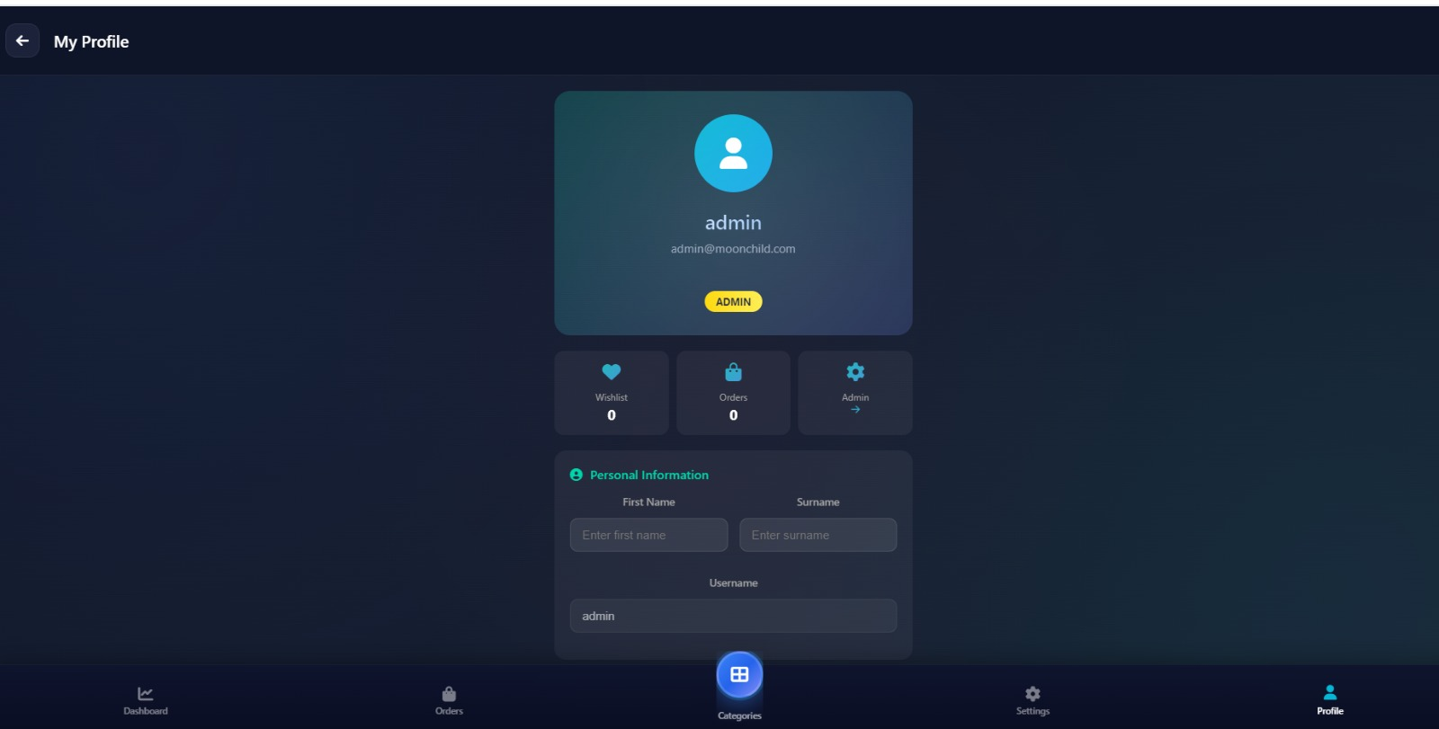

The image shows a dark-themed user profile dashboard. The background has a blue gradient design with soft lighting effects. At the top left, there is a back arrow and the title “My Profile.”
In the center, a profile card displays a circular avatar icon, the username “admin,” and the email “admin@moonchild.com.” A yellow badge labeled “ADMIN” indicates the user’s role.

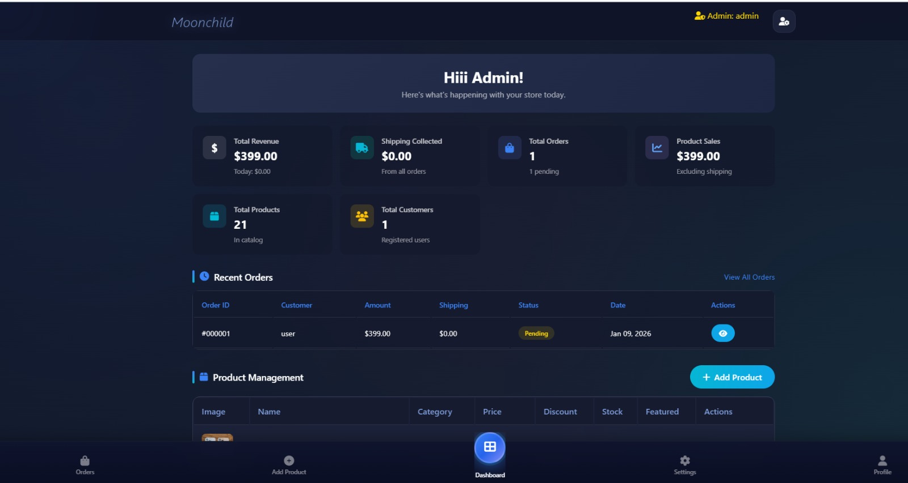

At the top, the brand name “Moonchild” appears on the left, and “Admin: admin” is shown on the right with a user icon. In the center, there is a welcome message: “Hiii Admin! Here’s what’s happening with your store today.

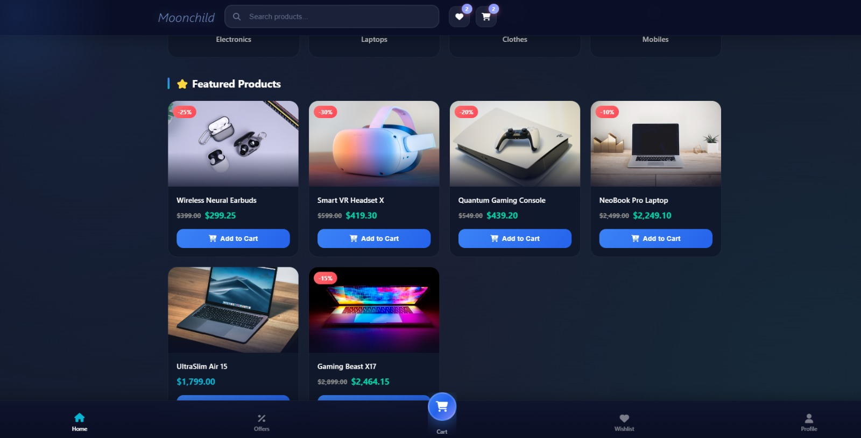

The image shows a dark-themed e-commerce homepage for a store named “Moonchild.”
At the top, there is the store name on the left, a search bar in the center, and wishlist and cart icons on the right with notification badges. Below this, product categories such as Electronics, Laptops, Clothes, and Mobiles are displayed.
The main section is titled “Featured Products.” Several product cards are shown with images, discount badges, product names, original and discounted prices, and “Add to Cart” buttons.

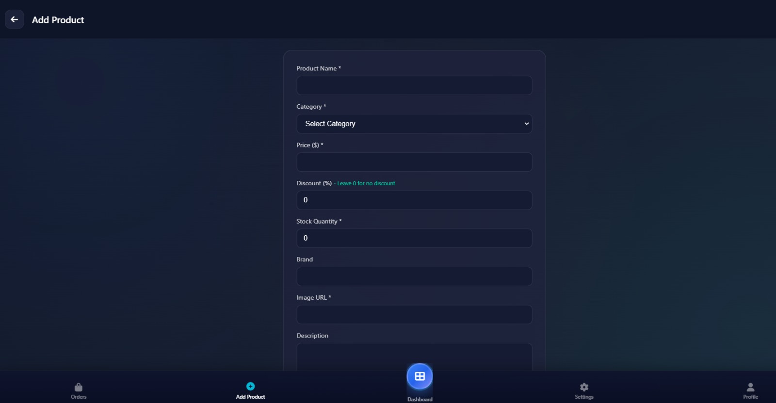

The image shows a dark-themed “Add Product” page from an admin dashboard.
At the top left, there is a back arrow and the title “Add Product.” In the center, a product form is displayed inside a rounded card.

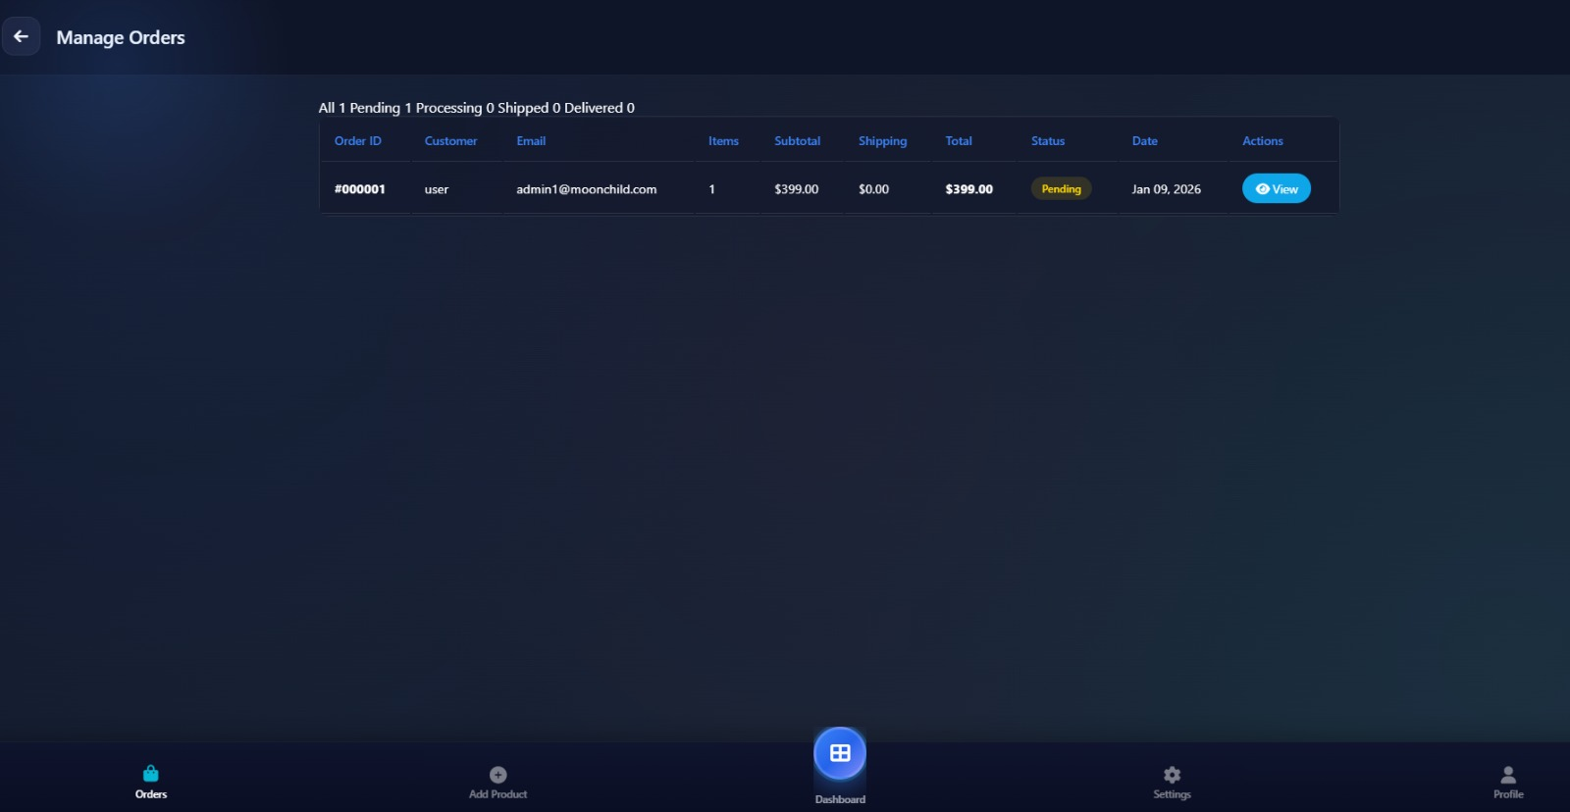

The image shows a dark-themed “Manage Orders” page from an admin dashboard.
At the top left, there is a back arrow and the title “Manage Orders.” Below it, a summary line displays order counts: All 1, Pending 1, Processing 0, Shipped 0, Delivered 0.

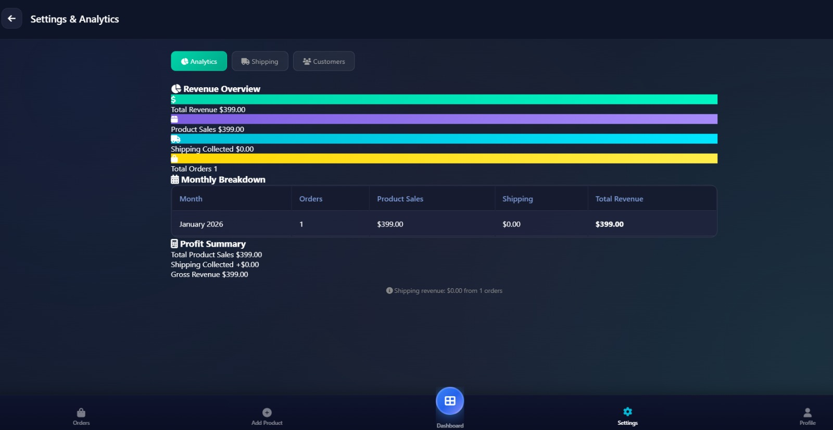

The image shows a dark-themed Settings & Analytics dashboard screen.
At the top left, there is a back arrow and the title “Settings & Analytics.” Below it are three tabs:
- Analytics (selected/highlighted)
- Shipping
- Customers

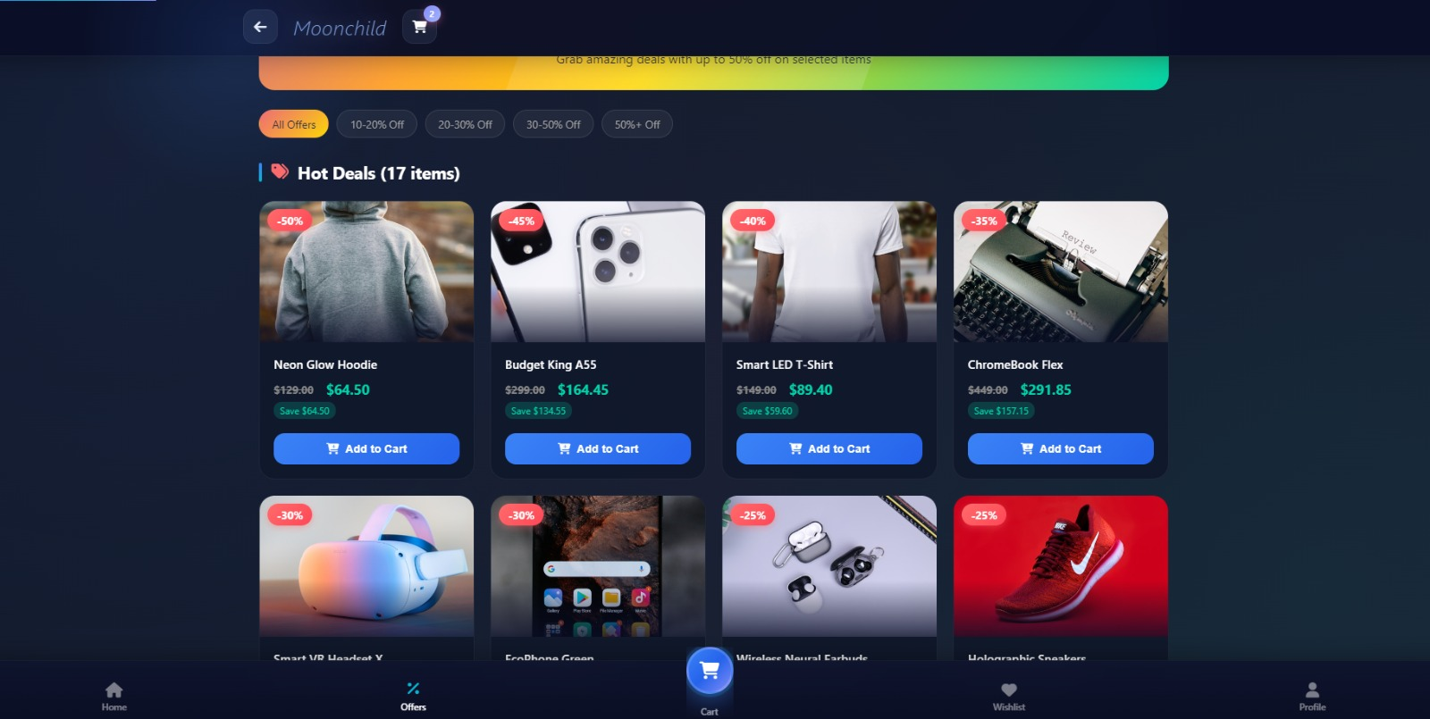

The image shows a dark-themed Moonchild shopping app screen displaying discounted products.
At the top:
- A back arrow on the left
- The store name “Moonchild” in the center
- A shopping cart icon on the right with a small badge showing 2 items
Below is a colorful banner promoting deals (up to 50% off selected items).

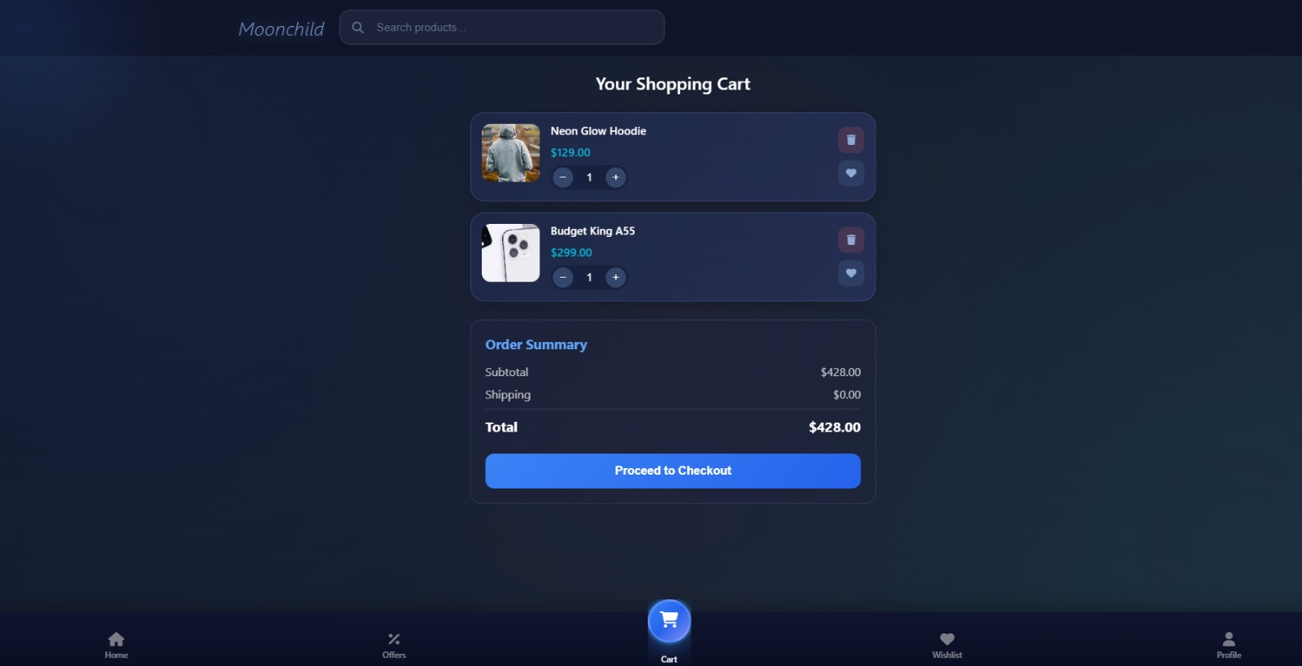

he image shows a shopping cart user interface for an e-commerce platform named Moonchild. The design features a dark theme with a sleek, modern aesthetic.

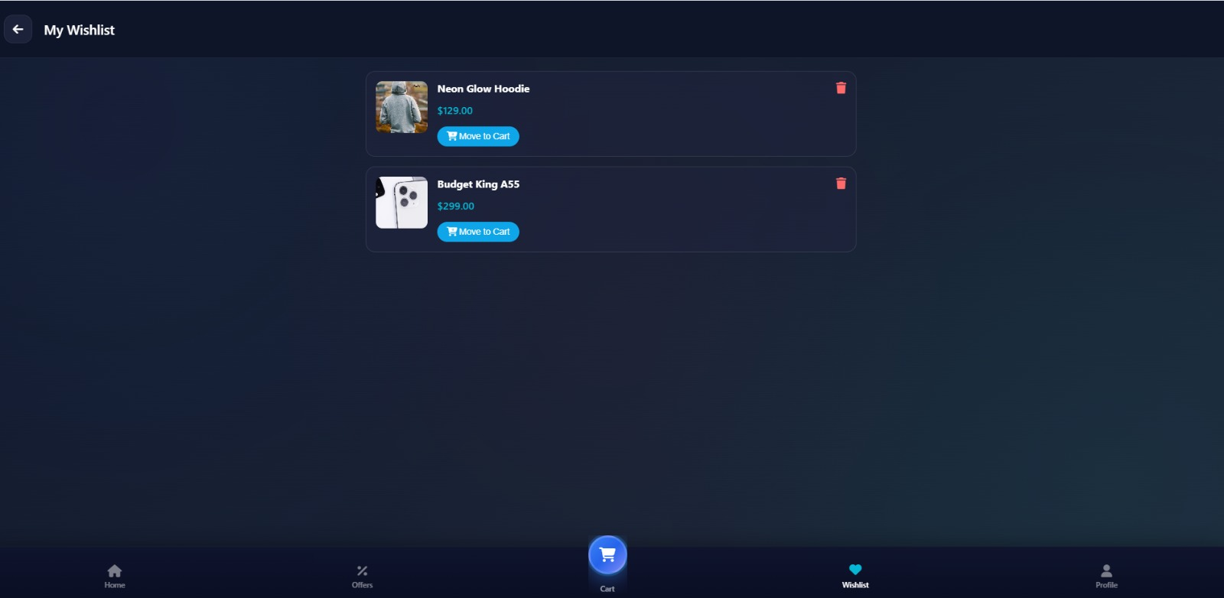

The image displays a wishlist user interface for an e-commerce application, maintaining the dark-themed aesthetic of the previous screen.

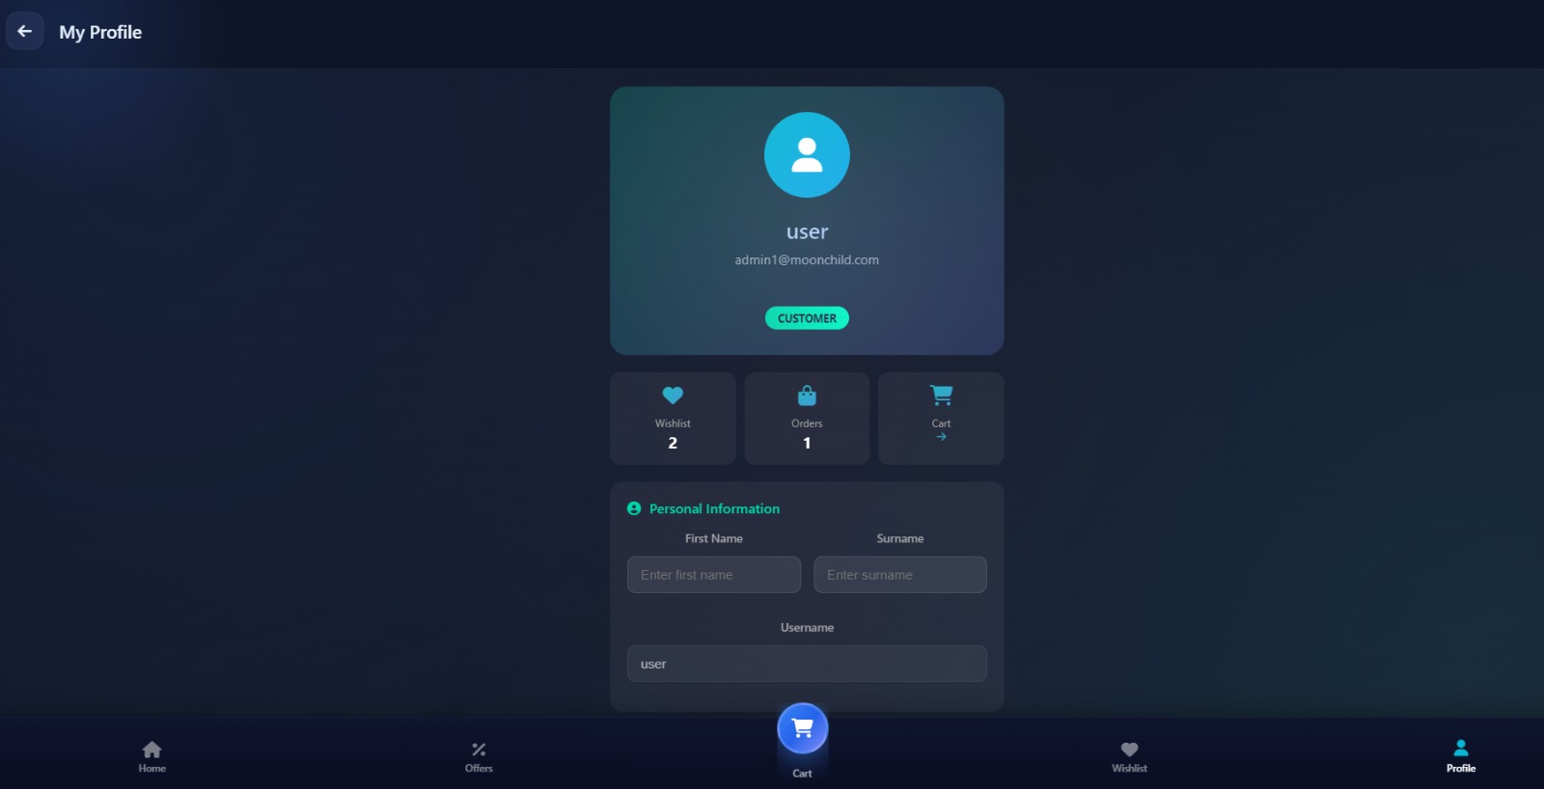

These images showcase the Wishlist and Profile interfaces for the Moonchild application, maintaining a consistent dark aesthetic.

Chapter 9
CONCLUSION

The “Moonchild” E-Commerce System has been successfully designed, developed, and tested. The project achieves its primary objective of providing a robust, user-friendly platform for buying and selling specialized electronic products.
Key Achievements:
* Successfully implemented a secure and scalable architecture using the PHP/MySQL stack.
* Created a seamless user flow from registration to checkout.
* Developed a comprehensive admin panel that simplifies inventory management.
* Bridged the gap identified in the problem statement by providing a dedicated platform for high-tech gadgets.

Limitations:
While the system is functional, it currently relies on a “Cash on
Delivery” or simulated payment method. Real-time integration with banking APIs is simulated for security reasons in this academic scope. Additionally, the recommendation engine is basic, relying on category matching rather than machine learning algorithms.
In conclusion, this project serves as a solid foundation for a scalable e-commerce business. It demonstrates the practical application of software engineering concepts and web development technologies to solve real-world retail challenges.

Chapter 10
FUTURE SCOPE

The current system lays the groundwork for a sophisticated e-commerce platform. Future enhancements can elevate “Moonchild” to an enterprise-level application:

- AI-Powered Recommendations:
integreate Machine Learning algorithms to analyze user behavior and suggest products based on browsing history and purchase patterns.

- Payment Gateway Integration:
implement secure, real-time payment processing using Stripe or PayPal APIs, and potentially cryptocurrency payments to match the futuristic theme.

- Mobile Application:
develop a React Native or Flutter mobile app to tap into the mobile-commerce market.

- Augmented Reality (AR):
given the nature of the products (e.g., VR headsets, furniture), an AR feature allowing users to visualize products in their space would be a valuable addition.

- Chatbot Support: integrate an AI chatbot for 24/7 customer support and order tracking inquiries.

Chapter 11
BIBLIOGRAPHY / REFERENCES

- Luke Welling and Laura Thomson, “PHP and MySQL Web Development”, 5th Edition, Addison-Wesley Professional, 2016.

- Robin Nixon, “Learning PHP, MySQL & JavaScript: With jQuery, CSS & HTML5”, 6th Edition, O’Reilly Media, 2021.

- IEEE Standard 830-1998, “IEEE Recommended Practice for Software Requirements Specifications”.

- W3Schools, “PHP 8 Tutorial”, [Online]. Available: https://www.w3schools.com/php/. [Accessed: 2023].

- PHP.net, “PHP Manual”, [Online]. Available: https://www.php.net/manual/en/.

- Mozilla Developer Network (MDN), “Web Technology for Developers”,
[Online]. Available: https://developer.mozilla.org/.

Chapter 12
APPENDIX

A. Sample Database Configuration
-- Database Name: moonchild_db
-- User: root
-- Host: localhost
CREATE DATABASE moonchild_db;
USE moonchild_db;

B. Abbreviations
- PHP: Hypertext Preprocessor
- SQL: Structured Query Language
- HTML: HyperText Markup Language
- CSS: Cascading Style Sheets
- JS: JavaScript
- RDBMS: Relational Database Management System
- IDE: Integrated Development Environment
- XAMPP: Cross-Platform, Apache, MySQL, PHP, Perl

C. Acknowledgement of Tools
The development of this project utilized various open-source tools including Visual Studio Code, XAMPP Server, and Google Chrome Developer Tools.

