OUTPUT FOR THE PYTHON PROGRAMS

1. ROCK,PAPER,SCISSORS,LIZARD,SPOCK

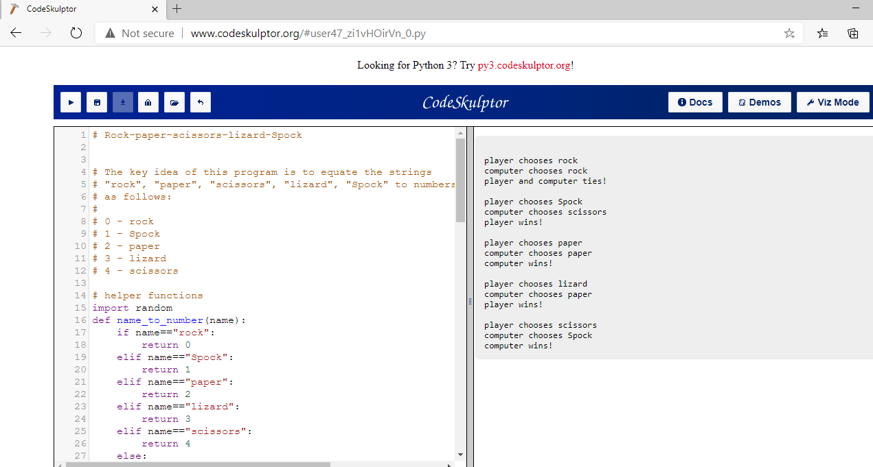

1. 2.GUESS THE NUMBER GAME

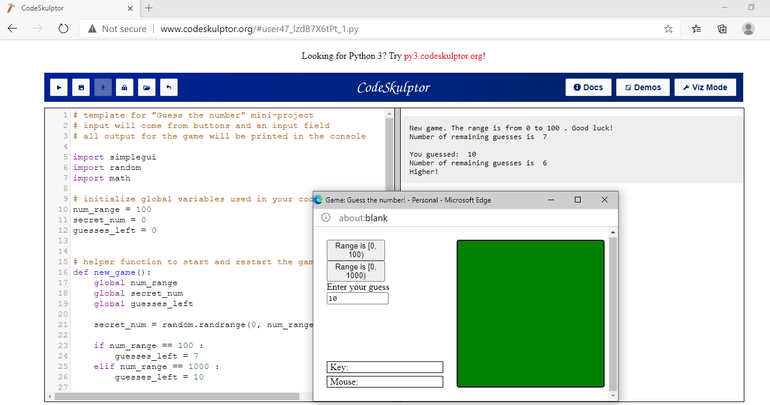

3.STOP WATCH GAME

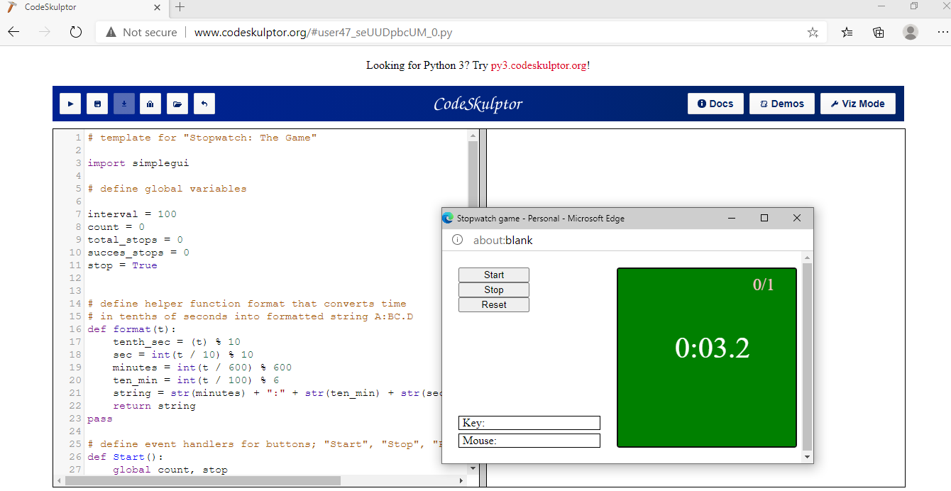

4.ARCADE GAME “PONG”

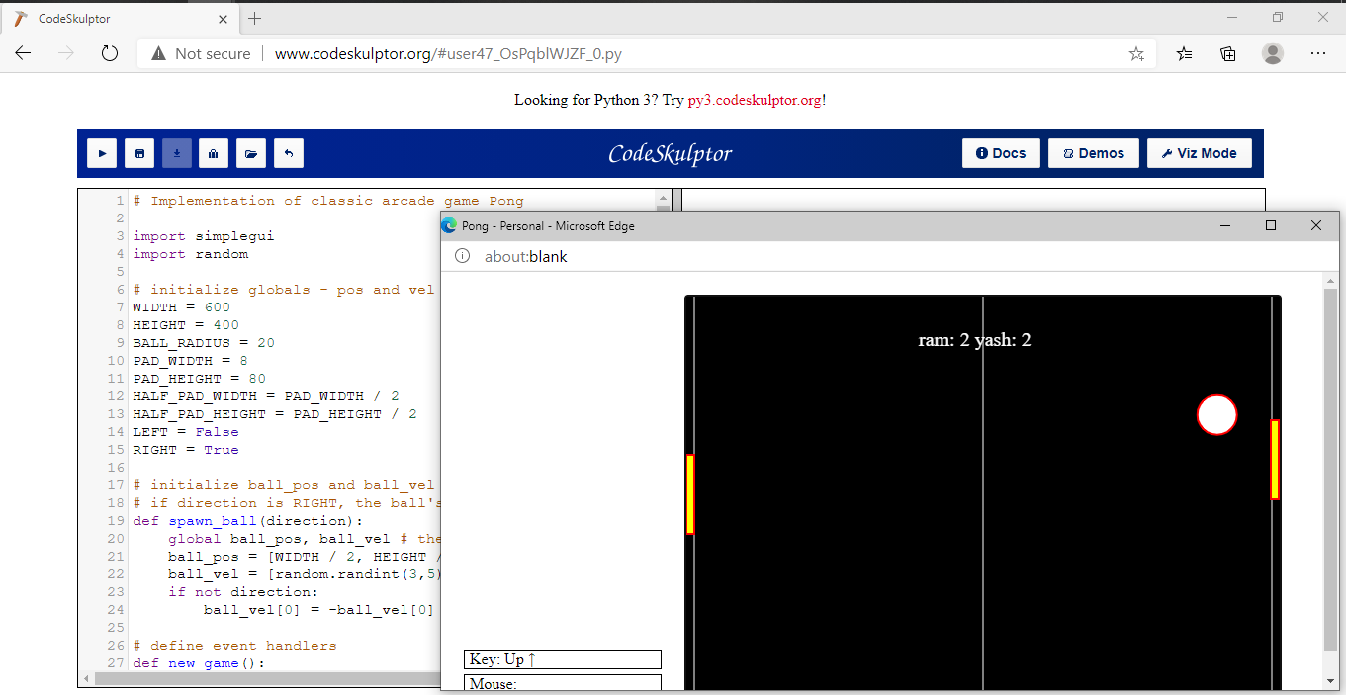

5. MEMORY GAME

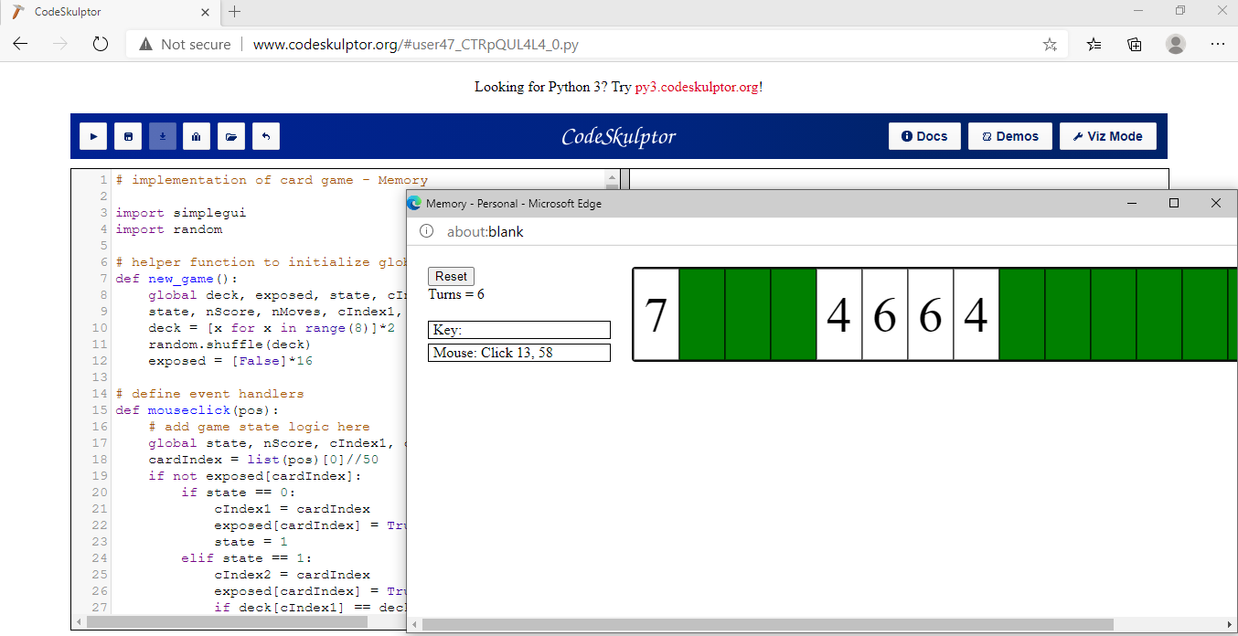

6.BLACKJACK GAME

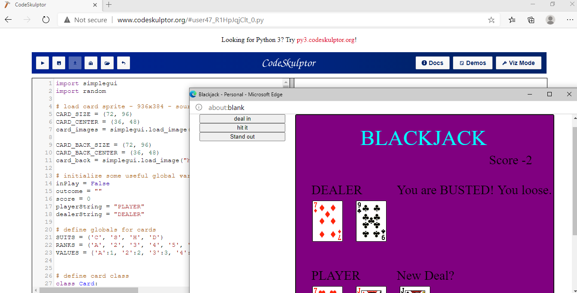

7. SPACESHIP GAME

