**Dissertation**

**On**

**Early Diagnosis of Influenza Using Machine Learning Classification**

By

Raman (20059570019)

Bharat Sharma (20059570040)

Rohan Bhalla (20059570041)

**Submitted as Partial Fulfilment**

**Of**

**B.Sc. (Hons) Computer Science - VI Semester**



Department of Computer Science,

Aryabhatta College,

University of Delhi

New Delhi – 110021

April, 2023

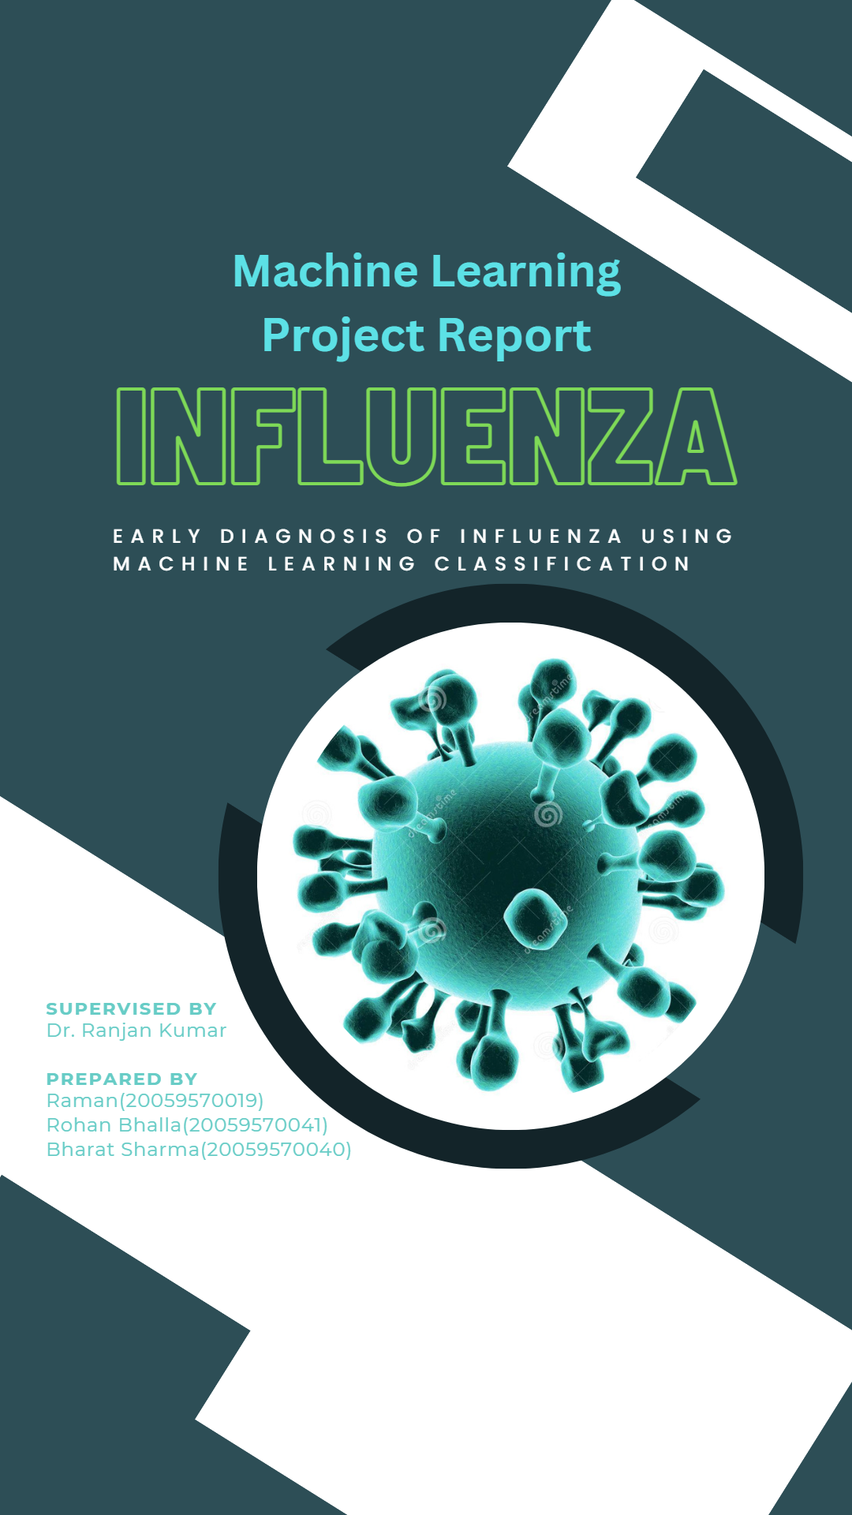

Acknowledgement

Undertaking the project "Early Diagnosis of Influenza Using Machine Learning Techniques - A Predictive Analysis Approach" has been an enriching and engaging experience. Over the course of four months, we had the opportunity to work with various supervised machine learning models and predictive analysis techniques, thereby enhancing our skills and knowledge in this field.

We extend our gratitude to Dr. Ranjan Kumar, who has been a constant source of guidance and support throughout the project. Without his valuable inputs and advice, completing this project successfully would not have been possible.

We are thankful to the Computer Science Department at Aryabhatta College for providing us with the opportunity to undertake this project. Our project coordinator, Dr. Ranjan Kumar, deserves a special mention for his unwavering support and encouragement, which enabled us to work efficiently as a team and tackle any challenges that arose.

Additionally, we would like to express our appreciation our seniors for their insightful discussions and valuable suggestions during this demanding yet fulfilling project. Their inputs and feedback have been instrumental in shaping the project and improving its quality.

Overall, this project has been a valuable learning experience, and we are grateful to all those who have contributed to its successful completion.

Raman (20059570019)

Bharat Sharma (20059570040)

Rohan Bhalla (20059570041)

Certificate

I am pleased to certify that Raman, Bharat Sharma, and Rohan Bhalla have successfully completed the project entitled "Early Detection of Influenza using Machine Learning Techniques: A predictive analysis approach," under my supervision. The project has been submitted as per the requirements of the Lab-based on Data Science of B.Sc. (H) Computer Science, VI Semester.

During the course of the project, Raman, Bharat Sharma, and Rohan Bhalla have demonstrated their proficiency in utilizing various machine learning techniques and predictive analysis methods to analyse the data and identify patterns that could be used to predict the onset of influenza.

As the project supervisor, I have had the privilege of working closely with the team and have been impressed with their commitment, dedication, and enthusiasm. They have shown a high level of professionalism and competence throughout the project, completing all tasks within the stipulated time and with exceptional quality.

I believe that the project submitted by Raman, Bharat Sharma, and Rohan Bhalla will be a valuable contribution to the field of data science and machine learning. I congratulate them on their success and wish them all the best for their future endeavours.

Raman (20059570019)

Bharat Sharma (20059570040)

Rohan Bhalla (20059570041)

Dr. Ranjan Kumar (Supervisor)