1-1 Logic

命题是：①陈述句。②立意明确。③有常数真值。

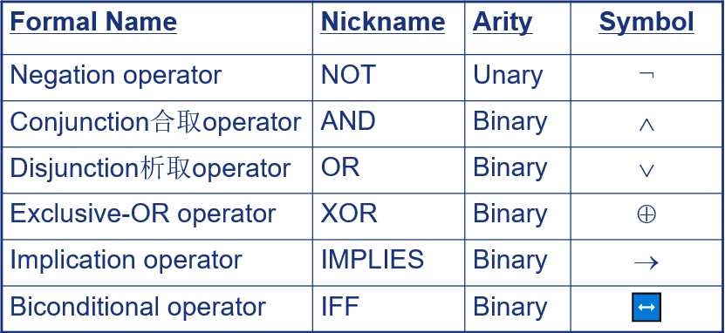

* “*p* implies *q*”
* “if *p*, then *q*”
* “if *p*, *q*”
* “when *p*, *q*”
* “whenever *p*, *q*”
* “*q* if *p*”
* “*q* when *p*”
* “*q* whenever *p*”
* “*p* only if (只有) *q*”
* “*p* is sufficient for *q*”
* “*q* is necessary for *p*”
* “*q* follows from *p*”
* “*q* is implied by *p*”
* “*q* unless (除非)￢*p*”
* 你会挂科的，除非你努力学习。
* 你会变胖的，除非你现在开始减肥。

Some terminology, for an implication *p* → *q*:

* Its *converse* is 逆蕴含: *q* → *p*.
* Its *contrapositive* 逆反式: ¬*q* → ¬ *p.*
* Its *Inverse 倒置*: ¬ *p* → ¬ *q.*

1-3 Propositional Equivalence

一个取值范围为{T, F}的记号Q, 如果没有确切的含义或者值随情景而变化, 那么就是一个命题公式或者命题变量.

如果Q有确切的含义, 例如Q =“今天下雨”, 那么Q就是一个命题.

命题变量（公式）与命题的区别: 真假值是否固定．

A *tautology* Q（x，y）重言式/永真式 is a compound proposition that is **true** *no matter what* the truth values of its atomic propositions x，y are!

一条重言式/永真式是一个无论其子命题x,y的真值为真/假，其真值都为真的复合命题。

A *contradiction* Q（ x，y ）*矛盾*式/永假式is a compound proposition that is **false** no matter *what* the truth values of its atomic propositions x，y are!

一条矛盾式/永假式是一个无论其子命题x,y的真值为真/假，其真值都为假的复合命题。

¬ *p*∨*q* ⇔ *p* → *q*

***Equivalence Laws - Examples***

* *Identity同一律*: *p*∧**T** ⇔ *p p*∨**F** ⇔ *p*
* *Domination零一律*: *p*∨**T** ⇔ **T** *p*∧**F** ⇔ **F**
* *Idempotence等幂律*:*p*∨*p* ⇔ *p p*∧*p* ⇔ *p*
* *Double negation双否律:* ¬¬*p* ⇔ *p*
* *Commutativity: p*∨*q* ⇔ *q*∨*p p*∧*q* ⇔ *q*∧*p*
* *Associativity 结合律:* (*p*∨*q*)∨*r* ⇔ *p*∨(*q*∨*r*) (*p*∧*q*)∧*r* ⇔ *p*∧(*q*∧*r*)
* *Distributive*: ***p*∨(*q*∧*r*) ⇔ (*p*∨*q*)∧(*p*∨*r*)**  
   ***p*∧(*q*∨*r*) ⇔ (*p*∧*q*)∨(*p*∧*r*)**
* *De Morgan’s*:  
   ¬**(*p***∧***q*)** ⇔¬***p*** ∨¬***q*** ¬**(*p***∨***q*)** ⇔¬***p*** ∧¬***q***
* *Trivial tautology/contradiction*:  
   ***p* ∨ ¬*p* ⇔ T *p* ∧ ¬*p* ⇔ F**

***Logical Equivalence Involving Implications***

* ***p***→ ***q***⇔¬***p*** ∨ ***q p***→ ***q***⇔¬***q*** →¬***p***
* ***p*** ∨ ***q*** ⇔¬***p*** → ***q p*** ∧ ***q*** ⇔¬(***p*** →¬***q***)
* ¬(***p*** → ***q***) ⇔ ***p*** ∧¬ ***q***
* (***p*** → ***q***) ∧(***p*** → ***r***) ⇔ ***p*** →(***q*** ∧ ***r***)
* **p是2个结论的充分条件**
* (***p*** → ***r***) ∧(***q*** → ***r***) ⇔(***p*** ∨ ***q***)→ ***r***
* **r有2个独立的充分条件**
* (***p*** → ***q***) ∨(***p*** → ***r***) ⇔ ***p*** →(***q*** ∨ ***r***)
* **p至少是1个结论的充分条件**
* (***p*** → ***r***) ∨(***q*** → ***r***) ⇔(***p*** ∧ ***q***)→ ***r***
* **r的充分条件由2部分构成**
* ***p***↔ ***q***⇔(***p*** → ***q***) ∧(***q*** → ***p***)
* ***p***↔ ***q***⇔¬ ***p***↔¬ ***q***
* ***p***↔ ***q***⇔(***p*** ∧ ***q***) ∨(¬ ***p*** ∧¬ ***q***)
* ¬(***p***↔ ***q***) ⇔ ***p***↔¬ ***q***

Some equivalences can be thought of as *definitions* of one operator in terms of others:

* Exclusive or: *p*⊕*q* ⇔ (*p*∨*q*)∧¬(*p*∧*q*)  
   *p*⊕*q* ⇔ (*p*∧¬*q*)∨(*q*∧¬*p*)
* Implies: *p*→*q* ⇔ ¬*p* ∨ *q*
* Biconditional: *p*↔*q* ⇔ (*p*→*q*)∧ (*q*→*p*)  
   *p*↔*q* ⇔ ¬(*p*⊕*q*)

1-4 Predicates and Quantifiers

**Predicate**

* P(x,y,z)

1. It is a *statement.*
2. It *has some definite meaning.*
3. It has a constant *truth value.*

* 与命题的区别: 真值变化, 随着(x,y,z)变化而变.
* 与命题的联系: 当(x,y,z)赋予常量(abc)时, P(a,b,c)成了命题.

1-5 Nested Quantifiers

* **∀***x* **∃***y* *P*(*x,y*) != **∃***y* **∀***x* *P*(*x,y*)
* **∃***x* **∀***y* *P*(*x,y*) != **∀***y* **∃***x* *P*(*x,y*)

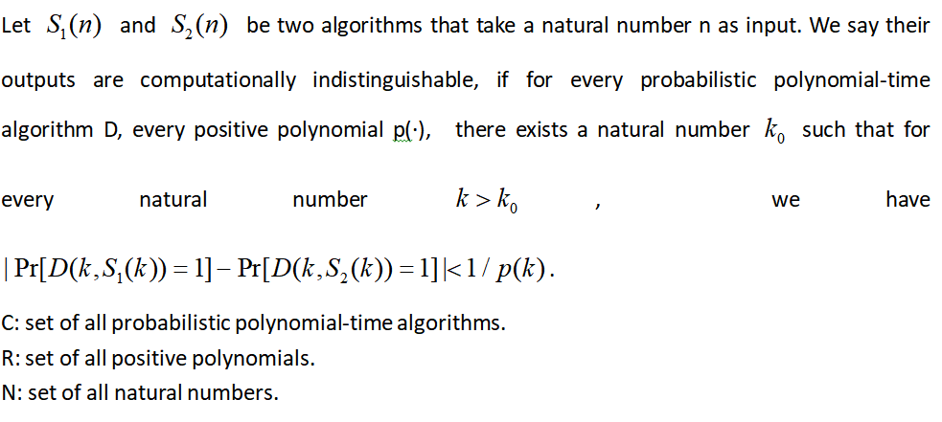

**∀D∈C ∀P(·)∈R ∃Ko∈N ∀k＞Ko :[公式]**

1-6 Rules of Inference

* **Axioms**公理 are the underlying assumptions about mathematical structures. 无需证明
* **Postulates假设前提** are hypotheses of the theorem to be proved.无需证明
* A **conjecture猜测** is a statement whose truth value is unknown. 等待证明.
* A **theorem** is a statement that can be shown to be true.
* A **Lemma引理** is a simple theorem used in the proof of other theorems.
* A **corollary推论** is proposition that can be established directly from a theorem that has been proved.
* A **proof** is that a sequence of statements that form an argument so that the theorem is true.

**Fallacies谬论** are some forms of incorrect reasoning, which will help clarity what makes a correct proof.

**Inference Rules**

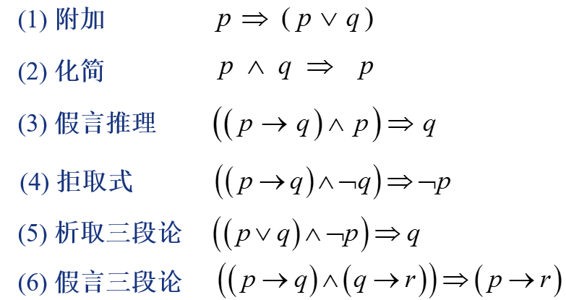

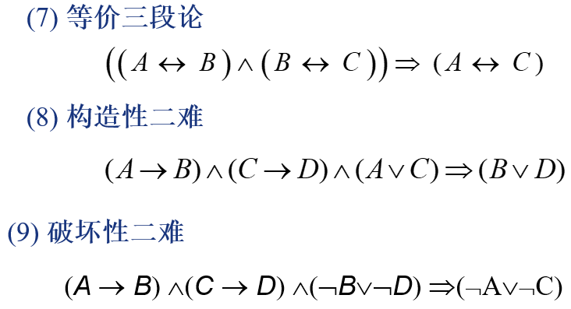

* **How to prove the Inference Rules ?**

**There are 3 different proofs.**

1. **Using truth table to show it .**
2. **Using equivalence rules to show it.**
3. **Prove it by cases.**

$$求证: p⇔q. 有哪些证明思路?$$

**1.利用推理公式进行形式化证明.(重点)**

**p⇒q**

**q ⇒p**

**2.利用真值表证明复合命题(p↔q)=T.(简单粗暴)**

**3.利用公式证明复合命题(p↔q)=T.**

**Rules of Inference for Quantified Statement 此项不理解！！！**

**谓词包含命题. 因为命题可以看作是没有变量的谓词.**

1. **∀ x (C(x) → P(x))**
2. **C(图灵) → P(图灵)**
3. **C(x) → P(x)**

**以上都是谓词逻辑, 但是只有1和2是命题.**

**一般先实例化 ∃, 后实例化∀**

**2.1-2.2 Sets and Set Operations**

* **Sets are ubiquitous无所不在的in computer software systems.**
* **Two sets are *equal* if and only if they have the same elements.**
* **{1, 3, 5} and {3, 5, 1} are equal.**
* **{1, 3, 3, 3, 5, 5, 5, 5} is the same as {1, 3, 5}**

**The Empty Set**

* **We have seen that there exists exactly one empty set, so we can give it a name:**
* **∅ (“the empty set”) is the unique set that contains no elements whatsoever.**
* **∅ = {} = {*x|x≠x*} = ... = {*x|*False}**
* **Any set containing exactly one element is called a *singleton set(单元素集合)***

**Computer Representation of Sets**

**In this representation, the set operators  
“∪”, “∩”, “-” are implemented directly by bitwise OR, AND, NOT!**

**For example, {2,3,5,7} ∪ {1,3,4}**

**= 01101010 ∨ 10110000**

**= 11111010**

**Cartesian Products of Sets**

* + **for finite *A*, *B:* |*A*×*B*| = |*A*||*B*|**
  + **notation extends naturally to *A*1 × *A*2 × … × *An***
  + **the Cartesian product is *not* commutative: *i.e.*, ¬∀*A*∀*B*: *A*×*B=B*×*A*.**

**How to prove *E*1 = *E*2 ?(where the *E*s are set expressions)**

1. **Prove *E*1 ⊆ *E*2 and*E*2 ⊆ *E*1 separately.**

**Use set builder notation & logical equivalences.**

**2. Use a *membership table*. 少用**

**2-3 Functions**

* **If *f*:*A*→*B*, and *f*(*a*)=*b* (where *a*∈*A* & *b*∈*B*), then we say:**
  + ***A* is the *domain* of *f*.**
  + ***B* is the *codomain 伴域* of *f*.**
  + ***b* is the *image* of *a* under *f*.**
  + ***a* is a *pre-image* of *b* under *f.***
    - **In general, *b* may have more than 1 pre-image.**

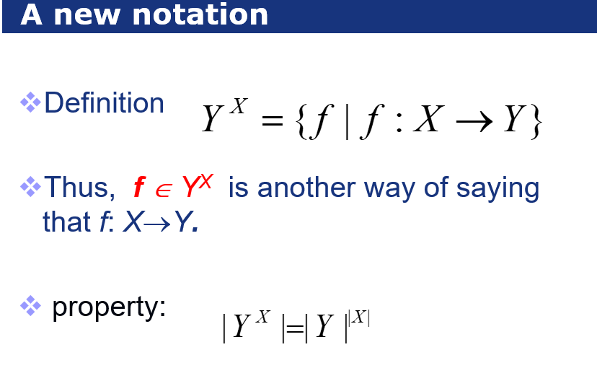

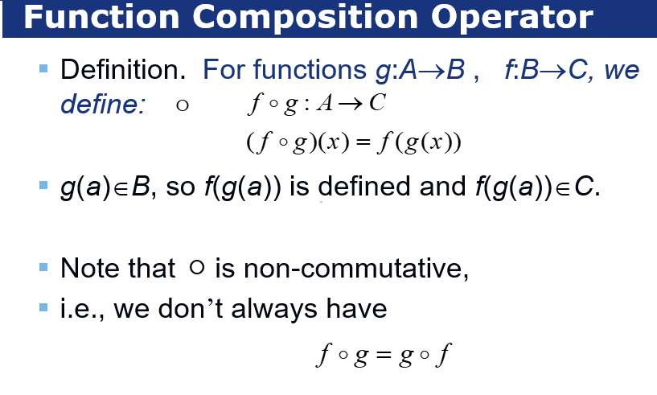

**PPT 44.45.46**

* **For bijections *f:A*→*B*, there exists an *inverse* of *f*, written  *f* −1: *B*→*A***
* **Given any binary operator •:*B*×*B*→*B*, and functions *f*,*g*:*A*→*B*,**
* **we define  
   (*f* • *g*):*A*→*B*    
   ∀*a*∈*A*, (*f* • *g*)(*a*) = *f*(*a*)•*g*(*a*).**
* **+,× (plus,times) are binary operators over R. (Normal addition & multiplication.)**
* **Therefore, we can also “add” and “multiply” *functions* *f*,*g*: R→R:**
  + **(*f* + *g*):R→R, where (*f* + *g*)(*x*) = *f*(*x*)+ *g*(*x*)**
  + **(*f* × *g*):R→R, where (*f* × *g*)(*x*) = *f*(*x*)× *g*(*x*)**
* **In discrete math, we frequently use the following two functions over real numbers:**
  + **The *floor* function向下取整 ⎣·⎦:R→Z,   
    ⎣*x*⎦ :≡ max({*i*∈Z|*i*≤*x*}).**
  + **The *ceiling* function向上取整⎡·⎤ :**

**⎡*x*⎤ :≡ min({*i*∈Z|*i*≥*x*})**

***5-1 Relations and Theirs Properties***

***5-2 n-ary Relations and Their Application***

矩阵 $A^{n}$ 中的 $A_{\text{ij}}$ 代表着从结点i到结点j的路径长度为n的条数。

***5-5 Equivalence Relations***