7.21

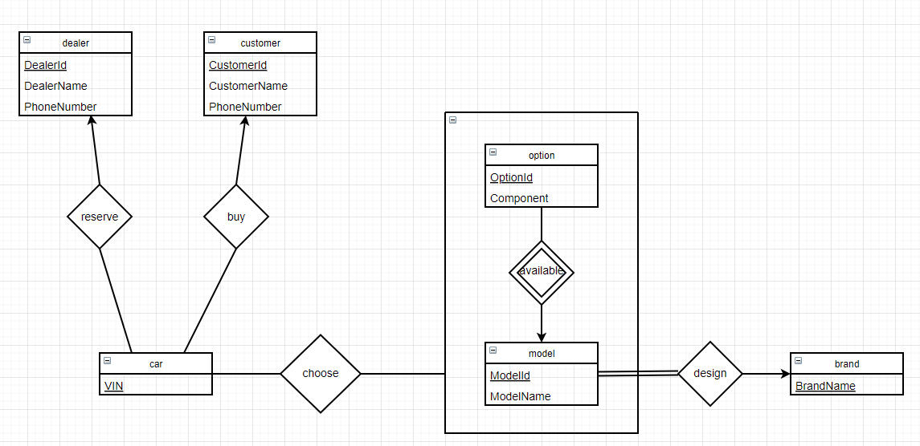

*dealer(DealerId, DealerName, PhoneNumber)*

*customer(CustomerId, CustomerName, PhoneNumber)*

*car(VIN)*

*model(ModelId, ModelName)*

*option(OptionId, Component)*

*brand(BrandName)*

*choose(*

*ModelId, ModelName, OptionId,*

*foreign key BrandName references brand ,*

*foreign key ModelId references model ,*

*foreign key OptionId references option*

*)*

*available(*

*ModelId, OptionId,*

*foreign key ModelId references car,*

*foreign key OptionId references option*

*)*

*design(*

*BrandName, ModelId,*

*foreign key BrandName references brand ,*

*foreign key ModelId references model*

*)*

*reserve(  
VIN, DealerId,*

*foreign key VIN references car*

*foreign key DealerId references dealer,*

*)*

*buy(*

*VIN, CustomerId,*

*foreign key VIN references vehicle,*

*foreign key CustomerId references customer,*

*)*

*7.23*

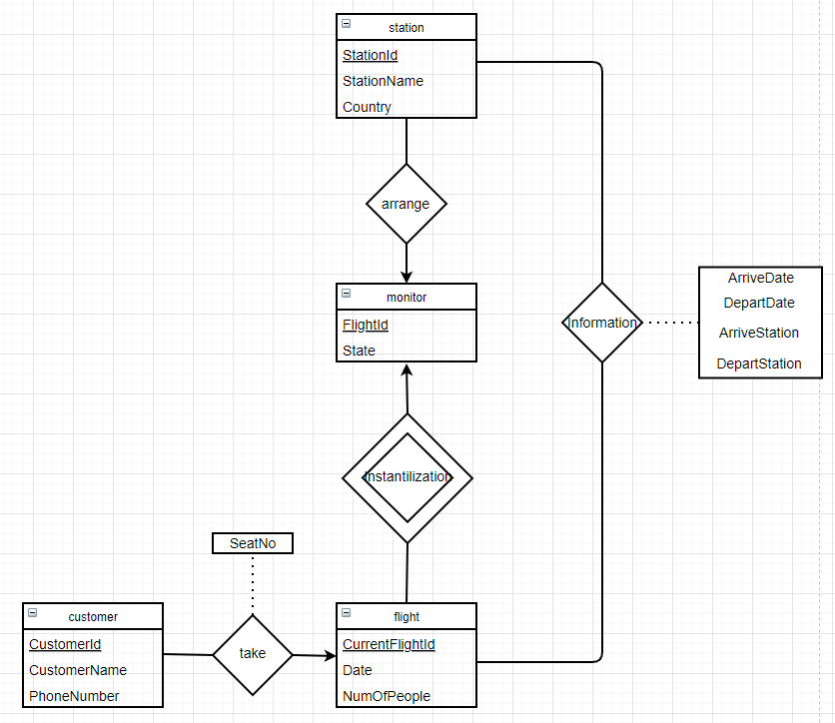

*customer(CustomerId, CustomerName, PhoneNumber)*

*flight(CurrentFlightId, Date, NumOfPeople)*

*monitor(FlightId, State)*

*station(StationId, StationName, Country)*

*take(*

*CurrentFlightId,*

*CustomerId,*

*SeatNo,*

*foreign key CurrentFlightId references flight,*

*foreign key CustomerId references customer*

*)*

*Instantilization(*

*CurrentFlightId,*

*FlightId,*

*No,*

*foreign key CurrentFlightId references flight,*

*foreign key FlightId references monitor*

*)*

*arrange(*

*FlightId,*

*StationId,*

*No,*

*Arriveday,*

*Departday,*

*foreign key FlightId references monitor,*

*foreign key StationId references station*

*)*

*Information(*

*CurrentFlightId,*

*ArriveStationId,*

*DepartStationId,*

*Arrivedate,*

*Departdate,*

*foreign key CurrentFlightId references flight,*

*foreign key StationId references station*

*)*

*ABC Banks.*

