

软件需求分析设计与建模
实验二
实验报告

姓名： | 张家健
班级： | 2020级软件工程2班
学号： | 202030482478

二〇二二年五月

实验目的
- 掌握面向对象的分析与设计的基本方法和基本步骤；
- 熟练运用UML的各种视图和图对实际需求描述进行系统分析和设计。

实验原理与预习内容
- 实验原理：面向对象系统分析与设计的基本理论与原理；统一建模语言UML的基本理论与原理。
- 预习内容：UML的五大视图和九种图。

实验环境
- 软件环境：StarUML 5.0或以上版本；Windows 7或以上版本。
- 硬件环境：CPU 2.0GHz或以上；4G以上内存；80G以上硬盘空间。

实验内容
请根据以下文字描述，完成题目要求的图。
Suppose we are planning an offline poke game system with a name of CDDGame（锄大地）. A player and 3 robot playmates play the game with 52 cards (without 2 jokers) on a board. A player could select 3 robot playmates and start to play the game. Also, a player could exit the game or register himself by giving a nick name, select a nick name, set the background music to initiate the game.
When a player and the 3 selected robots play the game, each of them is distributed with 13 cards at random. When the player takes the turn to show cards, the player selects a group of cards and show it. The group of cards should be validated by the type of card, which is established by the rules of CDD game. When one of the players has showed all of the cards on hand, the game is over and the system will calculate the score of each player according to the game rules. Players can decide to leave or continue the game. If a player leaves the game before the end of the game, he or she would be given penalty. All of the registered players are ranked with the scores they have won.
Please draw the following diagrams with the approach of OOA and OOD.
- Draw a UML use case diagram for the system.
- Draw an activity diagram for the use case of play game.
- Draw a UML sequence diagram to assign the responsibilities to objects for the scenario of starting game.
- Give a state diagram for the object of player.
- Give a VOPC diagram(View Of Participating Classes Class Diagram, 参与类类图, http://www.doc88.com/p-1992503566594.html(P30以后), https://wenku.baidu.com/view/286bce04ec3a87c24028c4ed.html) to realize the activity of starting game.

Use Case Diagram
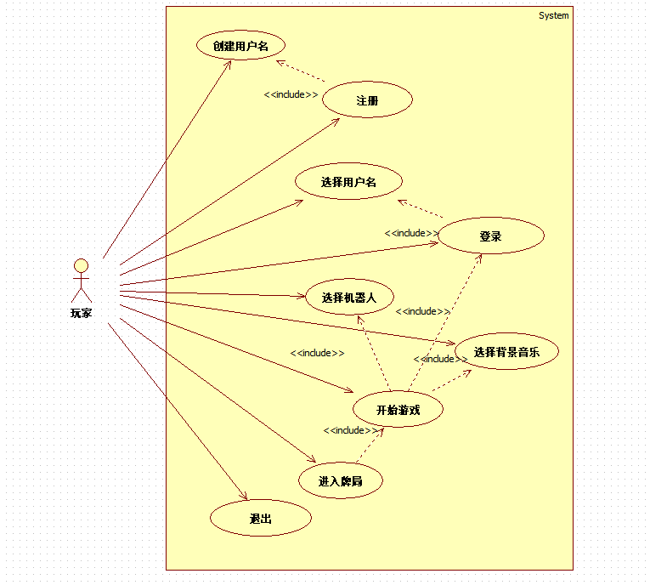实验结果图4.1

Activity Diagram
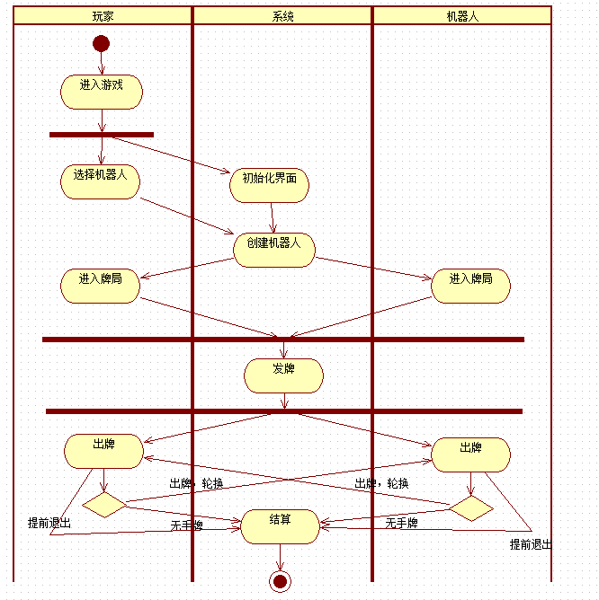实验结果图4.2

Sequence Diagram
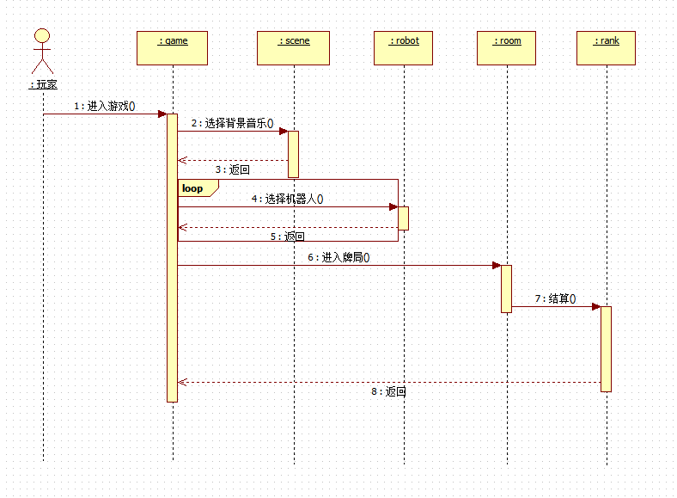
实验结果图4.3

State Diagram
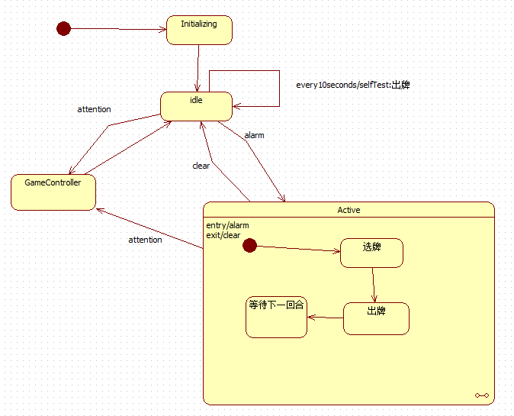实验结果图4.4

VOPC Diagram
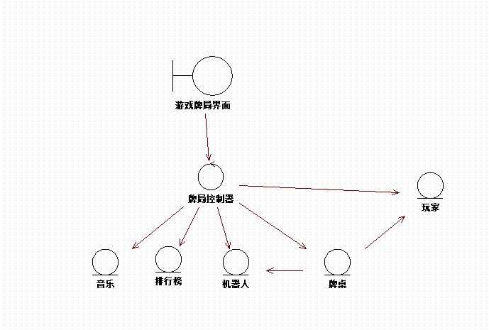实验结果图4.5

实验总结
本次实验令我受益匪浅，相比于上次的照葫芦画瓢，这次实验是完全自主创作，通过每一个uml图，我更加体会到了对每种图在设计过程中的重要性，通过各种图的呈现，我们可以让设计团队更能统一理念、紧密设计之间的联系。这一次的自主创作也让我加深了对各种箭头的理解，在何种情况下用何种箭头来表示两个对象之间的关系，每种图都有其独特的表述方式，能帮助设计团队各方各面统一理念，最重要的，是设计者本身的画图构思，如何更好地表达出自己的想法是重中之重。

