Name | Ramesh
Birth Date | July 18, 1983 Monday
Birth Time | 6:35 AM IST (+05:30)
Place of Birth | Kumbakonam, Tamil Nadu, India
Ayanamsa | Lahiri
​ Change Birth Details
Given below is the panchangam for the input date of birth.
Weekday | Monday
Nakshatra | Swati 2nd Pada  Jul 17, 07:39:55 PM to Jul 18, 08:06:52 PM
Tithi | Navami (Shukla Paksha )
Yoga | Sadhya
Karana | Balava
Your Birth Chart (Jathaga Kattam):
Given below is the South Indian style birth chart which shows the 12 Rasi and the position of planetary bodies in each rasi.
Rasi Chart
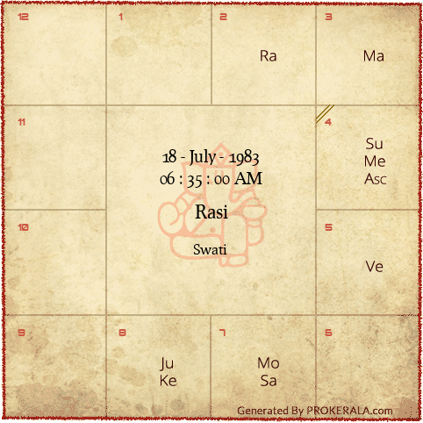
Navamsa Chart
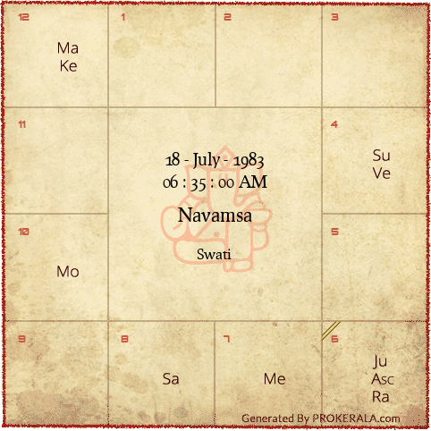
Planet Positions
The table below shows the position of planets at the date, time and place of birth as entered in the input form.
Planets | Positions | Degrees | Rasi | Rasi Lord | Nakshatra | Nakshatra Lord
Sun | 91° 14' | 1° 14′ | Karka | Moon | Punarvasu | Jupiter
Moon | 192° 40' | 12° 40′ | Tula | Venus | Swati | Rahu
Mercury | 100° 45' | 10° 45′ | Karka | Moon | Pushya | Saturn
Venus | 131° 6' | 11° 6′ | Simha | Sun | Magha | Ketu
Mars | 78° 55' | 18° 55′ | Mithuna | Mercury | Ardra | Rahu
Jupiter | 217° 38' | 7° 38′ | Vrischika | Mars | Anuradha | Saturn
Saturn | 184° 19' | 4° 19′ | Tula | Venus | Chitra | Mars
Ascendant | 98° 58' | 8° 58′ | Karka | Moon | Pushya | Saturn
Rahu | 59° 44' | 29° 44′ | Vrishabha | Venus | Mrigashirsha | Mars
Ketu | 239° 44' | 29° 44′ | Vrischika | Mars | Jyeshta | Mercury
Other astrological information about the date of birth:
Tamil date | Aadi 2, Rudhirodgari
Nakshatra | Swati 2nd Pada
Weekday | Monday
Tithi | Navami (Shukla Paksha )
Yoga | Sadhya
Karana | Balava
Nakshatra Lord | Rahu
God | Vayu, Pawan**
Animal Sign | Buffalo
Rasi | Tula
Rasi Lord | Venus
Ascendant | Karka
Ascendant Lord | Moon
Tree | Arjun Tree
Ganam | Deva
Bird | Crow
Yoni | Male
Gothram | Mareechi
Bhutham | Fire
Sunrise | 06:01 AM
Sunset | 06:35 PM

Your Vimshottari Dasha Details
Vimshottari dasha is the most important and most supreme dasha as per vedic astrology. There are 9 dashas divided over a period of 120 years. Each dasha has a ruling planet and the life of a person is directly influenced by the nature of his/her ruling planet governing a particular dasha. The first Maha dasha is determined by the position of the natal moon in a given nakṣatra.
Dasa Balance : 9 years, 10 months and 23 days
Given below is the start time and end time of various mahadashas
Mahadasha | Start | End
Rahu | 11-Jun, 1975 | 11-Jun, 1993
Jupiter | 11-Jun, 1993 | 11-Jun, 2009
Saturn | 11-Jun, 2009 | 10-Jun, 2028
Mercury | 10-Jun, 2028 | 11-Jun, 2045
Ketu | 11-Jun, 2045 | 10-Jun, 2052
Venus | 10-Jun, 2052 | 10-Jun, 2072
Sun | 10-Jun, 2072 | 11-Jun, 2078
Moon | 11-Jun, 2078 | 10-Jun, 2088
Mars | 10-Jun, 2088 | 11-Jun, 2095

