SATYAM BHARDWAJ
5
CSE
3rd year

1.
public class ToString{
String d_name;
int rating;
String model_name;
int price;
public ToString(String d_name, int rating, String model_name, int price){
this.d_name = d_name;
this.rating = rating;
this. model_name= model_name;
this.price = price;
}
public String toString(){
return (d_name+" "+ model_name+" "+ rating+" "+ price);
}
public static void main(String[] args)
{
ToString spec = new ToString("Samsung", 5, "M_31", 20000);
System.out.println(spec);
}
}
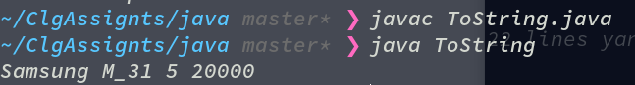

2.
class Stud{
String name;
String dept;
int year;
int std_id;
Stud(String name, String dept, int year, int std_id){
this.name = name;
this.dept = dept;
this.year = year;
this.std_id = std_id;
}
public String toString(){
return (name+" Department: "+ dept+" Year:"+ year+" Id:"+ std_id);
}
}

public class ArrObj{
public static void main(String args[]){
Stud[] arr;

arr = new Stud[5];

arr[0] = new Stud("Satyam Bhardwaj", "CSE", 3, 3422);
arr[1] = new Stud("Ramesses", "CSE", 3, 5422);
arr[2] = new Stud("Krishnakant", "ECE", 4, 3522);
arr[3] = new Stud("Kewal", "MEch", 30, 33422);
arr[4] = new Stud("Rishav", "ELE", 23, 3998422);
System.out.println(arr[0]);
System.out.println(arr[1]);
System.out.println(arr[2]);
System.out.println(arr[3]);
System.out.println(arr[4]);
}
}

