Satyam Bhardwaj
Roll 5
CSE
3rd year

1.
interface Vehicle{
void gear(int g);
void speed(int s);
void brakes(int b);
}

class Bike implements Vehicle{
int gear;
int speed;
public void gear(int g){
gear = g;
}

public void speed(int ss){
speed = speed + ss;
}

public void brakes(int b){
speed = speed - b;
}

public void printstatus(){
System.out.println("Speed = "+speed+" Gear no. = "+gear);
}
}

class Car implements Vehicle{
int gear;
int speed = 0;
public void gear(int g){
gear = g;
}
public void speed(int s){
speed = speed + s;
}
public void brakes(int b){
speed = speed - b;
}

public void printstatus(){
System.out.println("Speed = "+speed+" Gear no. = "+gear);
}
}

class Vstatus{
public static void main(String[] args){
Bike ninja = new Bike();
Car tesla = new Car();
System.out.println("For the bike");
ninja.gear(1);
ninja.speed(20);
ninja.brakes(10);
ninja.printstatus();

ninja.gear(4);
ninja.speed(70);
ninja.brakes(10);
ninja.printstatus();
System.out.println("For the car");
tesla.gear(1);
tesla.speed(20);
tesla.brakes(10);
tesla.printstatus();

tesla.gear(4);
tesla.speed(150);
tesla.brakes(10);
tesla.printstatus();
}
}
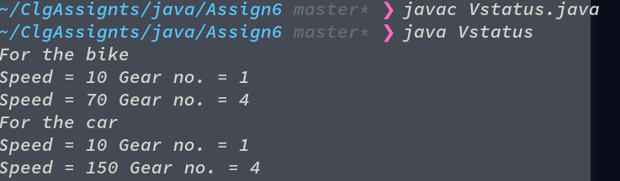
2.

interface Intaface{
Intaface(){
System.out.println("This can't be printed");
}
}
public class Noconst implements Intaface{
public static void main(String[] args){
Noconst obj = new Noconst();
}
}

}

3.
1. What is the default nature of a member and data declare in an
interface.
=> The methods declared are by default abstract (only method signature, no body), and data declared are final and static.

"""Interface variables are static because Java interfaces cannot be instantiated in their own right; the value of the variable must be assigned in a static context in which no instance exists. The final modifier ensures the value assigned to the interface variable is a true constant that cannot be re-assigned by program code."""

2. Can we declare an Interface with “abstract” keyword?
=> Yes, but every interface is implicitly abstract. This modifier is obsolete and should not be used in new programs.

3. Can interfaces have constructors?
=> No, interfaces cannot have a constructor in Java.

