Satyam Bhardwaj

5, CSE

3rd year

1.

class Cla{

public static void main(String args[]){

for(int i=0; i<args.length; i++)

System.out.println(args[i]);

}

}

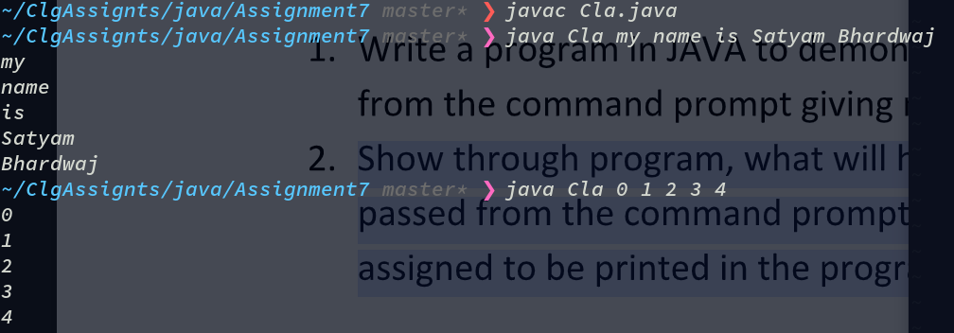

2.

class Warg{

public static void main(String args[]){

for(int i=0; i<args.length; i++)

System.out.println("Argument "+i+" = "+args[i]);

System.out.println("Argument 7 = "+args[7]);

}

}

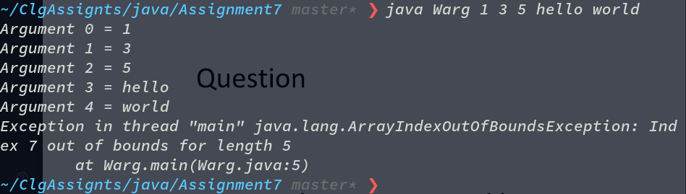

1. What is command line argument in JAVA?

=> The java command-line argument is an argument that is passed at the time of running the java program.

2. What is the type of argument accepted in JAVA?

=> Arguments are passed as Strings. So we can convert it to numeric or another format easily.