SATYAM BHARDWAJ

CSE, 7

3rd year

1

public class RethrowException {

public static void test1() throws Exception {

System.out.println("The Exception in test1() method");

throw new Exception("thrown from test1() method");

}

public static void test2() throws Throwable {

try {

test1();

} catch(Exception e) {

System.out.println("Inside test2() method");

throw e;

}

}

public static void main(String[] args) throws Throwable {

try {

test2();

} catch(Exception e) {

System.out.println("Caught in main");

}

}

}

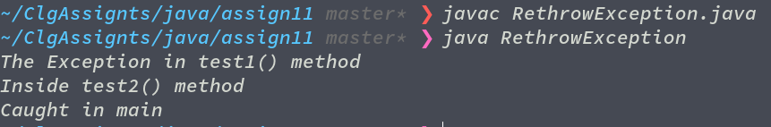

2

import java.util.Scanner;

public class Student {

int m;

public void setMarks(int marks) {

if(marks < 0 || marks > 100)

throw new IllegalArgumentException(Integer.toString(marks));

else

m = marks;

}

public static void main(String[] args) {

Scanner scan = new Scanner(System.in);

System.out.println("Enter an integer: ");

int marks = scan.nextInt();

Student s1 = new Student();

s1.setMarks(marks);

System.out.println(s1.m);

Student s2 = new Student();

s2.setMarks(marks);

System.out.println(s2.m);

}

}

