**Solar-Peltier Coupled Water**

**Purification System**



**Undergraduate Project**

**Department of Mechanical Engineering**

**IIT Kanpur**

**Project Supervisor**

Dr. Sameer Khandekar

**Group 18**

Avinash Kumar (150169)

Atul Bimbrahw (150162)

Rahul Kumar (150546)

**DESIGN CALCULATIONS**

**Objective:**

Fresh Water is a major demand for human existence as it is a vital component for survival. Of the Earth’s total surface area, only 1% contains water with most of it being saline water. With a population of 7.6 billion (and increasing) demanding for fresh water, it is someday going to end. We need an effective system/equipment to deal with this problem.

The solution we are proposing is a **Solar-Peltier Coupled Water Purification System** and we are now going to talk about how it is the best solution to this vital problem. With Peltier materials becoming cheaper and Solar PV also catching up very fast on commercial levels. We can elegantly couple these two fast emerging technologies to make pure water and package the unit as a modular system which can be scalable to larger sizes.

There are existing large water purification plants in operation worldwide however, for several applications, small modular plants are also needed (decentralized production). Specific advantages of this system will be:

* Uses only renewable source of energy for fresh water extraction
* Economically viable for any individual or in a household
* De-centralized, passive and small (integrated) in size
* Less bulky and have no moving parts

**Methodology:**

Less hot but humid air

Impure water from different sources

Hot

Dry air

Cold Dry air

Condensation

Peltier Element

Solar PV

Porous structure over which the air will pass through

Drinkable water

Atmospheric Air

Now we will look at different components of the Solar-Peltier Coupled Water Purification System and understand the functions they perform:

1. Peltier Effect 🡪 Performs Heating and Cooling of the air
   * When potential is given across the junctions of a Peltier element, it generates temperature difference and vice versa
   * This can be used to create a refrigerator that is compact and has no circulating fluid or moving parts
   * Such refrigerators are useful in applications where their advantages outweigh the disadvantage of their very low efficiency
2. Evaporation Slab 🡪 Enhances the evaporation of dirty water
   1. When the hot dry air passes through this slab the dirty water evaporates

**Calculation:**

Area of duct = 10 x 13 cm2 ; Fan = 12 × 12 cm2 ; Air flow = 0.04 m3/s

Fin thickness = 2 mm ; Gap = 5 mm

No. of fins = n = 13/0.7 = 18 fins

Now,

**Re =** [Reynolds Number between two fins]

ρ = = 1.15 kg/m3 ; v = = 80 m/s ; D = = = 17 cm

Re = = 864088 (Turbulent flow)

So,

**Nu =**  [Nusselt Number for air flowing through duct]

**Nu = (f/2)(Re – 1000)** [Because Pr=1]

Now, the friction factor

f = 0.00128 + 0.1143 ; f = 2.9 × 10-3

Therefore,

**Nu = 1255.09**

Now we know,

hL/k = Nu [Here, h & k are properties of air]

i.e **hL = 31.37 W/mK**

**Power of Peltier Module,**

**=** = = 104 W [which we now approximate to 100W]

Now, we se

h = 100 w/m2k, L = 31.3 cm, Q = 100W

Fin width = 2 mm, n = 18 fins; Ac = 0.313 × 0.002 = 6.26×10-4 m2 ; Perimeter = 2×0.315 = 0.63 m

a = (hp/kA)1/2 = ( )1/2 = 22.16

Now, we calculate Heat Flow rate

= 18 × (Tb - T∞) tanh(aL) + 18×(Tb - T∞) h (0.5×0.313/100)

= 18 × [× tanh(22.16×0.1)× (Tb-T∞)]

+ 18 × (Tb-T∞) × (100×0.5×0.313/100)

= (Tb-T∞)[49.98 + 2.817]

= 52.8 × (Tb - T∞)

Now we take into account the factor of safety,

**ns × = 52.8 × (Tb - T∞)** [**ns** to take into account the loss in base temperature]

ns × = (80 - T∞)

ns × (1.89) = (80 - T

take ns = 1.5

**T∞ = 77.2 °C** [Maximum temperature attainable by air]

**Representing the process on the Psychrometric chart:**

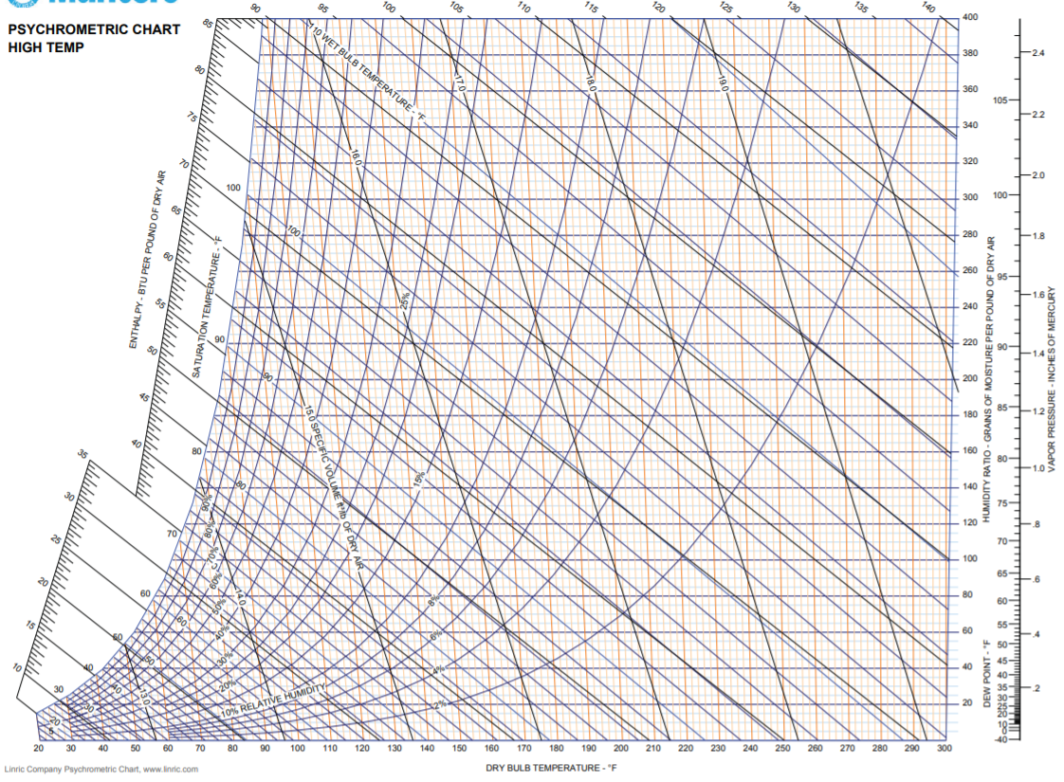

**D**

**B**

**C**

**A**

**w2**

**w1**

At A: TA = 30 °C ; RHA = 40 %

At B: TB = 77.4 °C ; RH = 4 %

At C: Tsat = 77.2 °C ; w2 = 200

At D: T = 5 °C ; w1 = 40

w2 – w1 = 160 × 0.143 = 22.88 g/kg of dry air

density of water = 1g/cc

0.0228 L 1 kg of air

1 L 43.859 kg of air

[We are able to heat 43.9 kg of air in 6 hours to give 1 Ltr of water]

Taking factor of safety ns = 1.5

**43.859 kg of air gives 666 ml of water in 6 hours**

**DESCRIPTION OF PARTS**

**Quantitative Specifications:**

1. Aluminium Fins module (72 fins); 320 x 50 x 2 mm3
2. 4 Peltier Module ; 25W, 60 x 40 mm2
3. Evaporation Slab: POP/Clay/Porous media
4. Flow channel/ ducting (Plexy Glass Casing)

**Parts to be fabricated:**

1. Aluminium Fins
2. Evaporation Slab/Porous media
3. Flow ducting (GI Sheet/ Plexy Glass)
4. Water collection Condensate tray
5. Instrumentation connectors (MS)
6. Instrumentation (DBT/WBT/VELOMETER)

**Parts to be purchased:**

1. Peltier Module

**Parts available:**

1. Solar PV Module
2. Thermocouples
3. Velometer
4. Data logging system

**Approximate Cost:**

1. 4 Peltier Module : Rs.10000 (to be partly supported by BTP Guide)

Approx. Total Cost= Rs. 12,000