**Solar-Peltier Coupled Water**

**Purification System**



**Undergraduate Project**

**Department of Mechanical Engineering**

**IIT Kanpur**

**Project Supervisor**

Dr. Sameer Khandekar

**Group 18**

Avinash Kumar (150169)

Atul Bimbrahw (150162)

Rahul Kumar (150546)

**DESIGN CALCULATIONS**

Area of duct = 10 x 13 cm2 ; Fan = 12 × 12 cm2 ; Air flow = 0.04 m3/s

Fin thickness = 2 mm ; Gap = 5 mm

No. of fins = n = 13/0.7 = 18 fins

Now, **Re =** [Reynolds Number between two fins]

ρ = = 1.15 kg/m3 ; v = = 80 m/s ; D = = = 17 cm

Re = = 864088

So,

**Nu =**  [Nusselt Number for air flowing through duct]

**Nu = (f/2)(Re – 1000)** [Because Pr=1]

Now , f = 0.00128 + 0.1143 ; f = 2.9 × 10-3

Therefore, **Nu = 1255.09**

Now we know, hL/k = Nu [Here, h & k are properties of air]

i.e **hL = 31.37 W/mK**

Power of Peltier Module,

**=** = = 104 W [which we now approximate to 100W]

Now, we set

h = 100 w/m2k, L = 31.3 cm, Q = 100W

Fin width = 2 mm, n = 18 fins ; Ac = 0.313 × 0.002 = 6.26×10-4 m2 ; Perimeter = 2×0.315 = 0.63 m

a = (hp/kA)1/2 = ( )1/2 = 22.16

Now, we calculate Heat Flow rate

= 18 × (Tb - T∞) tanh(aL) + 18×(Tb - T∞) h (0.5×0.313/100)

= 18 × [× tanh(22.16×0.1)× (Tb-T∞)]

+ 18 × (Tb-T∞) × (100×0.5×0.313/100)

= (Tb-T∞)[49.98 + 2.817]

= 52.8 × (Tb - T∞)

Now we take into account the factor of safety,

**ns × = 52.8 × (Tb - T∞)** [**ns** to take into account the loss in base temperature]

ns × = (80 - T∞)

ns × (1.89) = (80 - T∞)

take ns = 1.5

**T∞ = 77.2 °C** [Maximum temperature attainable by air]

At A

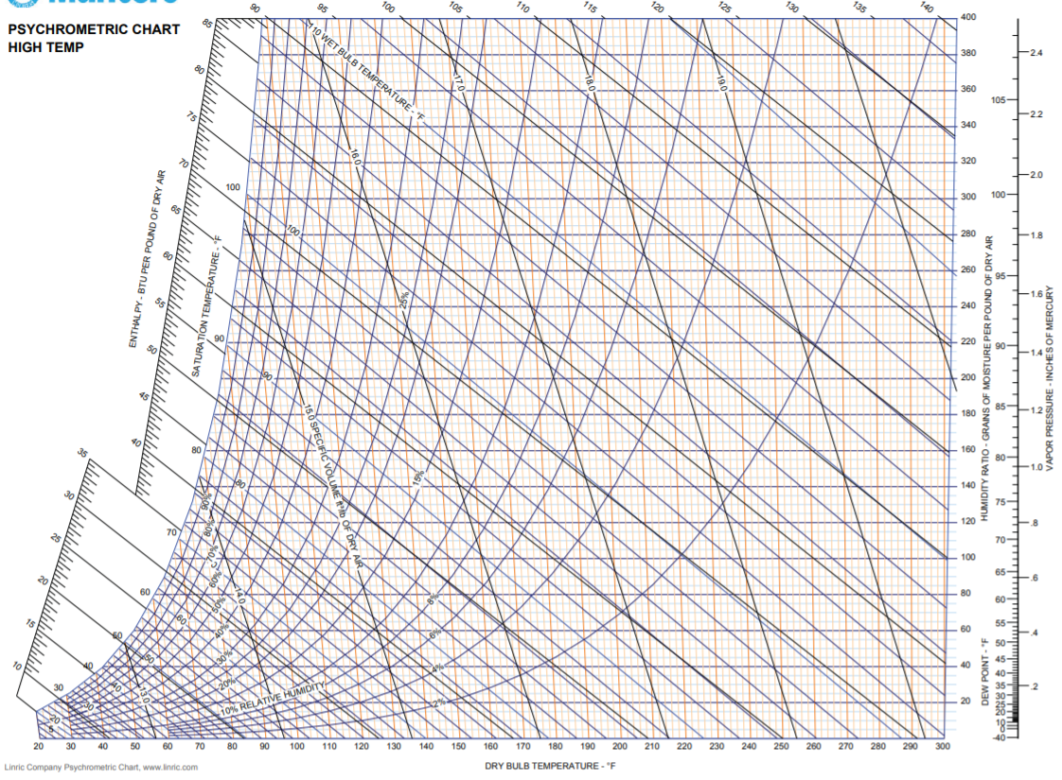

**D**

**B**

**C**

**A**

**w2**

**w1**

TA = 30 °C ; RHA = 40 %

At B

TB = 77.4 °C ; RH = 4 %

At C

Tsat = 77.2 °C ; w2 = 200

At D

T = 5 °C ; w1 = 40

w2 – w1 = 160 × 0.143 = 22.88 g/kg of dry air

density of water = 1g/cc

0.0228 L 1 kg of air

1 L 43.859 kg of air [We are able to heat 43.859 kg of air in 6 hours to give 1 Ltr of water]

Taking factor of safety ns = 1.5

**43.859 kg of air gives 666 ml of water in 6 hours**

**ORTHOGRAPHIC PROJECTIONS**

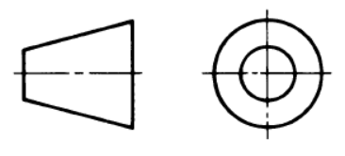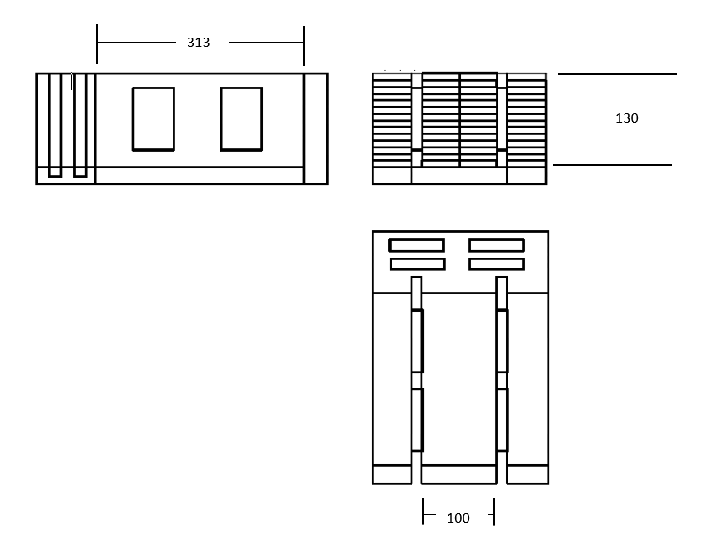

**All dimensions in mm**

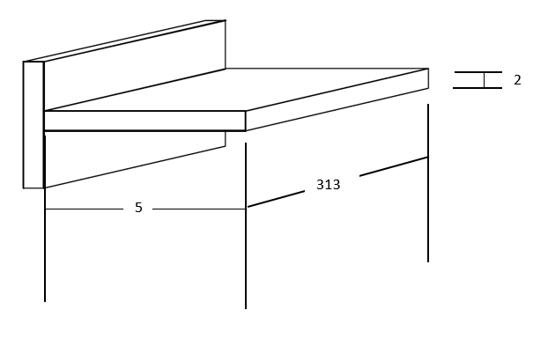

**PARTS DESCRIPTION**

**Quantitative Specifications:**

1. 72 Aluminium Fins ; 320 x 50 x 2 mm3
2. 4 Peltier Module ; 25W, 60 x 40 mm2
3. Evaporation Slab: POP
4. Plastic Casing

**Parts to be fabricated:**

1. Aluminium Fins
2. Evaporation Slab

**Parts to be purchased:**

1. Peltier Module
2. Plastic Casing

**Approximate Cost:**

1. 4 Peltier Module : Rs.10000
2. Casing : Rs.500

Approx. Total Cost= Rs. 10,000