**ME352 LAB REPORT**

**LAB 5: Balancing**

**Group - A5**

**Members:**

1.Asim Katakwar 150159

2.Atul Bimbrahw 150162

3.Avinash Kumar 150169

4.Ayush Singh 150177

**Date and Day Experiment was conducted**: 17/10/17 Tuesday

**Date of Submission of Report:** 24/10/17 Tuesday

**Part A: Static Balancing**

Static unbalance (Force Unbalance) is the easiest type of unbalance to eliminate. Static unbalance also has another condition which involves the rotational axis lying parallel to the central principal axis which means there is no uncouple balance.

In Static Balancing, the centre of mass lies on the axis of rotation. Masses m­1 and m2 are fixed at some angle. Then using the vector equation Σ𝑚𝑖𝒓𝒊 = 𝟎 (it give two equations), angles of m3 and m4­ are found out. After that the masses are adjusted according to analytic solutions obtained.

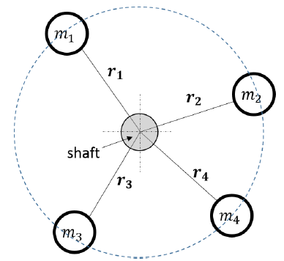

**Calculations with analytical and final orientations are attached with the lab report.**

**Reasons for fine adjustments after getting the analytical values are:**

1. **Due to friction present between shaft and masses. Weights and torques created by friction needed to be taken into account which resulted in fine adjustments.**
2. **Also because the centre of mass may not be equidistant from the axis of rotation.**
3. **Also the masses are not exactly same as what have been used while finding the analytic solution.**

**Sources of Error:**

* Human error while fixing masses at angles.
* Precision of protractor is not high.

**Part B: Dynamic Balancing**

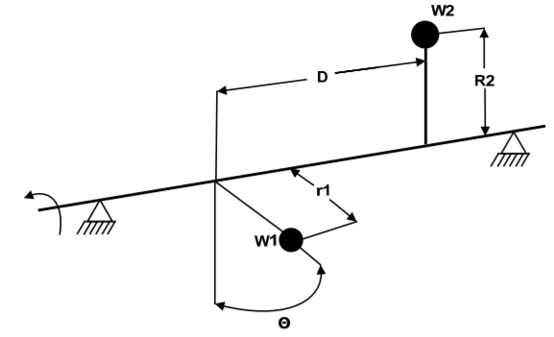

A system which is statically balanced is not necessarily dynamically balanced. In dynamic balancing, the significant parameters are the masses of the members and a distance squared.

In Dynamic Balancing, the net moment produced is zero. Orientations of all the masses are not disturbed. Masses m­1 and m2 are fixed at some axial distance from datum (which is rightmost part of shaft). Then using the vector equation Σai x 𝑚𝑖𝒓𝒊 = 𝟎 (it give two equations), axial distance of m3 and m4­ are found out and they are adjusted accordingly.

**Calculations with analytical and final orientations are attached with the lab report.**

**Reasons for fine adjustments after getting the analytical values are:**

1. **Due to friction present between shaft and masses. Weights and torques created by friction needed to be taken into account which resulted in fine adjustments.**
2. **Also because the centre of mass may not be equidistant from the axis of rotation.**
3. **Also the masses are not exactly same as what have been used while finding the analytic solution.**

**Sources of Error:**

* Human error while fixing masses at axial distances.
* Measuring scale has low precision.