**ME352 LAB REPORT**

**GRASHOF CRITERION EXPERIMENT**

**Experiment number**-2

**Sub-group number**-C3

**Name and Roll number**: -

1. Puthawala Faisal 150542
2. Raghav Gupta 150545
3. Rahul Kumar 150546

**Date and Day Experiment was conducted**: 04/09/17 Monday

**Date of Submission of Report:** 11/09/17 Monday

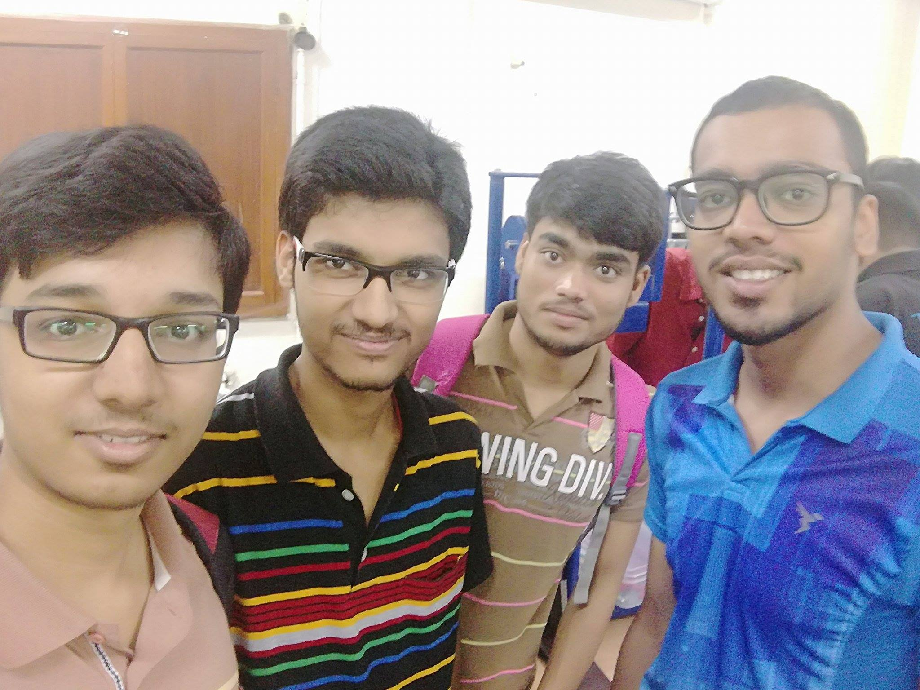

**Mechanism 2B**

**1. Construct a Grashof and a non-Grashof 4R mechanism. Consider all possible cases of a Grashof linkage.**

Ans: Grashof 4R Mechanism-

1) Double crank:

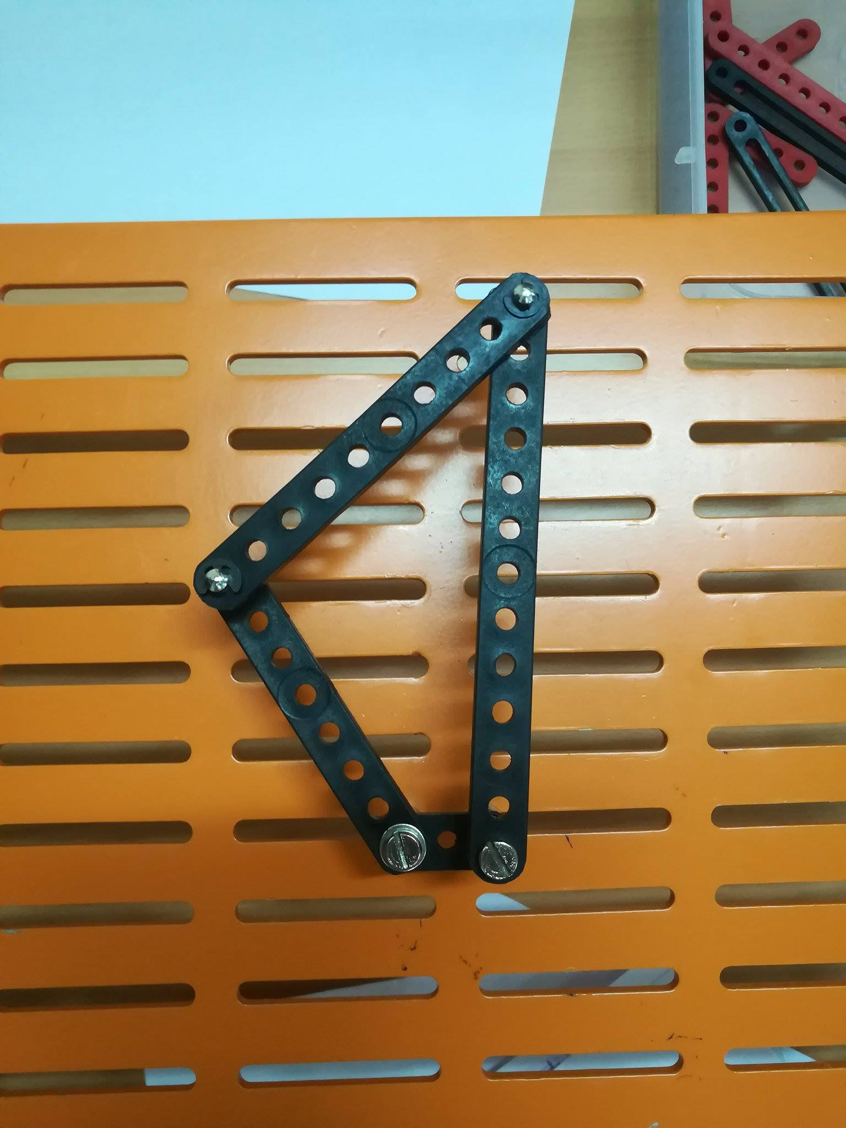

2) Crank-Rocker:

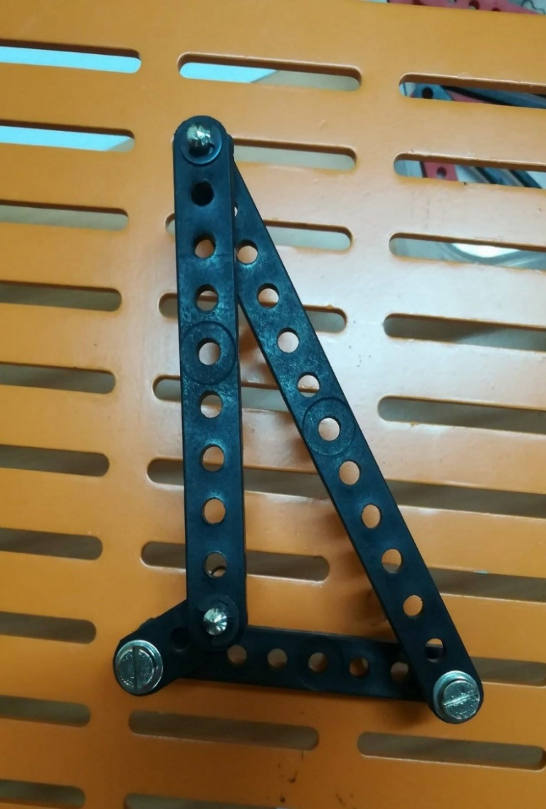

Observation Table:

|  |  |  |  |  |  |  |  |  |  |  |  |  |  |  |  |  |  |  |
| --- | --- | --- | --- | --- | --- | --- | --- | --- | --- | --- | --- | --- | --- | --- | --- | --- | --- | --- |
| Input Angle | 0° | 20° | 40° | 60° | 80° | 100° | 120° | 140° | 160° | 180° | 200° | 220° | 240° | 260° | 280° | 300° | 320° | 340° |
| Output Angle | 50° | 63° | 60° | 63° | 66° | 65° | 63° | 59° | 54° | 50° | 46° | 42° | 40° | 39° | 35° | 36° | 33° | 40° |

Plot for Crank-Rocker Grashof Mechanism

3) Double Rocker:

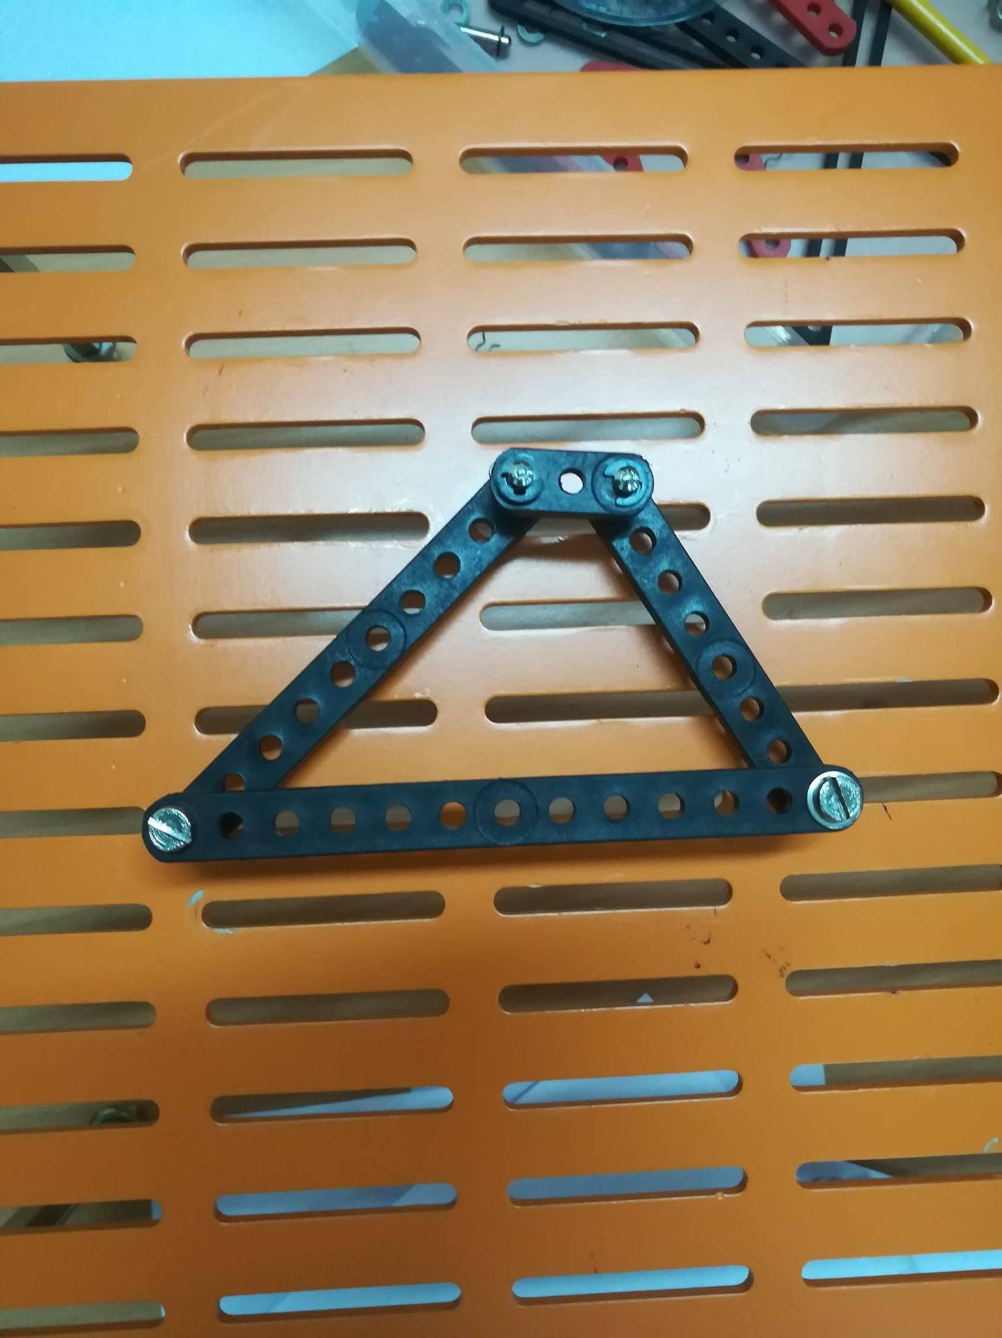

Non-Grashof 4R Mechanism-

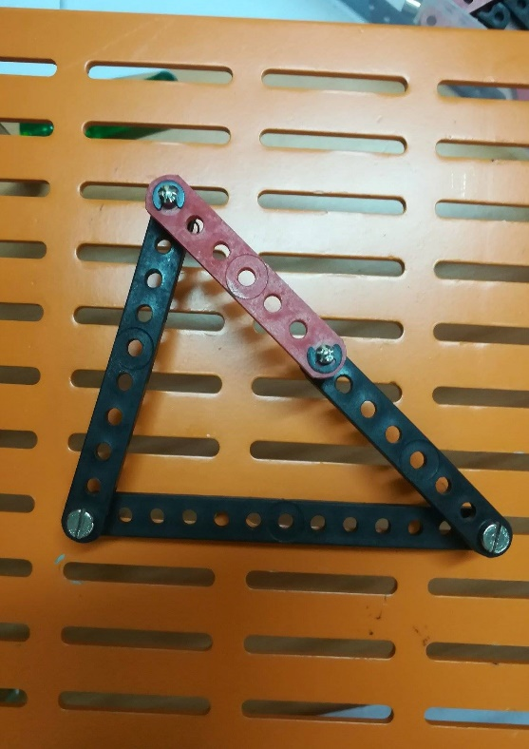

Observation Table

|  |  |  |  |  |  |  |  |  |  |
| --- | --- | --- | --- | --- | --- | --- | --- | --- | --- |
| Input Angle | 78° | 60° | 40° | 20° | 0° | -20° | -40° | -60° | -78° |
| Output Angle | 45° | 85° | 98° | 95° | 56° | 25° | 0° | -13° | -45° |

Plot for Non-Grashof Mechanism

**2. Discuss the features of the plots that you obtain.**

Ans: For Grashof crank-rocker, the rocker angle fluctuates for some range of crank angle and then decreases smoothly for crank angle range [100° - 250°] from maximum until it achieves its minimum.

For Non-Grashof, it can be seen that the limiting case will be a triangle, so the maximum and minimum angle will be same in absolute terms. Also, maximum/minimum of follower is achieved at maximum/minimum of the driver. Also, the forward and return path of the linkage will not be same.

**3. List and explain difference that you see between the various Grashof and Non- Grashof linkages.**

-In Grashof linkage sum of length of longest and smallest is less than sum of other two links. While in case of Non-Grashof, it is larger.

-Grashof linkage can be double crank, crank rocker, double rocker but non Grashof is always double rocker.

**4. Verify that two instances of a Grashof linkages cannot be achieved by a single construction.** **Show that this is not the case for Non-Grashof linkage.**

Ans. Using Grashof criterion, three different 4R mechanisms are possible and each requires a different construction. In non-Grashof linkage, only one mechanism, that is a double rocker mechanism is possible. So, any two instances of a Grashof linkage cannot be achieved by a single construction, while all constructions of non-Grashof linkage will give the same mechanism. This was verified by the constructions made in lab.

**Mechanism 2C**

**1. Describe your number synthesis in detail**

Ans: n=8

3n-2j-4 = 0

3*8-2j-4 = 0

* j = 10

n2+n3+n4 =8

2n2+3n3+4n4 = 2j = 20

Given n4 =0

n2+n3 =8

2n2+3n3 =8

* n2 = 4 and n3 = 4

**2. Show the 8-bar mechanism that you built.**

Ans:

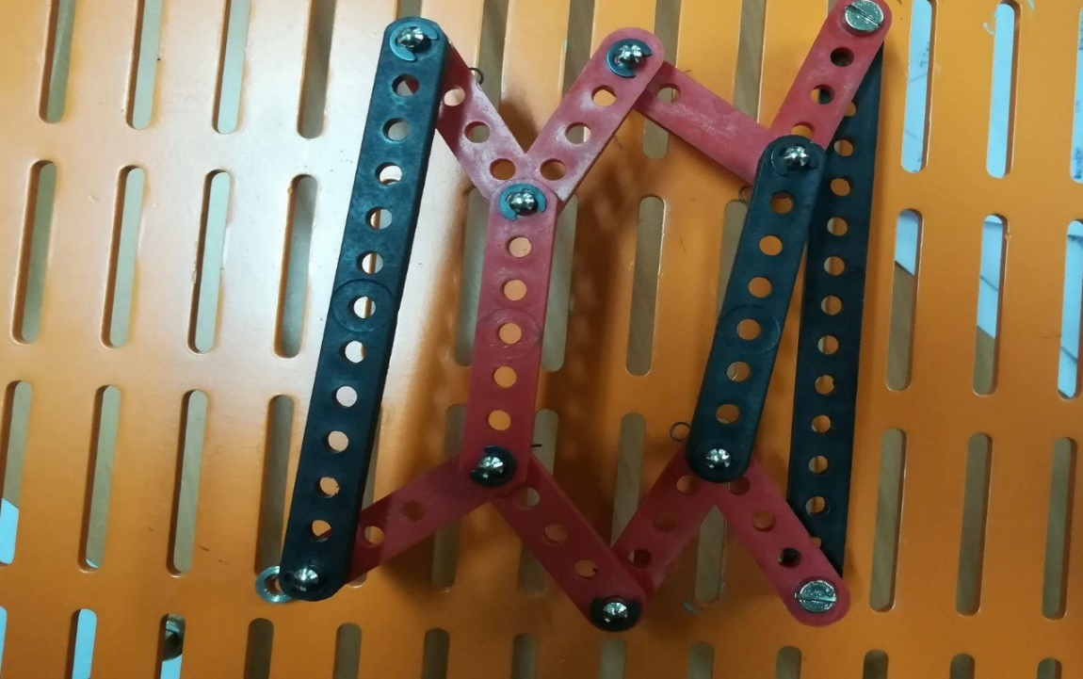

**3. Report any 8-bar constrained mechanism that you missed.**

Ans:

