**ME-352 Lab Report**

Group A5

Asim Katakwar

Avinash Kumar

Ayush Singh

Atul Bimbrahw

Arpit Mudgal

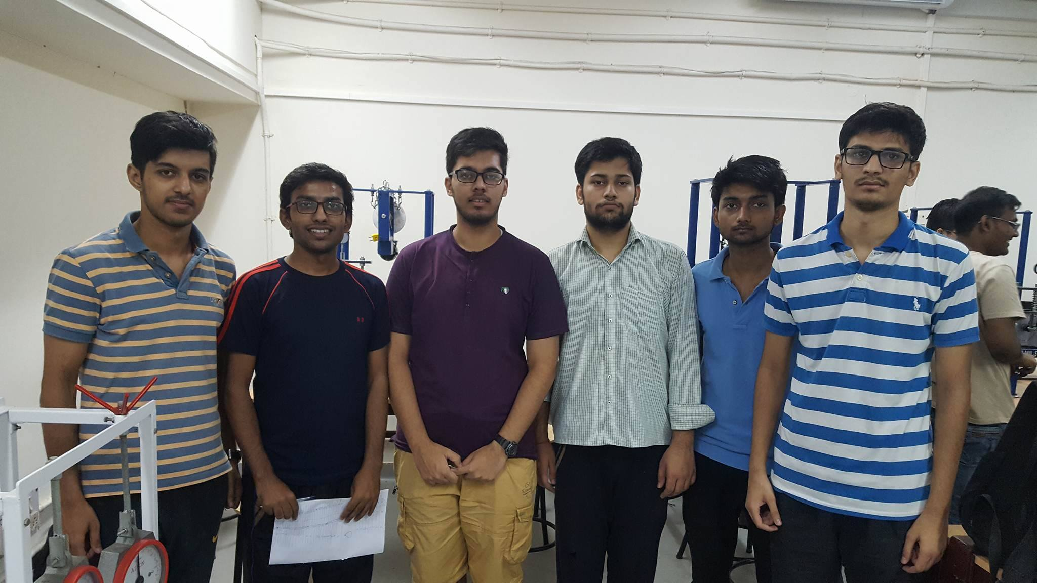

|  |  |  |  |
| --- | --- | --- | --- |
| **Table 1: Cam1 Circular Cam Rb=0.99cm** | | | |
|  |  |  |  |
|  | **Q(deg)** | **disp(mm)** | **Rb+disp (mm)** |
|  | 0 | 0.04 | 9.94 |
|  | 10 | 0.1 | 10 |
|  | 20 | 0.26 | 10.16 |
|  | 30 | 0.5 | 10.4 |
|  | 40 | 0.72 | 10.62 |
|  | 50 | 1.03 | 10.93 |
|  | 60 | 1.44 | 11.34 |
|  | 70 | 1.88 | 11.78 |
|  | 80 | 2.3 | 12.2 |
|  | 90 | 2.84 | 12.74 |
|  | 100 | 3.38 | 13.28 |
|  | 110 | 3.96 | 13.86 |
|  | 120 | 4.35 | 14.25 |
|  | 130 | 4.87 | 14.77 |
|  | 140 | 5.19 | 15.09 |
|  | 150 | 5.44 | 15.34 |
|  | 160 | 5.68 | 15.58 |
|  | 170 | 5.72 | 15.62 |
|  | 180 | 5.64 | 12.54 |
|  | 190 | 5.41 | 15.31 |
|  | 200 | 5.1 | 15 |
|  | 210 | 4.71 | 14.61 |
|  | 220 | 4.2 | 14.1 |
|  | 230 | 3.74 | 13.64 |
|  | 240 | 3.26 | 13.16 |
|  | 250 | 2.73 | 12.63 |
|  | 260 | 2.2 | 12.1 |
|  | 270 | 1.77 | 11.67 |
|  | 280 | 1.4 | 11.3 |
|  | 290 | 1.06 | 10.96 |
|  | 300 | 0.71 | 10.61 |
|  | 310 | 0.48 | 10.38 |
|  | 320 | 0.25 | 10.15 |
|  | 330 | 0.13 | 10.03 |
|  | 340 | 0.01 | 9.91 |
|  | 350 | 0 | 9.9 |

|  |  |  |  |
| --- | --- | --- | --- |
| **Table 2: Cam2 Eccentric Cam Rb=1.115cm** | | | |
|  |  |  |  |
| **Q(deg)** | **disp(mm)** | **Rb+disp (mm)** |  |
| 0 | 0.07 | 11.22 |  |
| 10 | 0 | 11.15 |  |
| 20 | 0 | 11.15 |  |
| 30 | 0.1 | 11.25 |  |
| 40 | 0.21 | 11.36 |  |
| 50 | 0.43 | 11.58 |  |
| 60 | 0.73 | 11.88 |  |
| 70 | 1.03 | 12.18 |  |
| 80 | 1.49 | 12.64 |  |
| 90 | 1.69 | 12.84 |  |
| 100 | 1.59 | 12.74 |  |
| 110 | 1.3 | 12.45 |  |
| 120 | 0.79 | 11.94 |  |
| 130 | 0.36 | 11.51 |  |
| 140 | 0.21 | 11.36 |  |
| 150 | 0.85 | 12 |  |
| 160 | 2.34 | 13.49 |  |
| 170 | 2.4 | 13.55 |  |
| 180 | 2.43 | 13.58 |  |
| 190 | 2.37 | 13.52 |  |
| 200 | 2.37 | 13.52 |  |
| 210 | 1.15 | 12.3 |  |
| 220 | 0.15 | 11.3 |  |
| 230 | 0.11 | 11.26 |  |
| 240 | 0.8 | 11.95 |  |
| 250 | 1.89 | 13.04 |  |
| 260 | 2.37 | 13.52 |  |
| 270 | 2.36 | 13.51 |  |
| 280 | 2.36 | 13.51 |  |
| 290 | 2.36 | 13.51 |  |
| 300 | 2.15 | 13.3 |  |
| 310 | 1.73 | 12.88 |  |
| 320 | 1.44 | 12.59 |  |
| 330 | 1.15 | 12.3 |  |
| 340 | 0.93 | 12.08 |  |
| 350 | 0.8 | 11.95 |  |

|  |  |  |  |
| --- | --- | --- | --- |
| **Table 3: Cam3 Tangent Cam Rb=1.152cm** | | | |
|  |  |  |  |
| **Q(deg)** | **disp(mm)** | **Rb+disp (mm)** |  |
| 0 | 0.31 | 11.83 |  |
| 10 | 0.37 | 11.89 |  |
| 20 | 0.39 | 11.91 |  |
| 30 | 0.53 | 12.05 |  |
| 40 | 0.74 | 12.26 |  |
| 50 | 1.01 | 12.53 |  |
| 60 | 1.32 | 12.84 |  |
| 70 | 1.72 | 13.24 |  |
| 80 | 2.14 | 13.66 |  |
| 90 | 2.59 | 14.11 |  |
| 100 | 2.74 | 14.26 |  |
| 110 | 1.74 | 13.26 |  |
| 120 | 1.21 | 12.73 |  |
| 130 | 0.33 | 11.85 |  |
| 140 | 0 | 11.52 |  |
| 150 | 0.29 | 11.81 |  |
| 160 | 1.12 | 12.64 |  |
| 170 | 2.63 | 14.15 |  |
| 180 | 3.61 | 15.13 |  |
| 190 | 3.62 | 15.14 |  |
| 200 | 3.63 | 15.15 |  |
| 210 | 3.62 | 15.14 |  |
| 220 | 3.61 | 15.13 |  |
| 230 | 3.61 | 15.13 |  |
| 240 | 3.05 | 14.57 |  |
| 250 | 0.91 | 12.43 |  |
| 260 | 0.26 | 11.78 |  |
| 270 | 0.14 | 11.66 |  |
| 280 | 0.5 | 12.02 |  |
| 290 | 1.09 | 12.61 |  |
| 300 | 1.25 | 12.77 |  |
| 310 | 1.09 | 12.61 |  |
| 320 | 0.68 | 12.2 |  |
| 330 | 0.48 | 12 |  |
| 340 | 0.27 | 11.79 |  |
| 350 | 0.17 | 11.69 |  |

|  |  |  |
| --- | --- | --- |
| **Serial No.** | **Cam** | **Maximum Displacement** |
| 1 | Circular | 5.72 |
| 2 | Eccentric | 2.43 |
| 3 | Tangent | 3.63 |
|  |  |  |

**Sources of Error:**

1. Manual reading led to discontinuity In points taken.

2. There was slip which led to error in reading.

3. Parallax error while reading

4. There was a gap which led to lateral movement of the rod and working​ ​failure​ ​of​ ​Dial​ ​Gauge​ which led to a lot of error .