**ME 361 LAB REPORT**

|  |  |  |
| --- | --- | --- |
| Experiment number | : | 1 |
|  |  |  |
| Sub-Group number | : | A4 |
|  |  |  |
| Name | : | AVINASH KUMAR |
|  |  |  |
| Roll number | : | 150169 |
|  |  |  |
| Date & Day experiment was conducted on | : | 12th Sep 2017 |
|  |  |  |
| Date of submission of report | : | 3rd Oct 2017 |

**Objective(s)**:

To measure cutting forces;

Identify cutting force coefficients;

Estimate cutting force coefficient from estimated chip thickness ratio;

Study influence of cutting speed on cutting forces.

**Answers to questions asked in the report:**

Ouside Dia = 70.5 mm

D = 68 mm, chip width (b)= 1.25mm

Table 1

|  |  |  |  |  |  |  |
| --- | --- | --- | --- | --- | --- | --- |
| Run | Feed rate (mm/rev) | Cutting Speed (m/min) | Spindle speed (rpm) | Fx | Fy | Fz |
| 1 | 0.075 | 150 | 702.15 | 44.07795 | 20.96405 | 96.23331 |
| 2 | 0.125 | 150 | 702.15 | 77.01303 | 38.52426 | 154.5667 |
| 3 | 0.175 | 150 | 702.15 | 97.75624 | 53.04551 | 202.0816 |
| 4 | 0.225 | 150 | 702.15 | 101.1206 | 60.80607 | 233.2497 |

Table 2 D = 66mm

|  |  |  |  |  |  |  |
| --- | --- | --- | --- | --- | --- | --- |
| Run | Feed rate (mm/rev) | Cutting speed (m/min) | Spindle speed (rpm) | Fx | Fy | Fz |
| 1 | 0.125 | 100 | 482 | 72.46611 | 48.15788 | 143.4523 |
| 2 | 0.125 | 150 | 723 | 63.02649 | 42.82458 | 128.2345 |
| 3 | 0.125 | 200 | 964 | 44.87504 | 31.66092 | 105.7153 |
| 4 | 0.125 | 250 | 1055 | 40.81723 | 29.79437 | 102.8608 |

1. **Force vs time**
2. Averaged force fit modeling using linear regression

**Force vs feed rate**

1. Experimental cutting force coefficients using following eqn : 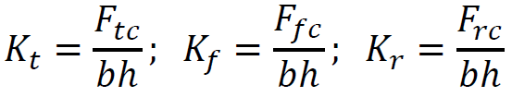

b = 1.25mm

using feed rate f = 0.175 mm/rev

uncut chip thickness (h) = f cos(Υ) = 0.175 cos(5) = 0.1743 mm

experimental results:

|  |  |  |  |  |  |
| --- | --- | --- | --- | --- | --- |
| Fy (N) | Fx (N) | Fz (N) | Kr = Ky (N/mm2) | Kf = Kx (N/mm2) | Kt = Kz (N/mm2) |
| 8.546 | 59.51 | 152.0816 | 39.382 | 274.23 | 700.489 |

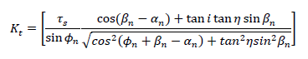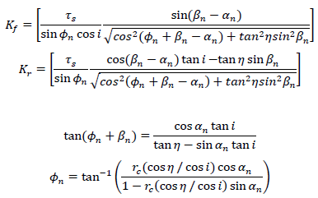

Cut chip thickness (hc) = 0.5463 mm

Rc = h / hc = 0.1743 / 0.5463 = 0.319

Rake angle a = 13 deg,

n = i = Y = 5 deg

using above eqn:

β = 32.9 deg

φ = 18.51 deg

Kx = Kf = 243.50 N/mm2 ; Ky = Kr = 24.536 N/mm2 ; Kz = Kt = 670.169 N/mm2

1. Table for comparisions:

|  |  |  |  |
| --- | --- | --- | --- |
| Force coefficients | Experimental | Theoretical | Error % |
| Kx | 274.239 | 243.50 | 12.62 |
| Ky | 39.382 | 24.536 | 60.50 |
| Kz | 700.489 | 670.169 | 4.52 |

**The difference in the experimentally identified and estimated cutting force coefficients is mainly because of following reasons :**

It may be due to approximate reading of chip thickness for the measurement had been taken by putting the chip under the microscope instead of the procedure specified

The possible sources of error were accuracy while calculating the thickness of chip using the electron microscope. Also, the nose of the tool was neglected while doing calculations.

Sources of error also includes: friction, higher shear deformation rate, higher temperature in the cutting region, BUE formation. These factors might result in variation in material property.

1. **Force vs cutting speed**

**Reason and Conclusion:** This is due to the reason that energy required for material removal per unit volume is a material property, it remains constant. As Power = Force ×Velocity, cutting forces in all directions decrease as the cutting speed. As we increase velocity, friction decreases, temperature in cutting region increases, shear deformation rate increases. High temperature in the flow region and a decrease of the contact area and the chip thickness cause the cutting force to decrease depending on the cutting speed. All these factors lead to decreases in cutting forces.