**ME 361 LAB REPORT**

|  |  |  |
| --- | --- | --- |
| Experiment number | : | 4 |
|  |  |  |
| Sub-Group number | : | A4 |
|  |  |  |
| Name | : | AVINASH KUMAR |
|  |  |  |
| Roll number | : | 150169 |
|  |  |  |
| Date & Day experiment was conducted on | : | 31th Aug 2017 |
|  |  |  |
| Date of submission of report | : | 7th Sep 2017 |

**Objective(s)**:

**1. To study the EDM machine and the relevant measuring systems.**

**2. To determine material removal rate (MRR) and tool wear rate (TWR) during machining of EN8 steel.**

**3. To measure the initial and final out of roundness of the copper tool.**

**Answers to questions asked in the report:**

1. **Table:**

|  |  |  |  |  |  |  |  |  |  |  |  |  |  |
| --- | --- | --- | --- | --- | --- | --- | --- | --- | --- | --- | --- | --- | --- |
| S.No | Initial job weight (g) | Initial tool weight (g) | Gap voltage | Pulse on time (us) | Pulse off time (us) | Duty cycle % | Current | Machining time | Final job weight (g) | Final tool weight (g) | MRR (kg/s) | TRR (kg/s) | REWR |
| 1 | 173.364 | 37.077 | 30 V | 30 | 16.8 75 | 64 | 10 A | 5 min | 172.867 | 37.020 | 1.6566E-06 | 1.9E-07 | 0.11469 |
| 2 | 172.867 | 35.323 | 30 V | 30 | 7.5 | 80 | 10 A | 5 min | 172.241 | 35.263 | 2.0866 E-06 | 2E-07 | 0.09585 |
| 3 | 172.241 | 36.972 | 30 V | 30 | 32.5 | 48 | 10 A | 5 min | 171.759 | 36.904 | 1.6066 E-06 | 2.27E-07 | 0.14108 |

**Basic Mechanism of EDM:**

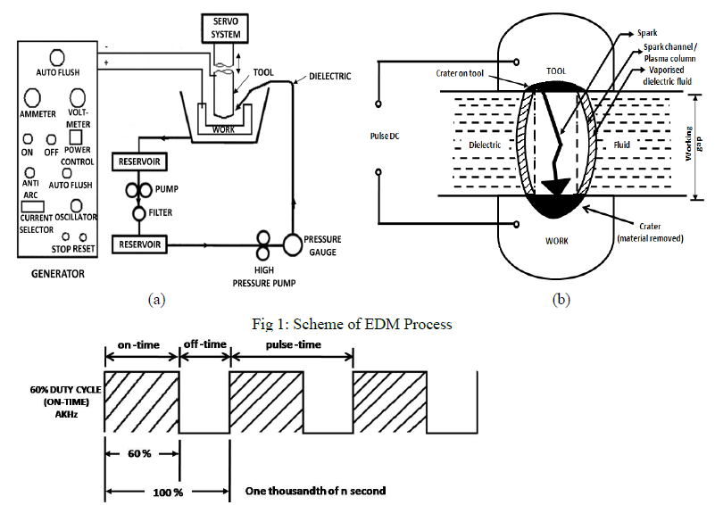

In EDM, a potential difference is applied between the tool and work piece. Tool is connected to the negative terminal and work-piece to the positive terminal. The whole process is divided into sub-processes which are as follows:

1. **Cold Emission:** In EDM, a potential difference is applied between the tool and work piece. Both the tool and the work material are to be conductors of electricity. The tool and the work material are immersed in a dielectric medium. A gap is maintained between the tool and the workpiece. Depending upon the applied potential difference and the gap between the tool and workpiece, an electric field would be established. Generally the tool is connected to the negative terminal of the generator and the workpiece is connected to positive terminal. As the electric field is established between the tool and the job, the free electrons on the tool are subjected to electrostatic forces. If the work function or the bonding energy of the electrons is less, electrons would be emitted from the tool (assuming it to be connected to the negative terminal). Such emission of electrons are called or termed as cold emission.
2. **Ionization** The “cold emitted” electrons are then accelerated towards the job through the dielectric medium. As they gain velocity and energy, and start moving towards the job, there would be collisions between the electrons and dielectric molecules. Such collision may result in ionisation of the dielectric molecule depending upon the work function or ionisation energy of the dielectric molecule and the energy of the electron. Thus, as the electrons get accelerated, more positive ions and electrons would get generated due to collisions. This cyclic process would increase the concentration of electrons and ions in the dielectric medium between the tool and the job at the spark gap.
3. **Breakdown** The concentration would be so high that the matter existing in that channel could be characterized as “plasma”. The electrical resistance of such plasma channel would be very less. Thus all of a sudden, a large number of electrons will flow from the tool to the job and ions from the job to the tool. This is called avalanche motion of electrons. Such movement of electrons and ions can be visually seen as a spark. Thus the electrical energy is dissipated as the thermal energy of the spark.
4. **Discharge** The high speed electrons then impinge on the job and ions on the tool. The kinetic energy of the electrons and ions on impact with the surface of the job and tool respectively would be converted into thermal energy or heat flux. Such intense localised heat flux leads to extreme instantaneous confined rise in temperature which would be in excess of 10,000o C. Such localized extreme rise in temperature leads to material removal. Material removal occurs due to instant vaporization of the material as well as due to melting.
5. **Plasma Collapse:** The molten metal is not removed completely but only partially. As the potential difference is withdrawn as shown in Figure, the plasma channel is no longer sustained. As the plasma channel collapse, it generates pressure or shock waves, which evacuates the molten material forming a crater of removed material around the site of the spark. Thus to summarize, the material removal in EDM mainly occurs due to formation of shock waves as the plasma channel collapse owing to discontinuation of applied potential difference.
6. Merits:

(a) Complex shapes that would otherwise be difficult to produce with conventional cutting tools.

(b) Extremely hard material to very close tolerances.

(c) Very small work pieces where conventional cutting tools may damage the part from excess cutting tool pressure.

(d) There is no direct contact between tool and work piece. Therefore delicate sections and weak materials can be machined without any distortion.

(e) A good surface finish can be obtained.

(f) Very fine holes can be easily drilled.

(g) Electrically non-conductive materials can be machined only with specific set-up of the process.

Demerits:

(a) The slow rate of material removal.

(b) The additional time and cost used for creating electrodes for ram/sinker EDM.

(c) Reproducing  sharp  corners  on  the  work  piece  is  difficult  due  to electrode wear.

(d) Specific power consumption is very high.

(e) Power consumption is high.

(f) "Over cut" is formed.

(g) Excessive tool wear occurs during machining.

Applications:

With its ability to create precise and unique shapes, EDM has been used by many industries in their manufacturing processes. Here are the most common types of applications for EDM.

Die Making - Dies are tools used to cut or shape materials into a solid product. EDM is used to create these dies, despite the size or commonness of the shape needed.

Mold Making - Molds are containers that transform liquid or substance into the shape of the container. A mold’s dimension and depth is achieved with use of EDM.

Small Hole Drilling - Without EDM, drilling small holes would be difficult. EDM’s ability to create small shapes accurately makes it ideal for drilling the exact size of holes needed.

1. Comments and Discussions:

A non-linear relationship between MRR, TRR, REWR and duty cycle has been observed. MRR increases as the duty cycle is increased from 48% to 80% but with further increase in duty cycle, decrease in MRR will be observed. Increasing duty cycle means increasing the pulse on time. So increase in pulse on time means applying the same heating flux for a longer time. This will cause an increase of heat that is conducted into the work piece as the plasma channel expands which will result in an increase in the MRR. It can be seen that the tool wear rate decrease as the Pulse On Time values increase from 48% to 64% duty cycle and increases after that. Reduction in Tool wear with respect to time may be attributed to spark energy which increases with increase in Pulse On Time but higher Pulse On Time leads to spreading of the spark (plasma channel), due to which heat transfer to the tool reduces and to the work piece and dielectric increases which results in less tool wear and high material removal rate. Also relative electrode wear rate varies non-linearly with pulse on time. It should be as min as possible.