 | College of Engineering and Computer Science  Mechanical Engineering Department  Mechanical Engineering 370  Thermodynamics
Fall 2010 Course Number: 14319
Instructor: Larry Caretto

Unit Two Homework Solutions, September 9, 2010
1 A frictionless piston-cylinder device initially contains 200 L of saturated liquid refrigerant-134a. The piston is free to move, and its mass is such that it maintains a pressure of 900 kPa on the refrigerant. The refrigerant is now heated until its temperature rises to 70ºC. Calculate the work done during this process.
The freely-moving piston can be interpreted as giving a constant pressure process such that P₁ = P₂ = P = 900 kPa. For a constant pressure process, the concept that the work is the area under the path is particularly simple. That area is a rectangle whose area is P (V₂ – V₁). We know that P is 900 kPa, and the initial volume is 200 L = 0.2 m³, but we have to find the final volume.
Because this is a constant pressure process, the final pressure equals the initial pressure of 900 kPa (0.9 MPa) and we are given that the final state has a temperature of 70ºC. From the superheat tables for refrigerant-134a in Table A-13 on page 930, we find that the specific volume at this temperature and pressure is 0.027413 m³/kg.
In order to find the volume (V in m³ as opposed to the specific volume, v, from the property tables in m³/kg), we have to know the mass. We can find the mass from the initial volume and the value of the specific volume at the initial state of saturated liquid at 900 kPa. At this pressure, we use the saturation table, A-12, on page 928, to find the specific volume of the saturated liquid, v_{f} = 0.0008580 m³/kg at 900 kPa. We can then find the mass as follows.
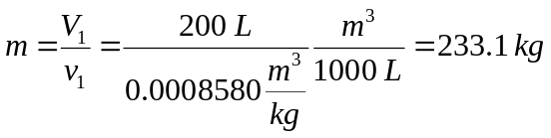
We can now compute V₂ = mv₂ and find the work done.
W = 5,571 kJ
2 A mass of 2.4 kg of air at 150 kPa and 12ºC is contained in a gas-tight, frictionless piston-cylinder device. The air is now compressed to a final pressure of 600 kPa. During the process, heat is transferred from the air such that the temperature inside the cylinder remains constant. Calculate the work input during this process.
In this case the path is a constant temperature path. If we assume that air is an ideal gas, we can write the ideal-gas equation of state, at a constant temperature, as follows:
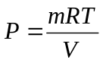
Since mRT is a constant in a constant temperature process, we can write the equation for work as follows.
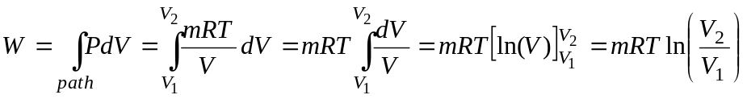
We can find the ratio, V₂/V₁ as follows for the constant temperature process.
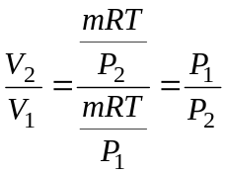
Substituting P₁/P₂ in place of V₂/V₁, using the gas constant for air = 0.2870 kJ/(kg•K) from Table A-1 on page 908, and using the given values of m = 2.4 kg, and T = 12ºC = 285.15 K, gives the following result for the work.
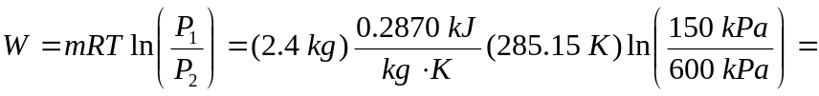–272 kJ
The negative sign for the work indicates that this is a work input of 272 kJ
3 A frictionless piston–cylinder device contains 2 kg of nitrogen at 100 kPa and 300 K. Nitrogen is now compressed slowly according to the relation PV^{1.4} = constant until it reaches a final temperature of 360 K. Calculate the work done during this process.
In this case the path equation is PV^{n} = C with n = 1.4. We can rewrite this equation as P = CV^{-n}, and integrate this revised path equation to find the work as follows.
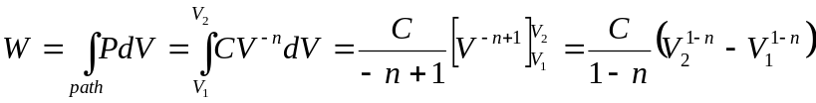
To reduce this equation further we can use a trick. Since PV^{n} = C, the constant C may be written either as P₁V₁^{n} or as P₂V₂^{n}. By carefully choosing which way we write this constant, we can simplify our result.
The equation above is valid for any substance. For an ideal gas, we can obtain a simpler result for the work by using the ideal gas equation of state, writing each P_{k}V_{k} product as mRT_{k}.
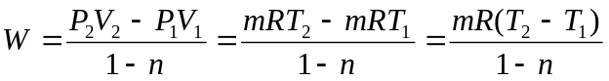
We can find the gas constant for nitrogen from Table A-1 on page 908; R = 0.2968 kJ/(kg•K). We are given m = 2 kg, T₁ = 300 K, T₂ = 360 K and n = 1.4. Substituting these values into the equation for the work gives the answer as follows.
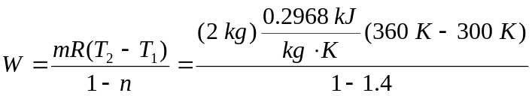=–89.0 kJ
The negative sign for the work indicates that this is a work input of 89.0 kJ
4 Hydrogen is contained in a piston-cylinder device at 14.7 psia and 15 ft³. At this state, a linear spring (F α x) with a spring constant of 15,000 lb_{f}/ft is touching the piston, but exerts no force on it. The cross sectional area of the piston is 3 ft². Heat is transferred to the hydrogen, causing it to expand until its volume doubles. Determine (a) the final pressure, (b) the total work done by the hydrogen, and (c) the fraction of this work done against the spring. Also show the process on a P-V diagram.
In this problem there are two components of the pressure. The initial pressure of 14.7 psia is due to the atmospheric pressure plus the weight of the piston. Call this initial pressure P₁. The second component is the pressure exerted by the spring. If the spring force is F and the cross sectional area of the piston is A, then the pressure exerted by the spring is P_{spring} = F/A.
For the linear spring, F = k(x – x_{e}), where x_{e} is the equilibrium displacement for the spring and k = 15,000 lb_{f}/ft for this spring. The displacement, x, can be written as the difference in volume divided by the cross-sectional area, A. If x_{e} is the equilibrium position of the spring and V_{e} is the system volume at this point, we can relate the spring displacement to volume as follows.
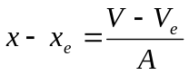
We can interpret the statement that the spring is just touching the piston, but exerts no force on it at the initial volume as saying that the equilibrium position of the spring occurs when the system volume is equal to the initial volume; that is, V_{e} = V₁. Now the pressure due to the spring is simply the spring force divided by the area of the cylinder. The spring force is proportional to its displacement and we have just derived an equation that relates spring displacement to volume change. We can combine all these to get a path equation as follows.
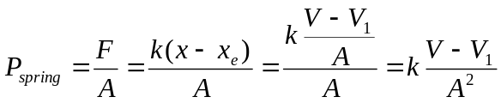
Since part (c) of the problem asks for the fraction of the work done against the spring, let’s keep track of both separately. The total pressure, P, will be the sum of the constant pressure from the weight of the piston (and atmospheric pressure), P₁, and P_{spring}.
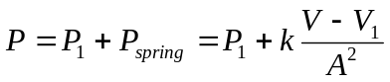
We can thus write the work as follows.
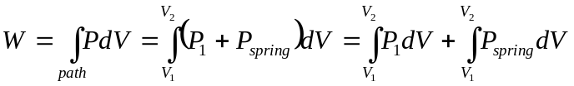
We can regard the final two integrals as two components of work. The first integral is simple to integrate since the pressure, P₁, is constant. We can thus write the following components of the work.
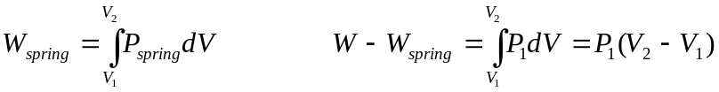
Using the equation for P_{spring} given above we can find the spring work as shown below. In this integration we introduce the variable y = V – V₁. Note that dV = dy and the lower and upper integral limits of V = V₁ and V = V₂ are equivalent to y = 0 and y = V₂ – V₁, respectively.
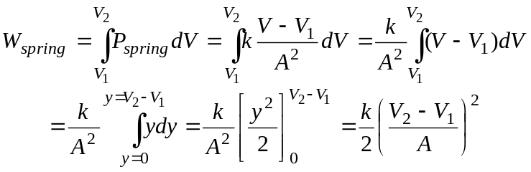
We have now completed the analysis of the equations for the pressure and the work; now we have to apply the given values: P₁ = 14.7 psia; V₁ = 15 ft³; V₂ = 2 V₁ = 30 ft³; A = 3 ft²; k = 15,000 lb_{f}/ft.
We can determine the final pressure by setting V = V₂ in the equation for the total pressure as a function of V.
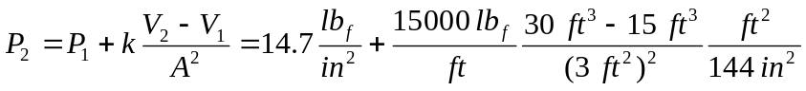
P₂ = 188.3 psia
We can evaluate the components of the total work term from the appropriate equations
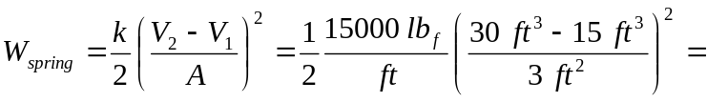1.875x10⁵ ft•lb_{f}
W = 2.193x10⁵ ft•lb_{f}
P₁
P
P₂
V
V₁
V₂
The proportion of work due to the spring is simply the ratio of the spring work, 1.875x10⁵ ft•lb_{f} to the total work, 1.875x10⁵ ft•lb_{f} . This ratio shows that
85.5% of the work is due to the spring.
From the equation for the path, we wee that P is a linear function of V. Thus the plot of the path on a P-V diagram will be a straight line from the initial point (P₁, V₁) to the final point (P₂, V₂). This path is shown on the diagram at the left. (Note that we could have found the total work as the area under this path. You can check the calculation to see if this is correct. Do you get the same answer for the total work when you compute it as (P₁ + P₂)(V₂ – V₁)/2?
Note that we never have to make use of the nature of the substance, hydrogen. The answer to this problem would be the same for any substance. If we were given or asked to find temperature data, we could use the ideal gas equation of state with the gas constant for hydrogen.
5 A piston-cylinder device contains 50 kg of water at 250 kPa and 25ºC. The cross sectional area of the piston is is 0.1 m². Heat is now transferred to the water, causing part of it to evaporate and expand. When the volume reaches 0.2 m³, the piston reaches a linear spring whose spring constant is 100 kN/m. More heat is transferred until the piston rises 20 cm more. Determine (a) the final pressure and temperature and (b) the work done during the process. Also show the process on a P-V diagram.
This problem is similar to the previous one, except that there are two steps to the process and we are not given all the pressure and volume data directly; we will have to use the property tables for water to get some of the data.
The process takes place in two steps. No information is given about the first step where the volume increases to 0.2 m³. Let’s assume that this process takes place at constant pressure, which is the pressure due to atmospheric pressure plus the weight of the piston.
The initial state of the water at 250 kPa and 25ºC is a compressed liquid. We can confirm this by looking at the saturation properties in Table A-4 on page 914. The given pressure of 250 kPa is greater than the saturation pressure at the given temperature of 25ºC, which is only 3.1698 kPa. We can reach the same conclusion by examining the data in Table A-5 on page 916 which shows that the saturation temperature at the given pressure of 250 kPa, which is 127.41ºC is greater than the given temperature of 25ºC. We can use the approximation that the specific volume of the compressed liquid at 250 kPa and 25ºC is the same as the specific volume of the saturated liquid at 25ºC, which is 0.001003 m³/kg from Table A-4.
We thus know that the initial volume, V₁ = m v₁ = (50 kg) (0.001003 m³/kg) = 0.05015 m³.
From the assumption that the first step of the process occurs at constant pressure, we know that the pressure at the end of this step, P₂ equals P₁ = 250 kPa.
In the second step, the pressure is the sum of this 250 kPa due to the piston weight and atmospheric pressure plus the pressure of the spring. From problem 4 we saw that the spring pressure is given by the following equation.
In this problem the equilibrium point of the spring occurs when the volume is V₂. The total pressure is then given by the following equation. (In this equation we write the constant pressure between steps 1 and 2 as P₁₋₂ to remind us that we have this constant pressure.)
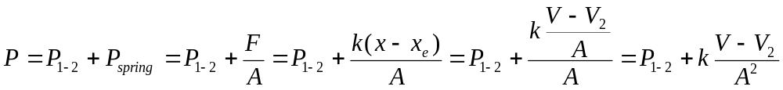
Using the data given for the spring constant, k = 100 kN/m, we can find the spring displacement at the final state, x₃ – x_{e} = 20 cm = 0.2 m, and are given the piston area, A = 0.1 m². We can thus solve for the final pressure as follows.
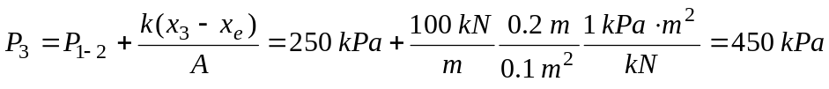
The final volume, V₃, is the sum of the volume at point 2, which is given as 0.2 m³ plus the increase in volume due to the piston motion. This volume increase is simply the piston area (A = 0.1 m²) times the piston displacement of 20 cm = 0.2 m. Thus we compute the final volume as follows.
V₃ = 0.2 m³ + (0.1 m²)(0.2 m) = 0.22 m³
We have already found the final pressure. To determine the final temperature, we have to determine the final specific volume, v₃.
v₃ = V₃/m = 0.22 m³ / 50 kg = 0.0044 m³/kg
At the final pressure of 450 kPa, the specific volumes of the saturated liquid and saturated vapor are 0.001088 m³/kg and 0.41392 m³/kg, respectively. (Table A-5, page 916). Thus the final temperature must be the saturation temperature at 450 kPa. Table A-5 gives T₃ = 147.90ºC.
The P-V diagram for this process is shown on the right. From this diagram we see that we can compute the work for each step in the process. The first step from point 1 to point 2 is a constant pressure process. Call this constant pressure between points one and two P₁₋₂, where P₁₋₂ = P₁ = P₂ 250 kPA. The work for this constant pressure step is simply P₁₋₂ (V₂ – V₁).
P₁=P₂
P
P₃₃
V
V₁
V₂
V₃
The second step from (P₂, V₂) to (P₃, V₃) is a straight line. This is true because of the equation for total pressure along the path, which we derived earlier, and is shown below, gives P as a linear function of V.
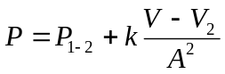
Because of this linear relationship, the work for the second step, from (P₂, V₂) to (P₃, V₃) is given by the formula for the area of a trapezoid. (P₂ + P₃) (V₃ – V₁)/2. Adding the work for both steps in this process gives the following result for the work.
W = P₁₋₂ (V₂ – V₁) + (P₂ + P₃) (V₃ – V₂)/2
We now know the values for all the pressures and volumes in this equation so we can compute the work.
W = 44.5 kJ
Here, the positive sign for work indicates that there is a work output.

