Tutorial Sheet 4   
ESC101 – Fundamentals of Computing

**Revision (ask for doubts)**

1. **Increment, decrement operators**: both ++a and a++ increment value of a and store incremented value in a. But a++ generates the old value whereas ++a generates new value. Can use with int, long, float, double.
2. ++3 or 3++ will cause errors. Mr. C will try 3 = 3 + 1 which is wrong.
3. **Compound assignment** is useful a += 5, b *= c;
4. **Relational Operators**: <, <=, ==, !=, >=, >. Be careful about their precedence (write down BODMAS table in notebook). All relational expressions generate 0 (interpreted as FALSE) or 1 (interpreted as TRUE).
5. **Logical Operators**: &&, ||, and ! are used to construct powerful conditional expressions. Be careful to use brackets.
6. **if, if-else Statements**: Careful to put curly brackets, especially if multiple statements inside if part or else part. Indentation is ignored by Mr. C. Use brackets to tell him what all to do in if/else.
7. **Ternary Operator**: cute shortcut, do not misuse/overuse.
8. **Switch Statement**: a shortcut that only checks equality and that too only for int. For inequality checks, float etc, use if-else yourself. Be careful about fall-through and use of break, default.

**Sample Questions to discuss**

*Some cute ways to manipulate things without using logical operators*

**Print “Odd” if a given integer number is not even**

Just writing ; on its own creates an ***empty statement***. No operation takes place and Mr. C takes no action on an empty statement.

Remember**, every *else* needs an *if*,** but an *if* doesn’t need an *else*

#include<stdio.h>

int main(){

int a = 5;

if(!(a % 2 == 0))

printf(“Odd”);

return 0;

}

#include<stdio.h>

int main(){

int a = 5;

if(a % 2 != 0)

printf(“Odd”);

return 0;

}

#include<stdio.h>

int main(){

int a = 5;

if(a % 2 == 0)

; // Empty statement

else

printf(“Odd”);

return 0;

}

**Print “Leap Year” if a multiple of 4 but not multiple of 100**

if((year%4 == 0) && (year%100 !=0)){

printf(“Leap Year”);

}

if(year%4 == 0){

if(year%100 !=0){

printf(“Leap Year”);

}

}

**Set CPI to 10 if marks > 80 or if attendance >= 50 or both, else 8**

if((marks > 80) || (att >= 50)){

cpi = 10;

}else{

cpi = 8;

}

cpi = 8;

if(marks > 80){

cpi = 10;

}

if(att >= 50)){

cpi = 10;

}

**Quiz**: **Print “Leap Year” if any one of the following happens**

1. year a multiple of 4 but not multiple of 100
2. year a multiple of 400

Do the above first using logical operators and then not using them.

**Some Pitfalls and recognizing compiler error messages**

1. Mr. C. may not give compilation warnings or errors on type and operator errors (using =, &, | instead of ==, &&, || respectively).
2. When using scanf to just input numbers (int, long, float, double), can be careless about whitespaces. However, if scanf format string contains English words and other characters (‘=’,’Hello’,’*’), then it is better to specify every whitespace character (space,\t,\n) explicitly.

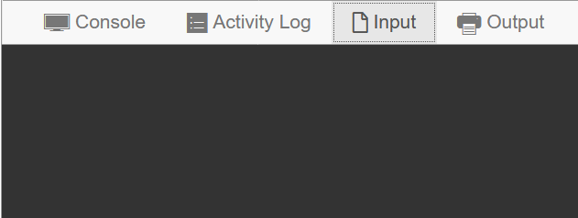E.g if input is in two lines, then the following code will read the numbers erroneously

a = 5, b = 7

c = 6

scanf("a = %d, b = %d", &a, &b);

scanf("c = %d", &c);

However, the following code will read things very well

scanf("a = %d, b = %d\nc = %d", &a, &b, &c);

1. When using double, float variables, be prepared for some approximation errors when doing math operations like addition, multiplication, typecasting etc since Mr C does not mind making small approximations given the huge numbers he is storing. If exact digits are important, use int or long.
2. 10 <= x <= 20 may give errors and is a dangerous way to write a conditional expression. Safer way (x >= 10) && (x <= 20).
3. Using == and != comparisons with float and double variables and constants can be risky and erroneous. Use these safely with int and long. For floats, doubles, usually we check if the values are close together or not. E.g. float a, double b; Instead of saying

if(a == b)

it is much safer to instead write

if(fabs(a – b) < 1e-5)

where 1e-5 = 0.00001 is some accuracy value which would be given to you.