Task 1: Basic Network Scanning with Nmap
Output
Screenshots
First Scan
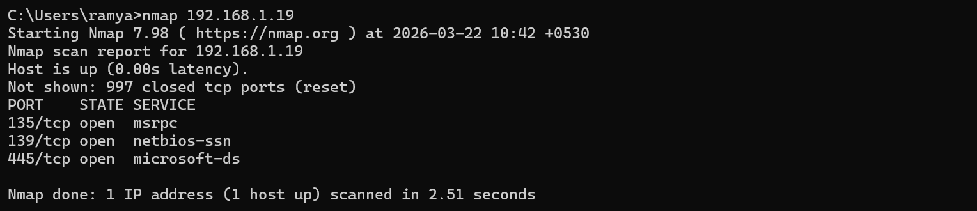
Detailed Scan
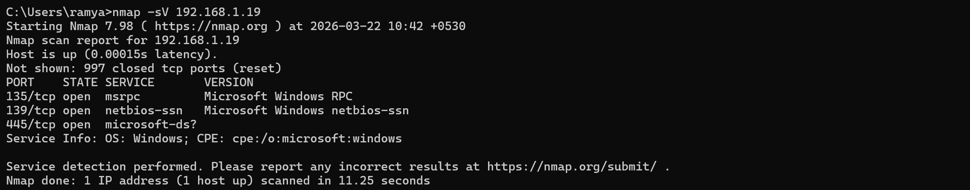
Scan All Ports
