3/25/2026
RAMYA SRI BATTALA
Common Network Security Threats

Task 4: Research Report on Common Network Security Threats
Report
Overview
This report provides a detailed study of common network security threats such as Denial-of-Service (DoS) attacks, Man-in-the-Middle (MITM) attacks, and spoofing. It explains how these attacks work, their impact, and the methods used to prevent them.
Objective
- To understand common network security threats
- To analyze how these attacks are performed
- To study their impact on systems and networks
- To identify preventive measures and solutions
1. Denial-of-Service (DoS) Attack
Description
A Denial-of-Service (DoS) attack is an attempt to make a system, server, or network unavailable to users by overwhelming it with excessive traffic.
Diagram
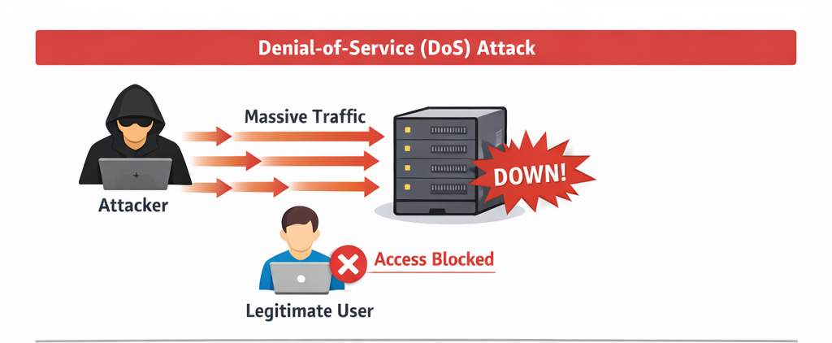
How it Works
- The attacker sends a large number of requests to a target server
- The server becomes overloaded
- Legitimate users cannot access the service
Impact
- Website or service becomes unavailable
- Loss of revenue and reputation
- Increased downtime
Real-World Example
- The Dyn DNS attack (2016) disrupted major websites like Twitter and Netflix
Prevention
- Use firewalls and intrusion detection systems
- Implement rate limiting
- Use load balancers
- Deploy anti-DDoS services
2. Man-in-the-Middle (MITM) Attack
Description
A Man-in-the-Middle attack occurs when an attacker secretly intercepts communication between t wo parties.
Diagram
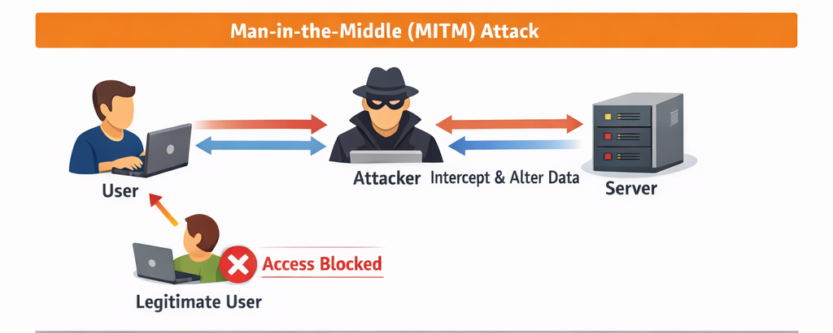How it Works
- Attacker positions between sender and receiver
- Intercepts and possibly modifies data
- Both parties think they are communicating directly
Impact
- Theft of sensitive data (passwords, banking info)
- Data manipulation
- Privacy breaches
Real-World Example
- Public Wi-Fi attacks where hackers intercept user data
Prevention
- Use HTTPS (SSL/TLS encryption)
- Avoid public Wi-Fi for sensitive transactions
- Use VPN services
- Enable two-factor authentication
3. Spoofing Attacks
Description
Spoofing is when an attacker pretends to be a trusted source to gain unauthorized access.
Types of Spoofing
- IP Spoofing
- Email Spoofing
- ARP Spoofing
Diagram
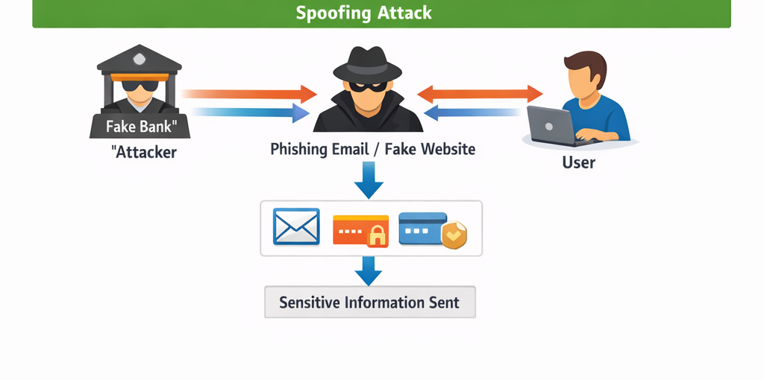
How it Works
- Attacker disguises identity
- Tricks system or user into trusting them
- Gains access or redirects traffic
Impact
- Unauthorized access
- Data theft
- Malware distribution
Real-World Example
- Phishing emails pretending to be from banks
Prevention
- Use authentication methods
- Implement network monitoring tools
- Use anti-spoofing filters
- Educate users about phishing

Comparison of Threats
Threat | Main Target |  | Impact | Prevention
DoS | Server |  | Service downtime | Firewalls, load balancing
MITM | Communication |  | Data theft | Encryption, VPN
Spoofing | Identity |  | Unauthorized access | Authentication
General Security Measures
- Use strong passwords
- Regularly update software
- Install antivirus and firewall
- Monitor network activity
- Use encryption for data transfer
Conclusion
Network security threats such as DoS, MITM, and spoofing pose serious risks to systems and data. Understanding how these attacks work and implementing proper security measures can significantly reduce vulnerabilities and protect network infrastructure.
References
- Cybersecurity documentation
- Online security resources
- Networking textbooks

