Common Network Security Threats
RAMYA SRI BATTALA

Cyber Security

Research Report on Common Network Security Threats

Objective
The objective of this task is to study and understand common network security threats such as Denial-of-Service (DoS), Man-in-the-Middle (MITM), and spoofing attacks. It aims to explain how these attacks work, their impact on systems and networks, and the methods used to prevent them, thereby improving knowledge of network security and protection techniques.
Introduction
Network security is the practice of protecting computer networks, systems, and data from unauthorized access, misuse, or cyberattacks. In today’s digital world, almost every activity such as communication, banking, education, and business operations depends on networks and the internet. This makes network security extremely important.
With the rapid growth of technology, cyber threats are also increasing. Attackers use various techniques to exploit system vulnerabilities and gain unauthorized access. These attacks can lead to serious consequences such as data theft, financial loss, and damage to reputation.
This report focuses on understanding common network security threats such as Denial-of-Service (DoS), Man-in-the-Middle (MITM), and Spoofing attacks. It also explains how these attacks work, their impact, and the methods used to prevent them.
Basics of Network Security
Network security includes policies, practices, and technologies designed to protect networks and data. It ensures confidentiality, integrity, and availability of information.
Key Concepts:
- Confidentiality: Data should be accessible only to authorized users
- Integrity: Data should not be modified without permission
- Availability: Systems should be accessible when needed
These three principles form the foundation of network security.
Types of Network Security Threats
Network threats can be categorized into different types:
- Denial-of-Service (DoS) Attack
- Man-in-the-Middle (MITM) Attack
- Spoofing Attack
- Distributed Denial-of-Service (DDoS)
Understanding these threats helps in designing better security systems.
1.Denial-of-Service (DoS) Attack
Definition
A Denial-of-Service (DoS) attack is an attack in which a system or server is flooded with a large number of requests, making it unavailable to users.
Working
The attacker sends continuous fake requests to the server. The server becomes overloaded and cannot handle real user requests.
Impact
- Website becomes unavailable
- Business loss
- Reduced performance
- Customer dissatisfaction
Real Example
The Dyn attack in 2016 affected major websites like Twitter and Netflix.
Prevention
- Use firewalls
- Apply rate limiting
- Use load balancing
- Monitor traffic
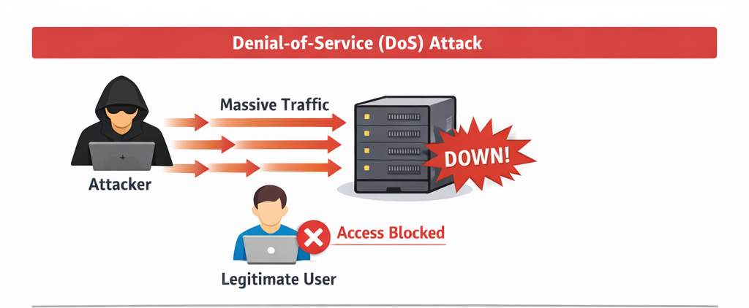
2.Man-in-the-Middle (MITM) Attack
Definition
A MITM attack happens when an attacker secretly intercepts communication between two users.
Working
The attacker places themselves between sender and receiver. They can read or modify the data.
Impact
- Data theft
- Privacy issues
- Unauthorized transactions
Real Example
Hackers stealing data over public Wi-Fi networks.
Prevention
- Use HTTPS
- Avoid public Wi-Fi
- Use VPN
- Enable 2FA
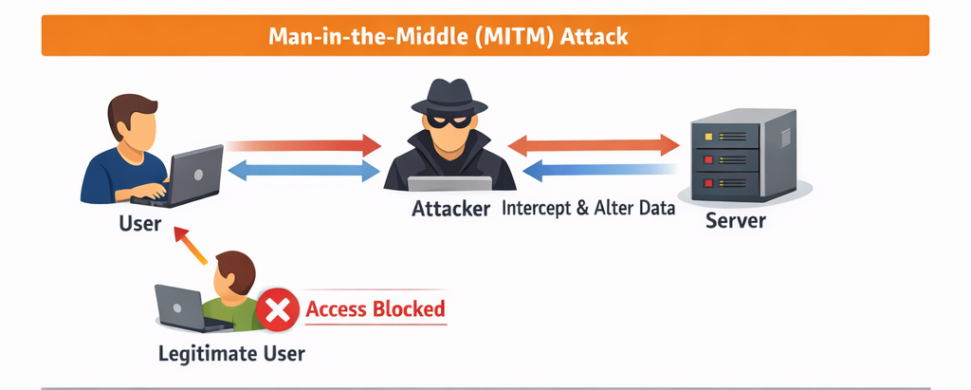
3.Spoofing Attack
Definition
Spoofing is when an attacker pretends to be a trusted source.
Working
The attacker creates a fake identity and tricks users into sharing sensitive data.
Impact
- Data theft
- Unauthorized access
- Phishing attacks
Real Example
Fake emails pretending to be from banks.
Prevention
- Authentication systems
- Email filters
- User awareness
- Verify sources
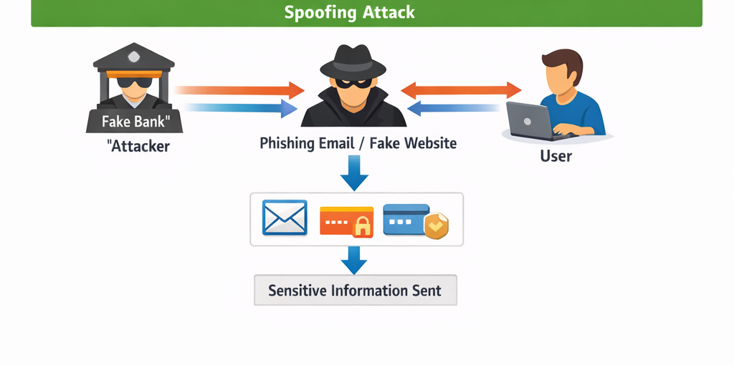
4.Distributed Denial-of-Service (DDoS)
A DDoS attack is an advanced version of DoS where multiple systems attack a target at the same time.
Working:
- Many compromised devices (botnet) send traffic
- Target system crashes
Impact:
- More powerful than DoS
- Hard to detect
Prevention:
- Use anti-DDoS services
- Traffic filtering

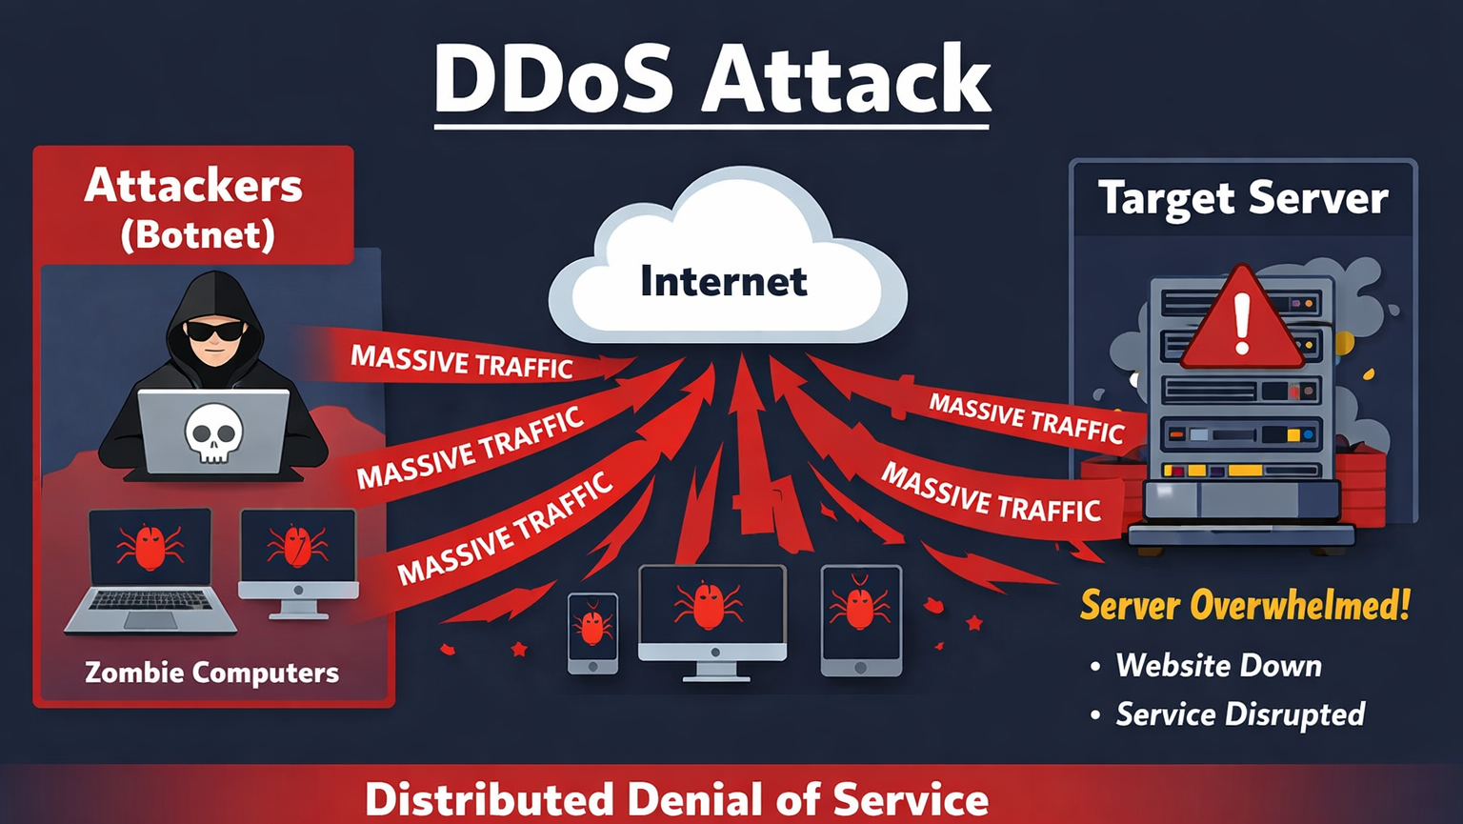

Comparison Table
Attack | Target | Impact | Prevention
DoS | Server | Downtime | Firewall
DDoS | Network | Crash | Anti-DDoS
MITM | Communication | Data theft | Encryption
Spoofing | Identity | Unauthorized access | Authentication

General Security Measures
- Use strong and unique passwords for all accounts
- Change passwords regularly
- Enable two-factor authentication (2FA)
- Keep operating system and software updated
- Install antivirus and keep it updated
- Use a firewall to block unauthorized access
- Avoid using public Wi-Fi for sensitive activities
- Use VPN for secure internet access
- Do not click on unknown links or attachments
- Verify emails and websites before sharing information
- Backup important data regularly
- Use secure websites (HTTPS)
- Log out from systems after use
- Limit user access based on roles
- Monitor network activity regularly
- Disable unused services and ports
- Use encryption to protect sensitive data
- Install security patches on time
Importance of Network Security
- Protects Sensitive Data
Network security helps protect important data such as personal information, passwords, financial details, and business data from unauthorized access.
- Prevents Cyber Attacks
It helps in detecting and preventing attacks like DoS, MITM, and spoofing, reducing the risk of system damage.
- Ensures Privacy
It keeps user communication and information private, preventing hackers from stealing or misusing data.
- Maintains System Availability
Security measures ensure that systems and services are always available and not disrupted by attacks.
- Protects Business Reputation
A secure network builds trust with customers and prevents damage to an organization’s reputation.
- Prevents Financial Loss
Cyber attacks can cause financial damage. Network security helps avoid losses due to fraud or downtime.
- Supports Safe Communication
It ensures secure communication over networks, especially in emails, online transactions, and data sharing.
- Helps in Compliance
Many organizations must follow security rules and regulations. Network security helps meet these requirements.
- Protects Against Unauthorized Access
It ensures that only authorized users can access systems and data.
- Improves Overall System Performance
A secure network runs smoothly without interruptions caused by attacks.
- Reduces Risk of Data Breaches
Prevents leakage of confidential information.
- Enhances User Trust
Users feel safe when their data is protected, increasing confidence in the system.
Challenges in Network Security
- Increasing cyber threats
Cyber attacks are growing rapidly in number and complexity. Hackers continuously develop new techniques, making it difficult to defend against all threats.
- Lack of awareness
Many users are not aware of security risks. They may use weak passwords, click on unknown links, or share sensitive information, making systems vulnerable.
- Weak passwords
Using simple or repeated passwords makes it easy for attackers to gain access to systems.
- Outdated systems
Old software may contain security vulnerabilities that attackers can exploit if updates and patches are not applied regularly.
- Insider Threats
Employees or authorized users may misuse their access intentionally or unintentionally, leading to data leaks or security breaches.
- Advanced Persistent Threats (APT)
These are long-term attacks where attackers remain hidden in the system and continuously collect data without being detected.
- Rapid Technological Changes
New technologies like cloud computing and IoT introduce new security risks that organizations must manage.
- Limited Resources
Small organizations may lack the budget, tools, or skilled professionals needed to maintain strong security systems.
- Network Complexity
Modern networks are large and complex, making it difficult to monitor and secure every part effectively.
- Phishing and Social Engineering
Attackers trick users into revealing sensitive information, which is difficult to prevent completely.
- Data Privacy Issues
Protecting user data while maintaining accessibility is a major challenge.
- Mobile Device Risks
Use of smartphones and laptops increases the risk of data breaches, especially when connected to unsecured networks.
- Zero-Day Vulnerabilities
These are unknown security flaws that attackers exploit before developers can fix them.
- Difficulty in Monitoring and Detection
Identifying attacks in real time is challenging due to the large volume of network traffic.
Future Scope
- AI-based security systems
- Advanced encryption
- Automated threat detection
- Internet of Things (IoT) Security
- Blockchain for Security
- Biometric Authentication
- Cybersecurity Awareness and Training
- Quantum Computing Impact
- Threat Intelligence Sharing
Conclusion
Network security plays a vital role in protecting systems, data, and communication from various cyber threats. Attacks such as Denial-of-Service (DoS), Man-in-the-Middle (MITM), and spoofing can cause serious damage, including data loss, financial loss, and disruption of services. Understanding how these attacks work helps in identifying vulnerabilities and taking appropriate preventive measures.
By implementing security techniques such as firewalls, encryption, authentication methods, and regular system updates, the risk of cyberattacks can be significantly reduced. User awareness also plays an important role, as many attacks occur due to human errors such as weak passwords or clicking on suspicious links.
As technology continues to grow, network security will become even more important. Future advancements like Artificial Intelligence and improved encryption methods will help in detecting and preventing threats more effectively. Therefore, adopting strong security practices and staying updated with new technologies is essential for maintaining a safe and secure network environment
References
- Cybersecurity textbooks
- Online security resources
- Research articles
- https://www.cloudflare.com/learning/ddos/what-is-a-ddos-attack/
- https://www.kaspersky.com/resource-center/threats/man-in-the-middle-attacks
- https://www.ibm.com/topics/spoofing
- https://www.cisco.com/c/en/us/products/security/what-is-network-security.html
- https://www.fortinet.com/resources/cyberglossary/network-security
- https://www.imperva.com/learn/application-security/ddos-attacks/
- https://www.techtarget.com/searchsecurity/definition/man-in-the-middle-attack-MITM
- https://www.checkpoint.com/cyber-hub/network-security/what-is-spoofing/
GitHub
https://github.com/RAMYASRIBATTALA/Common-Network-Security-Threats.git

