

|  |  |
| --- | --- |
| SUBMITTED TO | SIR SHAHID BHATTI |
| TOPIC | LAB ASSIGNMENT 4 |
| PROJECT NAME | COIN FLIPPER |
| SUBMITTED BY | RANA DANISH(139),M QASIM(079) AND M TAYYAB(57) |

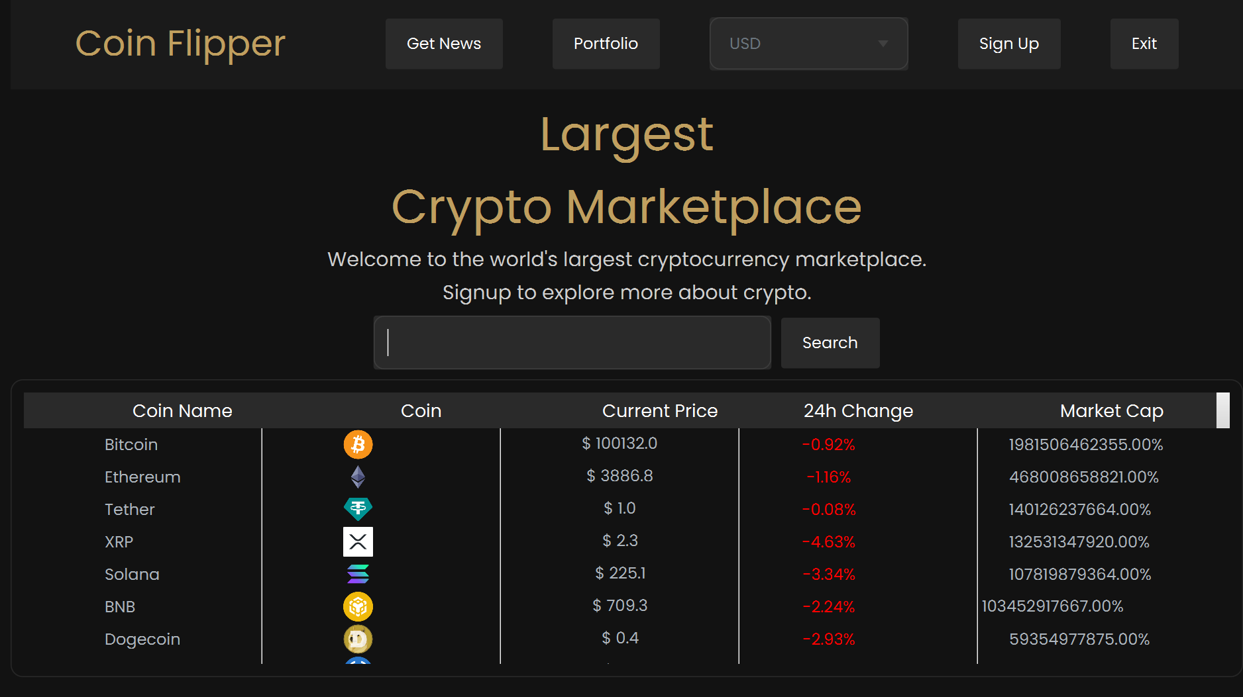

DESCRIPTION :

**Coin Flipper - Crypto Marketplace Overview**

1. **Navigation Buttons**: The page includes buttons like **Get News**, **Portfolio**, and **Sign Up**, each opening a new JavaFX page. After signing up, the "Sign Up" button changes to **Sign Out**, and a **Change Password** button appears. The **Exit** button closes the application.
2. **Coin Search**: Users can search for specific cryptocurrencies, displaying results (name, icon, price, 24h change, and market cap) fetched from a live API.
3. **Coin Details**: Clicking a coin opens a new page showing price graphs and detailed insights about that cryptocurrency.
4. **Currency Conversion**: A combo box allows currency selection (USD, EUR, INR), dynamically updating coin prices based on the chosen currency.
5. **Real-Time Data**: All data is live, sourced from a cryptocurrency API, ensuring up-to-date market trends and information.

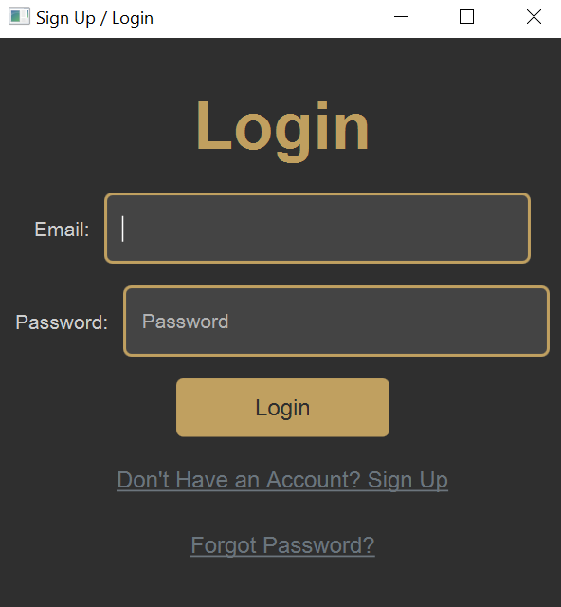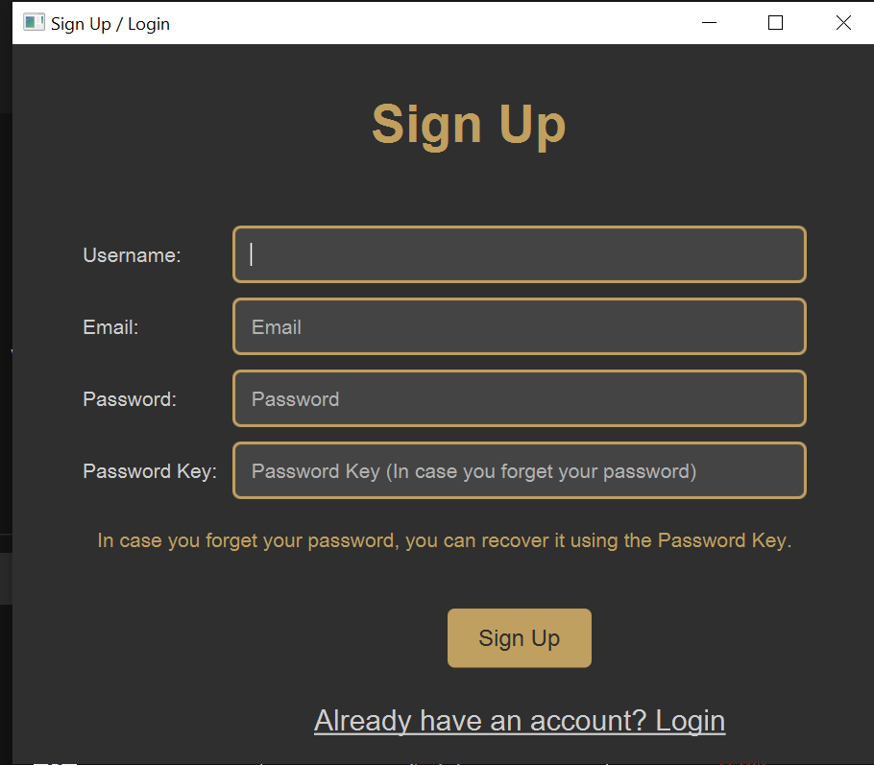

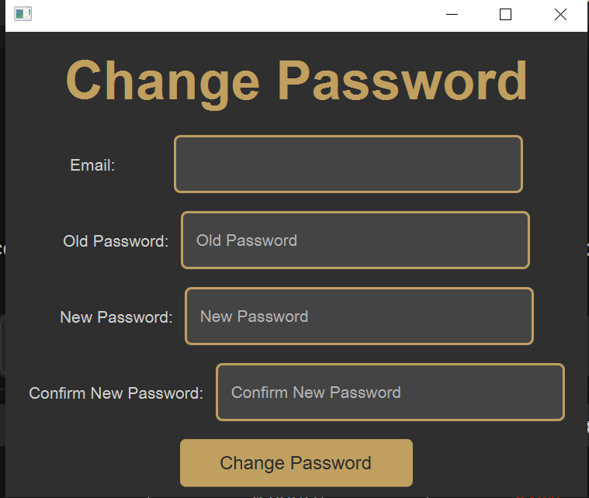

• **Sign Up**:  
The Sign-Up page allows new users to create an account by entering their username, email, password, and a password key (used for password recovery). A "Sign Up" button completes the registration, and a link redirects users to the login page if they already have an account.

• **Login**:  
The Login page enables registered users to access their accounts by entering their email and password. It includes links for **Sign Up** (for new users) and **Forgot Password** (for password recovery).

• **Change Password**:  
This page allows users to update their password securely. By entering their email, old password, and new password (with confirmation), they can change their credentials using the "Change Password" button.

• **Get Password**:  
The Get Password page is for recovering lost passwords. Users must enter their email and password key to retrieve their account credentials. The "Get Password" button initiates the recovery process.

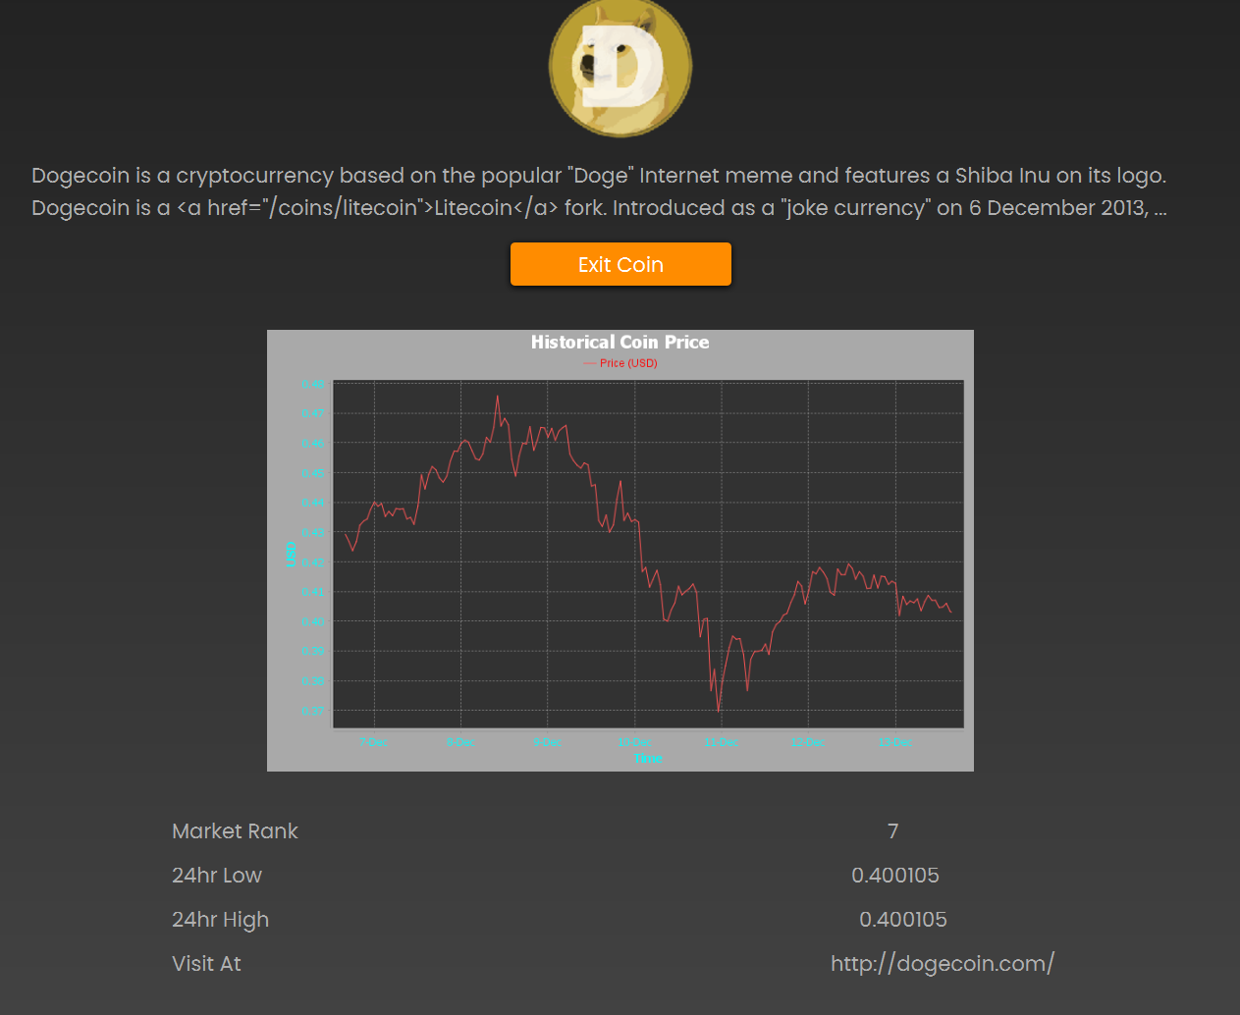

DESCRIPTION:

**Individual Coin Information Page**

1. **Coin Overview**:  
   This page displays detailed information about a specific cryptocurrency, fetched dynamically using an API. It includes the coin's description, market rank, 24-hour low and high prices, and a link to the official website for further exploration.
2. **Historical Graph**:  
   A real-time graph shows the historical price trends of the selected coin, giving users insights into its market performance over time.
3. **Navigation**:  
   The **Exit Coin** button allows users to return to the main page seamlessly.

This feature provides users with in-depth, real-time details and price analytics of individual cryptocurrencies for better decision-making.



**Methodology:**

1. **Data Source:**
   * We utilize a reliable and efficient API to fetch the latest news articles from reputable sources.
   * The API is configured to retrieve news specifically related to stocks and cryptocurrencies.
2. **Data Extraction:**
   * The API-fetched data is processed to extract relevant information, including:
     + Headline
     + News Source
     + Publication Date
     + Summary
     + Links to the full article
3. **Data Filtering and Categorization:**
   * The extracted data is filtered based on predefined criteria, such as:
     + Relevance to cryptocurrencies
     + Importance of the news event
     + Stock ticker symbols mentioned
4. **News Presentation:**
   * The filtered news articles are presented in a user-friendly format, with clear headings and concise summaries.
   * Key information, such as stock ticker symbols and relevant figures, is highlighted for easy comprehension.

**News API Integration:**

* **API Selection:** A robust and reliable news API is chosen based on factors like accuracy, coverage, and ease of integration.
* **API Configuration:** The API is configured to fetch news articles relevant to stocks and cryptocurrencies.
* **Data Fetching:** The API is used to fetch the latest news articles on a regular schedule.
* **Data Processing:** The fetched data is processed to extract relevant information and filter out irrelevant content.

**News Format and Display:**

* **Headline:** The headline of the news article is displayed prominently.
* **Source:** The source of the news article is mentioned.
* **Publication Date:** The date when the news article was published is displayed.
* **Summary:** A concise summary of the news article is presented.
* **Link to Full Article:** A link to the full news article is provided for further reading.

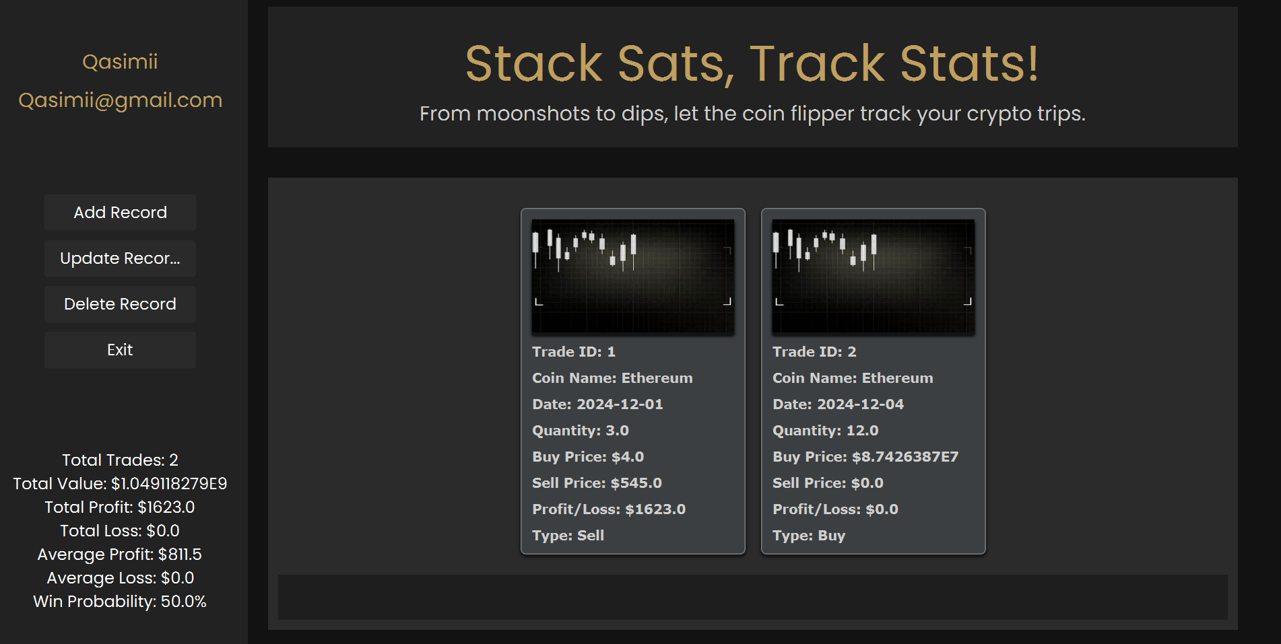

**Features:**

* **Add Record:** This feature allows users to add new trades to their record, including details such as coin name, date, quantity, buy price, sell price, and type (buy or sell).
* **Update Record:** Users can update existing trade records with accurate information if needed.
* **Delete Record:** This feature enables users to remove unwanted or incorrect trade records from their history.
* **Exit:** Users can exit the full-screen mode and return to the main interface.

**User Authentication:**

* Qasimii requires users to log in using a password to access and manage their trade records.
* This ensures data security and privacy, protecting sensitive information such as trading history and financial details.

**Data Storage and Retrieval:**

* User-entered trade data is securely stored and retrieved using a database system.
* This allows users to access their trading history and analyze their performance over time.

**Data Analysis and Visualization:**

* Qasimii calculates key performance metrics such as total trades, total value, total profit/loss, average profit/loss, and win probability.
* This data is presented in a clear and concise format, enabling users to gain valuable insights into their trading strategies.