**Week 2**

**Directory Structure on Week 2:**

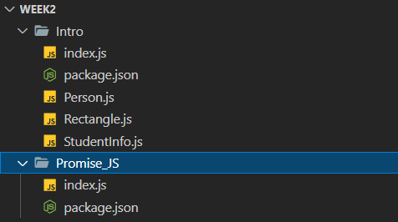

**Exercise 1**: In this exercise I am going to make a JavaScript function that takes two argument and return the data in console with parameters data. Two arguments are name of employee and salary of employee that will be passed in EmployeeInfo function as shown below in the pic.

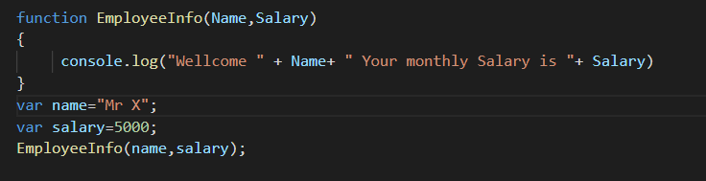

After passing name and salary to EmployeeInfo Function output on console is



**Exercise 2**: In this exercise I am going to create another function but this time I will use arrow function approach for function declaration as shown in below pic.

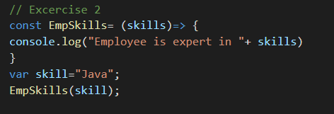

Output of above function is



Now I am aware about function calling approach by both methods. Now I am going to make some local module and call them in my index.js file. We will also define functions in local modules and call them in index file one by one Let’s start with two modules that are StudentInfo and Person

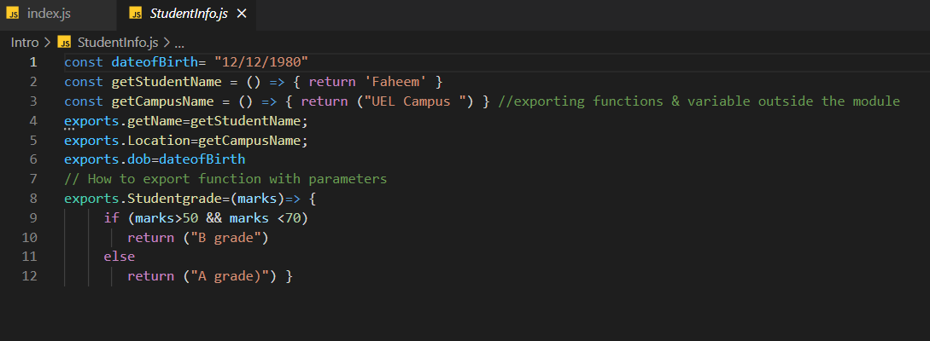

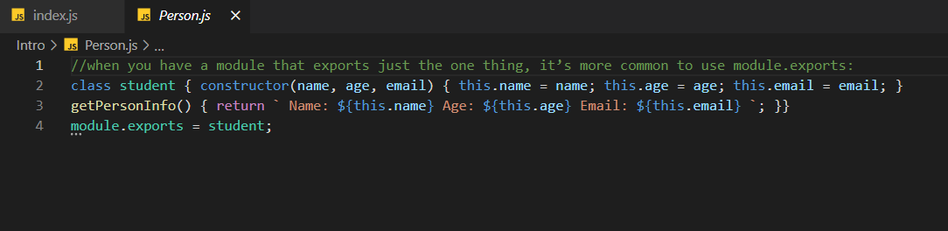

Now first we will create instance of each module in code and then call the related method of each function.

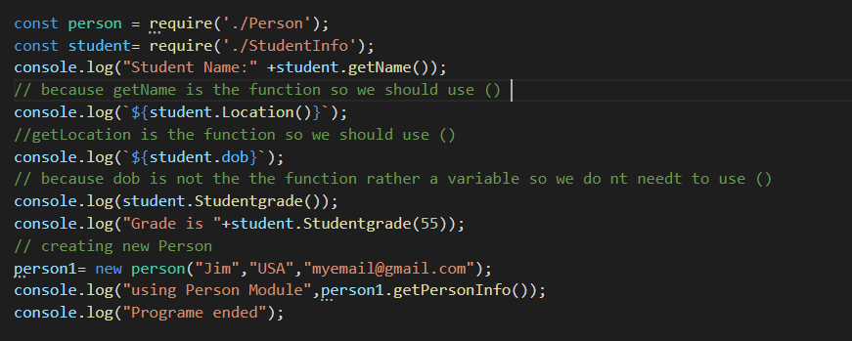

Output of above code is given below

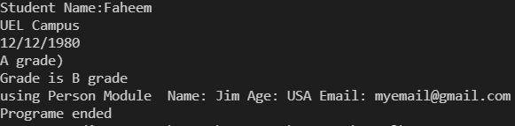

**Exercise 3**: In this exercise we want to use pre-define os module to get info related to our system. We will first create an instance of os module and then call related functions to get info.

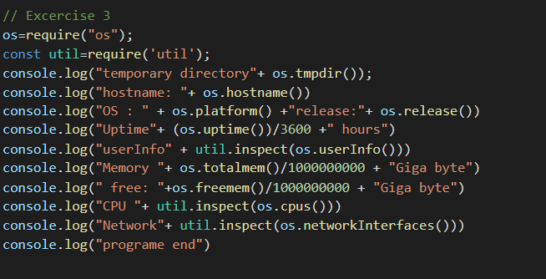

Result of above code is something like that:

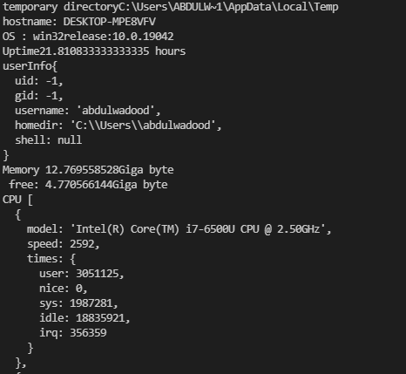

**Homework**: Now we have a homework task in which we will create a rectangle module that will take length and width as parameter and will return Parameter and Area of rectangle on function calling.

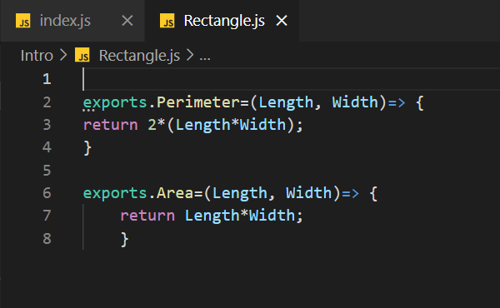

We will call these functions in our index.js file like this

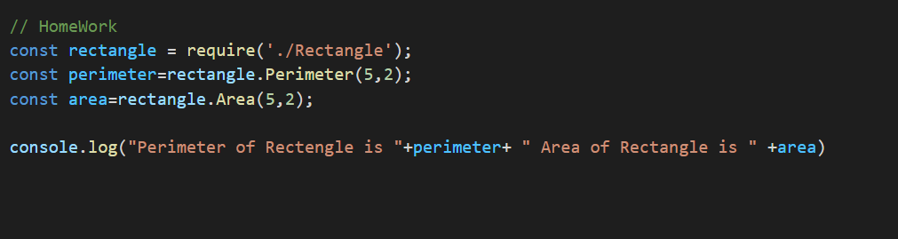

And output will be like this



**Exercise 3**: In this exercise we will first create another project name as Promise_JS and in this project, we will learn how to use promises in JavaScript. In index.js file we will define a promise and then in another example given below we will use promises to call function on the basis of decision made by promise.

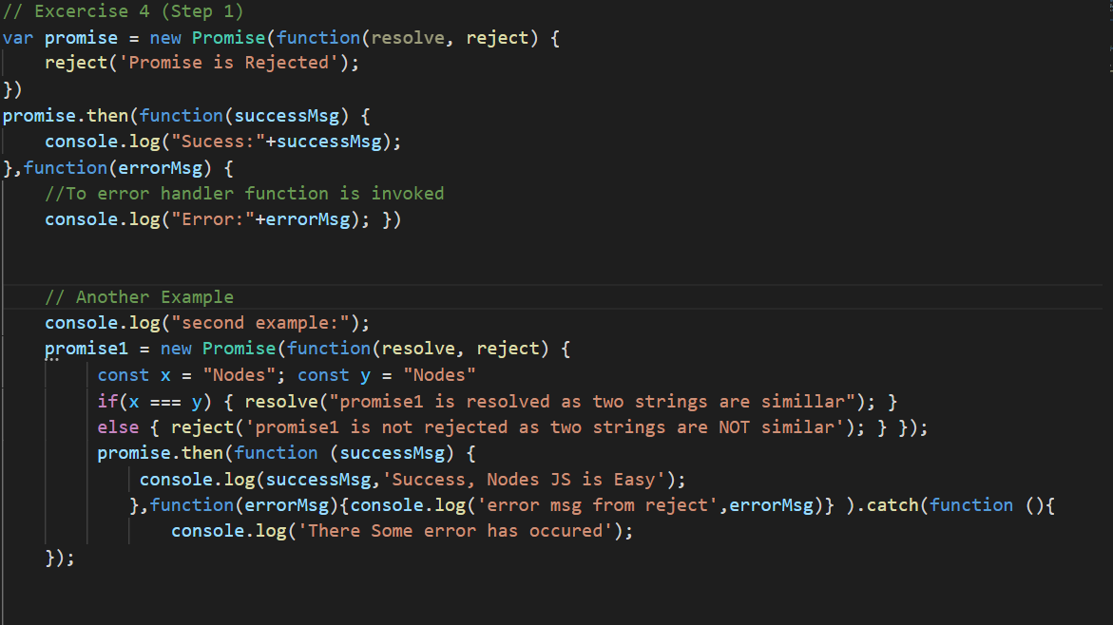

As you can see from above code we use two parameter in promise resolve and reject. If we will call resole in promise it will invoke function with successMsg parameter and if we will call reject then it will call errorMsg function.

Output of above code is given below

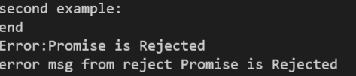

Now for better understanding we will use promise in the function and shown below in the code.

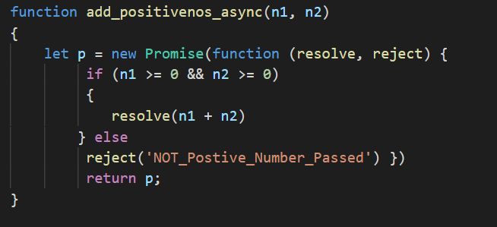

Now we will call this function multiple time

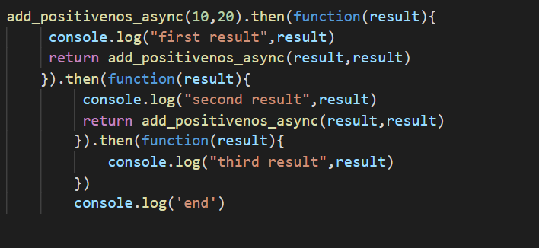

The result of above code is given below

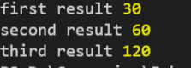

We can get promise reject by passing a negative number as argument.

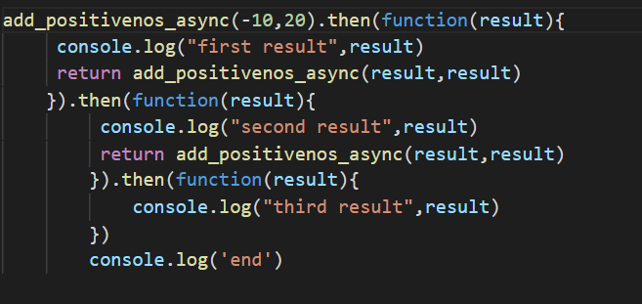

Result for rejected promise is given below

