**Week3**

**Directory Structure is given below:**

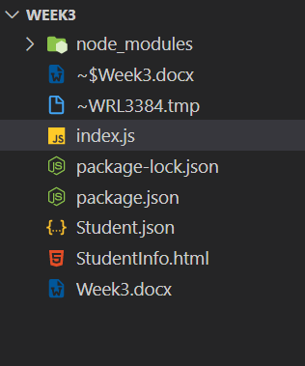

**How to create a web application using express?**

Today we are going to learn how to make a web application using express framework. First of all, we will define install express from node package manager using following command:

npm i express --save

and then we will use that package to start our web application.

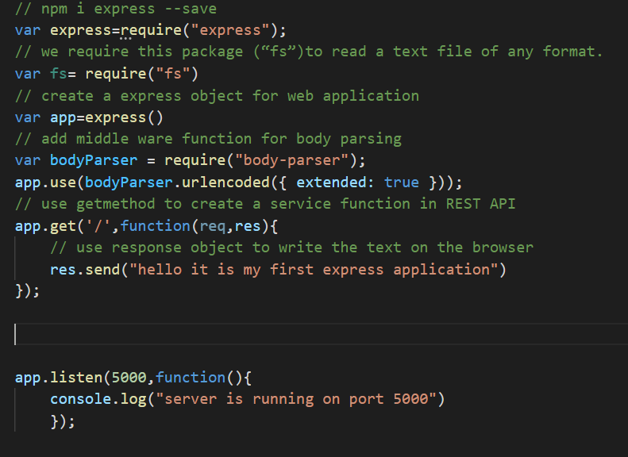

As shown in above picture first we define the express variable and then define fs for file reading. We use express function for app variable so we can later use other function of this library. We use body parser function for parsing URLs and listen function for listening on specific port i.e., 5000 according to above picture. Currently we are using only one url that will return string on request. We will use other paths as well in later part of this blog post.

Output of above code is given below



**What is the purpose of request and response object in REST API call?**

Request object in api call contain the object that server receives during the api request. It contains information send by user while response object is used to send data fetched from database on user request. Both these objects are passed as parameter of function in API call.

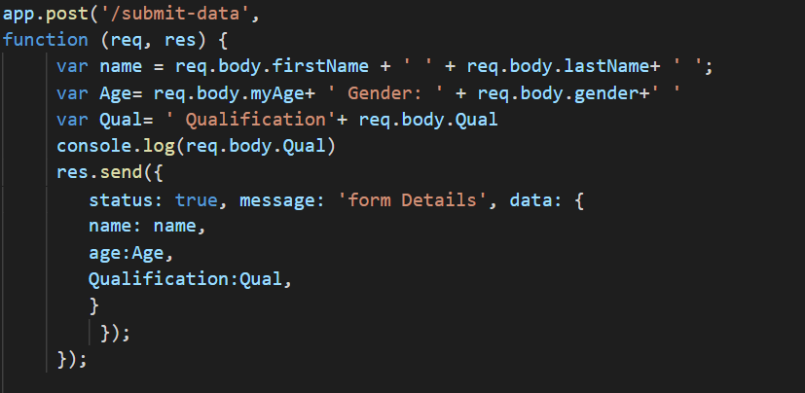

Above image represent the working of request and response object behavior. We receive the student firstname, lastname and other information in request object and then we are send back the response object with that student detail in proper format of response. Here is the response of the above api call.



**What code you will use if you want if you want to pass parameter in your URL?**

We will use the following code for passing parameter in url

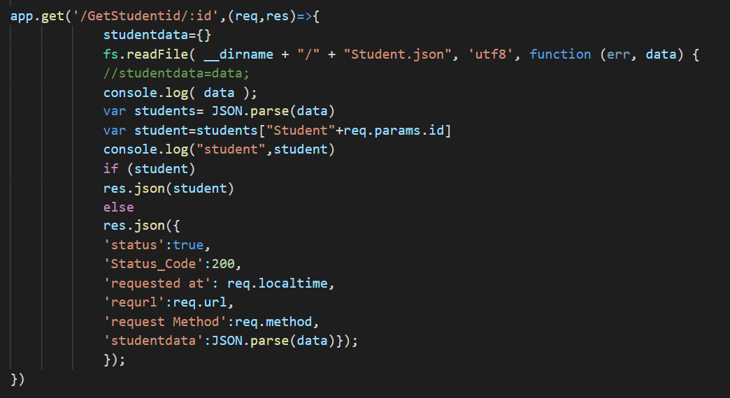

Response of the above code is given below

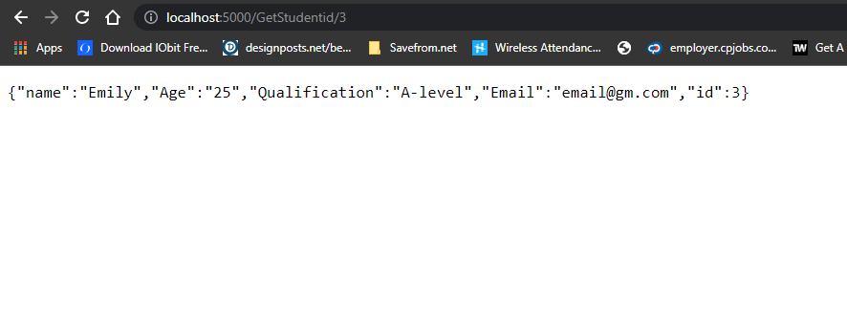

**What is meaning of fs in your code that you used today.**

We use fs when we deal with files in our code. We are using json file and read data from it that’s why we use fs in our code. Fs basically used for reading, writing, creating, updating and renaming files mostly.



**What is the Get and POST methods. when will you use POST methods.**

Get method is used to request data from a specific resource while post method is used to send data to server for updating or creating any record. We will use post method while creating new record or updating any previous record. An example of Get and Post request is given below.

When we will submit following form then we will get a response from our server.

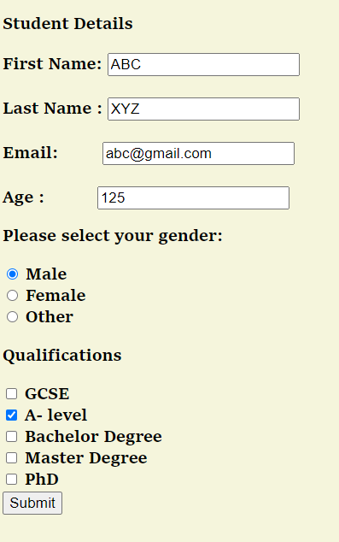

Server will use following code to handle form submission

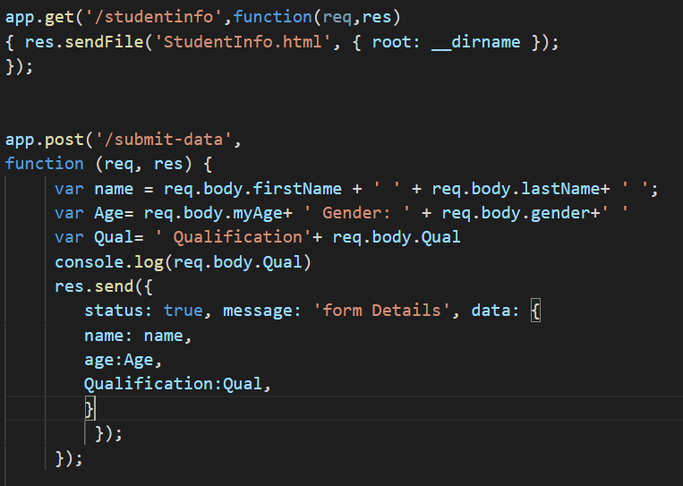

Response on submission will be this

