**Week5**

1. **What is React?**

React is an open-source UI library from Facebook. React mostly used to develop SPA (Single Page Application).

1. **What do you understand by React component and what command you use to create a react component with or without property?**

React component is functionally independent part of react app used for performing specific task. To create a react component we will create a new JavaScript file and import in into index.js. To assign a certain property to control its behavior we will pass property as an argument to component as shown in below code.

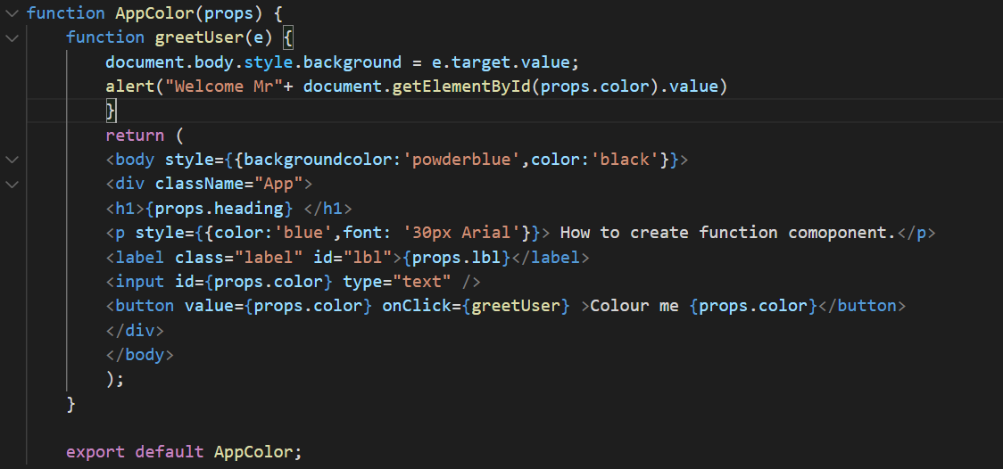

We will call it in index.js like this.

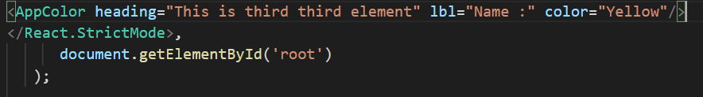

1. **What command will you use render the newly created component named as MyReact?**

We will use render function to render newly create MyReact function as shown below

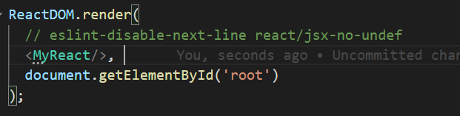

1. **Suppose the MyReact Component has a property heading, write down the code that could be used to render the MYReact Component , pass the message to property heading as “this is my first element”**

We will use the following code in MyReact Component to handle message

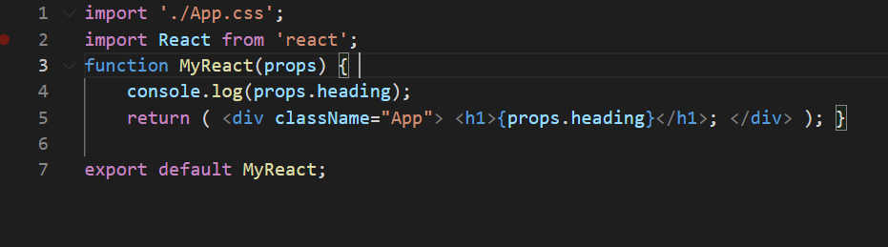

To pass property to this component we will use following code in index.js

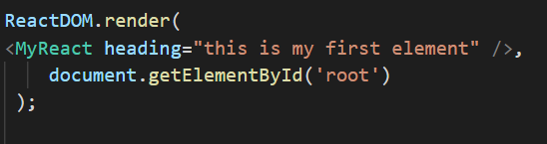

This code will render the code with given property as shown in following picture.



1. **Observe Code and answer questions.**

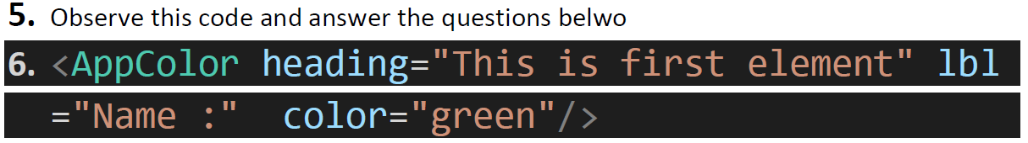

* 1. **What is the name of React Component?**

AppColor

* 1. **How many properties this component uses?**

3

1. Same as Above (Mistake in Assignment)
2. Look at the following code

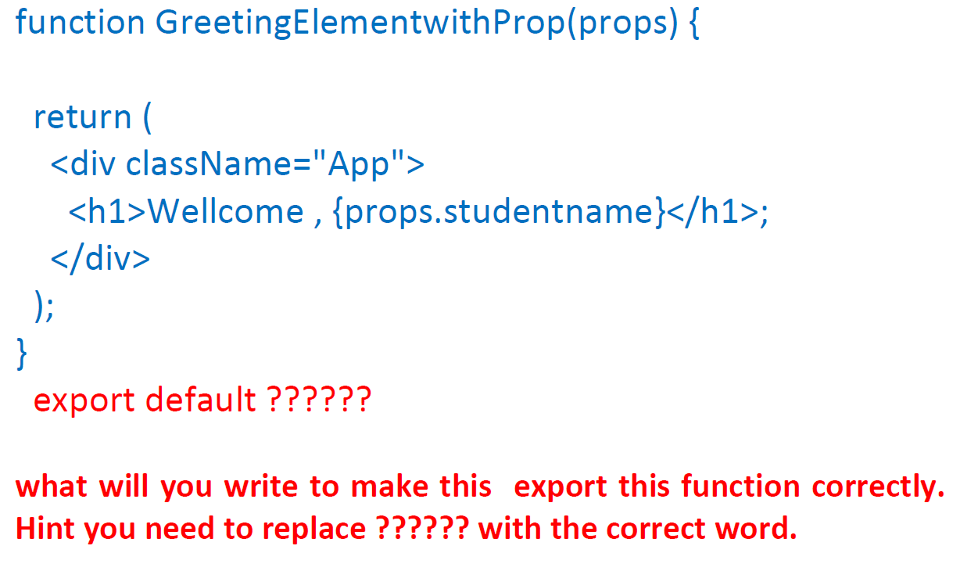

Following line will replace the last line of code

export default GreetingElementwithProp;