**Week6**

* **What is Name of the Component you have created in EmojeeCounters.js**
* **EmojeeCounter**
* **Identify the line of code that uses the EmojeeCounter in index.js**

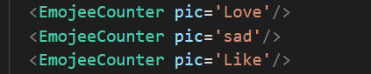

* **Declares the states of each of the html elements defined in the EmojeeCounters.js ( identify these lines and explain only those lines )**



in above picture we can clearly see that there are two states that are part of EmojeeCounter.js file. First state pic is used for counting reaction on emotion pic while count state is used for counting button clicks. We are using useState hook for these states and each state have its own set Function like pic has setPic and count has setCount that will be trigger on state change event.

* **Lines of codes that are used to associate the event handler used.**

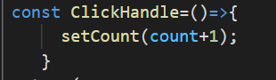 Following code is used for event handling in EmojeeCounter.js

* **Explain the line : <EmojeeCounter pic='Love'/> , what is pic=’Love’ means in this line.** 
  + 1. 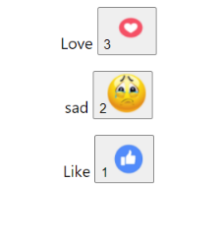 In above example pic is property and we are passing it as argument with value ‘Love’. On the basis of this property output shows the emojee name on webpage as shown below.
* **What is useEffect and why you think we have used it in the Component.**

userEffect is a hook that is used for to pass a hook variable with set function that let react know that after dom updates call this function. This function is also used for many other purposes like calling api etc.

* Explain these line of the codes in functional component EmojeeCounter.js:

return (

<div className="App">

<p>{props.pic} <span></span>

<button onClick={ClickHandle}>{count }

<img src={pic} alt=""/>

</button>

</p>

</div>

)

}

In above lines of code props.pic is property that define the name of emoji and passed through props from index.js to EmojeeCounter.js. ClickHandle is event handle function in EmojeeCounter.js that is used for counting clicks. pic in src contain pic URL that will be shown on webpage on rendering.