**Week 8**

We will go through and discuss one by one mongo db command that we will run in mongodb shell.

Following command will help us to run mongodb terminal in command line mode. Now we can run mongodb commands one by one.



To saw all dbs in mongo we use show dbs command as shown below in the picture.

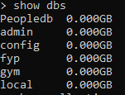

Now we will select peopledb to perform quries. Lets select db like shown below



After selecting db, we want to see all the collection in this db. Let do it with show collections command.



This db contain only one collection i.e. db. Now will insert a document in this collection and observe the response.

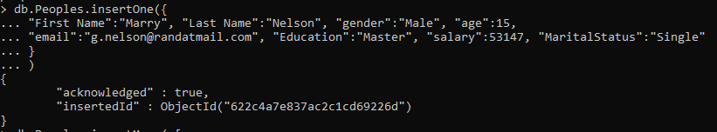

Return object show insertedId which means we successfully inserted the document into collection.

Now if we want to add multiple documents at the same time then we will use insertMany command as shown below 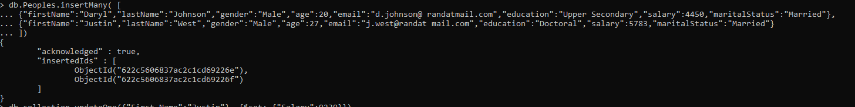

Response shows that we succesfully added multiple documents at the same time.

Now if we want to update a document we will use update query like shown below



First parameter of the function contain filter object while other parameter set the updated values.

Now we want to delete a record from collection. First we will check total number of records with count function as shown below



We have total 201 records in our collection. Let delete one of them using deleteOne command



Now let count again



After successfully deleting a document let’s use find to query some data.

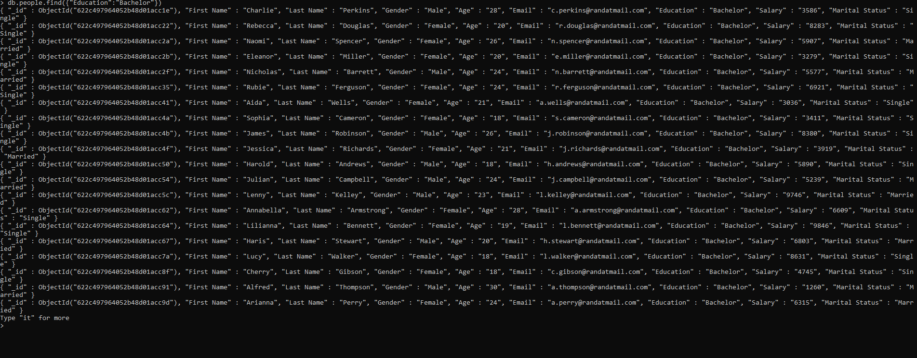

Above picture show data related to our filter. All records contain Education Bachelor. Let’s count all of them.



Total records are 34. Let use multiple parameters in find query to increase complexity

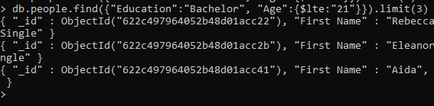

Above pic use two parameter to fetch data first one is education and other one is age. Logic for this query was to get data where people have Bachler education with age less then or equal to 21 with a limit of maximum 3 records only. Let’s apply some Boolean operator to find data with conditional requirement

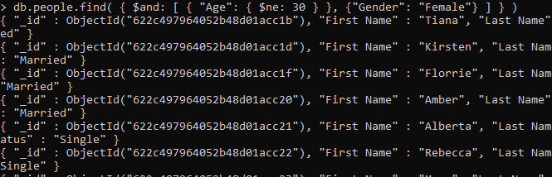

In above example we are using and operator to find data that is within the requirement of both sets. Now we will apply sorting on the selected records. After finding records if we want to show the records in descending order then we will pass -1 in sort function with fields name as shown below in other case we pass 1.

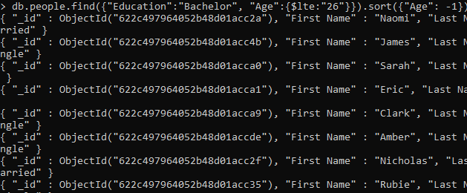

To find specific set of data with some operations as group we use aggregate function. For example if we want total number of people of every education in our collection we will use following command

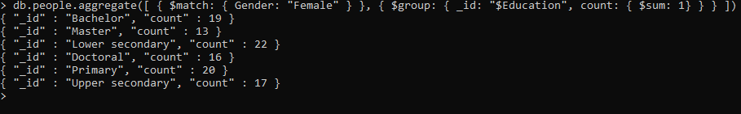

$match is used for filter purpose while $group object represent the group data that we are calculate through $sum function. Result is given in above picture.