# 4CS012 – Server Management and Virtualisation

Workshop 1

STUDENT NAME:

STUDENT NUMBER:

You will need to complete the workshop tasks, answer the questions and then submit this Word file, complete with your screenshots and answers, via Canvas.

## **This workshop should be completed using AWS cloud platform. Please look for the email (your wlv emails) that you received from AWS Academy on the 20/01/2022 and click on the “Get Started” to access the AWS Academy Canvas platform. Choose “Create Account” and you will need to create a password for your account.**

## Task 1 - Installing and Windows Server 2019 on AWS

1. Once you have logged in AWS Academy, locate the course “AWS Academy Learner Lab - Foundation Services”

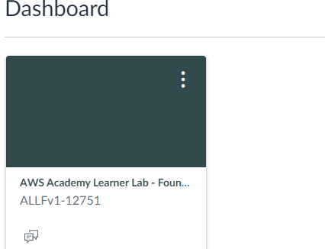

1. Click on “Modules” and then “[Learner Lab - Foundational Services](https://awsacademy.instructure.com/courses/12751/modules/items/1101934)”. This will give you access to a Sandbox environment on AWS where you can complete the workshops for this module. Take a few minutes to explore the main menus that will be needed.

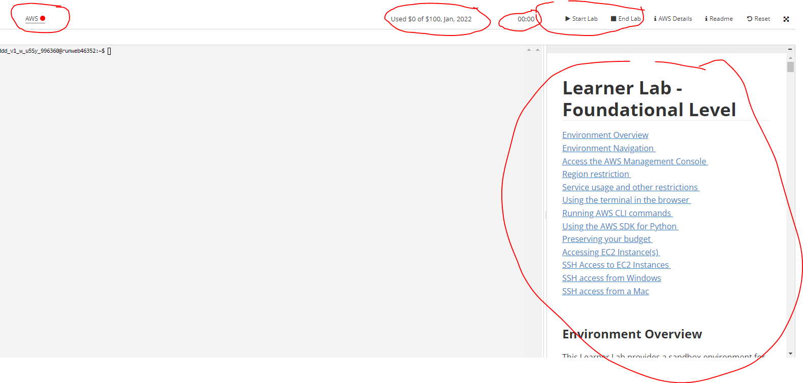

1. Click on “Start Lab” to start the cloud environment. This might take a couple of minute to load. You will notice that the AWS button on the top left side will turn green and if you click on AWS details it will give you access to the different security keys needed later in the workshop. You are limited to using the cloud environment for 6 hours in one session.

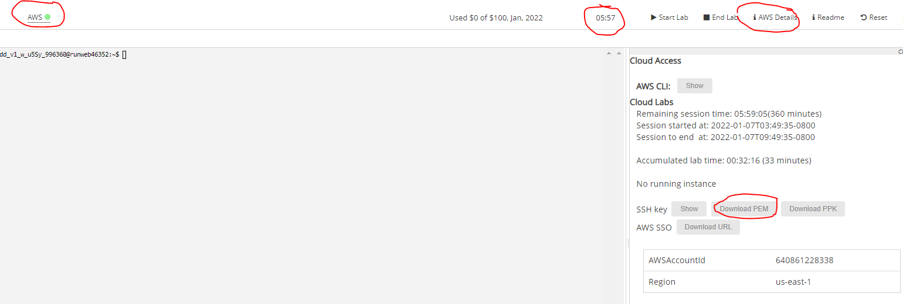

1. Click on the “AWS” button in the top left to access AWS Console
2. On the AWS services page, choose “**EC2**” under ‘Compute’

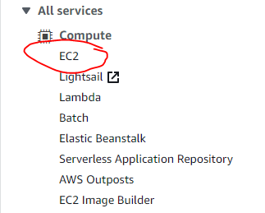

1. Create a AWS VM by clicking on ‘**Launch Instance’**

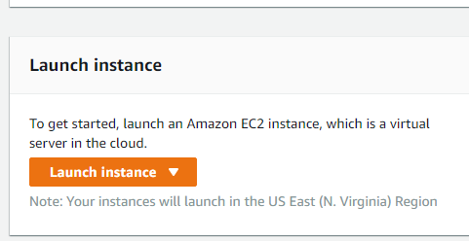

1. On the list of machine images available, choose **Microsoft Windows Server 2019 Base**



1. Make sure the “t2.medium” is selected and click on ‘**Next: Configure Instance Details**’

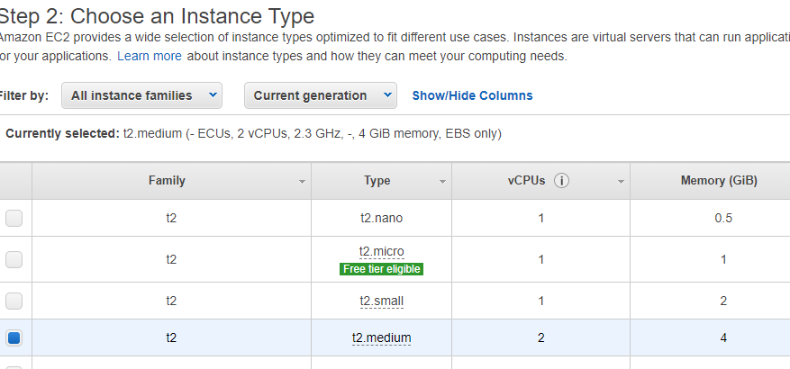

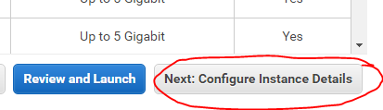

1. On the “Configure Instance Details” page, leave everything on default. And click on “Add Storage”
2. Leave the settings on default and click on “Add Tags”. You can add any tags you wish but it’s not necessary. Click on “Next: Configure Security Group”
3. On the “Configure Security Group”, you are going to allow traffic to your server. The RDP rule is already added but you need to specify the IP addresses allowed. Under the “**Source**” column dropdown menu, choose “**Anywhere**”
4. Next click on “Add Rule” and add the following traffic types and configure the Source as Anywhere for all of them: **HTTP, HTTPS, DNS, SSH and SMB**. Also add All **ICMP-IPv4. Add** another **TCP custom and specify port “21”.** This will allow FTP traffic.

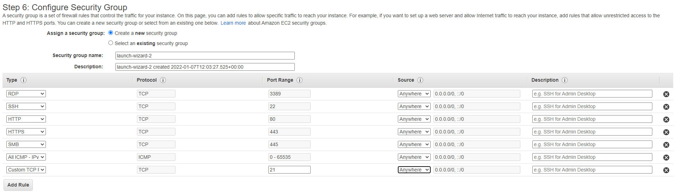

1. Click on “**Review and Launch**” and then “**Launch**”
2. You now need to create a security pair to connect to your instance. Choose “A**n existing key pair**” in the dropdown menu and make sure you choose “vockey|RSA. Click on **“Launch Instance”**

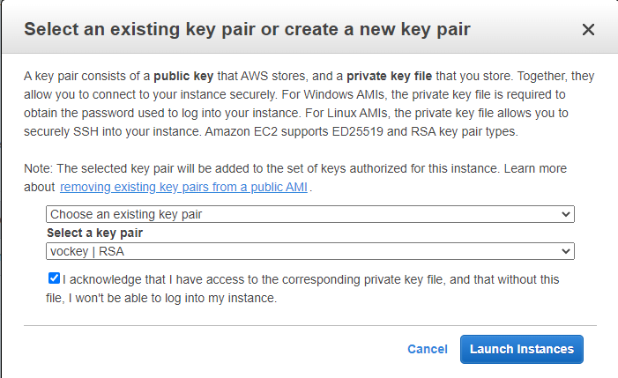

1. **You must now download the Key Pair from the canvas topic.** 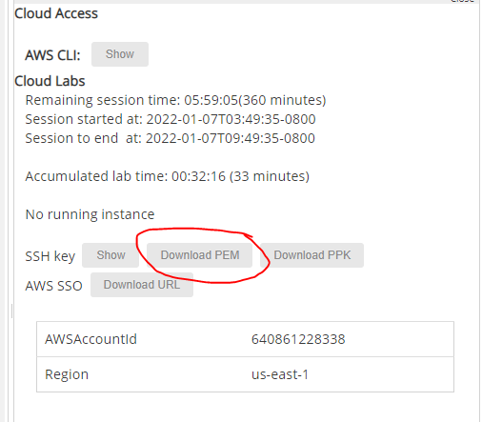
2. Your instance will now be running and click on **“Instances**” to view it.

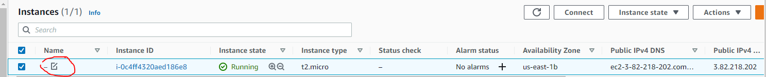

If you hover the mouse under the name, you will get an option to give a name to your instance. Give it a name using your initials and student number eg: CM1234567

1. Next select your instance, select “**Connect**”

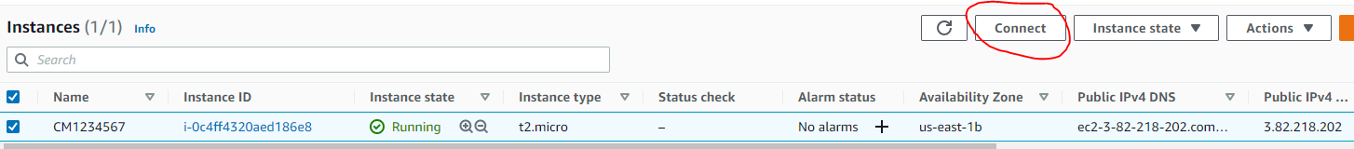

1. On the “**Connect to instance**” page make sure you are on the “**RDP client** “tab
2. You are then going to “**Download Remote Desktop file**”. You also need to acquire the password to your instance by clicking “**Get password**”. This will ask you to upload your “Key Pair” file that you saved in Step 15. After you have decrypted your password select it and copy it

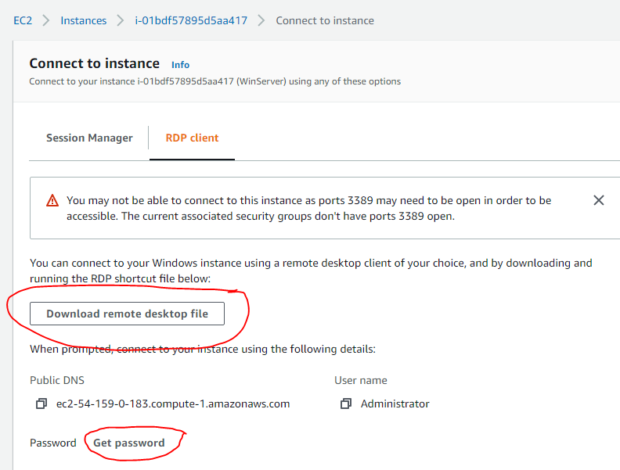

1. You now need to open you downloaded “RDP” file and click on “Connect”

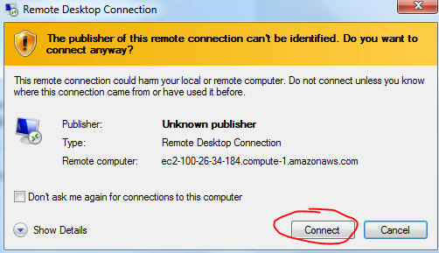

1. Login as Administrator
2. 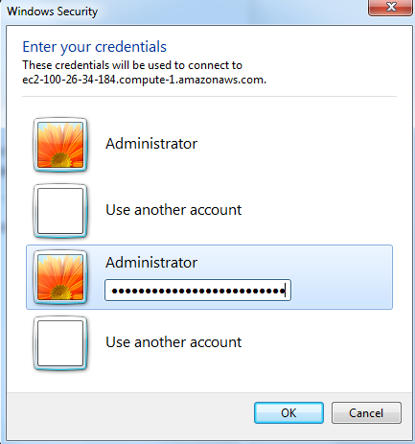
3. You should be logged in your Windows Server 2019 take a screenshot similar to the one below and paste it:

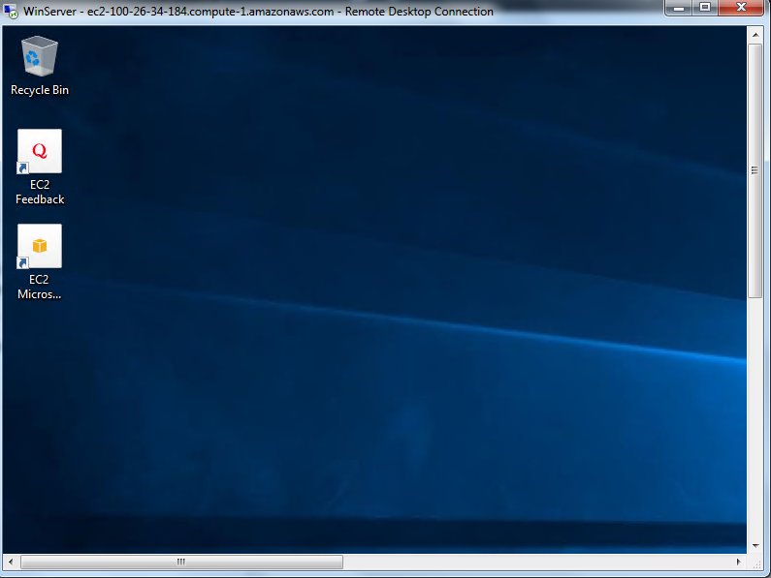

**[Paste your screen shot here] (Marks)**

1. You may be asked “Do you want to find PCs, devices and content on this network?”. Click “Yes”.

## Task 1 – Verifying the Installation

1. Next go on the “Windows start” menu and choose “Server Manager”

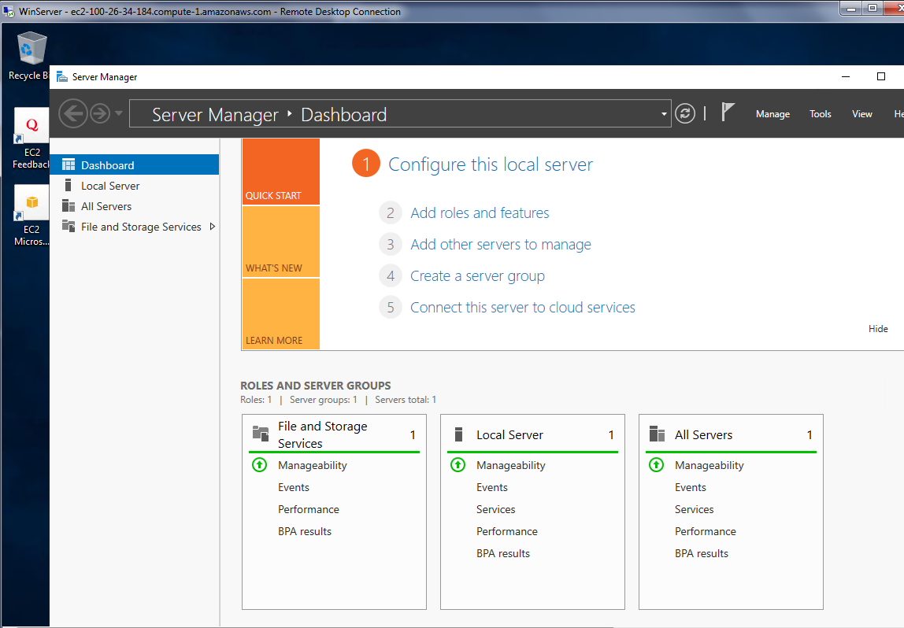

1. Now capture your full screen Windows Server desktop and paste the screenshot into the space below:  
     
   **[Paste your screen shot here] (Marks)**
2. We are now going to set the Computer Name of this VM.
3. Do a bit of research and find out how to change the name of the server you have created. You should name it using your initials and the student number eg: **CM1234567**
4. The server will ask you to restart
5. Once successful, capture a screen showing the new name and paste it below:

**[Paste your screen shot here] (Marks)**

1. To verify that you have installed the Windows Server system correctly, you will now run the SYSTEMINFO utility. Within the Windows server system, start Windows PowerShell, by opening the start menu:

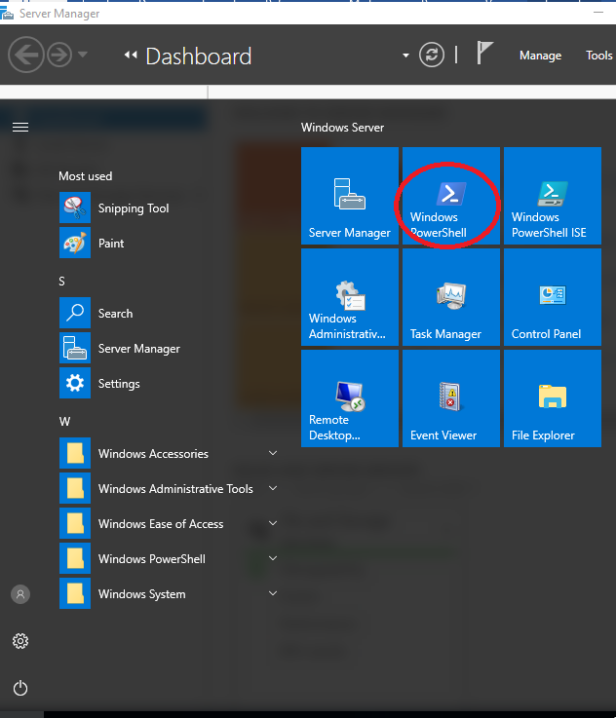

1. Maximize this PowerShell window so that it is as large as it can be. Click within this window window and type the command "**systeminfo**" and press the Return or Enter key.
2. 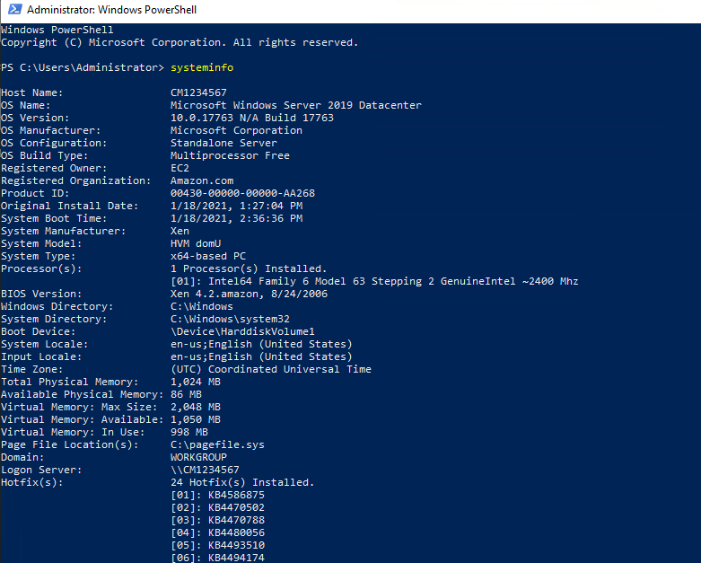
3. Capture your own screen paste it into the space below:  
     
   **[Paste your screen shot here] (Marks)**

**What useful information can you deduct from the output of this command? (Marks)**

**Make sure that the information is legible. Otherwise you will lose marks.**

## Task 3 – Creating User Accounts

1. In Windows Server 2019, right-click on the “Start” button and then click “Computer Management”.

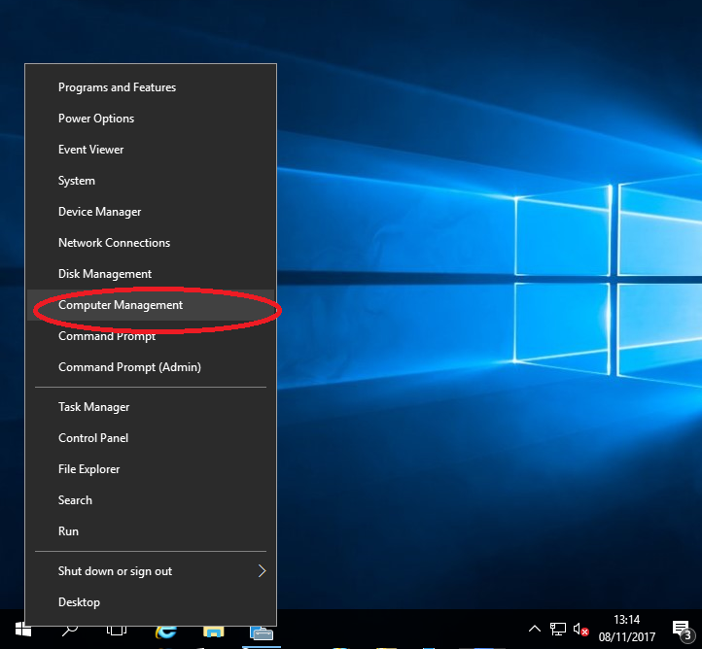

1. Expand the Local Users and Groups folder, until you get the following screen:

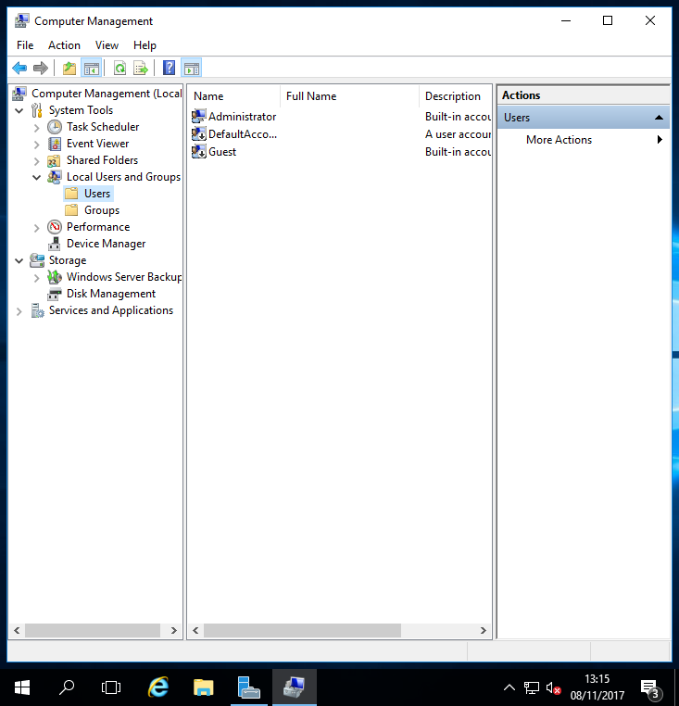

1. Expand More Actions on the right hand side on “Action” and “New User”.
2. Name your new user as your **student ID** such as “**1234567**” and set the password to “**ABCdef123**”.
3. Uncheck(clear) the “User must change password...”, as below:

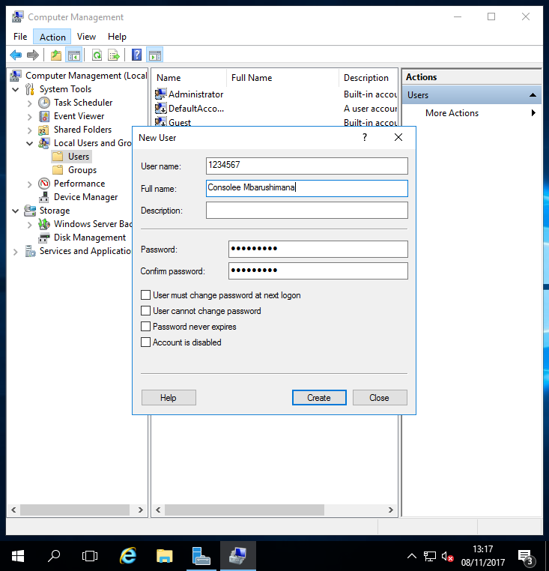

1. Obviously, use your own name rather than mine!
2. Click “Create” and then “Close”, and your new user should be shown on Computer Management:

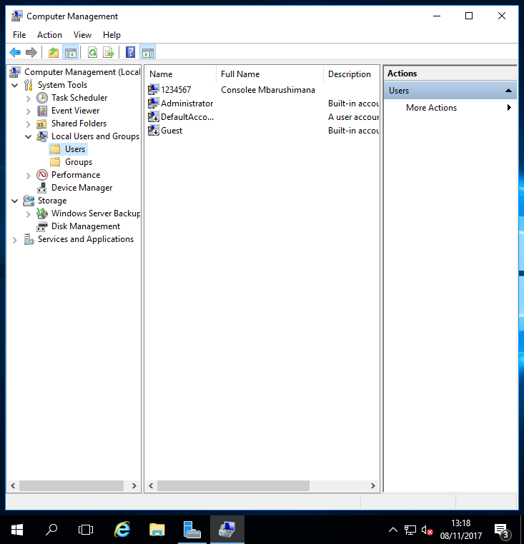

1. Capture and paste your equivalent screen below:

**[Paste your screen shot here] (marks)**

1. We are now going to make this user **an administrator** as well so that if anything should happen to the original Administrator account, we have a second chance at logging on and fixing the problem.
2. Do a bit of research of how to do this and paste a screenshot of your result below (the screenshot should show that the new user is now also a member of **"Administrators**". Capture the screen showing this information and paste it below:

**[Paste your screen shot here] (marks)**

## Task 4 – Identify Running Processes

Processes are programs or applications in execution. You will explore the processes using Process Explorer in the Windows Sysinternals Suite. You will also start and observe a new process.

1. Download Windows Sysinternals Suite. Navigate to the following link to download Windows Sysinternals Suite: <https://technet.microsoft.com/en-us/sysinternals/bb842062.aspx>
2. After the download is completed, right+click the zip file, and choose Extract All…, to extract the files from the folder. Choose the default name and destination in the Downloads folder and click Extract.
3. Exit the web browser.
4. Navigate to the SysinternalsSuite folder with all the extracted files.

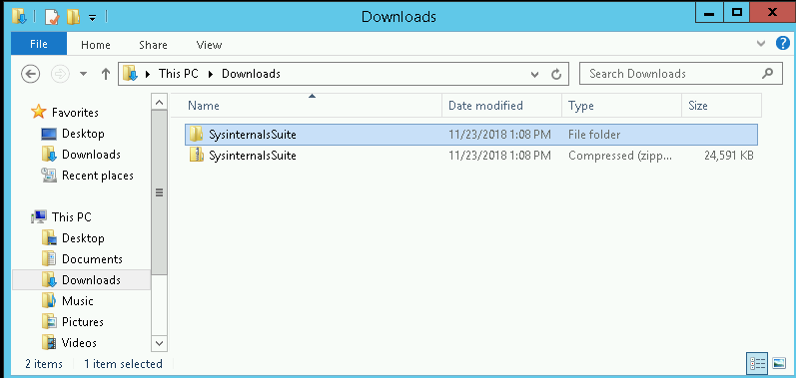

1. Open **Tcpview.exe**. Accept the Process Explorer License Agreement when prompted. Click **Yes** to allow this app to make changes to your device.

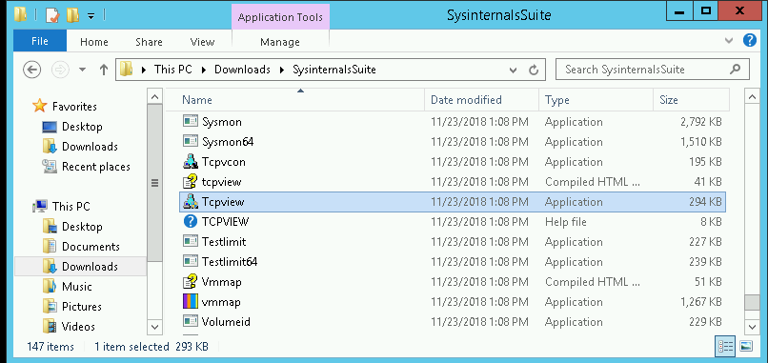

1. Exit the File Explorer and close all the currently running applications.
2. TCPView lists the process that are currently on your Windows Server. At this time, only Windows processes are running.

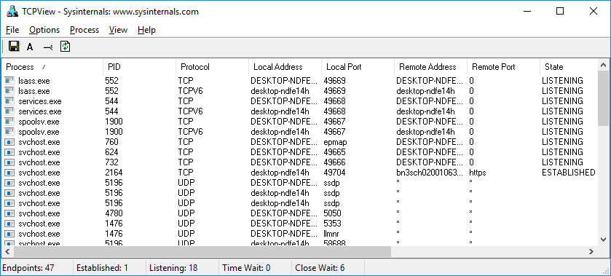

1. Double-click **lsass.exe**. What is lsass.exe? In what folder is it located?

**[Your answer here] (marks)**

1. Close the properties window for lsass.exe when done and View the properties for the other running processes.

**Note**: Not all processes can be queried for properties information.

1. Explore a user-started process. Open a web browser, such as Microsoft Edge. What did you observe in the TCPView window?

**[Your answer here] (marks)**

**[Paste the corresponding screen shot here] (marks)**

1. Close the web browser. What did you observe in the TCPView window?

**[Your answer here] (marks)**

1. Reopen the web browser. **Research 3 of the processes listed in TCPView**. Record your findings.

**[Your answer here] (marks)**

**YOU MUST NOW SHUT DOWN YOUR SERVER. FAILING TO SHUT IT DOWN WILL USE UP YOU CREDIT AND YOU RISK RUNNING OUT BEFORE THE END OF THE MODULE.**

1. Click “Shutdown”, and select “Operating System Reconfiguration (Planned)”
2. Make sure that the instance has stopped by checking on AWS console. If it hasn’t, select the instance, then Instance state and select “Stop instance”

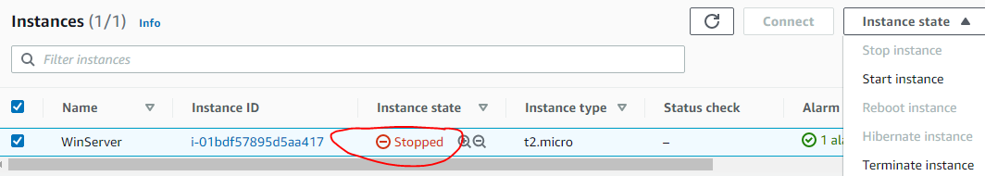

This is the end of the workshop. Make sure that you have saved this Word file in a safe place and location that you know, and then upload it to the **Canva**s submission folder. You can always over-write the copy in Canvas with a later updated copy if necessary.

1. BE 100% SURE YOU’VE RECORDED YOUR KEY PAIR FOR FUTURE WEEKS! ☺