# 4CS012 –Server Management and Virtualisation

## Workshop 2 - Windows Server Roles

**STUDENT NAME:**

**STUDENT NUMBER:**

You will need to complete the workshop tasks, answer the questions and then submit this Word file, complete with your screenshots and answers, via Canvas

Please use the same workstation for all your workshops, or you will not have access to the virtual machines that you have created previously. If you are unable to use the same workstation for a good reason, then check with the tutor to see if your files can be copied to another workstation.

The Windows Server that you have set up can perform many Server Roles. In this workshop, your existing Windows Server installation will be configured to perform file storage server. First it will be configured as a network Windows File Server, and then as a FTP Server

## Part 1 - Setting up as a Windows File Server

In this first part, we are setting up the server as a network file server. In order to access the server however, a client will be need. You can use your existing Windows machine or you can use a VM Windows client in order to demonstrate access to the server. Instead of setting up a Windows client from scratch, you can create a client from a ready-made Windows 7 Client VMware virtual machine. You can download a copy of **a Windows 7 VM from the “Resources**” on Canvas.

## Task 1 - Run Windows 7 Client

1. Load up “Security Windows 7” VM or your other client VM.
2. You need to find out the IP address of the client VM. Investigate how you can find it and record the IP address below:  
     
   **Question: What is your IP address of your client?**
3. For the moment leave the Windows client running. Don't shut it down or close it for the next part.

## Task 2 - Configuring the Windows File Server

1. First you need to make sure EC2 firewall rules are set to accept FTP traffic.
2. Go on the AWS instances page, select your server and click on the Security Groups Settings

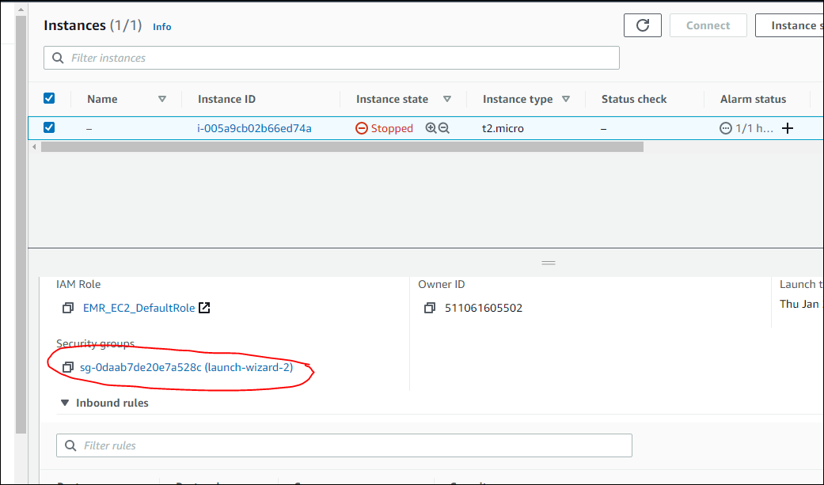

1. You are now going to add a firewall rule to allow FTP. Click on Edit inbound rules

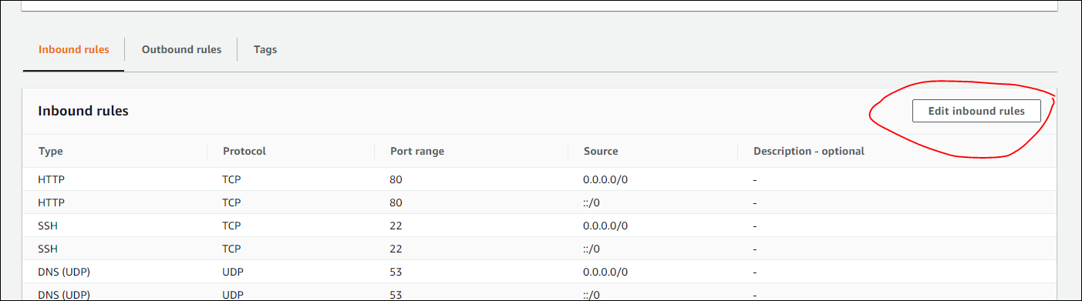

1. Add rule and select a “Custom TCP”, add port “21” and allow from “Anywhere”. Add rule and exit.



1. Now Start up your Windows Server virtual machine and log in.
2. In order for the Windows File Server to authenticate its resources, you need to have users on the server.
3. Please refer to the details of the user you created in Workshop 1 (your user should be your student ID and a password of ABCdef123)
4. Start “Server Manager” if it is not already running.
5. Click “Add roles and features” and click next.
6. For “Installation Type”, make sure “Role-based or feature-based installation” is selected, then click “Next”.
7. On “Server Selection”, click “Next”.
8. On “Server Roles”, click on “File and Storage Services” to expand the list, as below:

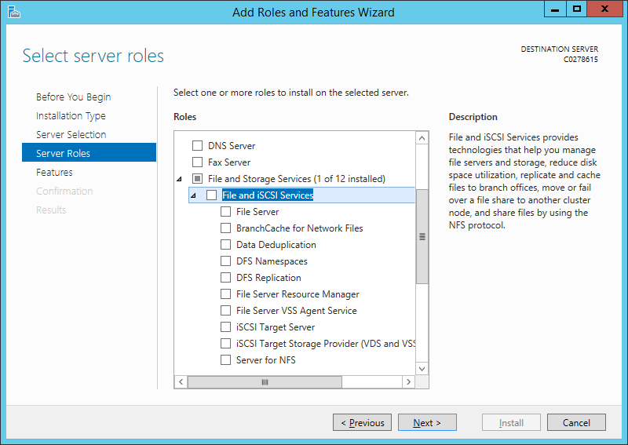

1. Select “File Server” and click “Next”.
2. On “Features”, keep the default, and click “Next”.
3. On “Confirmation”, click “Install”.
4. Open “File Explorer”, and go to the C: drive. Create a new folder, called “Shared”.
5. Click on “Shared”, and click “Share” 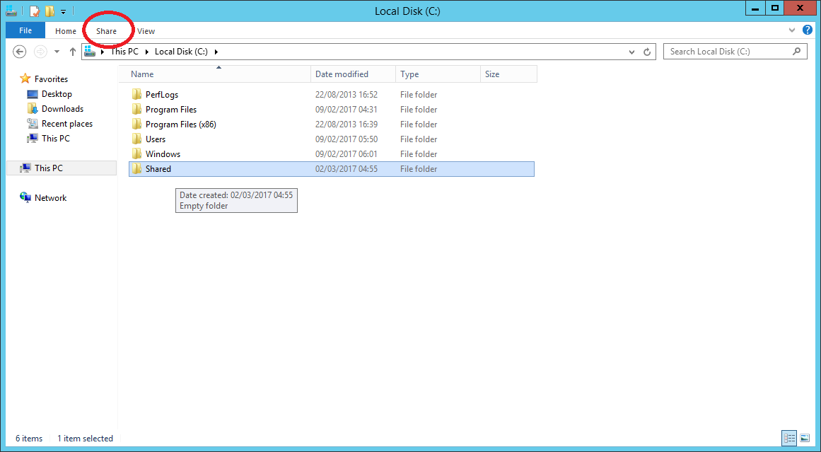
6. Look for the username you created and click it.
7. The following window will appear:
8. 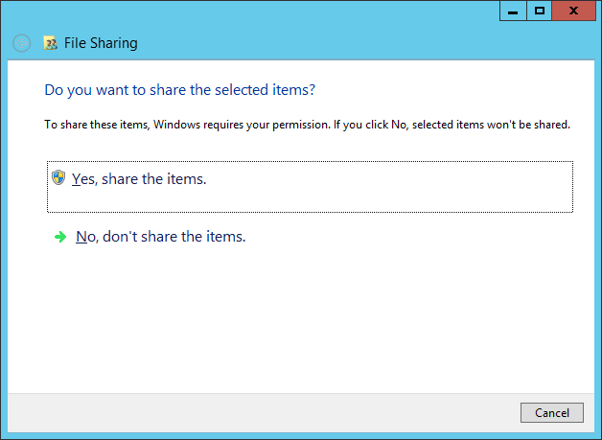
9. Click “Yes, share the items”.
10. Right click on the “Shared” folder, and go to “Properties”, and click on the “Sharing” tab.
11. Click “Share”.

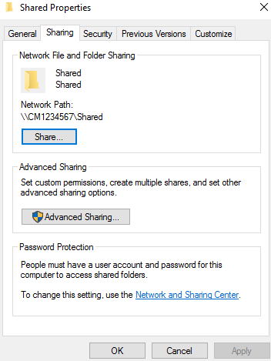

1. Confirm your user account has “Read/Write” permissions, and click “Share”.
2. Now you need to find out what your server’s IP Address is.

**Question : What is your Windows Server IP address? (marks)**  
[your answer here]

## Task 3 - Connecting to the File Server

1. Go back to your Windows 7 Client.
2. Start Windows Explorer
3. In the Address field, enter \\”your server IP” address, for example:  
     
   \\100.26.34.184  
   (**Obviously, use your own server's IP address for 192.168.xxx.yyy**)
4. You will be prompted for a login. Use the username and password of the user that you created on the server.
5. Open up the “Shared” folder on the server and create a new text file with your Student ID:  
     
   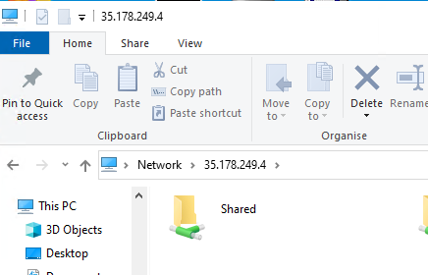
6. 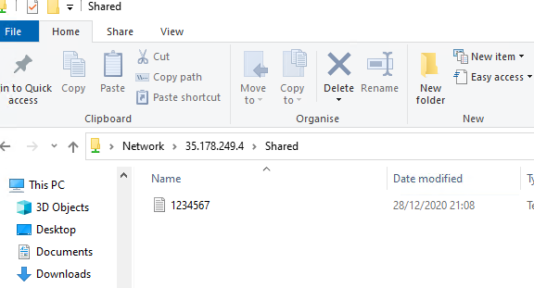  
   Capture and paste your screen below:  
     
   [Paste your screen shot here] (marks)

## Task 4 - Create another shared folder

1. On your Windows Server**,** go to the "Server Manager" screen, click on "File and Storage Services".
2. Click on “Shares”. You should get the following screen:

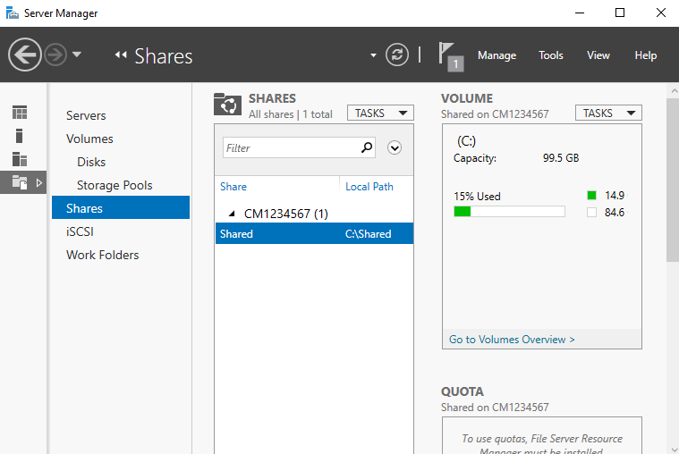

1. Right-click in the white space under “Shared”, and click “New Share…”
2. In “New Share Wizard”, click “Next”.
3. On the “Share Location” screen, click “Type a custom path”, and then click “Browse”.
4. In “Select Folder”, browse to the C: drive, then click “Select folder”.
5. Click “Next” to get to the “Share Name” screen, and give the Share a name. Click “Next”.
6. On “Other Settings”, click “Next”.
7. On “Permissions”, click “Customize Permissions”.
8. On the new window, click “Add”.
9. Click where it says “Select a principal”:

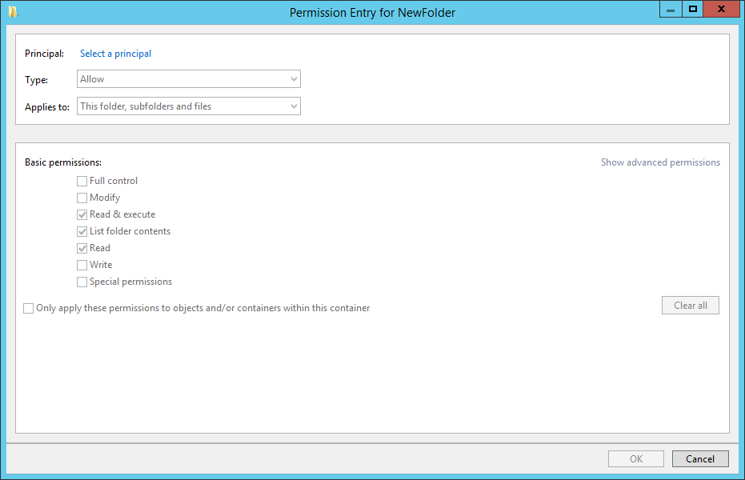

1. In the “Select User or Group” box, type in your username, and then click “Check Names”.
2. Click “OK” to close.
3. Make sure “Full control” is ticked for “Basic Permissions” (All boxes ticked, except Special Permissions”), before clicking “OK”.
4. Click the “Share” tab.
5. Click “Add”.
6. Click where it says “Select a principal”:

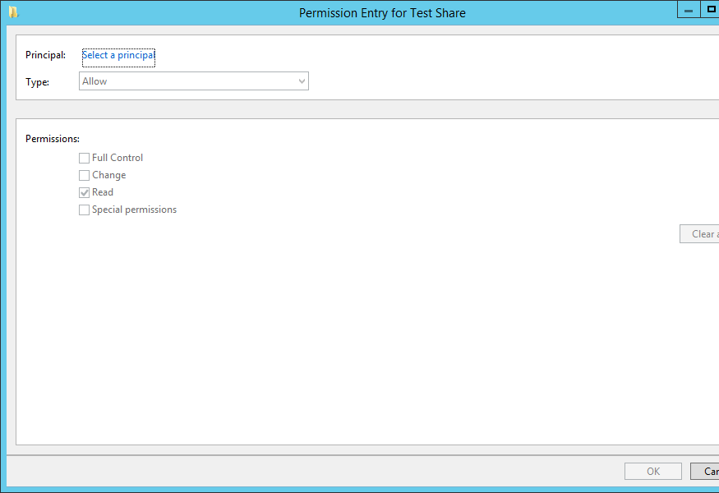

1. In the “Select User or Group” box, type in your username, and then click “Check Names”.
2. Click “OK” to close.
3. Under “Permissions”, make sure “Full Control”, “Change” and “Read” are selected, then click “OK”.
4. Click “Apply”, followed by “OK”.
5. Click “Next”, and finally “Create”. When complete, click “Close”.
6. Go to the new shared folder from the Windows 7 client and create another text file, with your name as the filename.
7. Capture and paste the screen like that in Task 3.  
     
   **[Paste your screen shot here] (marks)**

# Part 2 - Windows Server as an FTP Server

As you have seen in the previous task, Windows Server can perform a number of Server Roles. In this part of the workshop, your existing Windows Server installation will be configured to perform as an FTP Server.

## Task 1 - Installing the FTP Server Service

1. Bring up the Server Manager (if it’s closed, you can re-open it from the taskbar)
2. In the top right, click “Manage” and then “Add Roles and Features”, as below:

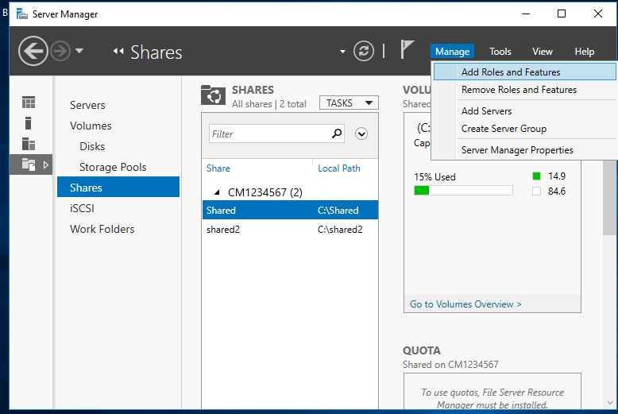

1. In the Add Roles and Features Wizard, click “Next”.
2. Tick “Role-based or feature-based installation”, click “Next”.
3. Select this server, and click “Next”.
4. On the “Server Roles” screen, click “Web Server (IIS)”. Another window should pop up.
5. Make sure “Include management tools” is ticked, and click “Add features”.
6. Now you can click “Next”.
7. On the “Features” screen, click “Next”.
8. On the “Web Server Role (IIS)” screen, click “Next”.
9. On “Role Services”, scroll down the list, making sure all options are UNTICKED.
10. Finally, tick FTP Service, and “IIS Management Console”, as below.

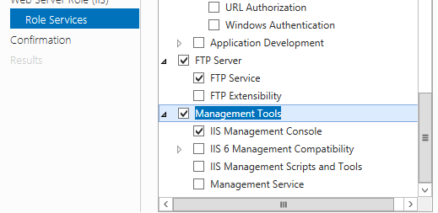

1. Click “Next”, and then “Install”. The FTP server will install – and when it’s complete, click “Close”.
2. If you open the Windows Search box and type “IIS”, you should see “Internet Information Services (IIS) Manager” appear. Click it
3. IIS will load – this is the management console for creating websites and FTP sites on Windows Server.

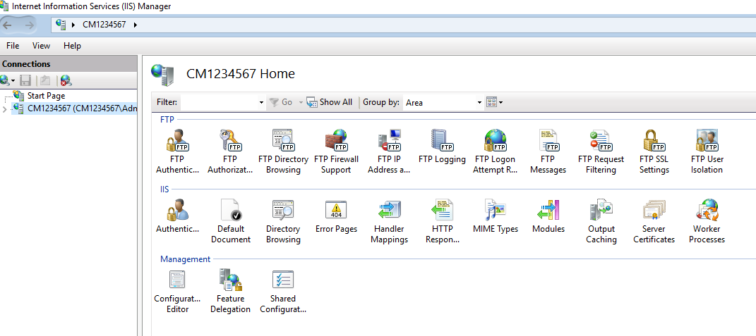

1. If you click on the small triangle, next to your server name in the list on the left, it will expand to reveal:

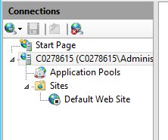

1. Right-click on “Sites”, and select “Add FTP Site…”.
2. For the FTP site name, call it your student number.
3. For Physical Location, click the browser button (…), and navigate to the C: drive. Click “Make New Folder”, and create a new folder called “FTP” inside C:
4. Your screen should look like:

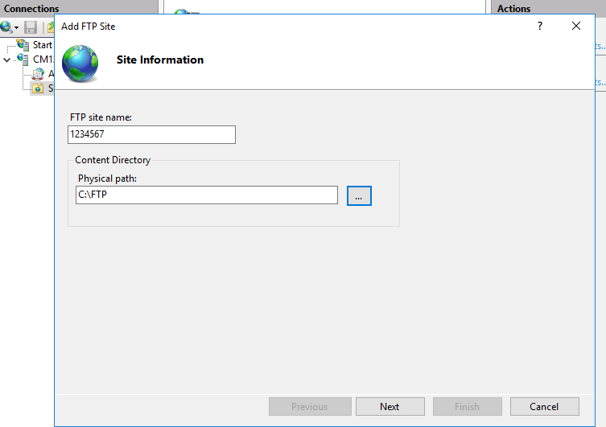

1. Click “Next”.
2. For IP address, leave “All unassigned”, and leave the port at 21.
3. Tick “No SSL”, and then click “Next”.
4. For “Authentication”, click “Anonymous”, and for “Authorization” select “Anonymous users”. Make sure “Read” is ticked for “Permissions” and then click “Finish”.
5. Click on your new site (called your student number), and take a screenshot. It will look like:

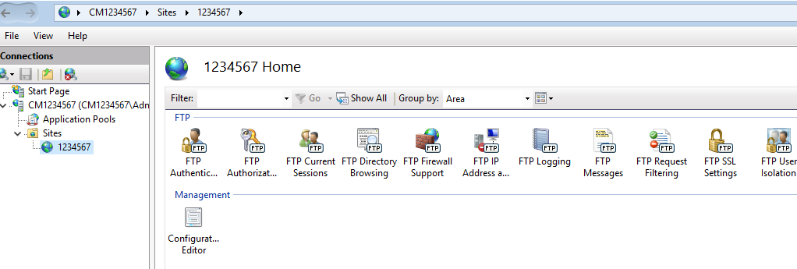

**[Paste your screen shot here] (marks)**

1. Using File Explorer, browse to the C:\FTP folder you created.
2. Create a new text file in the folder, called “Student number”FTP – it will look similar to:

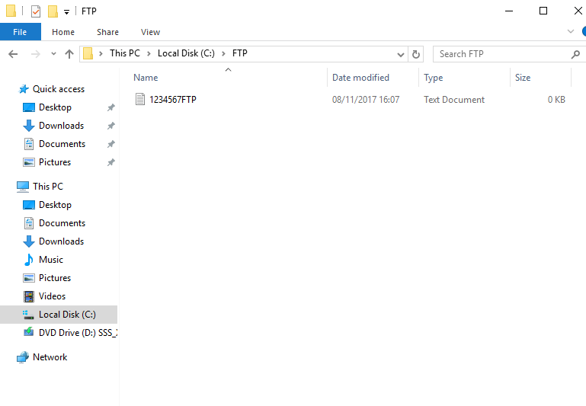

1. Finally, we need to turn off the Windows Firewall, to allow the FTP client to connect.
2. Go to the Start Menu, and type in Firewall – “Windows Firewall” should appear. Click it.
3. Find “Turn Windows Firewall on or off”, and click it.
4. Under “Private network settings”, click “Turn off Windows Firewall (not recommended)”. Normally, you would not disable the firewall – you would configure it to work with the FTP server, but for this workshop, we will disable it. When complete, click “OK”.

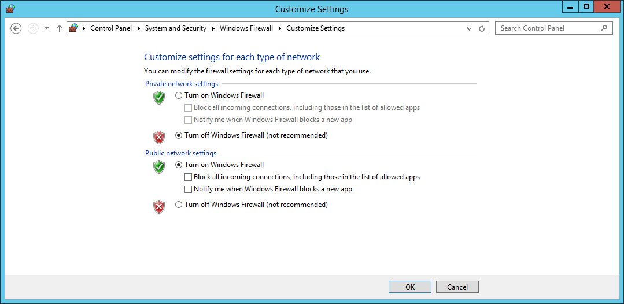

1. Move back to the Windows 7 VM we opened previously, and start a Command Prompt, by clicking Start, and typing “cmd”, followed by return.
2. Then enter:   
   **ftp 192.168.xxx.yyy**  
   (**Obviously, use your own server's IP address**)  
   (While connecting or downloading the file, you may get a message asking if you’d like to Allow or Deny access for FTP. Click Allow)
3. When the ftp program prompts for a user name, respond with the word “anonymous”. This indicates to the server that you want to log in anonymously.
4. When it prompts for your email name as password, just enter your email address.
5. To list the files on the FTP server, enter “dir”, and you should see the files available for download on the FTP server. You should see the file that you copied into the FTP home folder, **yourusernameFTP.txt**
6. The FTP program normally starts up in a default text mode. We now need to switch the ftp program into binary transfer mode to transfer the image file. Enter “bin” into FTP program.
7. Transfer the file we created earlier by entering:   
   **get “1234567FTP.txt”**

**(Obviously replacing my username with yours!)**

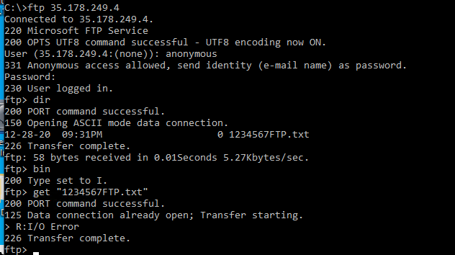

1. Take a screenshot of your Command Prompt, showing the Transfer Complete.

**[Paste your screen shot here] (marks)**

1. Once the transfer finished. Enter “quit” to end the FTP program.

## Task 2 - Configuring the FTP Server for authenticated user logins

1. On your Windows Server, go to the IIS Manager.
2. Click on your FTP site.
3. Double click on FTP Authentication.
4. Disable “Anonymous Authentication”.
5. Enable “Basic Authentication”.
6. Click on your site name to go back to the main menu.
7. Double click on “FTP Authorization Rules”.
8. Where it says “Allow”, “All Users”, right-click and select “Edit…”.
9. Under “Permissions”, make sure both Read and Write are ticked. Click “OK”.
10. Double click on “FTP User Isolation”.
11. Under “Isolate users”, enable “User name directory (disable global virtual directories)”.
12. Go back to the FTP folder you created on the C:\ drive.
13. Inside C:\FTP, create a new folder, called “LocalUser”. Type this exactly, with the correct casing, and no space.
14. Inside “LocalUser”, create another new folder. Put in the username of the account you created earlier in the workshop.
15. Copy the usernameFTP.txt file you created earlier, from the C:\FTP folder to the C:\FTP\LocalUser\username folder.
16. When complete, your folder should look like this:

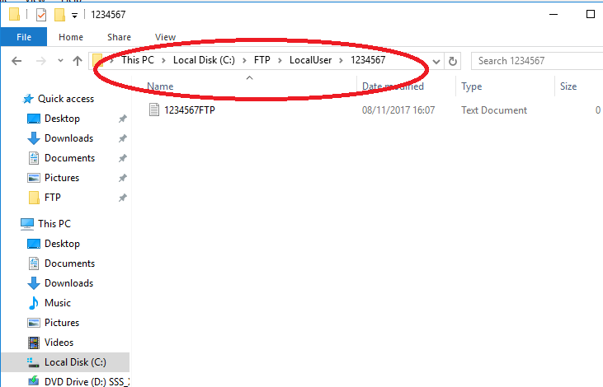

1. Go back to your Windows 7 VM.
2. Create a new folder on the C:\ drive, called “your user name”.
3. Go inside that folder, and create a new text file, called “USER”.
4. It should look like:

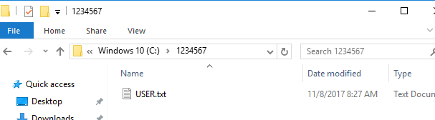

1. In the Windows 7 VM, go back to the Command Prompt.
2. Type in “cd C:\username”, where username is the name of the folder you created. So, in my example above, it would be “cd C:\1234567”put
3. Reconnect to the FTP by typing:  
   **ftp 192.168.xxx.yyy**   
   (**Obviously, use your own server's IP address rather than 192.168.xxx.yyy** )
4. Now try to log into your FTP server using the username name of “anonymous” as in the first exercise.  
     
   **Question: What happens?**   
     
   **[Your answer here] (marks)**
5. Now type in “user”.
6. It should ask for a username again – this time put in the username you created earlier.
7. For the password, put in the password you created for this user account.
8. Transfer the file that you just created to the server by entering:   
   **put "USER.txt"**.
9. When it is finished. Enter “quit” to finish.
10. Now screen capture the Command Prompt screen and paste it below:  
      
    **[Paste your screen shot here] (marks)**

## Task 3 - Installing and configuring a Graphical FTP Client

1. On the Windows 7 VM, go to the Start Menu and open FileZilla. You will need to install Filezilla if it’s not available. Note: You need to install **Filezilla Client** not the server.
2. Open FileZilla settings available in Edit menu. Under FTP make sure you select “Active”. Then click OK to close.

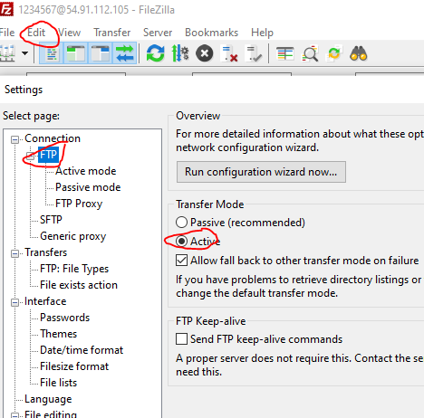

1. Connect using your server's IP address for the "Host", your student ID for the username and the password that you created on the server for that user. The port is 21.

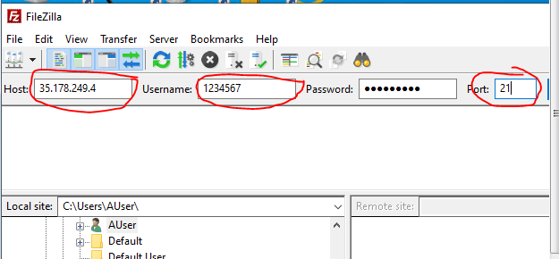

1. When you are successfully connected to your server, capture the screen showing Filezilla's main window similar to the image below:
2. 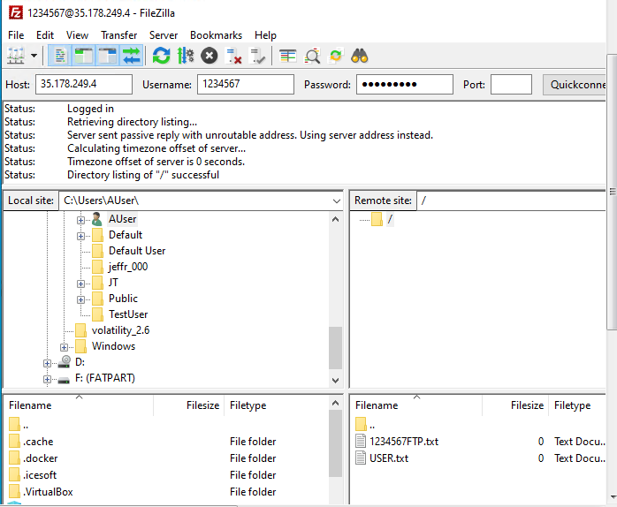  
     
     
   **[Paste your screen shot here] (marks)**
3. Now shutdown your Windows Server as explained in previous workshop.

**Task 4**

1. Do research into FTP Service trying to identify any challenges with this service and how they can be overcome. Max 500 words **(marks)**

**This is the end of this workshop. If you have finished the workshop, please submit it to Canvas.**