# **4CS012 –Server Management and Virtualisation**

## **Workshop 3- Windows Server as a Web Application Server**

**STUDENT NAME:**

**STUDENT NUMBER:**

You will need to complete the workshop tasks, answer the questions and then submit this Word file, complete with your screenshots and answers, via Canvas.

Please use the same computer for all your workshops, or you will not have access to the virtual machines that you have created previously.

In this workshop, your existing Windows Server installation will be configured to perform as an Internet Information Server and Web Application Server.

## **Task 1 - Setting up a Web Application Server**

1. Start your Windows Server virtual machine or your AWS instance, and login as Administrator.
2. Start “Server Manager” if it is not already running.
3. Click “Manage”, and then “Add Roles And Features”.
4. Click Next.
5. Select “Role-Based or feature-based installation” and click next.
6. Select your server, and click next.
7. Click “Web Server”, and drill down into the options. Set them as following:

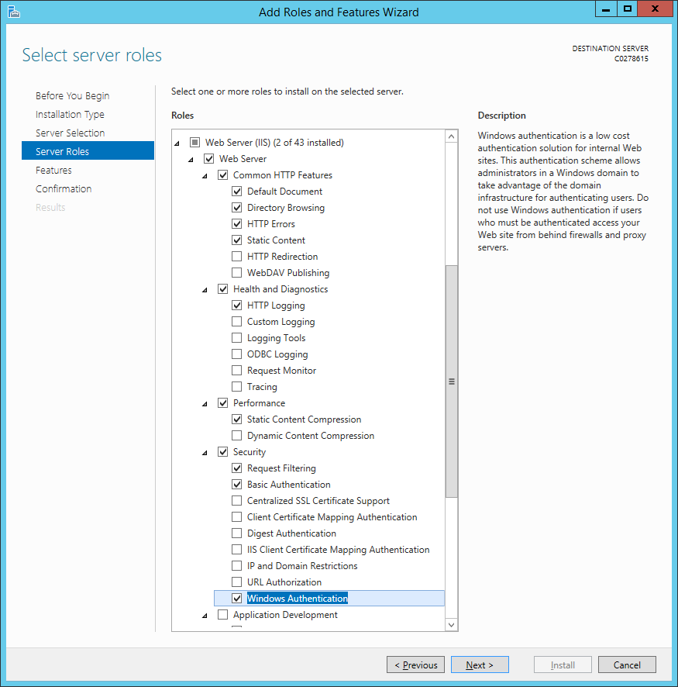

1. Also, click “ASP.NET 4.7” under “Application Development”. You will get the following popup:

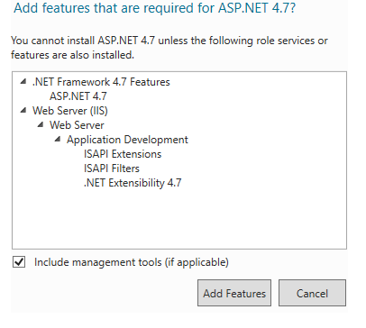

1. Click “Add Features”.
2. Click “Next”.
3. And then click “Install”.
4. When it has finished installing, click “Close”.
5. When you have finished, open Internet Explorer, and go to <http://127.0.0.1>
6. You should get a page saying “Internet Information Services”. Paste your screenshot below:

**[Paste your screen shot here] (marks)**

## **Task 2**

1. Go to the Start Menu, and start IIS.
2. Click on your server name, from the list on the left of IIS.
3. If you get a message asking “Do you want to get started with Microsoft Web Platform”, tick “Do not show this message”, and then click “No”.
4. You should see “Default Web Site” under “Sites”. Right-click, and click “Explore”.

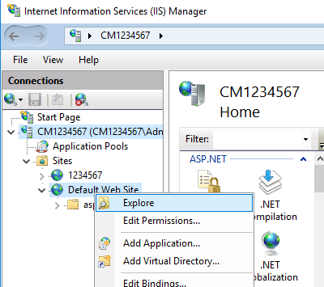

1. Windows Explorer should appear.
2. Click “View”, “Options”, and then “Change folder and search options”:

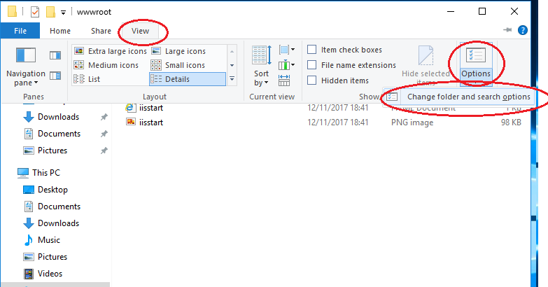

1. In the “Folder Options” window, click “View”, and scroll down. Untick “Hide extensions for known file types”, and then click “Apply”, and “OK”.
2. Create a new text file, called “test.aspx”. Open it for editing.
3. Copy and paste the following into the file:

<%@ Page Language="C#" %>

<script language="C#" runat="Server">

void Page_Load(object sender, EventArgs e)

{

lblMessage.Text = "Hello **YOUR_STUDENT_NUMBER**";

lblServerIP.Text = "Server IP is " + System.Net.Dns.GetHostByName(System.Net.Dns.GetHostName()).AddressList[0].ToString();

lblClientIP.Text = "Client IP is " + HttpContext.Current.Request.UserHostAddress;

lblType.Text = "Authentication: " + User.Identity.AuthenticationType;

lblUser.Text = "Logged on as: " + User.Identity.Name;

lblScheme.Text = "Using protocol: " + Page.Request.Url.Scheme;

}

</script>

<html>

<head>

<title>First ASP.NET page written in Notepad</title>

</head>

<body>

<asp:Label ID="lblMessage" runat="Server" />

<br />

<asp:Label ID="lblServerIP" runat="Server" />

<br />

<asp:Label ID="lblClientIP" runat="Server" />

<br />

<asp:Label ID="lblType" runat="Server" />

<br />

<asp:Label ID="lblUser" runat="Server" />

<br />

<asp:Label ID="lblScheme" runat="Server" />

</body>

</html>

**Remember to put in your student number!**

1. Save the file
2. Using Internet Explorer, go to <http://127.0.0.1/test.aspx>
3. Take a screenshot and paste below:

**[Paste your screen shot here] (marks)**

**Question:**

**Are the Client and Server IPs the same, or different? If they are the same, why?**

**If they are different, why?**

1. Open PowerShell, and type “ipconfig” to get the server IP.
2. Open the “Security Windows 7” VM or any other client that you used in the previous workshop.
3. Using Internet Explorer in the Windows client, visit <http://SERVERIP/test.aspx> . Replacing **SERVERIP** with your own server IP address. Remember to use your **public IP address** if you are on AWS.
4. Take a screenshot, and paste below:

**Question:**

**Are the Client and Server IPs the same, or different? If they are the same, why?**

**If they are different, why?**

## **Task 3**

1. Go back to the Server VM
2. Bring up the IIS window.
3. Click on “Default Web Site” again, and from the options on the right, open “Authentication”.
4. Click on “Anonymous Authentication”, and click “Disable” on the right.
5. Click on “Basic Authentication”, and click “Enable” on the right.
6. Click on “Default Web Site”, and the go to “Manage Website”, and click “Restart”, as below:

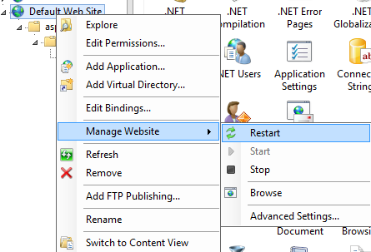

1. Go back to client machine, close Internet Explorer, restart it, and go back to <http://SERVERIP/test.aspx>
2. Take a screenshot of the login screen, and paste it below:

[Paste your screen shot here] (marks)

1. Press “Cancel” on the login box.

**QUESTION: What happens? What error do you get? Why did you get it?**

1. Refresh the page, and log in using the username you created on the server previously, and the password.
2. When you have logged in successfully, take a screenshot and paste it below:

**[Paste your screen shot here] (marks)**

## **Task 4**

1. Go to IIS, and click on your server name from the list on the left.
2. From the options on the right, select “Server Certificates”.
3. Under “Actions” on the right, click “Create Self-Signed Certificate”
4. Where it asks for a friendly name, type in your student number.
5. Select “Web Hosting” for “Select a certificate store for the new certificate”.
6. Finally, click “OK”.
7. Select “Default Web Site” from the “Sites”, and then on the far right, under “Actions”, click “Bindings”.

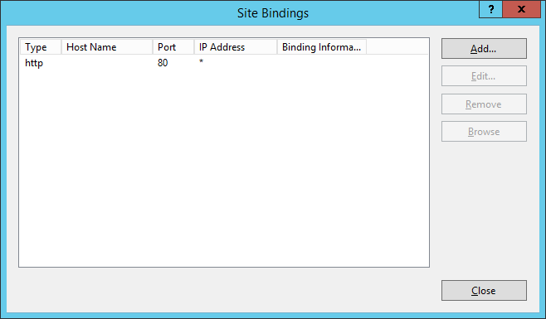

1. Click “Add”.
2. Under “Type”, select “https”.
3. In the “SSL Certificate” box, select the certificate you just created.
4. Finally, click “OK”.
5. Click “Close”.
6. Restart the website again.
7. Using Internet Explorer in the client, visit <https://SERVERIP/test.aspx>

**(Note it’s HTTPS this time, not HTTP)**

1. You may get a message telling you the page is not secure, or telling you there is a problem with this website’s security certificate. Click “Continue”.
2. Log back in.
3. Take a screenshot of the page, and paste it below:

**[Paste your screen shot here] (marks)**

1. Now shutdown your Windows Server as explained in Workshop 1.

## **Task 5**

Write a short paragraph summarizing the elements used in this client/server setup. Explain how this could be used by a small business. What are the alternatives? (max 500 words) **(Marks)**

**This is the end of this workshop. If you have finished the workshop, please submit it to Canvas.**