# 4CS012 –Server Management and Virtualisation

## Workshop 4

STUDENT NAME:

STUDENT NUMBER:

You will need to complete the workshop tasks, answer the questions and then submit this Word file, complete with your screenshots and answers, via Canvas.

Please use the same computer for all your workshops, or you will not have access to the virtual machines that you have created previously.

Windows Server as an Internet Server

In this workshop, your existing Windows Server installation will be configured to perform as an Internet Information Server and Web Application Server.

## Task 1 – Setting Up WAMP

1. Load your client machine if you are using a VM, and start your Server 2019.
2. Log into the Server 2019 VM as the account you created previously. (Username should be your student number, and password should be ‘ABCdef123’)
3. Download XAMPP from <https://www.apachefriends.org/index.html>

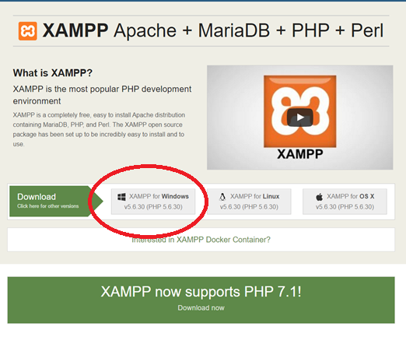

1. Using File Explorer (NOT Internet Explorer), go to your Downloads folder, and find the file you just downloaded.
2. Run the installer. (By double-clicking on it).
3. You may see a warning message, similar to the one below. Click “OK”.

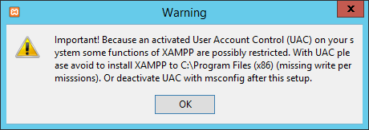

1. **Question: What does UAC do? Explain its function on Windows.**

**[Write Answer Below]**

1. Click “Next”.
2. Leave all the default features enabled, and click “Next”.
3. Make sure the installation folder is set to “C:\xampp”, and click “Next”.
4. Untick “Learn more about Bitnami for XAMPP”, and click “Next”.
5. Click “Next”.
6. XAMPP will install.
7. Untick “Do you want to start the Control Panel now”, and click “Finish”.
8. Go to the folder “C:\xampp\apache\conf” using File Explorer.
9. Find the file “httpd.conf”, and right-click on it. Click “Open with”, as below:

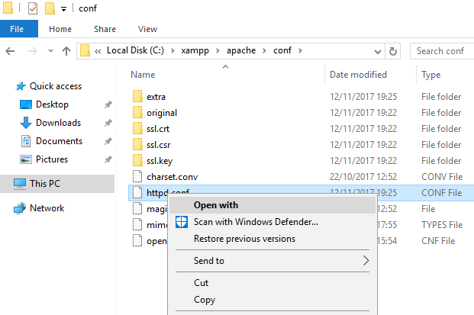

1. Windows will say “Windows can’t open this type of file (.conf)” - click “Try an app on this PC”.
2. From the list, tick “Use this app for all .conf files”.
3. Finally, click Notepad.
4. Using Notepad, go to the Edit menu, and click “Find…”.
5. Type “Listen 80” into the Find box, and click “Find next”.
6. On the line that says Listen 80, change the number to 100, like so:

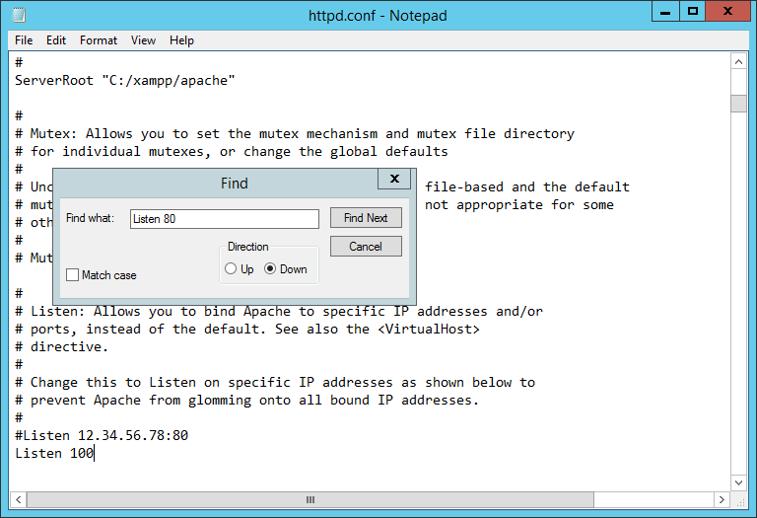

1. Using Find again, find “ServerName localhost:80”.
2. Change the line in the file to “ServerName localhost:100”
3. When done, go to File, and click Save – and close Notepad.
4. **Question: Why did we change the port that Apache is listening on, from the default for HTTP, port 80, to port 100? (Hint: What did we install in Workshop 3?)**
5. Go to the Start Menu, and type in XAMPP. Click “XAMPP Control Panel”.
6. Select the American flag (For English), and click “Save”.

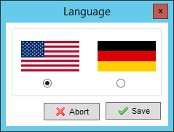

1. The Control Panel will open, with various error messages in red text.
2. Next to Apache, click “Config”, and click “Apache (httpd-ssl.conf)” , as below:

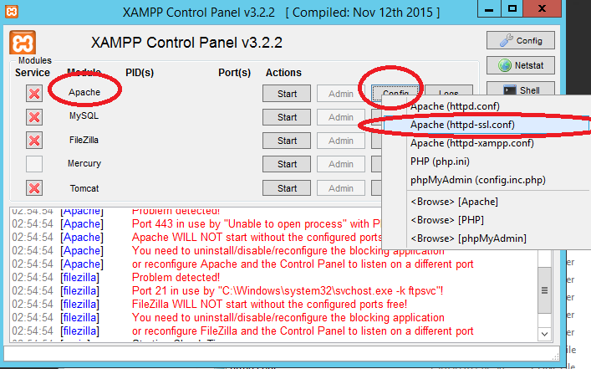

1. Notepad should open again.
2. Click “Edit”, and “Replace…”.
3. In the “Find what” box, type “443”, and in the “Replace with” box, type “446”.
4. Click “Replace all”, Save the file (File > Save), and then close Notepad.
5. In the XAMPP Control Panel, click the main “Config” button, as below:

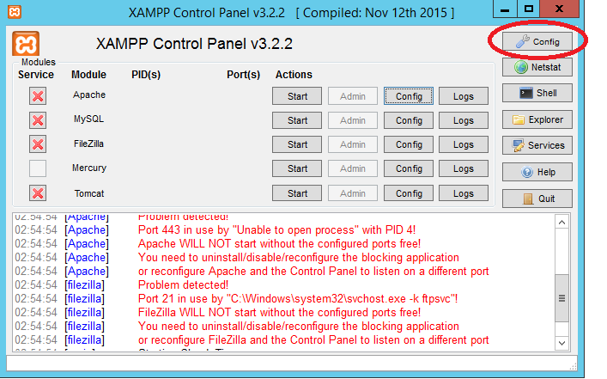

1. Click “Service and Port Settings”.
2. Under the Apache tab, type “100” for “Main Port”, and “446” for “SSL Port”, as below:

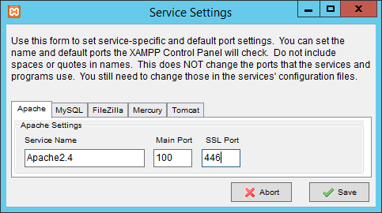

1. Click “Save”.
2. Click “Save”.
3. Click “Quit”.
4. Finally, restart XAMPP Control Panel, via the Start Menu again.
5. All being well, the XAMPP Control Panel will no longer report any Apache errors. (It will still mention errors with FileZilla. **That is fine.)**

## Task 2: Starting Apache and MySQL

1. On the XAMPP Control Panel, next to Apache and next to MySQL, click “Start”.
2. Take a screenshot of the XAMPP window, and paste it below:

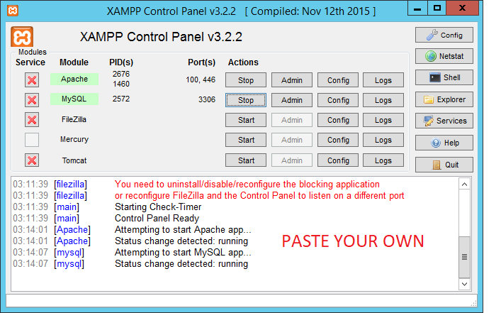

**[Paste your screen shot here] (marks)**

1. Using File Explorer, go to “C:\xampp\htdocs”.
2. In that folder, right-click, and select “New > Text Document”.
3. Call the file “test.php” and hit Enter. You will get the following message:

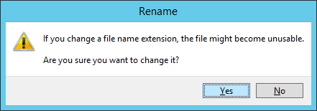

1. Click “Yes”.
2. Double-click on test.php. It will ask you which program you want to use to open .php files – click “Notepad”, as you did before.
3. In Notepad, copy and paste the following code:

Hello from YOUR_STUDENT_NUMBER!

</br>

<?php

phpinfo();

?>

**Change YOUR_STUDENT_NUMBER to whatever your student number is.**

1. Go to File > Save, and then close Notepad.
2. Open PowerShell from the Taskbar (Check previous workshops if you’re unsure how to open PowerShell).
3. Type in “ipconfig” and hit Enter.
4. Take a screenshot of the window and paste it below:

**Change firewall to allow port 100**

**[Paste your screen shot here] (marks)**

1. Go to the client machine and Open a browser (Chrome or Internet Explorer).
2. Go to <http://YOUR_SERVER_IP:100/test.php>. Replace the server IP with your own.
3. Take a screenshot of the screen you see, like the following:

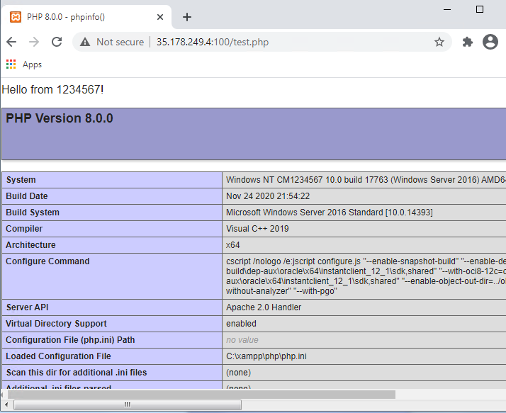

**[Paste your screen shot here] (marks)**

## Task 3: PHPMyAdmin

1. Switch back to the Server 2019.
2. Using Internet Explorer, go to http://localhost:100/phpmyadmin/
3. You should see the following screen:

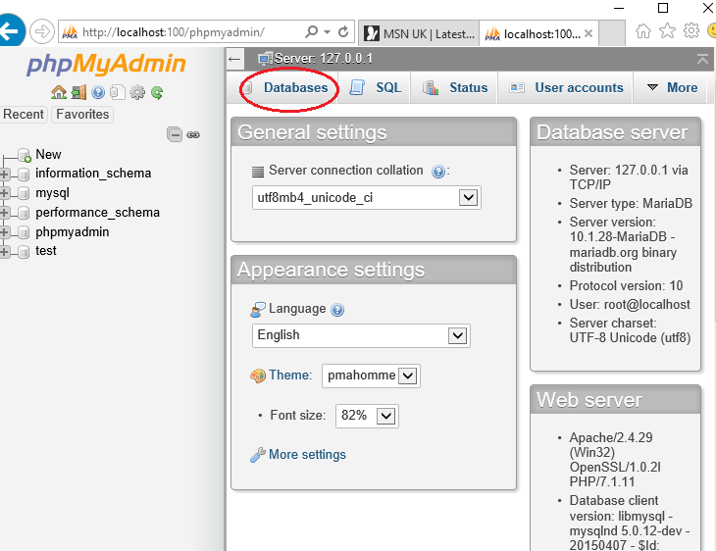

1. Click “Databases” at the top of the screen, as highlighted above.
2. Under “Create database”, type in “4CS012” for database name, and click “Create”.
3. On the “Create Table” screen, type “MyTable”.
4. Set Number of Columns to “2”.
5. Click “Go”.
6. On the next screen, set the options as follows:

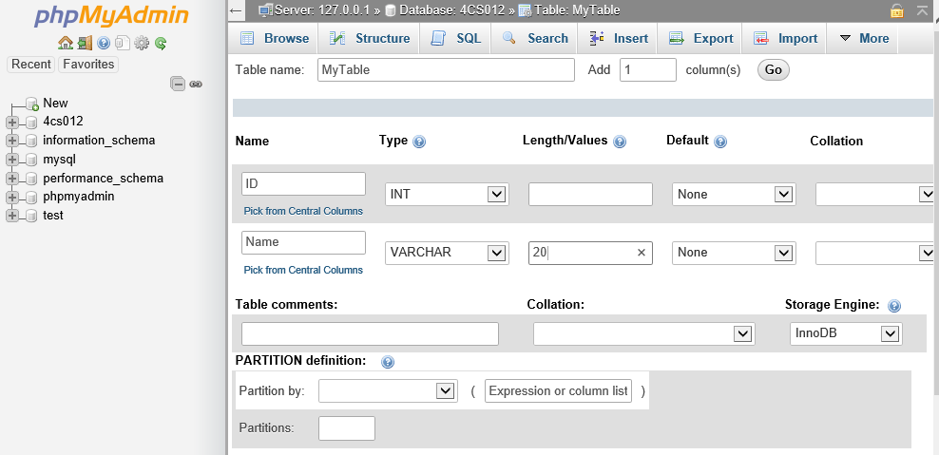

1. Under Name, the first column is called “id”, and of Type “INT”.
2. Under Name, the second column is called “name”, and of Type “VARCHAR”. Length is “20”.
3. Click “Save”, in the bottom-right of the window.
4. From the menu along the top, click “Insert”, as below:

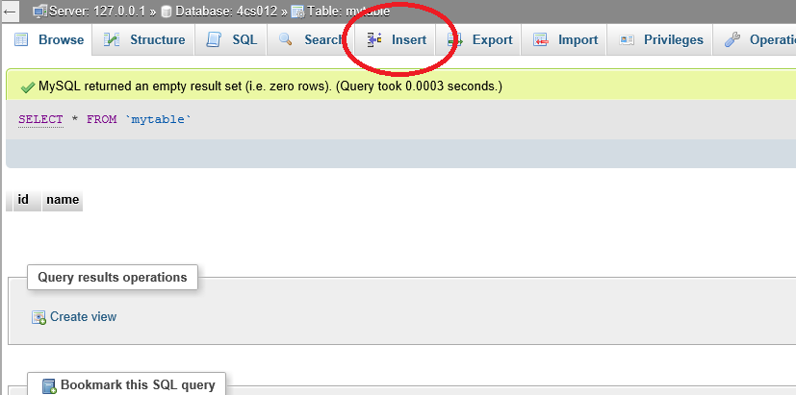

1. On the “Insert” screen, type some sample data:

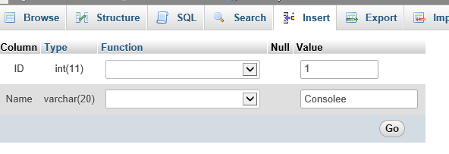

1. In the value box for “id”, type “1”, as above.
2. In the value box for “name”, type in your name, as above.
3. When done, click “Go”.
4. The next screen should show the data has been inserted into the database. Take a screenshot, and paste it below:

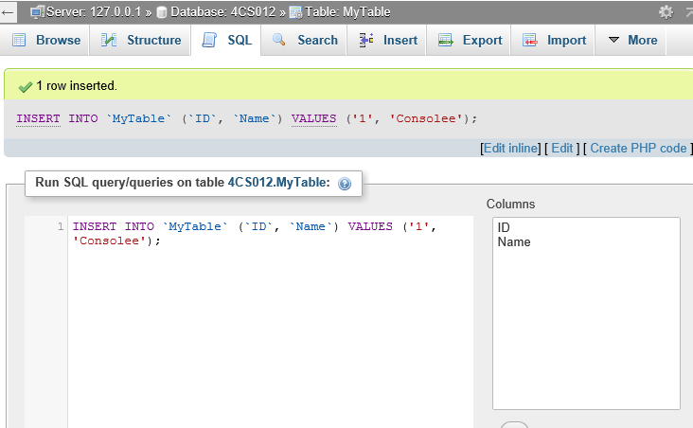

**[Paste your screen shot here] (marks)**

## Task 4: Testing MySQL

1. Using File Explorer, go back to the folder “C:\xampp\htdocs”
2. Create a new file, called “database.php”, and open it in Notepad. (See earlier in the workshop if you need a reminder)
3. Using Notepad, copy and paste the following code:

<?php

$servername = "localhost";

$username = "root";

$password = "";

$dbname = "4CS012";

// Create connection

$conn = new mysqli($servername, $username, $password, $dbname);

// Check connection

if ($conn->connect_error) {

die("Couldn't connect to the database. Error: " . $conn->connect_error);

}

$sql = "SELECT ID, Name FROM MyTable";

$result = $conn->query($sql);

if ($result->num_rows > 0) {

// output data of each row

while($row = $result->fetch_assoc()) {

echo "ID: " . $row["ID"]. " - Name: " . $row["Name"]. "<br>";

}

} else {

echo "0 results";

}

$conn->close();

?>

1. Switch back to the client machine.
2. Using Chrome or Internet Explorer, go to <http://MY_SERVER_IP:100/database.php>

(Obviously put in your server IP).

1. Take a screenshot of the page, and paste it below:

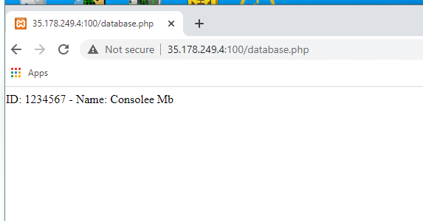

**[Paste your screen shot here] (marks)**

1. **Question: What was the default username and password for connecting to MySQL? (Check the PHP code)**
2. **Question: In the context of software, what does “Production Ready” mean? Do you think the default username and password for MySQL would be secure enough to be ‘production ready’? How could it be improved?**

This is the end of this workshop. If you have finished the workshop, please submit it to Canvas.