# ­4CS012 –Server Management and Virtualisation

## Workshop 5 – Windows Server Storage

**STUDENT NAME:**

**STUDENT NUMBER:**

You will need to complete the workshop tasks, answer the questions and then submit this Word file, complete with your screenshots and answers, via Canvas, before the deadline.

Please use the same workstation for all your workshops, or you will not have access to the virtual machines that you have created previously.

## Windows Server Storage

Windows Server can work with hard disk storage in several different ways. The different types of physical hard disks that can be used are ATA (IDE), SATA, or SCSI. These are the different types of logical interfaces that the hard disks use to communicate with the computer system motherboard and thus the operating system. Most systems have an upper limit in the number of physical hard disks that they can accommodate.

However, each physical hard disk can be further divided up into several partitions, volumes or logical drives. For Windows Server 2019, making use of MBR, each hard disk can have either up to 4 primary partitions or 3 primary partitions and 1 extended partition. A primary partition can be used to boot an operating system such as Windows, but an extended partition cannot. An extended partition, however, can be further sub-divided into smaller logical drives.

There are additional rules for partitions, depending on the firmware used by the hard drives, and whether the PC uses BIOS or UEFI. For this workshop, we will be assuming a BIOS-based PC, using an MBR partition structure. If you wish to know more, detailed information can be found at this link to [Microsoft TechNet](https://technet.microsoft.com/en-us/library/dd799232%28v=ws.10%29.aspx?f=255&MSPPError=-2147217396) (Not required, but additional background reading if you wish to know more.) A glossary of terms is included at the end of this workshop.

A Windows Dynamic Disk can be configured as a single disk, or it can be used as part of a Spanned Volume, a Striped Volume, a Mirrored Pair or a RAID 5 set. These types of storage are explored in this workshop.

## Types of Disk Storage Arrangements

* Single Disk - this is the simplest and most common arrangement and often the default one used. It is the only option available if you have only one hard disk.
* Spanned Volume - this is a single logical volume constructed from more than one hard disk. This is the easiest way of increasing storage space, simply by adding more hard disks to the spanned volume. The down side with a spanned volume is that as soon as one hard disk fails, the whole spanned volume is destroyed and all the data on it lost.
* Striped Volume - this is a volume that stores data in stripes on two or more disks. Data in a striped volume is allocated alternately and evenly (in stripes) across the disks. Striped volumes potentially offer the best performance of all the different types of storage arrangements, but they do not provide fault tolerance. If a disk in a striped volume fails, the data in the entire volume is lost.
* Mirror Pair - this uses two disks to store the same piece of data, which means it requires twice the storage space to store the data. However, it offers good fault tolerance if one of the disks fails, the system will still work as normal with one disk.
* RAID 5 - this uses the equivalent of the space of one disk in the RAID-5 volume for storing enough data encoding information so that if one disk in the set was to fail, all the data would still be safe. This extra encoding information is spread across all the disks in the set and is recoverable from any of the disks in the set. The minimum number of disks for a RAID 5 set is 3.

## Task 1 Adding new volumes on AWS

Any EC2 instance you create using the ArcGIS Server Amazon Machine Images (AMIs) has an Elastic Block Store ( EBS) volume attached. If you need more space, you can create additional volumes and attach them to your EC2 instance.

The steps below explain how to create a new EBS volume and attach it to your EC2 instance.

1. Open the AWS Management Console and display the EC2 page corresponding to your Amazon region.
2. On the left menu, under **Elastic Block Store** click **Volumes**.
3. Click the **Create Volume** button.
4. In the **Volume Type** list choose **Magnetic (standard)**
5. Type a value for Size. Remember that you will be charged by Amazon for the size you choose, and you cannot change this size once you've created the volume. In this workshop assign the value of **1GB**
6. Choose a value for Availability Zone. You need to match the zone of the EC2 instance to which you will attach the volume. We are creating VMs in the **us-east-1a** zone

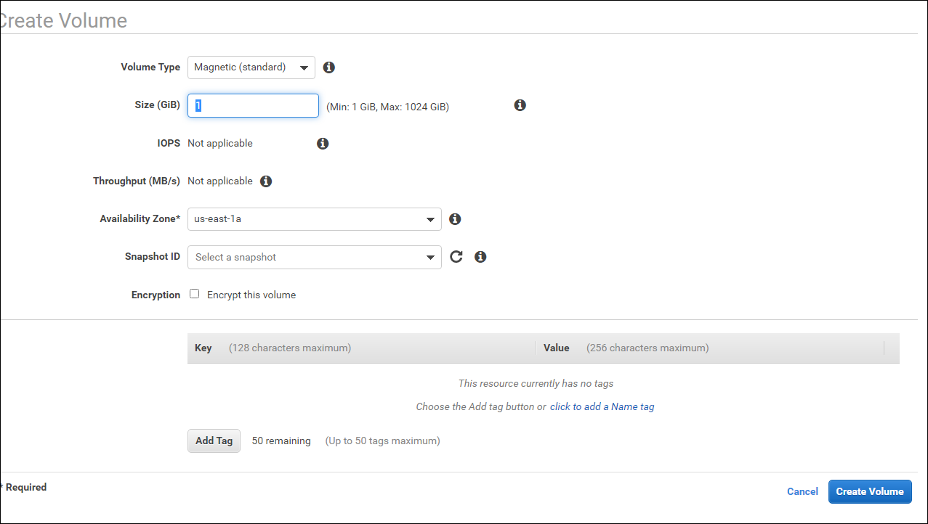

*Tip: If you don't know the zone of the instance to which you want to attach the volume, return to the AWS Management Console, click Instances, click your instance, then examine the Description tab to find the zone.*

1. Click “Create Volume” to create the volume. This can take a while. When the volume is ready, you'll see its status change from **creating to available** in AWS Management Console.

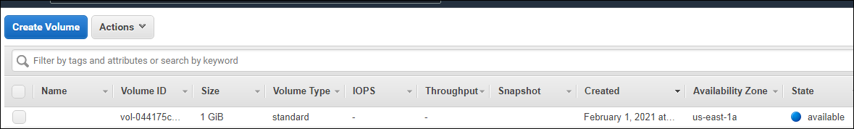

1. You've successfully created your EBS volume, but it's not attached to your EC2 instance yet. The remaining steps explain how to format the disk and attach it to your instance.
2. Select the volume and click on the **Actions** menu and choose **“Attach Volume**”

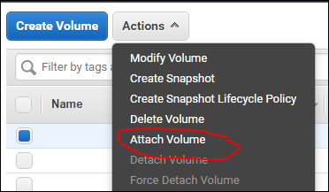

1. Click in the Instance field and choose your instance from the drop-down list. Remember that you can only attach your volume to instances that reside in the same availability zone.
2. Type the four-letter code for an available Windows device, such as xvdf, and click Attach.

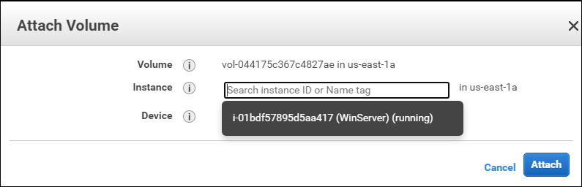

1. It may take a few minutes to attach your volume. You can see the status in the Attachment Information column in the AWS Management Console list of volumes. After a while, attaching changes to attached.
2. Repeat the previous process and create another volume of the same size and attach it to your server
3. [Log in to your EC2 instance](https://enterprise.arcgis.com/en/server/10.3/cloud/amazon/administer-amazon-ec2-instance-with-rdp.htm) using Windows Remote Desktop.

## Task 2 - Creating and configuring a Simple Dynamic Disk

1. Click Start and type diskmgmt.msc in the search box and then press Enter. Or right click on the Windows start button and click Disk Management. 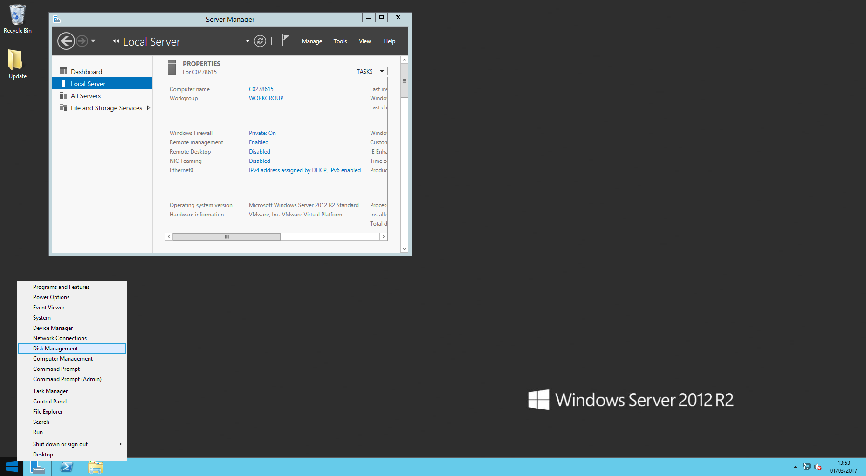
2. In the bottom section of the Disk Management console, scroll through the list of disks until you find an unallocated disk matching the size of the volume you just attached.
3. Right-click the disk and click Online.

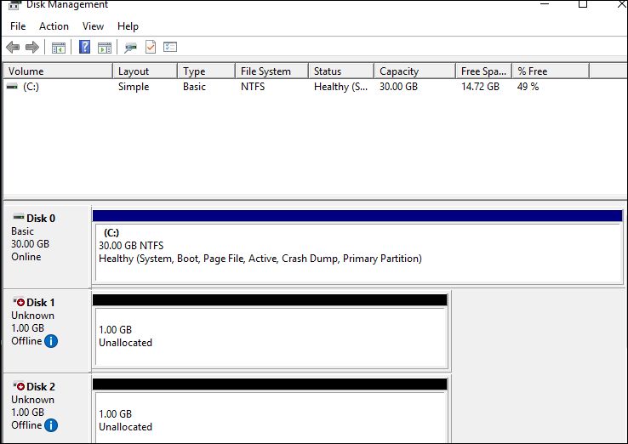

1. 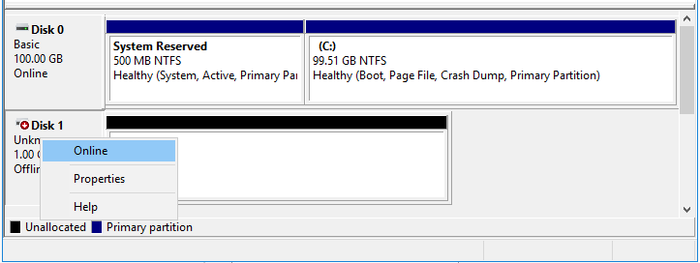

When it’s online, right click on it again, and select “Initialise Disk.”

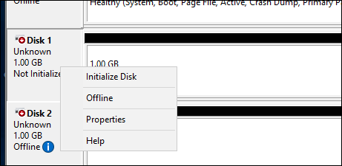

1. A window will pop up – select “MBR”, and “OK”.

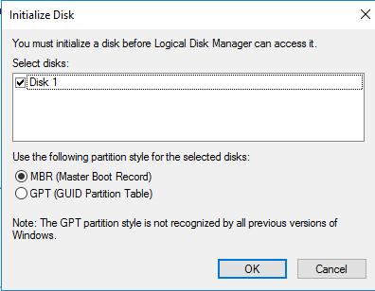

1. Once the disk has been initialised, Right click on it again, and “Convert to Dynamic Disk”:  
   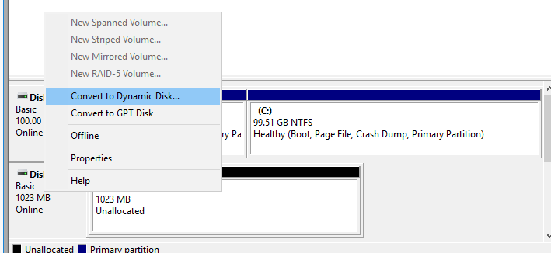
2. Another window will pop up; leave the default selected, and click “OK”.
3. Once converted, right click on the unallocated portion and create a New Simple Volume:  
   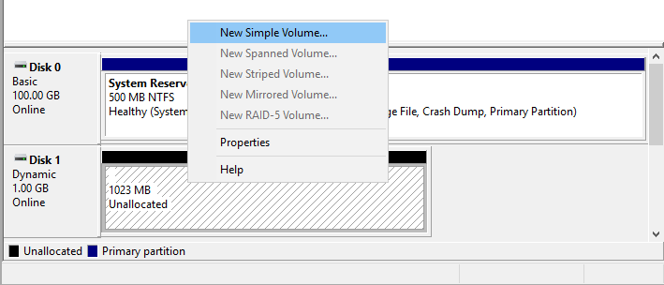
4. The subsequent screen, opt for the default size, and click “Next”.

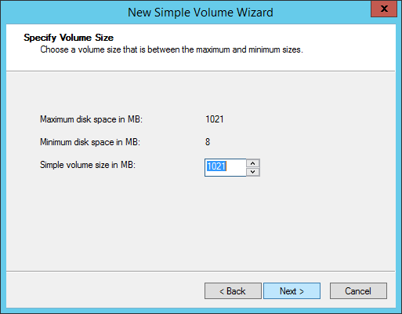

1. Assign it to the Drive letter “S”, click Next.
2. Call the volume lable “Simple” and select a “Quick Format” with NTFS. Click “Next”, then “Finish”.

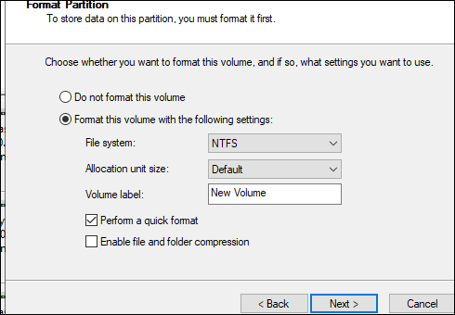

1. When successful, you should end up with a screen like the following:

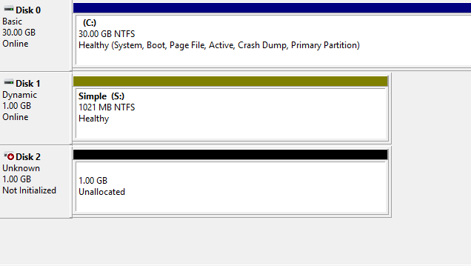

1. Now capture and paste your own screen below:  
     
   [Paste your screen shot here] (marks)

## Task 3 - Extending the Simple Disk to a Spanned Set

1. Go to File Explorer and create a text file called your-student-id.txt (eg. 1023456.txt) and save it onto drive S:
2. Initialise the other 1GB disk. Convert it to dynamic disk.
3. You should end up with the following screen:  
   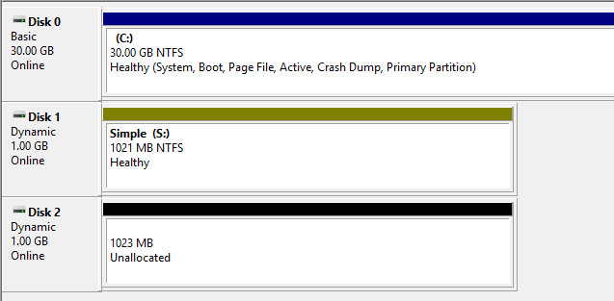
4. Now convert Drive S: into a Spanned Drive by right-clicking on it and selecting “Extend Volume”:  
     
   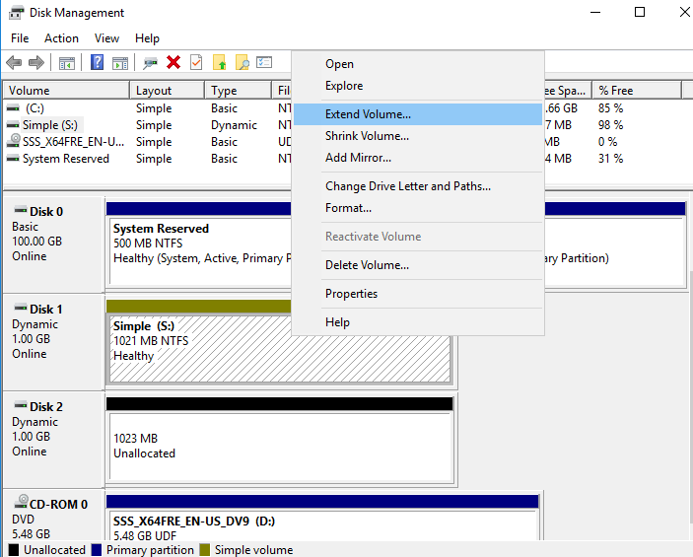
5. Select and add the new disk that you have just created:  
   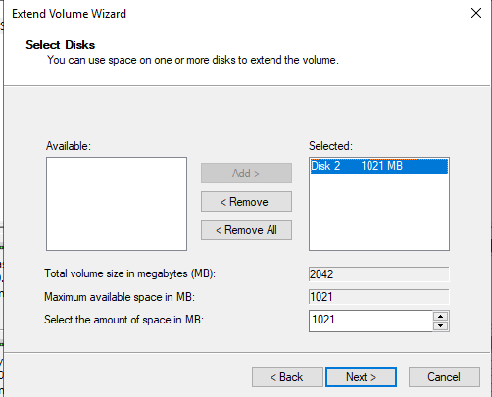
6. Once finished, confirm that you have now successfully extended the original 1GB Drive S: to a 2GB Spanned Drive by producing your own screen shot like the example below:  
   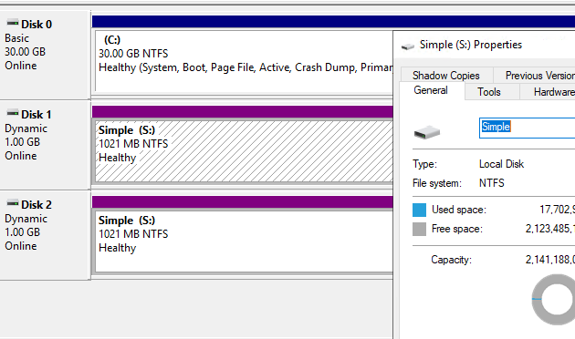  
     
   [Paste your own screen shot here] (marks)  
   **Question 1 – What happened your original text file? Did it remain the same, or was it altered or deleted? (marks)**[your answer here]
7. Switch off your server go back on the EBS page on EC2 and detach Disk 2. Once it’s successfully detached, restart your server, check your drives again and answer the following question:  
     
   **Question 2 – What has happened to Drive S: and your text file? (marks)**  
     
   [your answer here]
8. Navigate to Disk Management, and capture your screen shot of it and paste it below:  
     
   **[Paste your screen shot here] (marks)**  
   **Question 3 – Does a Spanned Drive have any protection against disk failures? (marks)**  
     
   [your answer here]

## Task 4 - Creating a Mirrored Disk

1. In disk management, right click on the first disk and choose “Delete volume”. Go back on EBS and reattach Disk2. Make sure that the two disks are online and converted to “Dynamic”  
     
   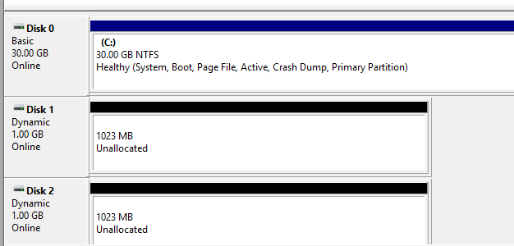
2. This time we will create a “Mirrored Volume” by right-clicking on an unallocated disk. Click “New Mirrored Volume”.

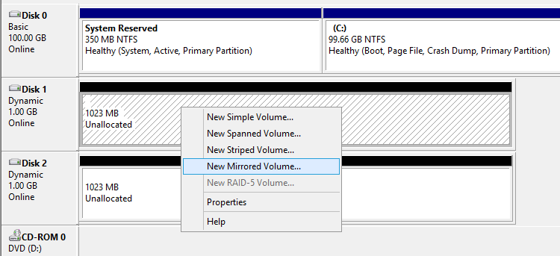

1. Then add both disks to the set:  
     
   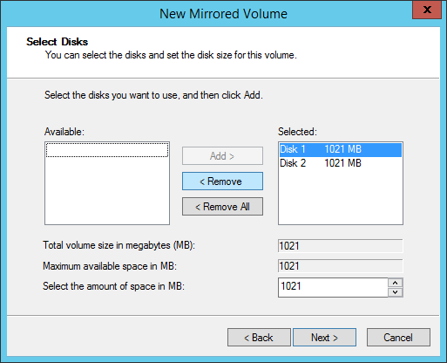
2. Set the Drive letter to “S”, call the volume “Mirrored” and set it to quick format NTFS.
3. You should end up with a screen similar to:  
   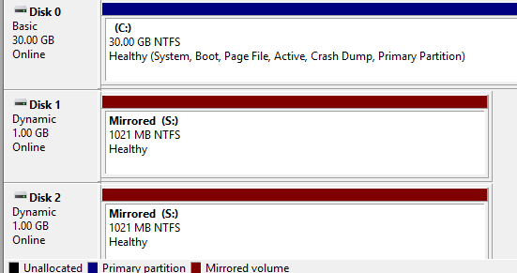
4. Paste your own screen shot below:  
     
   [Paste your screen shot here] (marks)
5. Now create your text file as before “12345767.txt” (substitute with your own ID) on Drive S:
6. Shut down your server, go back to EBS and detach Disk 2.
7. Start your Windows Server again and answer the following question:  
     
   **Question 4 – What has happened to Drive S: and your text file? (marks)**  
     
   [your answer here]
8. Navigate to Disk Management, and capture your screen shot of it and paste it below:  
     
   [Paste your screen shot here] (marks)  
     
   **Question 5 – Does a Mirrored Drive have any protection against disk failures? (marks)**  
     
   [your answer here]

## Task 5 - Recovering from a failed Mirrored Disk

1. Shutdown your Windows Server, go to EBS and create and attach another new 1GB.
2. Initialise and convert the new disk to Dynamic.
3. Next, you will need to break the mirror and remove the missing disk. Right click on the S: drive and select “Remove Mirror”.   
   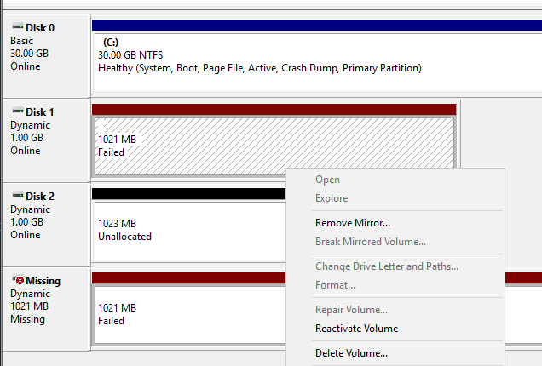
4. Select the missing disk and remove it.
5. Then repair the mirror by right clicking the S: drive and selecting “Add mirror” and then selecting your new disk.
6. Your Mirrored Disk should re-synchronise and repair itself.
7. Capture your screenshot confirming this and paste it below:  
     
   [paste your screen shot here] (marks)

**Question 6 – What has happened to your text file? (marks)**  
  
[your answer here] (marks)

## Task 6 - Creating a RAID 5 Disk

1. Reattach Disk2 and reinitialise the other to basic disks.

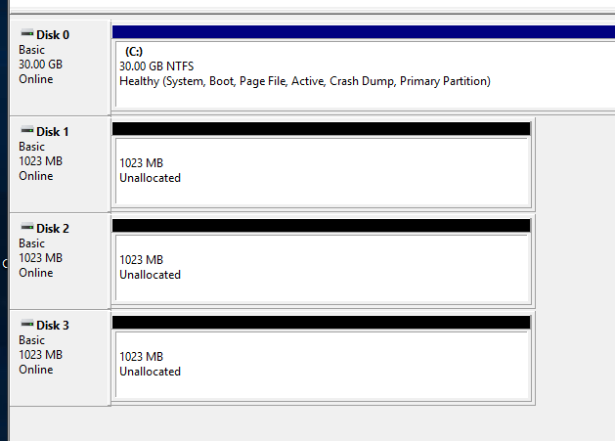

1. **Using what you have learnt** so far, create a RAID-5 Disk from the 3 new disks.
2. Paste your screen shot of the Disk Management screen here, similar to:

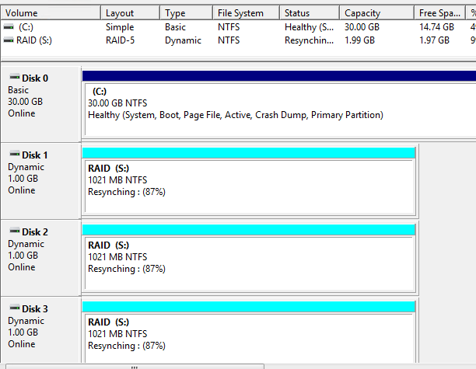  
  
[paste your screen shot here] (marks)

**Question 7 - What size is the resulting RAID-5 Disk? (marks)**

[your answer here]

1. By creating files and then removing a disk, answer the following question. **Question 8 – Does a RAID-5 Drive have any protection against disk failures? (marks)**  
     
   [your answer here]
2. Now shutdown your Windows Server as explained in Workshop 1.

## Task 7

Most organisations and data centers rely on some kind of networked storage. Research and explain the differences between DAS, NAS and SAN. How is RAID technology used in networked storage?

**This is the end of this workshop. If you have finished the workshop, please submit it to Canvas.**