**Task1**

In this task we are going to generate a random password based on user input and user preferences.

First we will ask for the length of password after that we will ask user about the characters that he wants to include in the password e.g. Uppercase, Lowercase and Special Character etc. After the generation of password we will use pwnedpasswords library to check if the password is unique or not. Here is the code

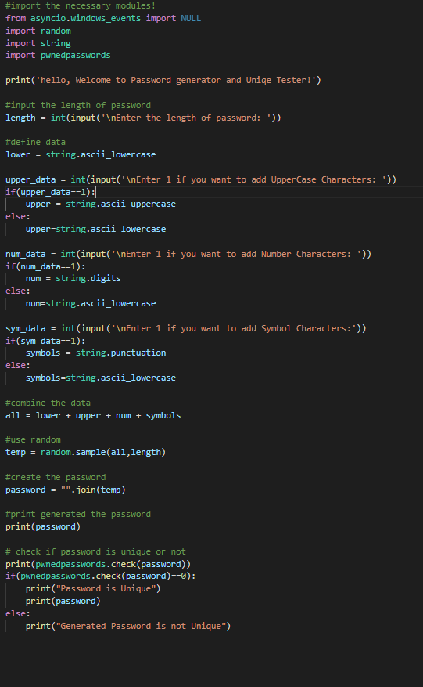

After running the above code out put was some thing like this.

