**Task2**

In this task we are going to use api documentation for retrieval of courses data. First, we will take access token from canvas according to given instructions and then we will use courses api documentation to test and run api. In first step we run api online and check the result After this we will use postman and private token to test api and retrieve data as shown below

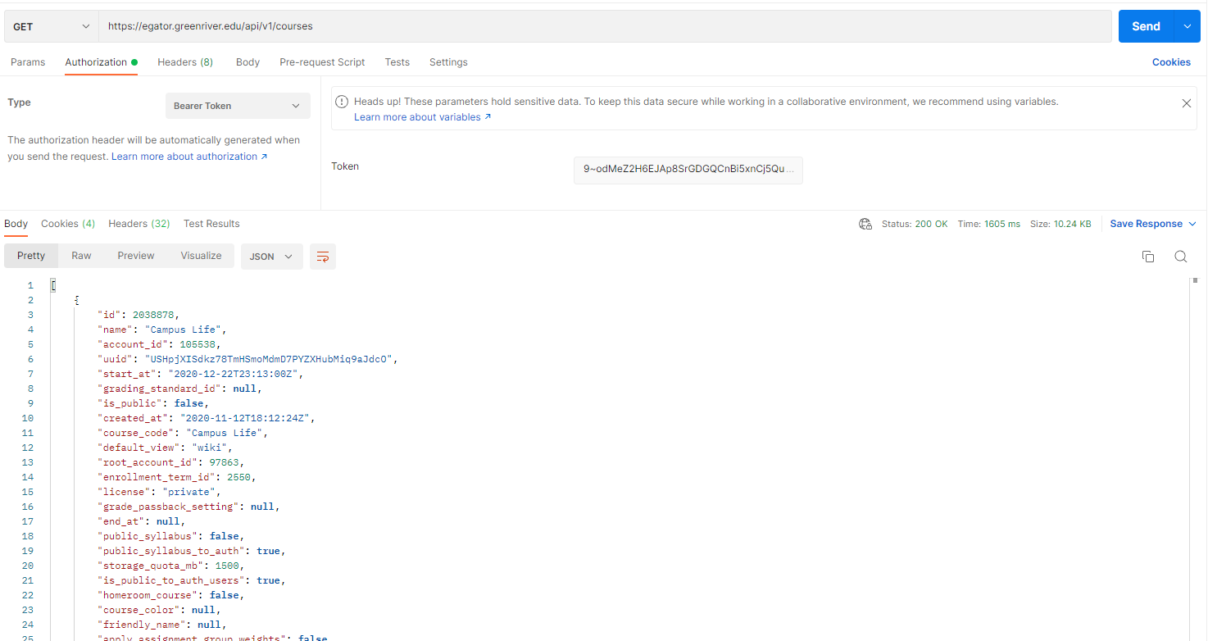

Now it is time to code. We will use request library of python to call course api request along with Authorization header to send token along with request in it as shown below in the code

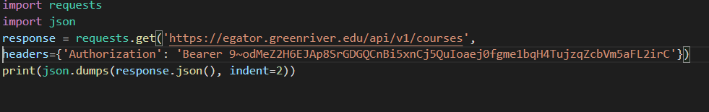

Output of the code will how the canvas classes of student as shown below.

