**Task2**

First we test API through Postman and here is the response.

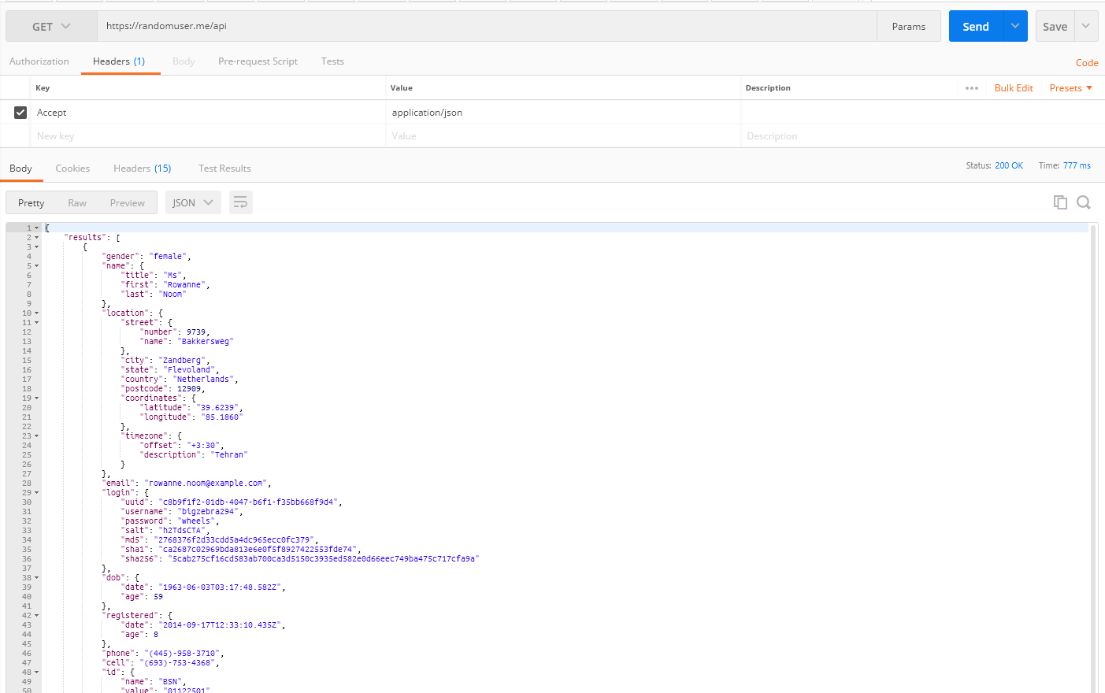

After the success response we have to code in python for accessing api. Code screenshot is attached below

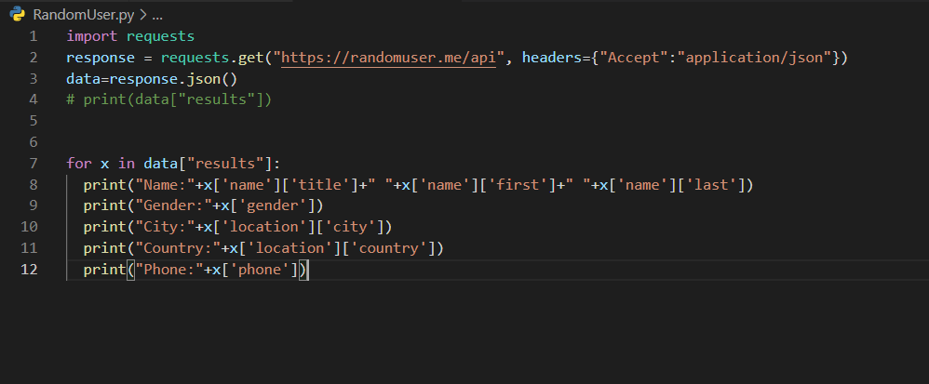

After the execution of code response was as given below

