**Task3 (Web Log Monitoring)**

In this task we want to access the logs of a web server and want to monitor the activities of most accessed resources. First of all we will get the Apache server access.log file and read it through python sys library. After reading the file we will parse it to final report function. After parsing it to final report function that function will read each line of log one by one and pass it to Apache output whare, we will split the line into multiple parts and after that we will save the resource path into another array name as logs. After that our main function will call print report function where we will use Counter function from collection class that will count occurrence of each resource in log file. After that it will print the report on console with pprint library for better user view.

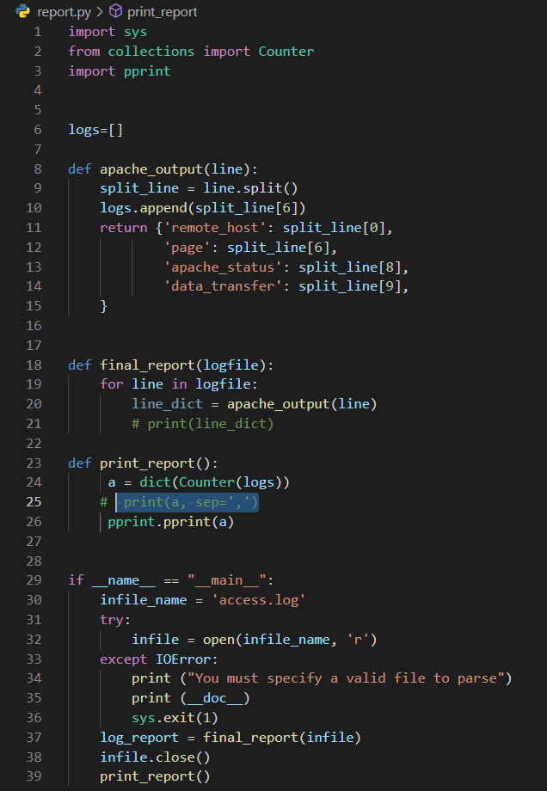

After the execution of code response was as given below

